Composer: Simple TEM Tutorial

# Adding a type

1: Select “Administration”  
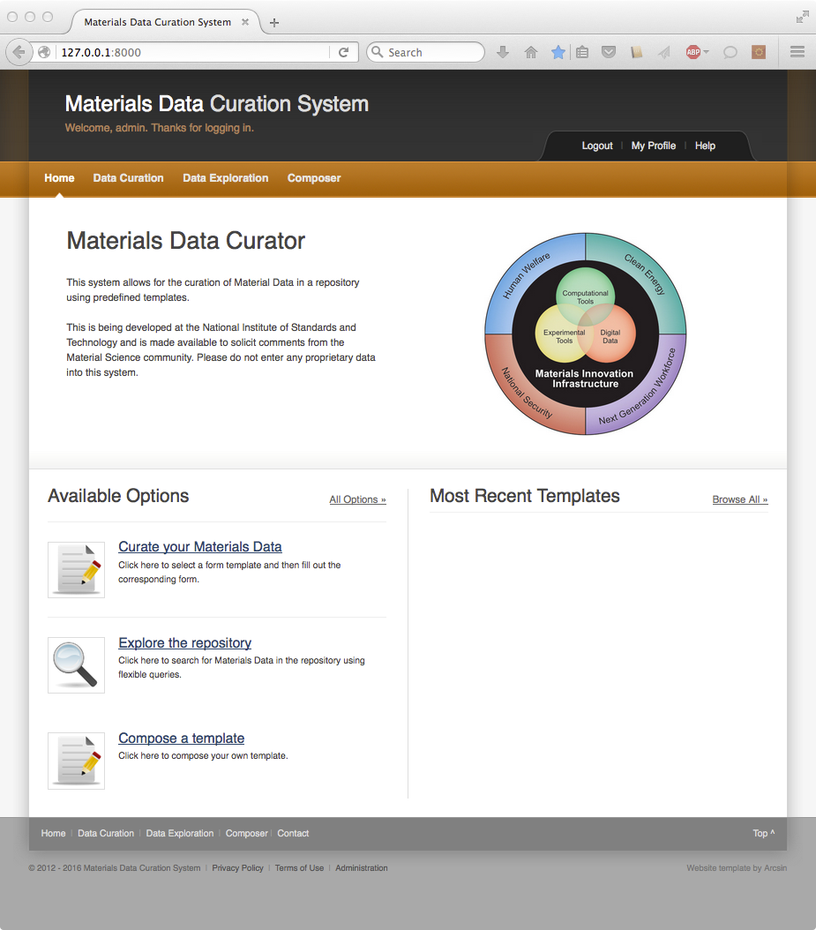

2: Select “Templates & Types”, select “Manage Types”, and select “Upload Type”  
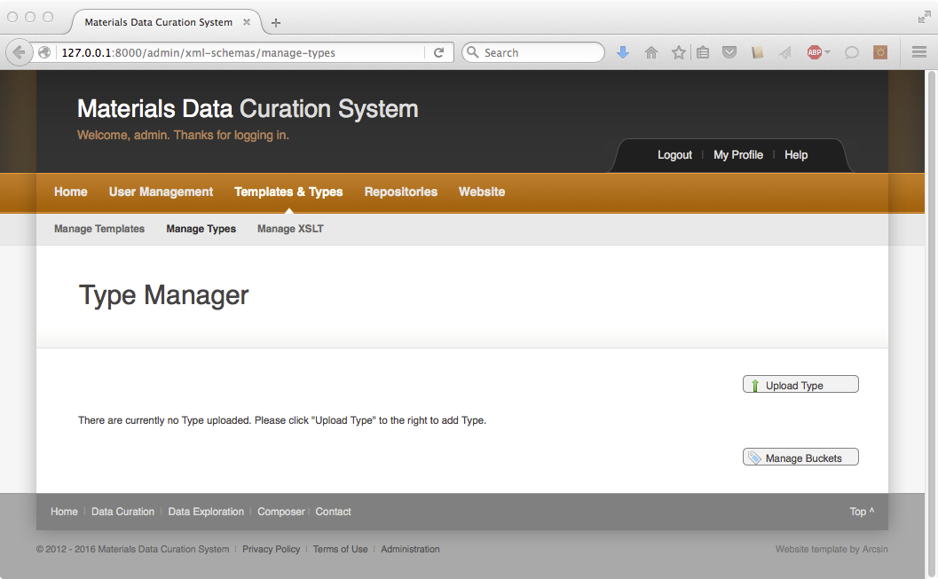

3: Navigate to the TEM Tutorial folder and select “note.xsd”. Enter “note” as the type name.  
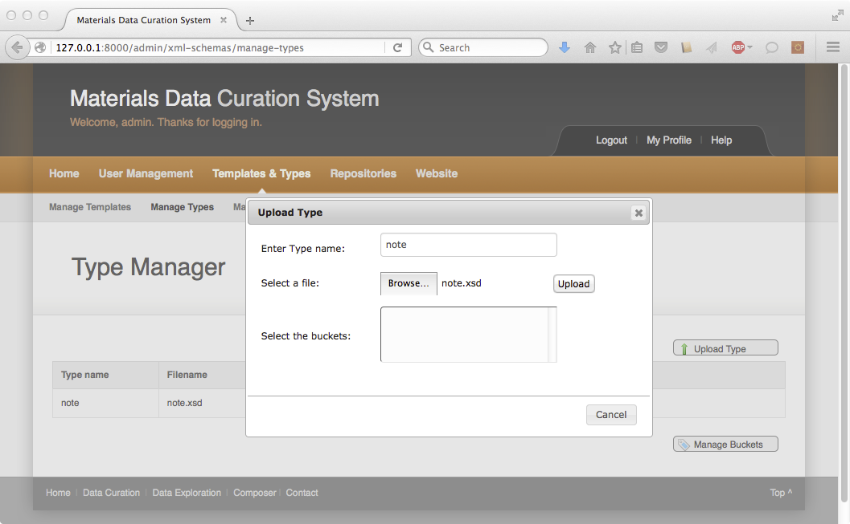

4. Click on “Home”  
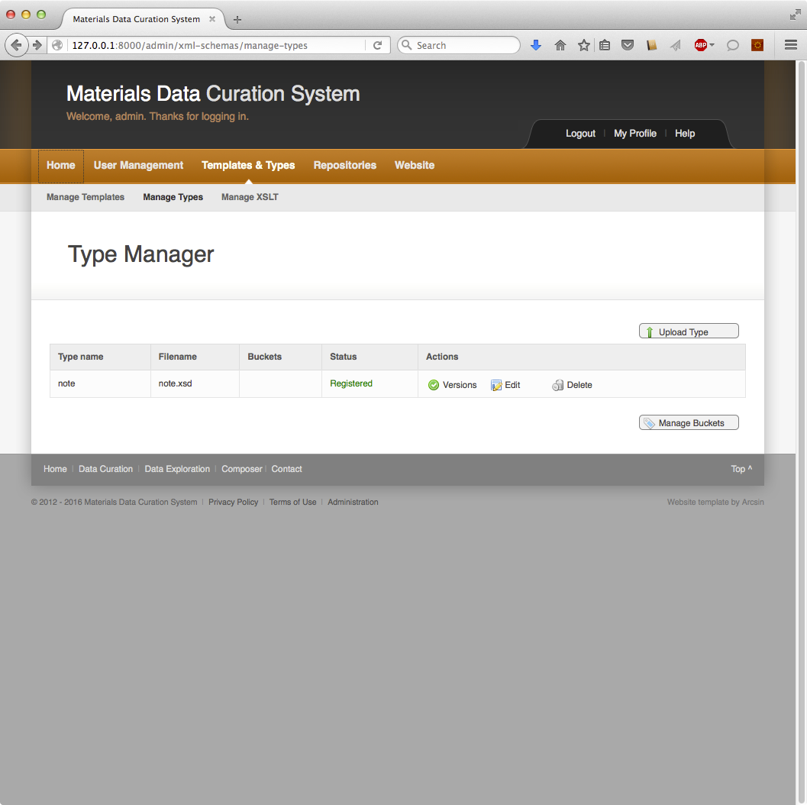

# Modifying an existing Template

1: Click on “Composer”  
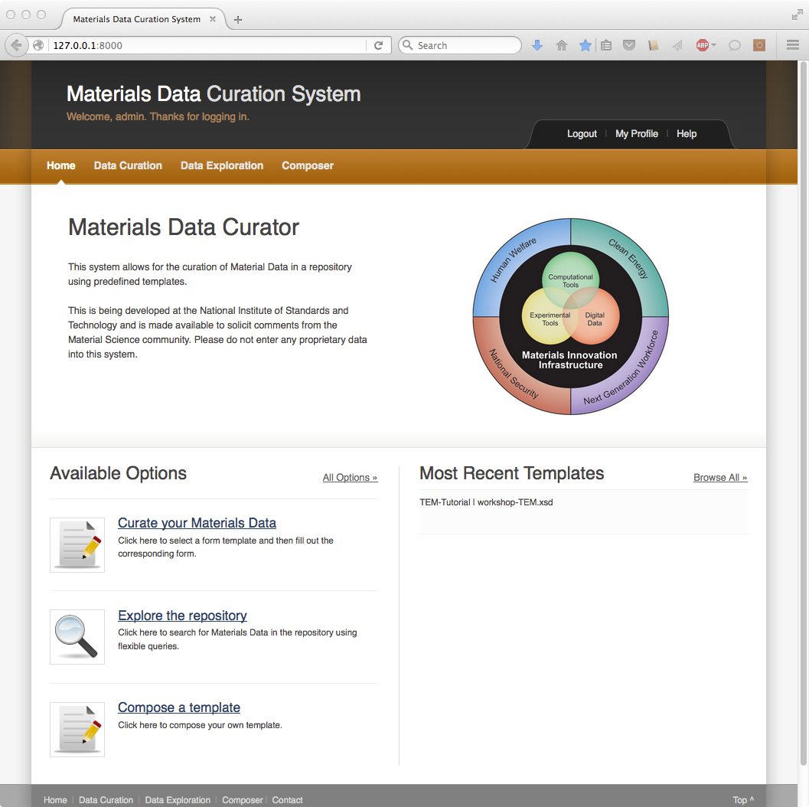

2: Select “TEM-Tutorial” as current template. Proceed to second step: “Compose Tempalte”  
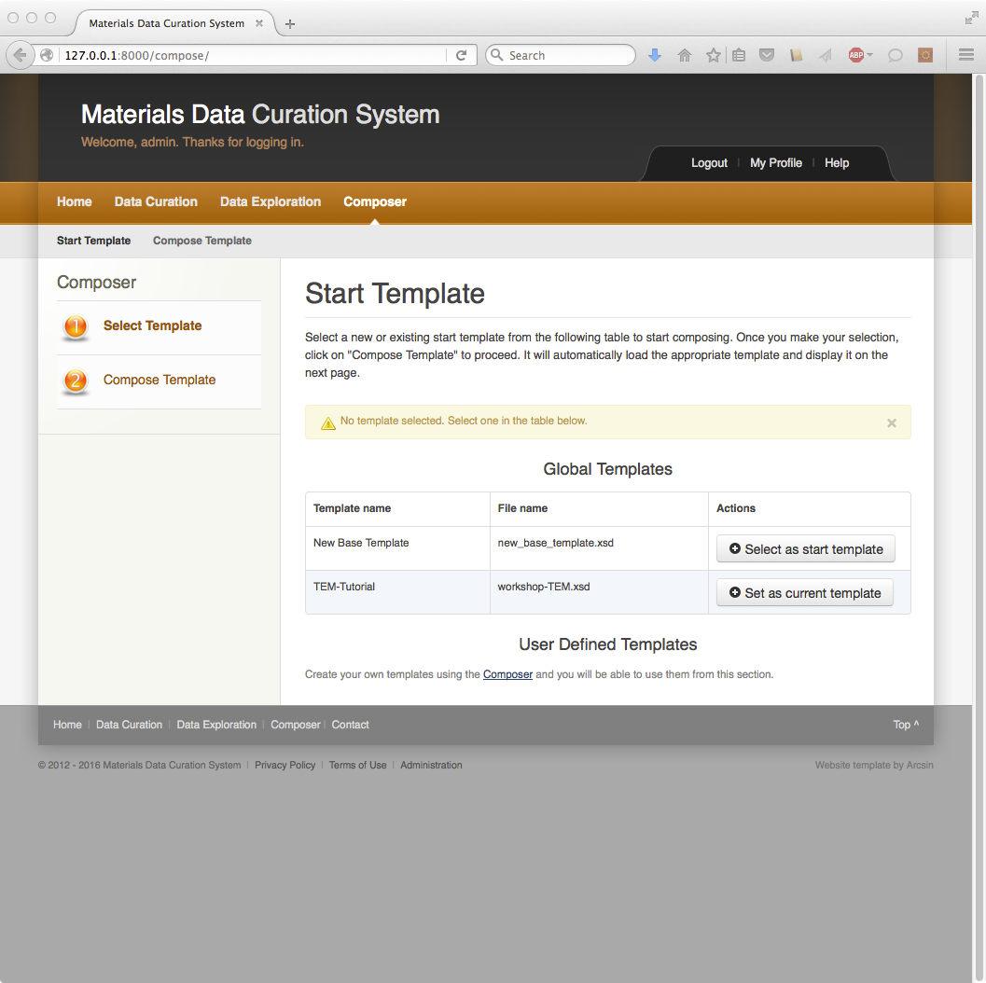

3: Click on the top-level xsd:sequence and select “Add Element”  
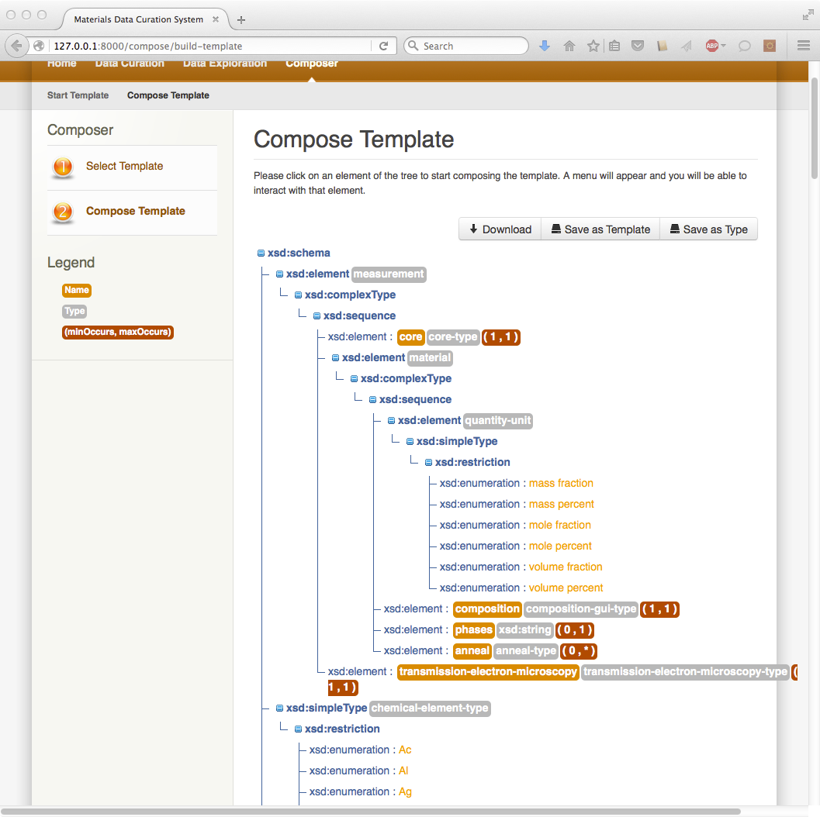

4: Drop-down “No Buckets” menu and insert “note”  
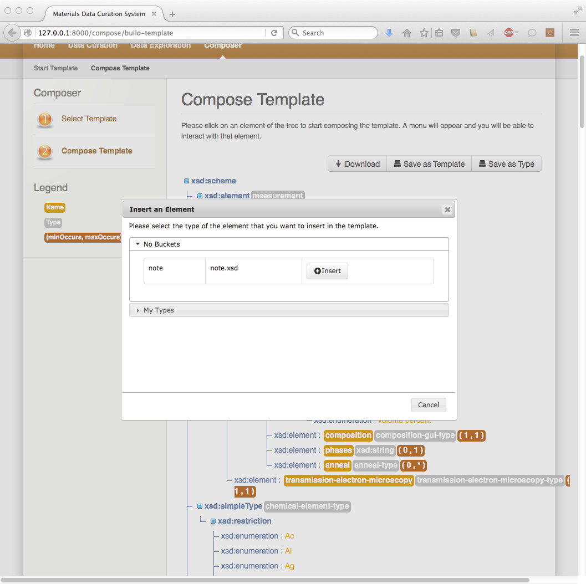

5: Notice new element  
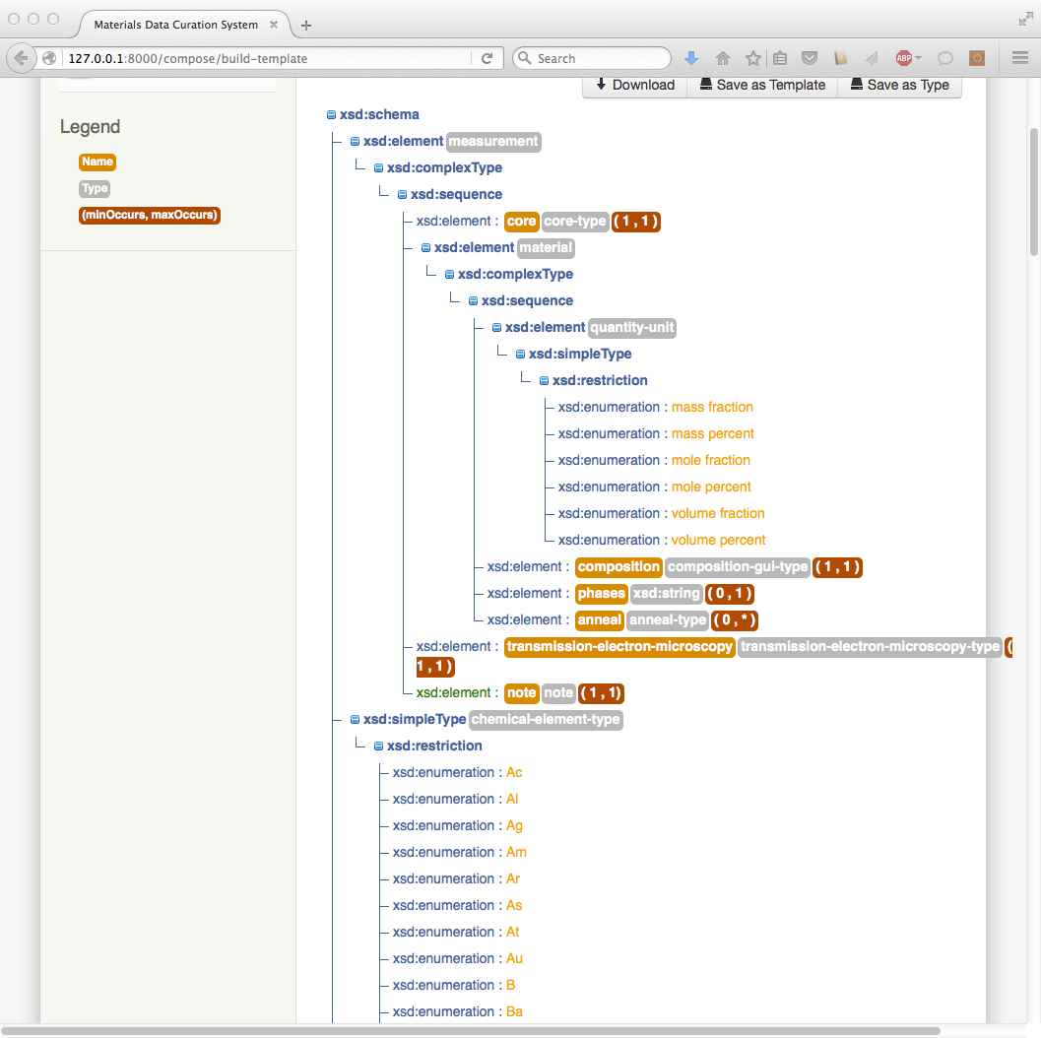

6: Scroll to the top and click “Save as Template”. Enter “TEM note” and click “save”.  
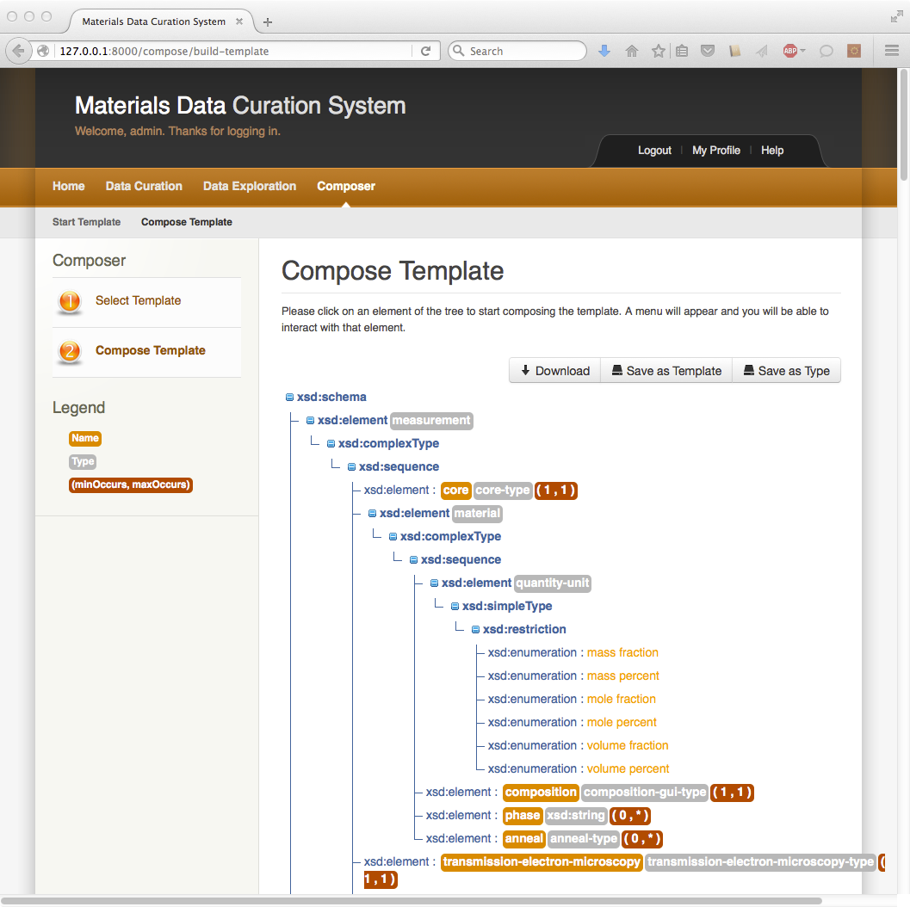

7: After selecting “Ok” click “home”  
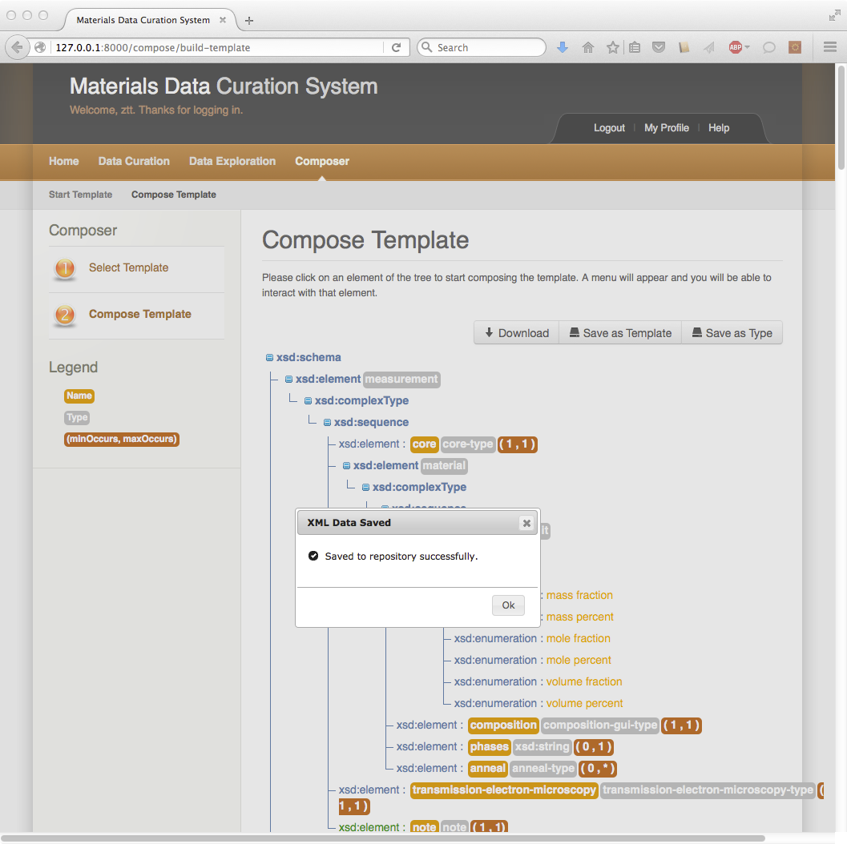

8: Click on “Data Curation” and set “TEM note” as the current template  
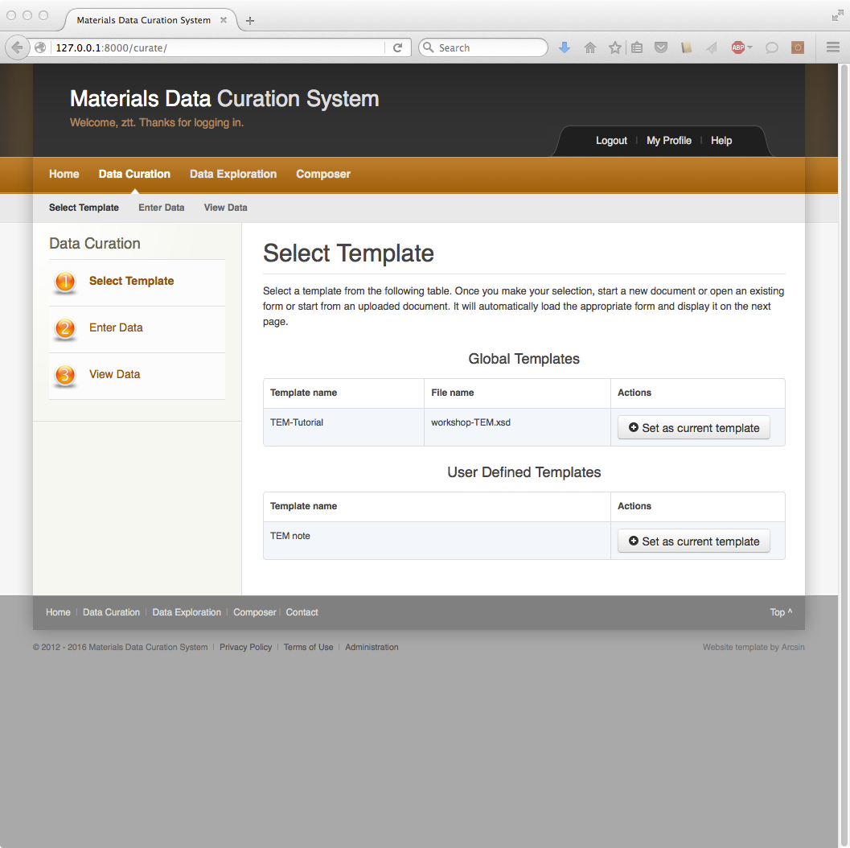

9: Select “Create a new document”. Enter “test-interface” and click “Start”. Verify “note” element was added to the template.  
