Data Curation: Simple TEM Tutorial

# Adding a Template

1: Select “Administration”  
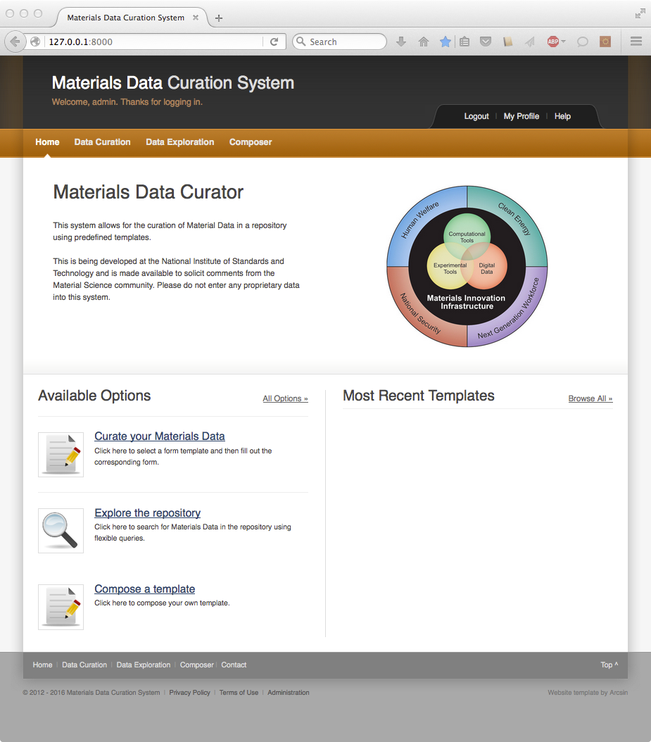

2: Select “Templates & Types” and select “Upload Template”  
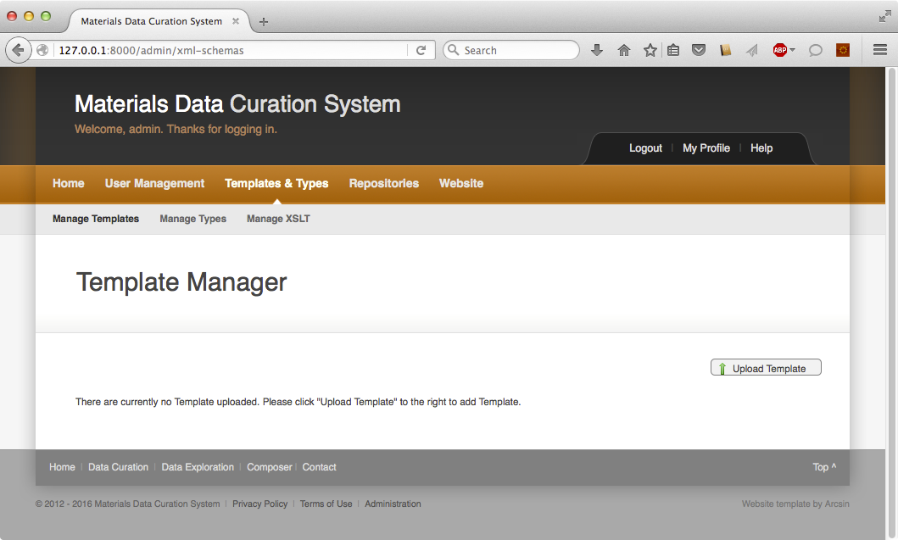

3: Navigate to the TEM Tutorial folder and select “workshop-TEM.xsd”. Enter “TEM-Tutorial” as the template name.  
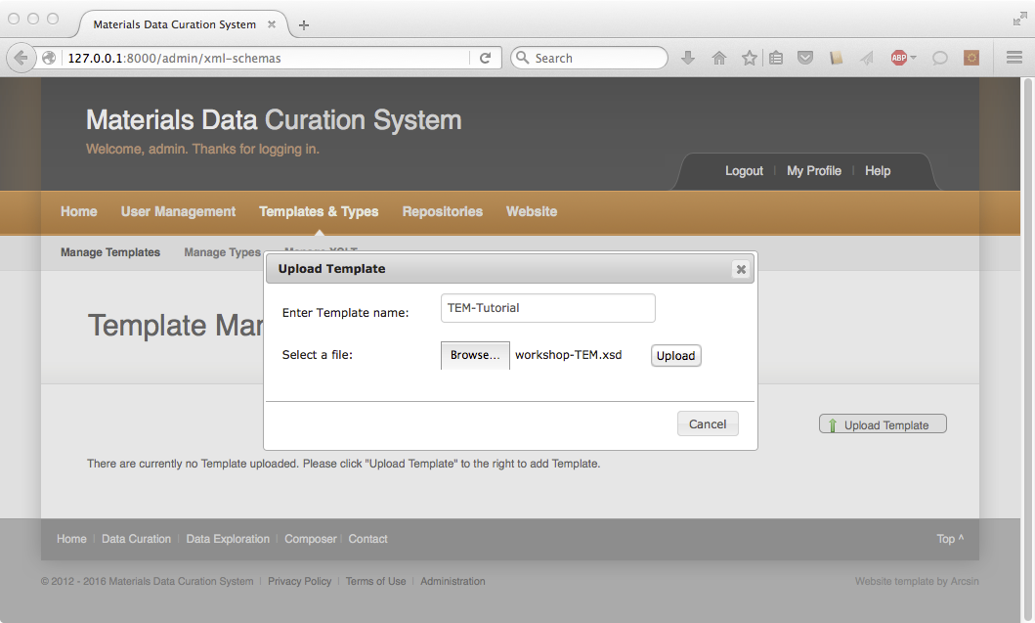

# Adding Modules to the TEM-Tutorial Template

1: Select “Modules”

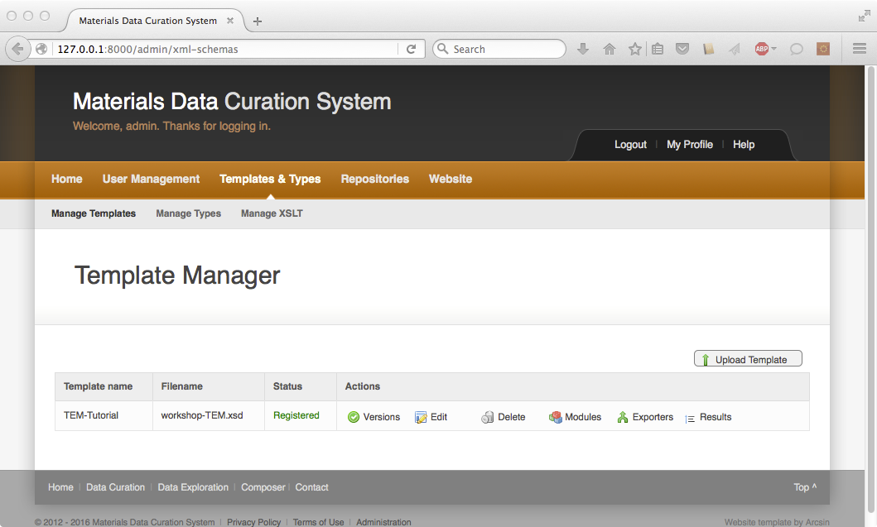

2: Scroll to “composition”. Click on “xsd:element” to the left of composition.  
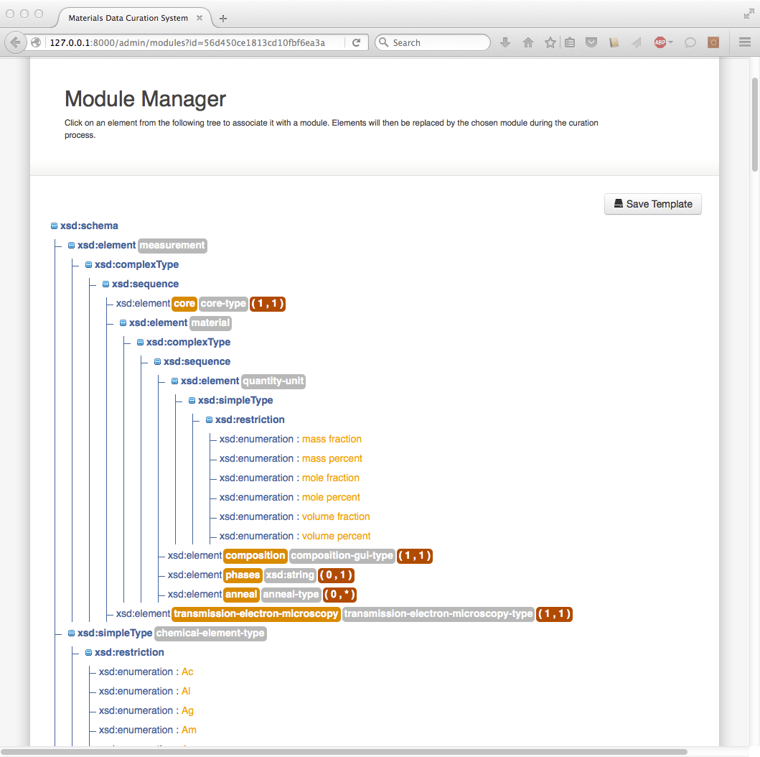

3: Scroll to “Periodic Table Multiple” and click on insert.  
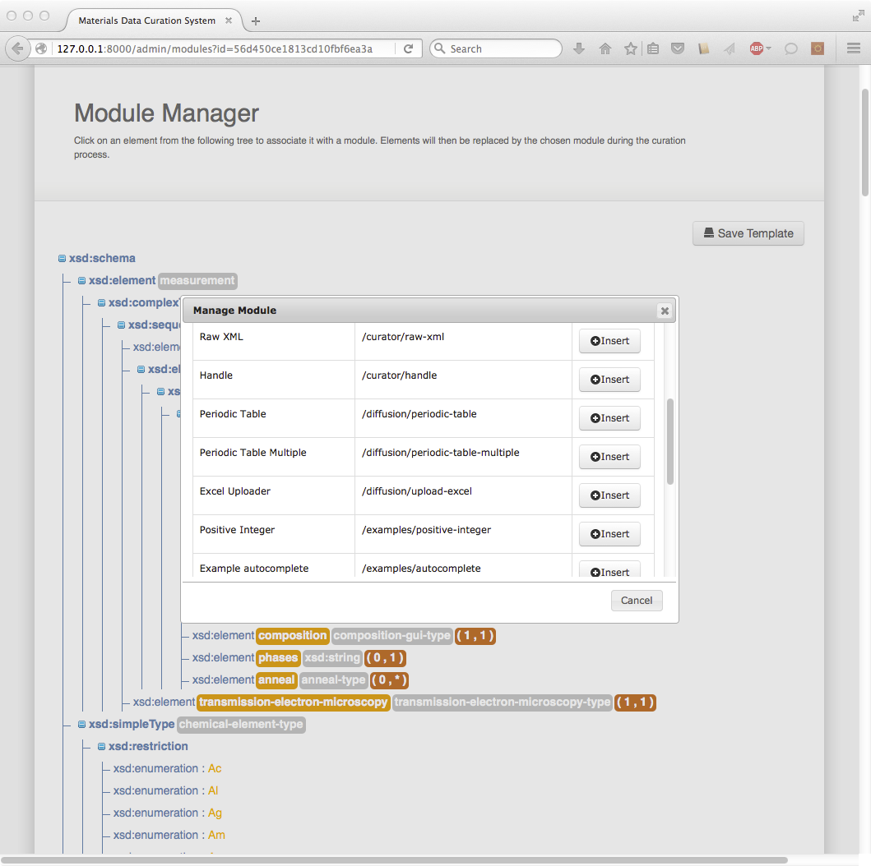

4: Notice the addition of “/diffusion/periodic-table-multiple”  
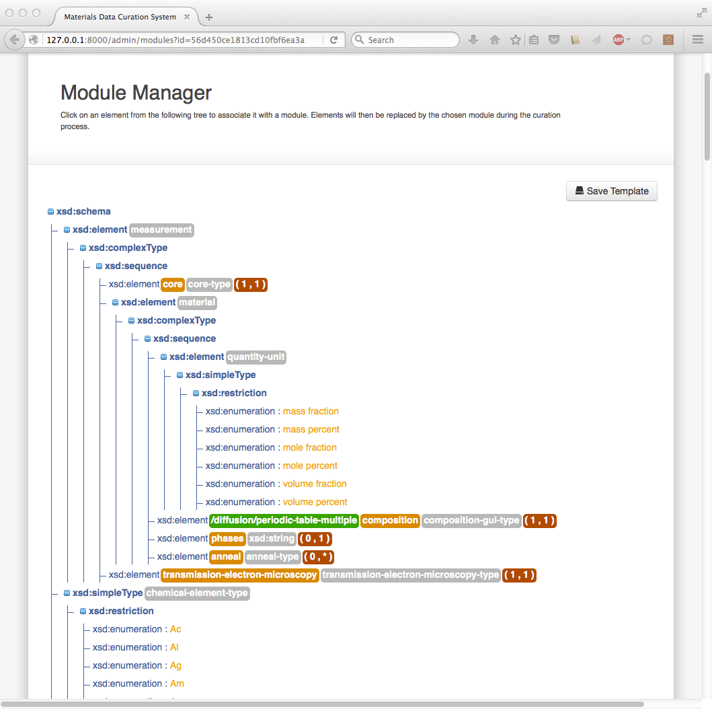

5: Scroll to “downloadURL”, click on “xsd:element”, and insert “BLOB Hoster”:  
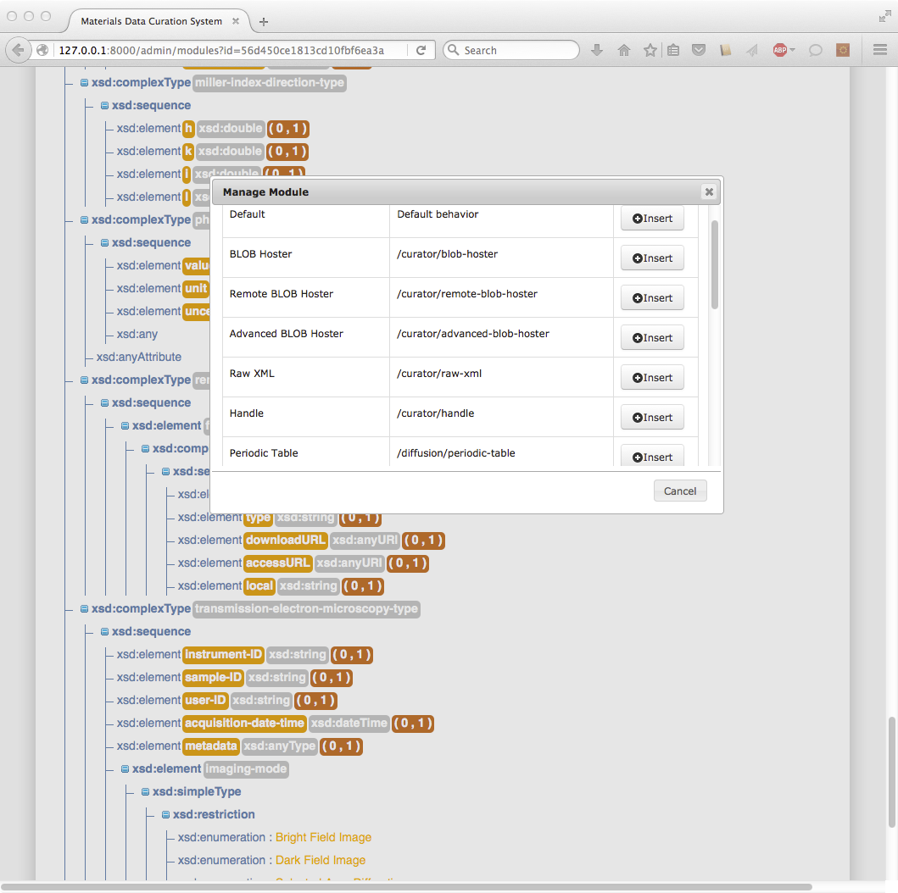

6: Scroll to the top and click on “Save Template”  
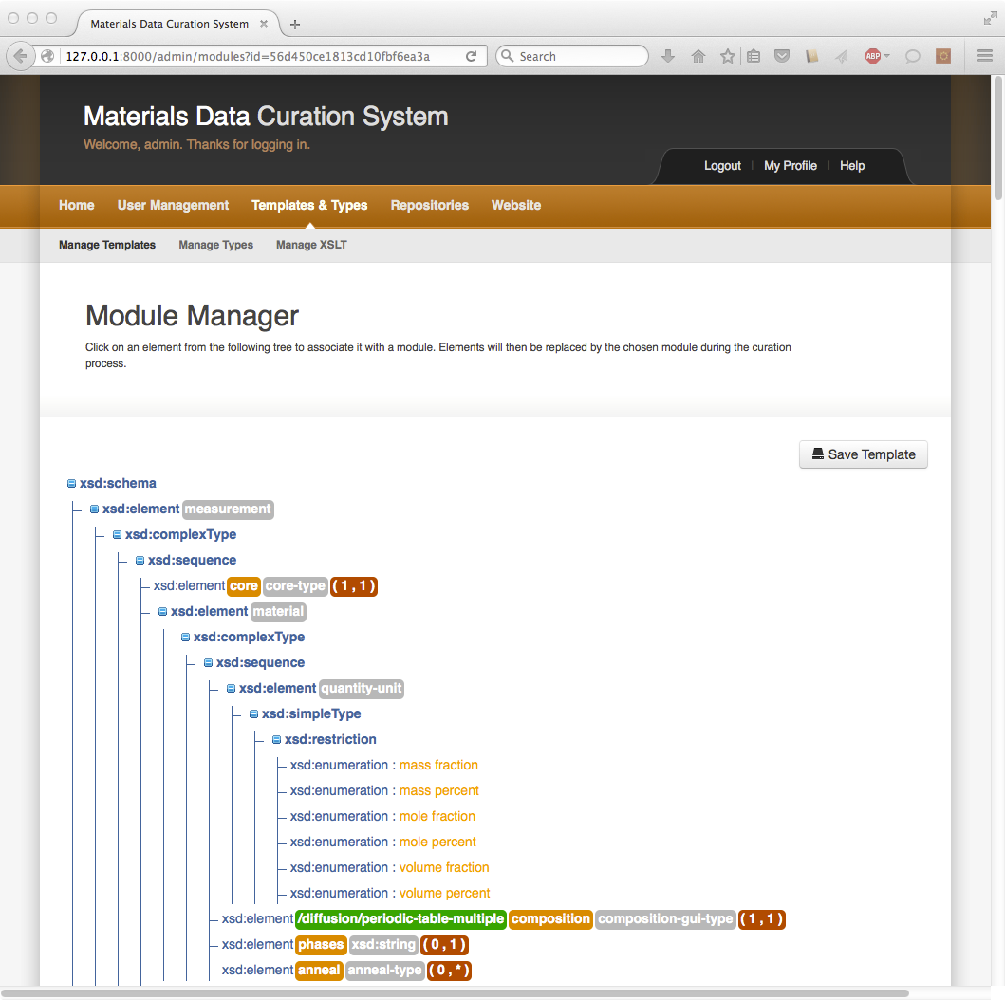

7: Click on “Home”  
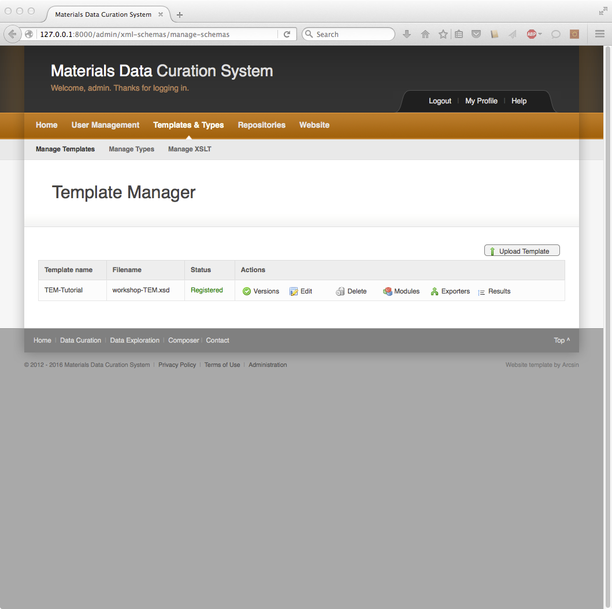

# Curate TEM Micrograph

1: Click on “Data Curation” and set “TEM-Tutorial” as the current template.  
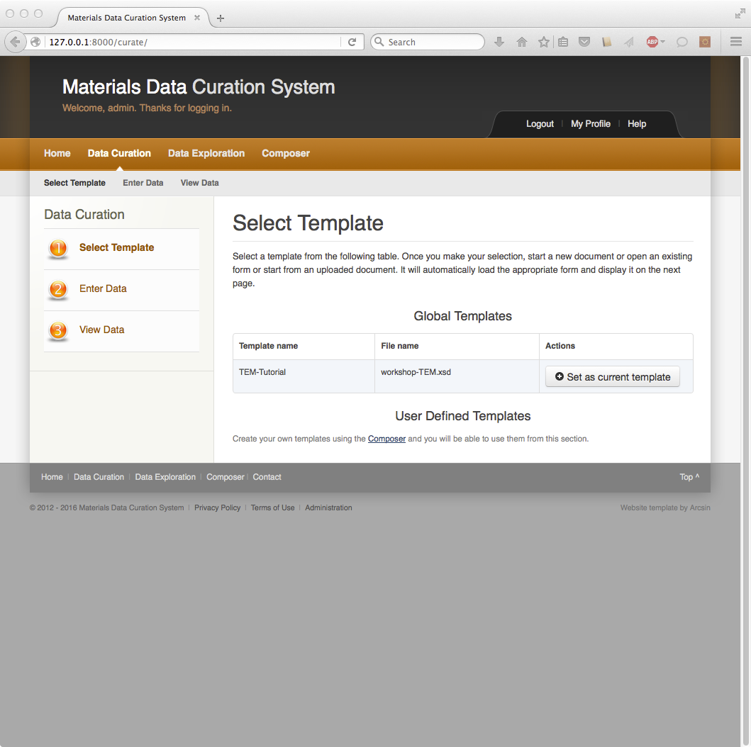

2: Select “Create a new document”. Type in “Co-L06-1000h-900C” and click “Start”  
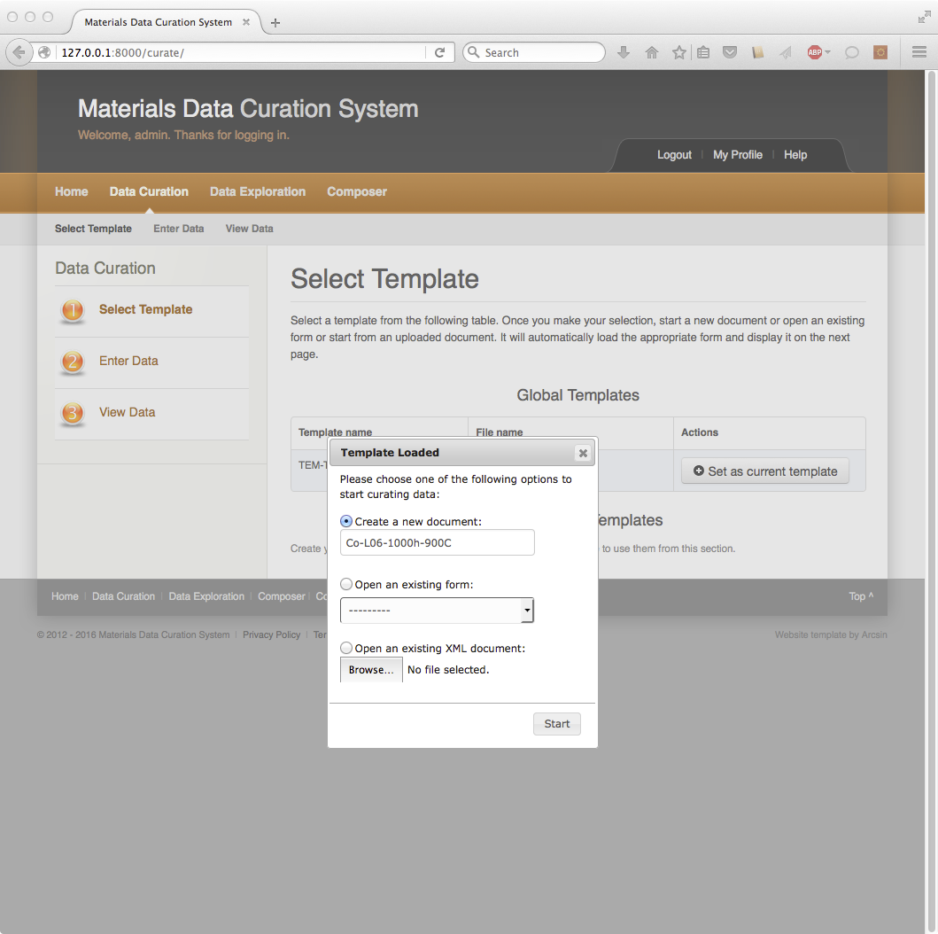

3: The following information will be entered via the web interface in the next few steps:  
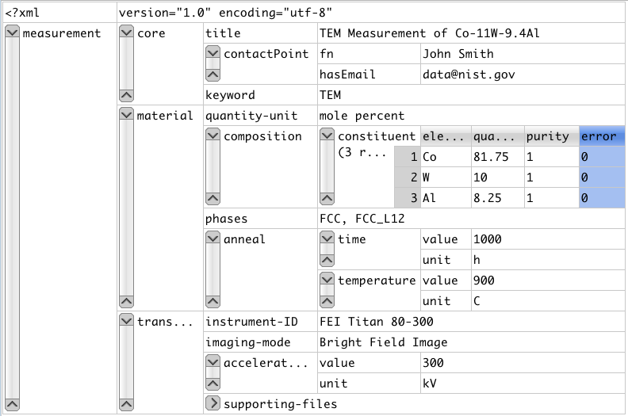

4: Enter “core” metadata:  
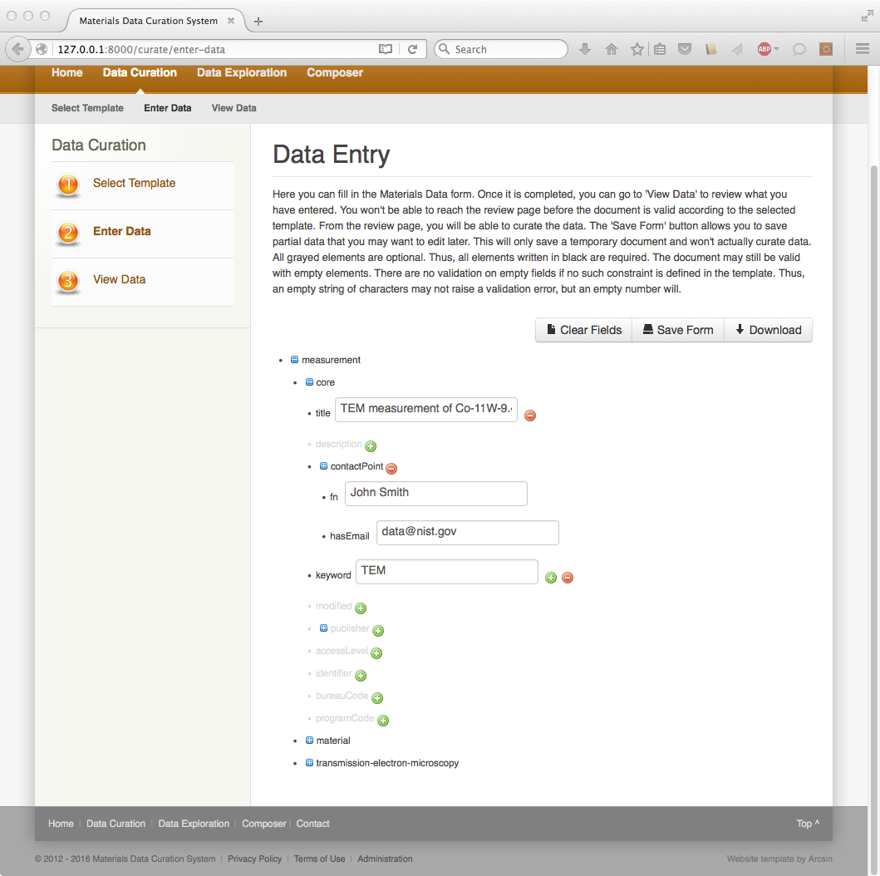

5: Enter composition by clicking “Select Elements” and enter the composition via the periodic table  
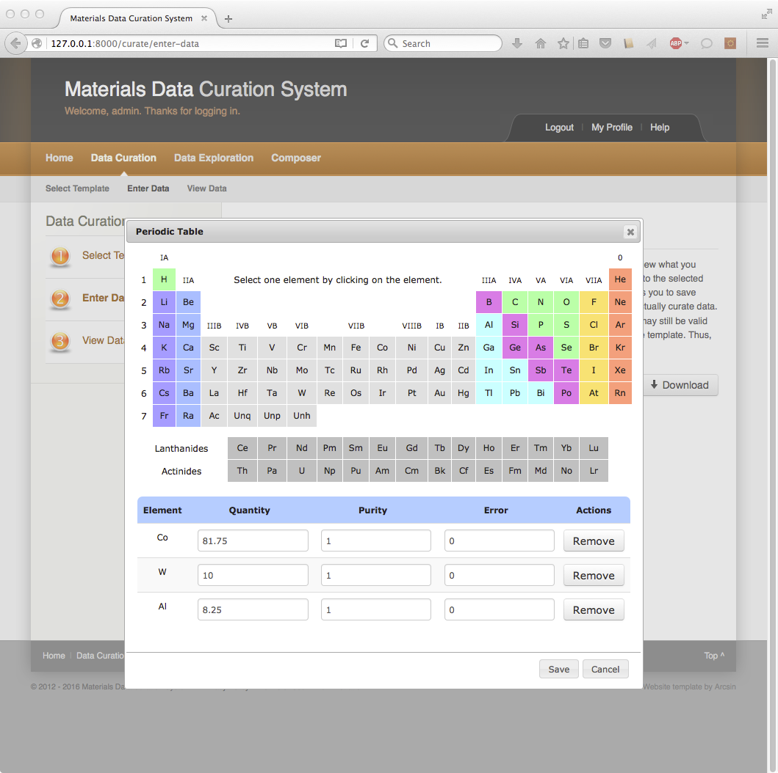

6: Select “mole percent” quantity unit and enter phase and annealing metadata:  
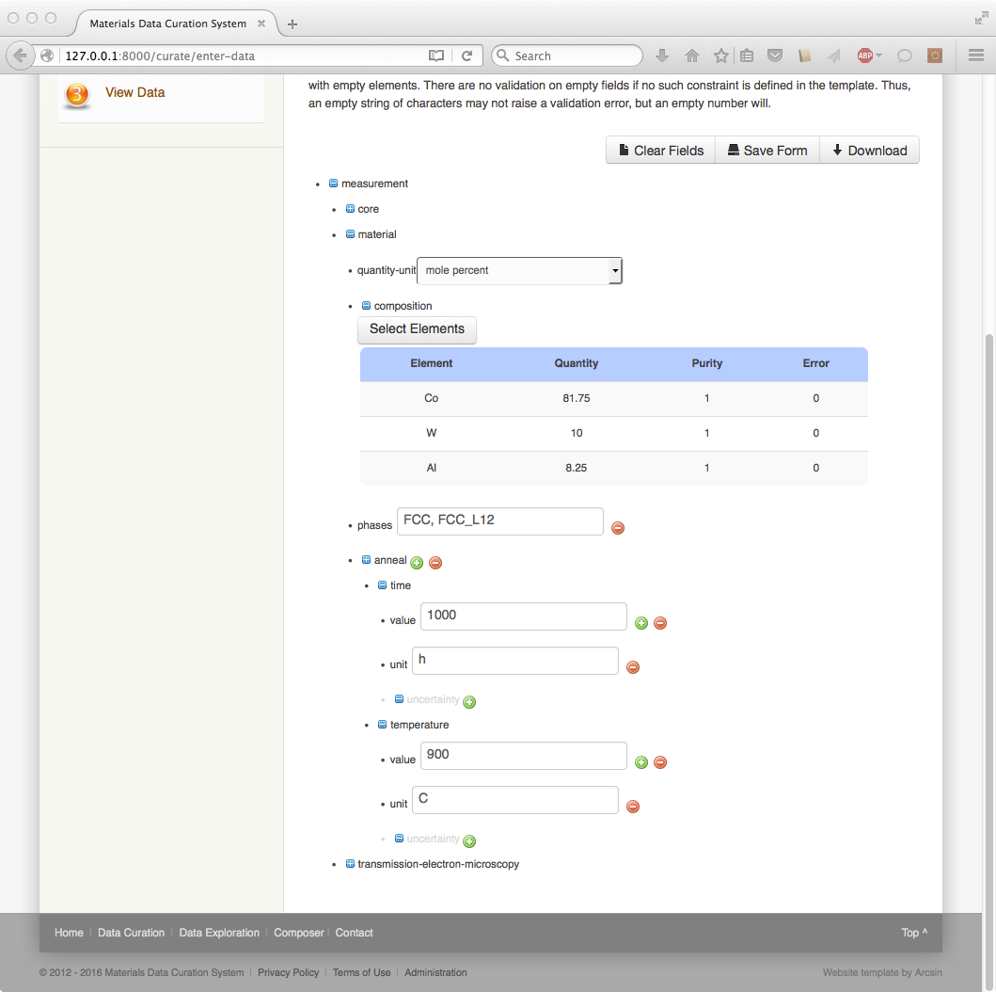

7: Enter the TEM image metadata:  
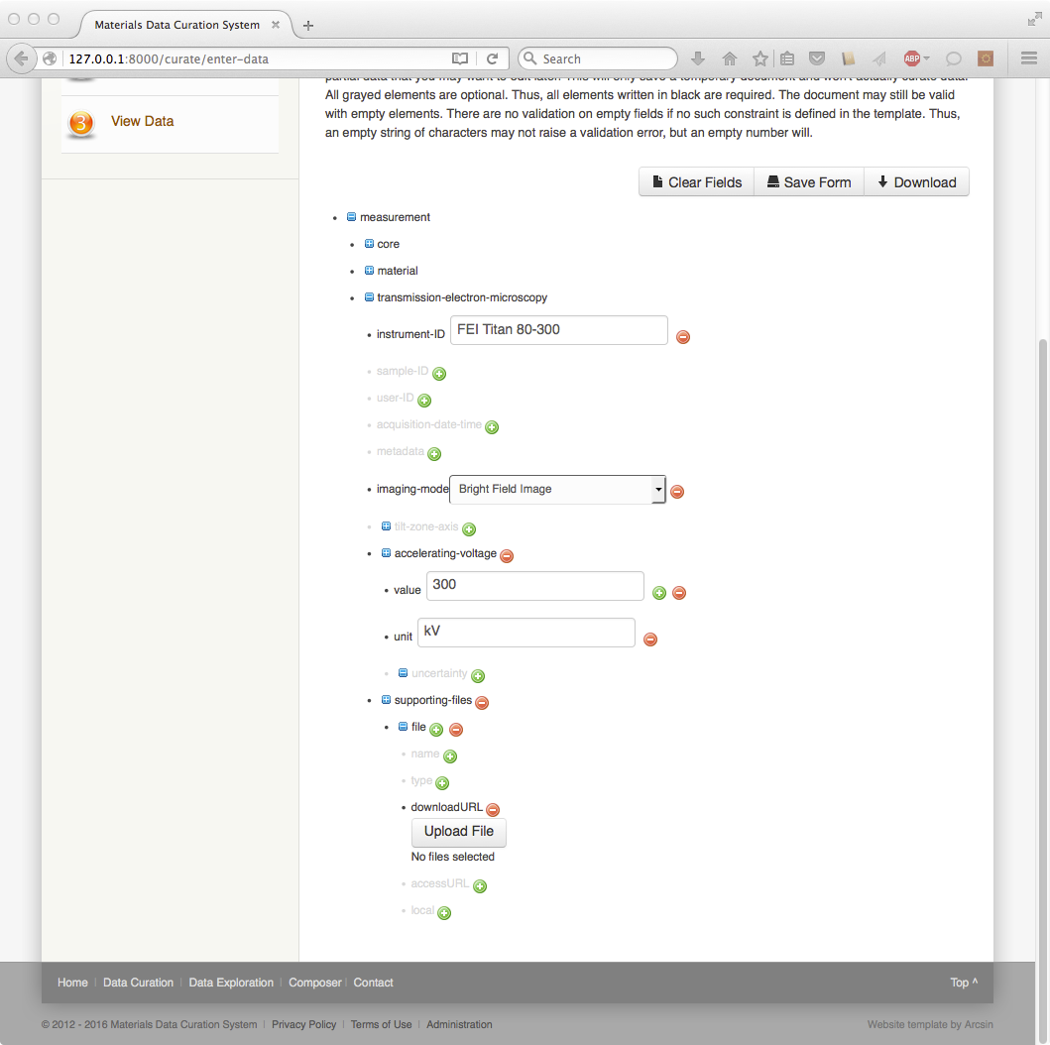

8: Expand “supporting-files”, “file”, and “downloadURL”. Click on “Upload File” and select Co-L06-1000h-900C.jpg. Click “Save”.  
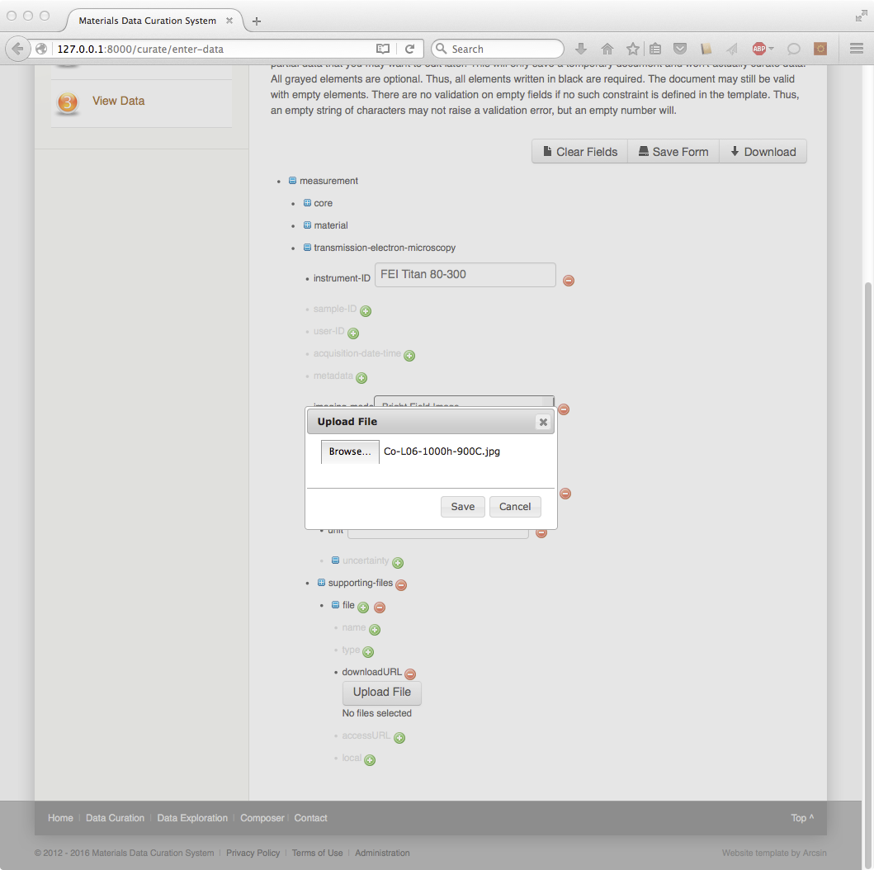

9: A URL should be present. Click on “View Data”.  
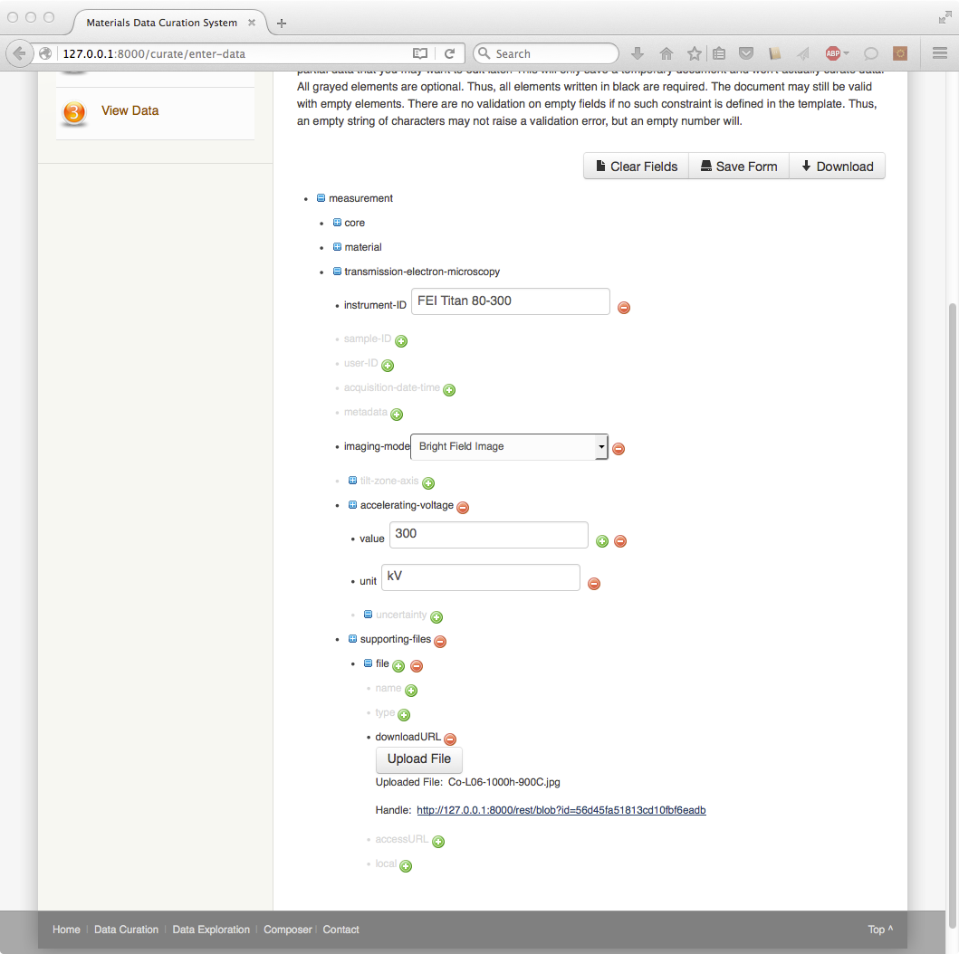

10: The metadata should be rendered as shown below. Click on “Save to repository”.  
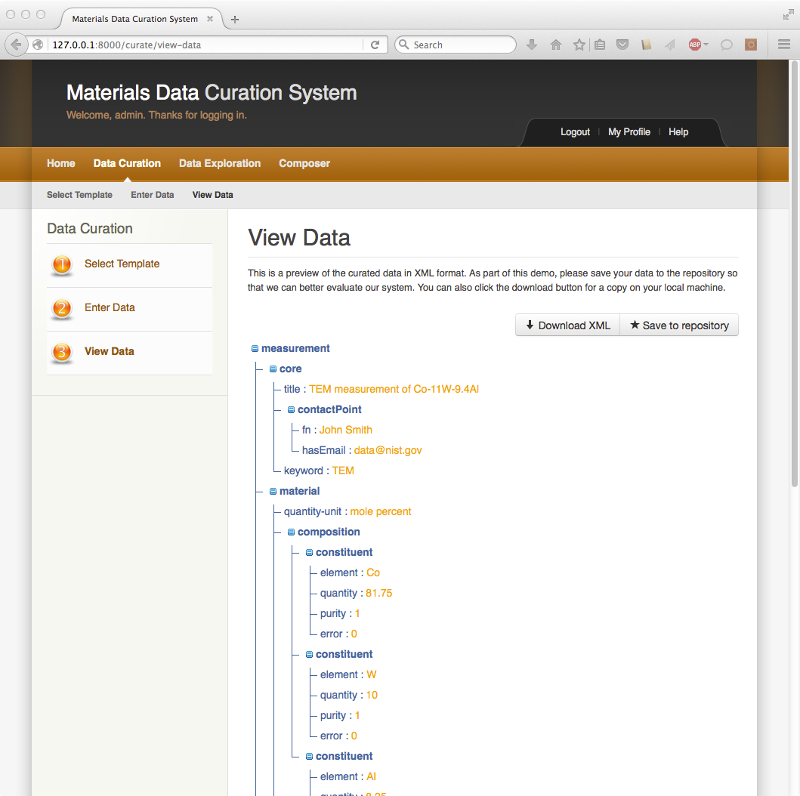

11: The document name should be populated. Click “Save”.  
