Data Curation: Diffusion Couple- Rene88-IN100

1. Select “DemoDiffusion” template in the Data Curation Menu

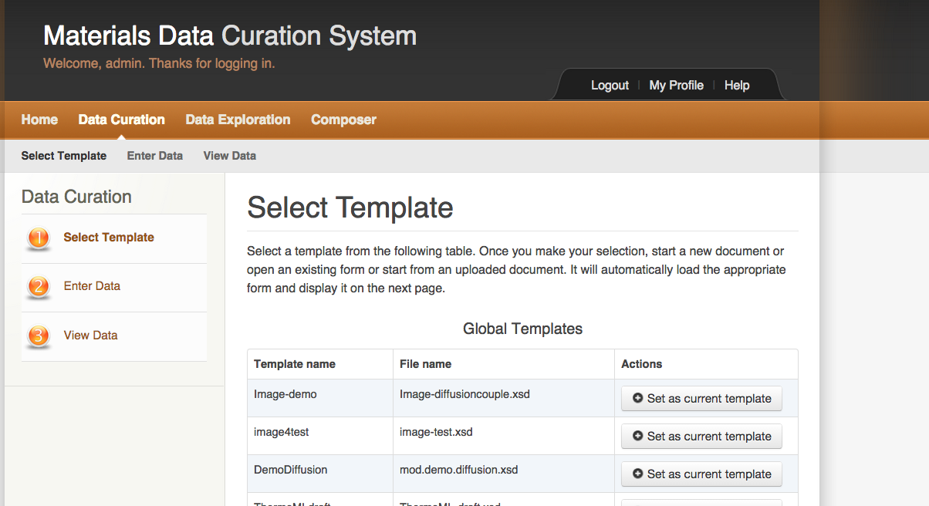

1. Create a new document “R88IN100”

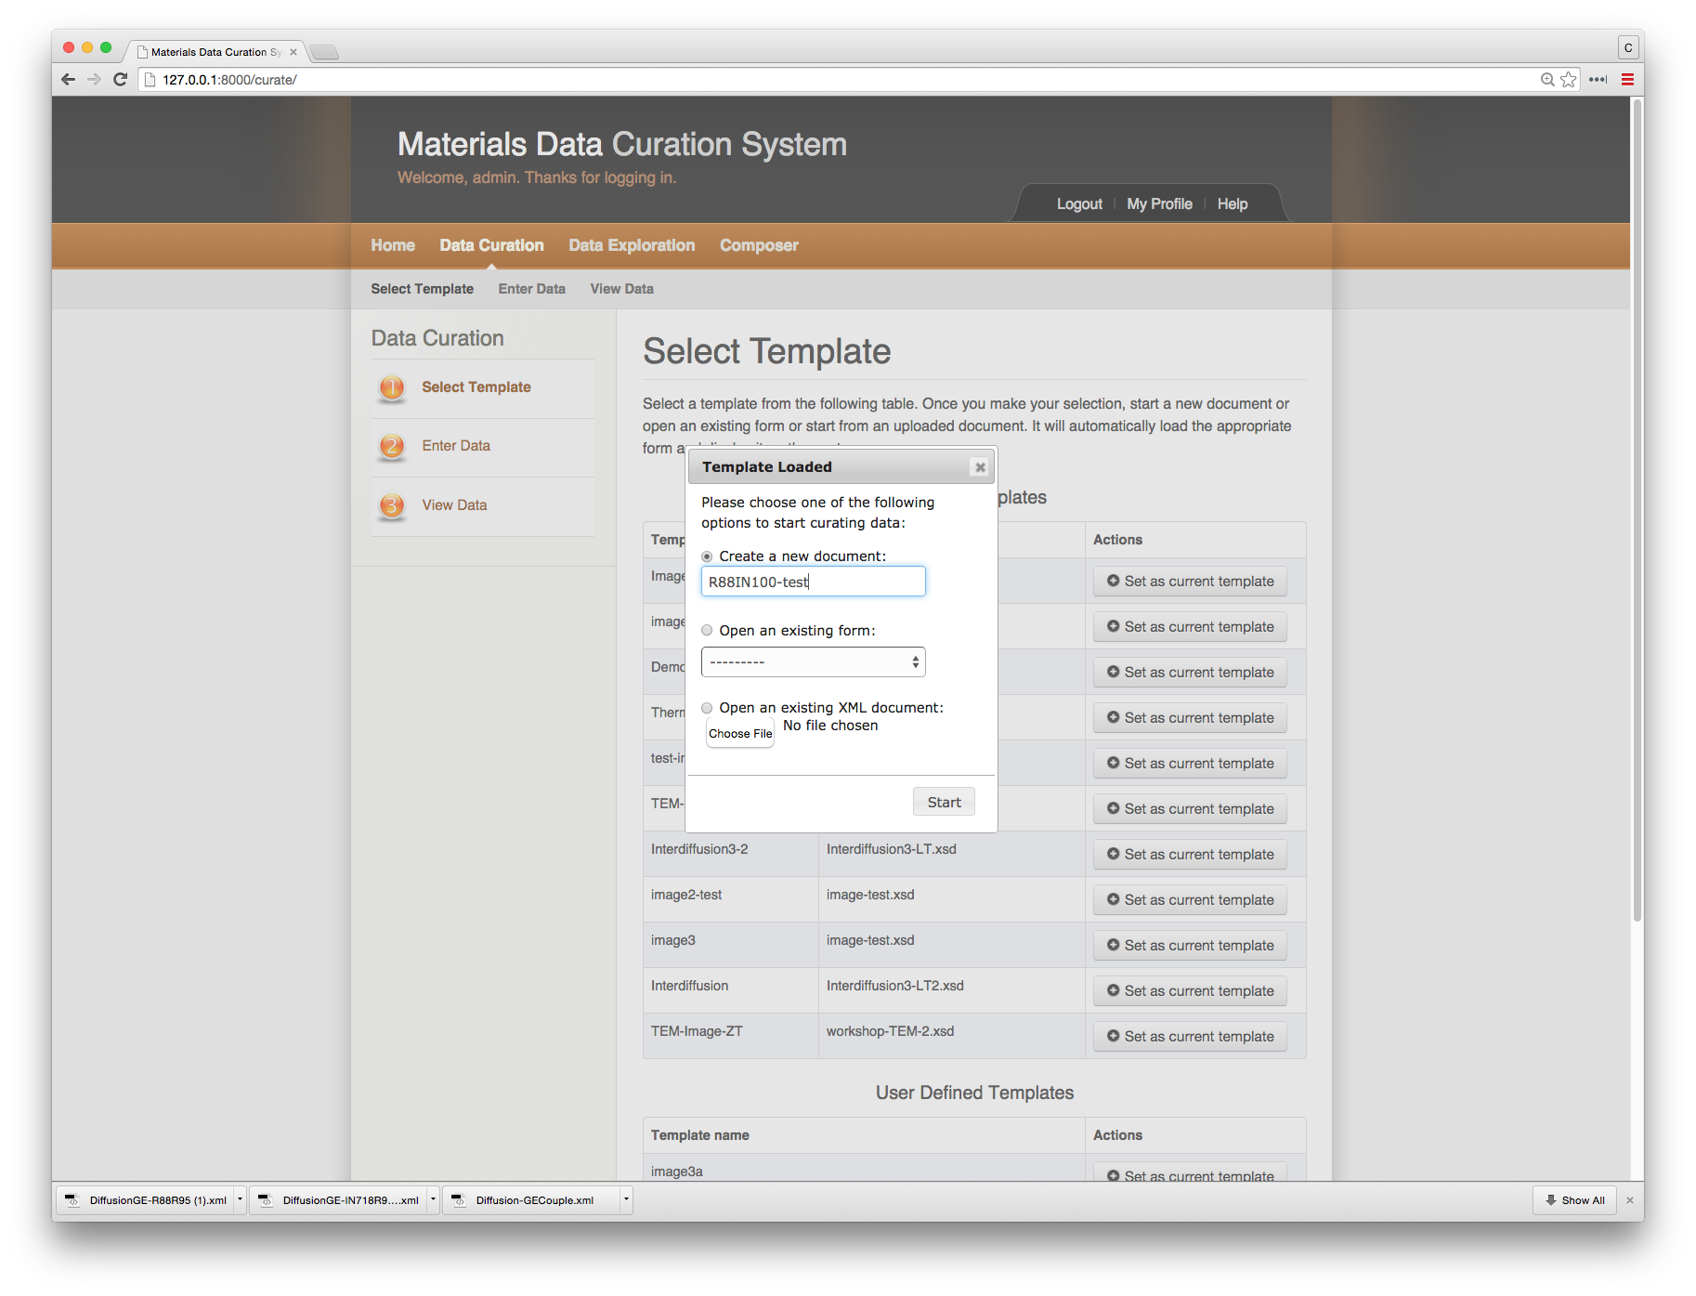

1. The next step is to select the type of diffusion experiment. In this case it is “chemical diffusivity”

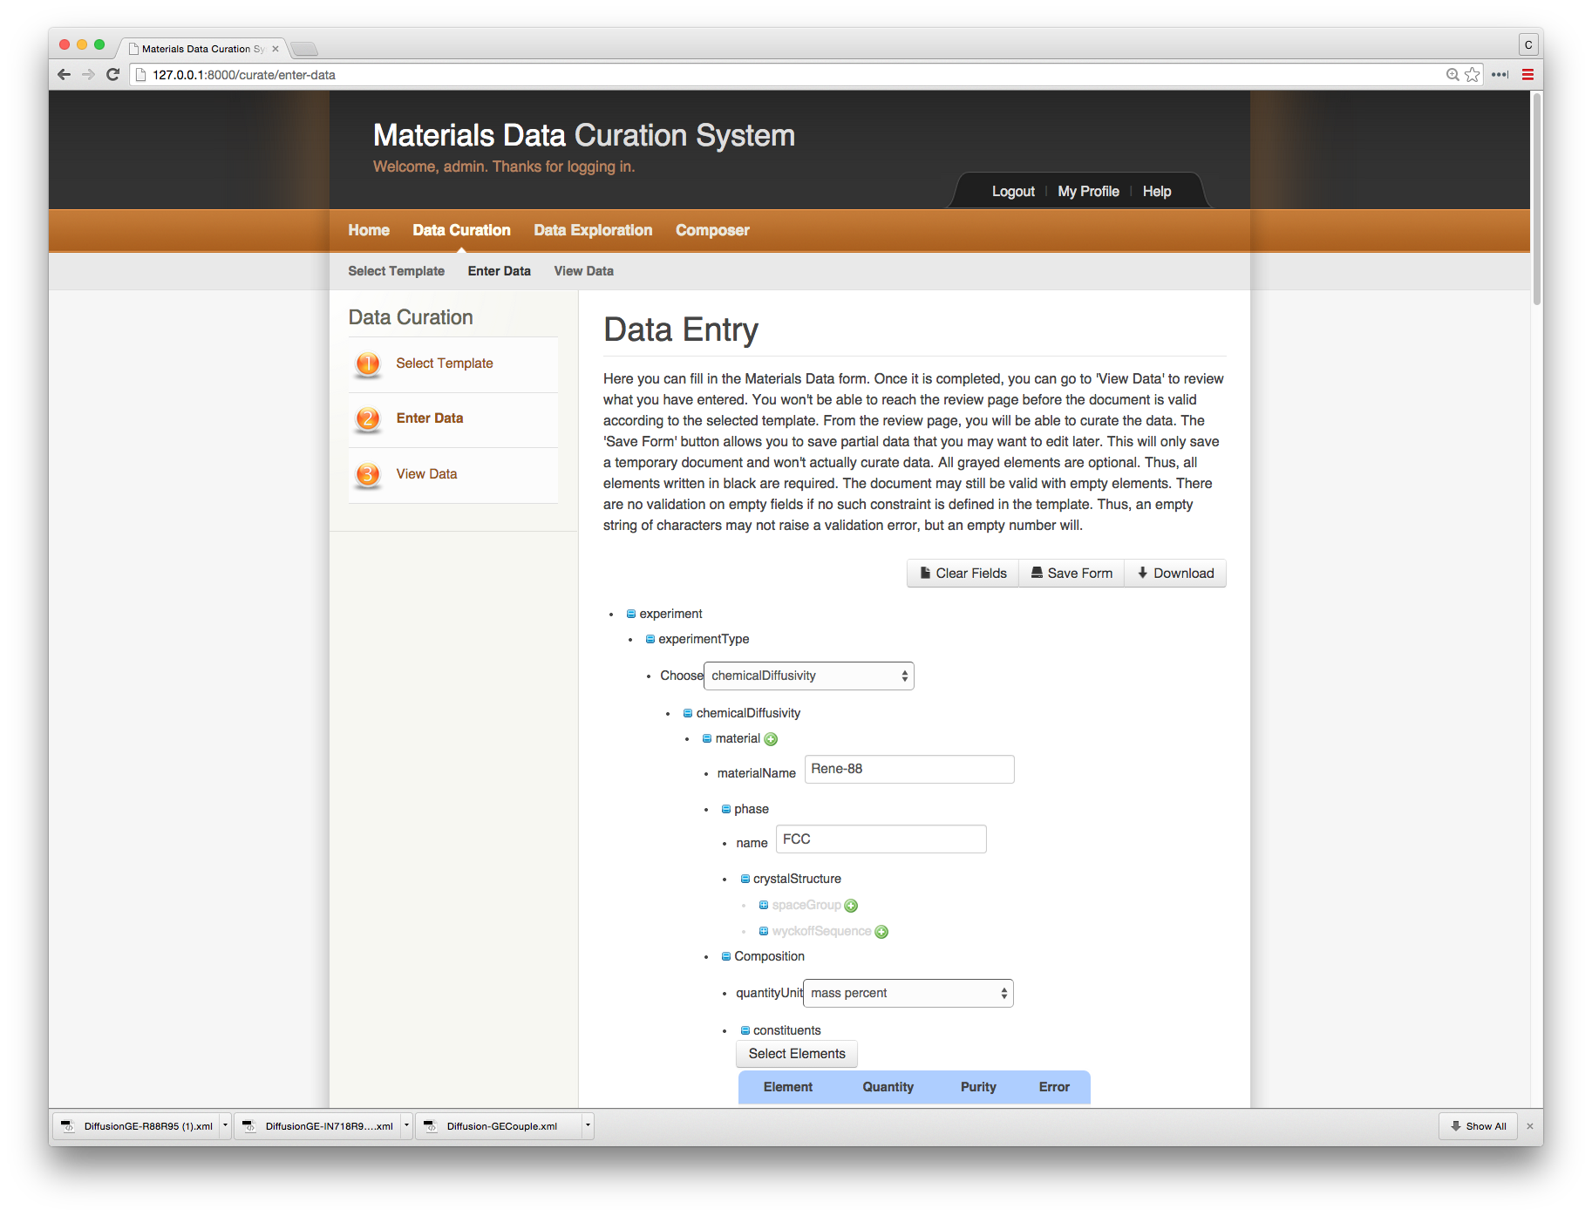

Next enter the information at about the diffusion couple end-members. First, the information for Rene-88.

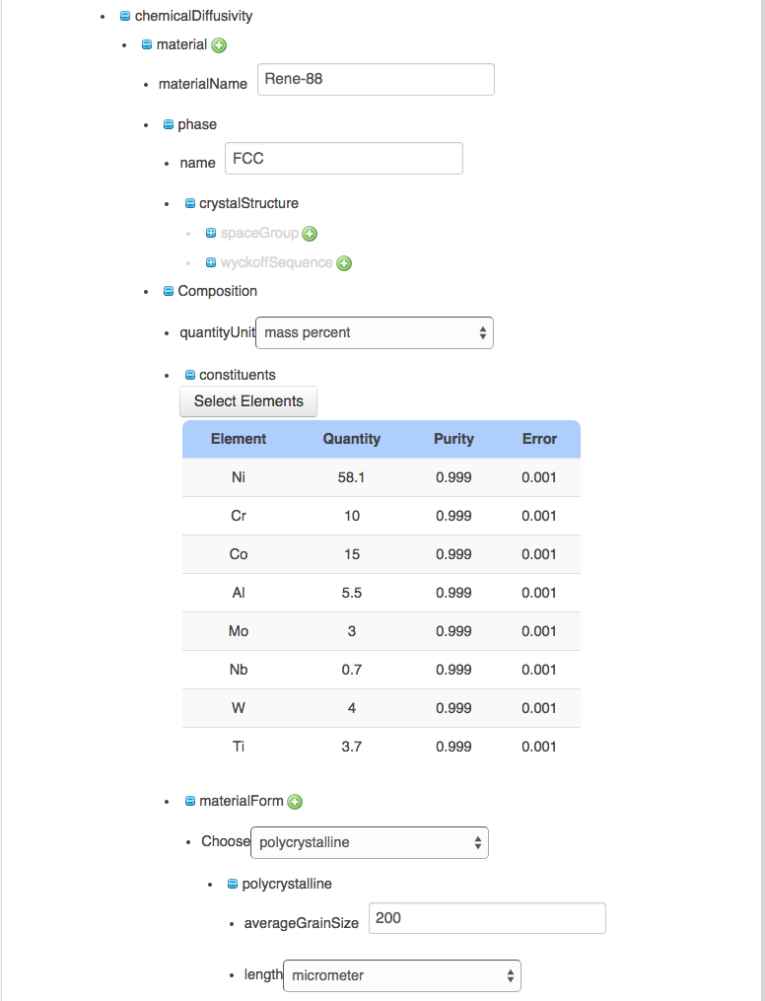

Now enter the information for IN100 alloy.

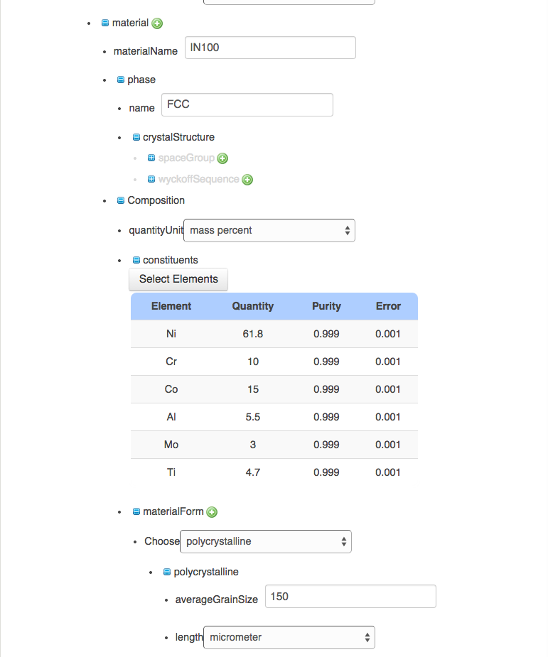

Next, enter the experimental conditions for the diffusion anneal.

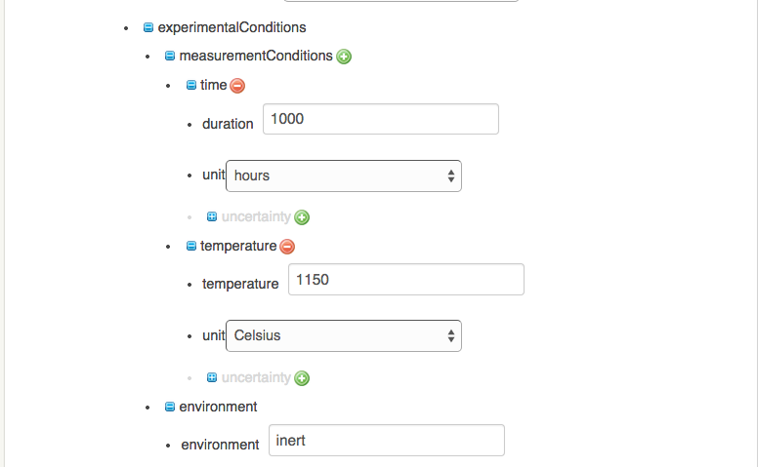

Enter the sample geometries for the two end-members of the diffusion couple.

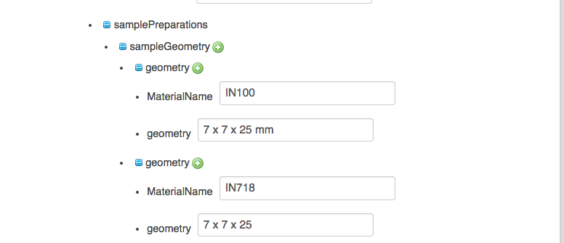

Next enter some sample preparation information. Note these are just text strings.

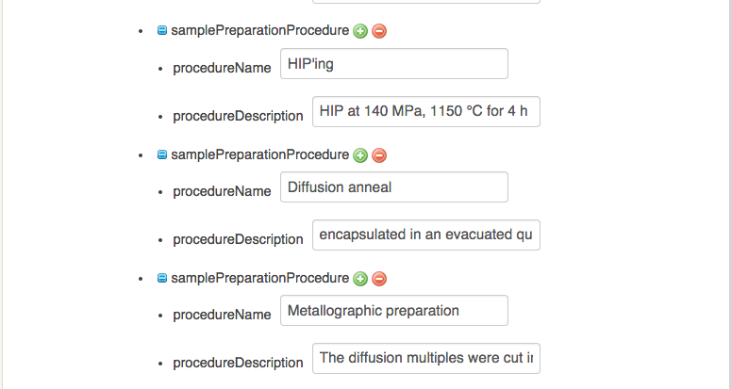

Now enter some information on the data collected. The composition profiles for this experiment were collected using EPMA.

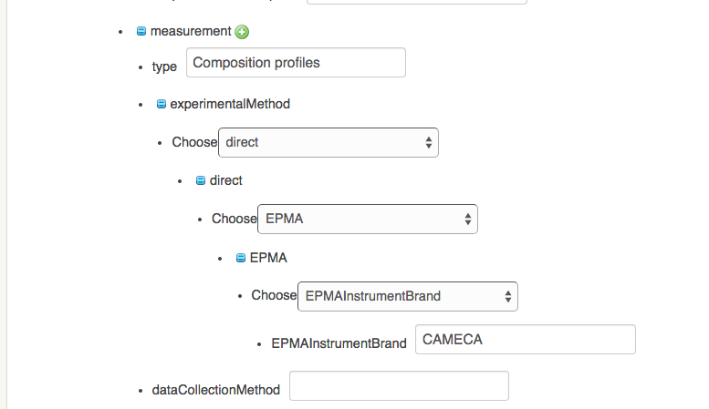

Now enter the collected experimental composition profile (upload an excel spreadsheet: GE-DiffusionCouple-R88-IN100.xlsx)

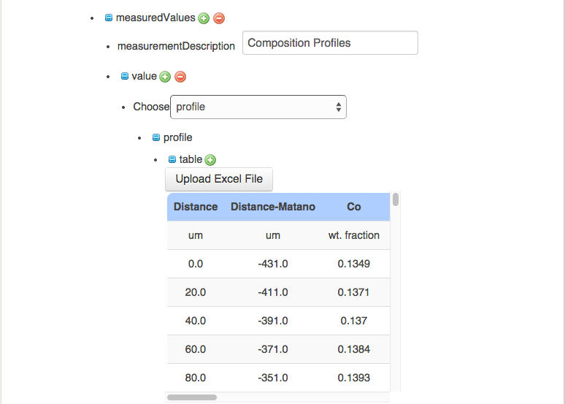

Next upload the corresponding micrograph (GE-DiffusionCouple-R88-IN100.tif)

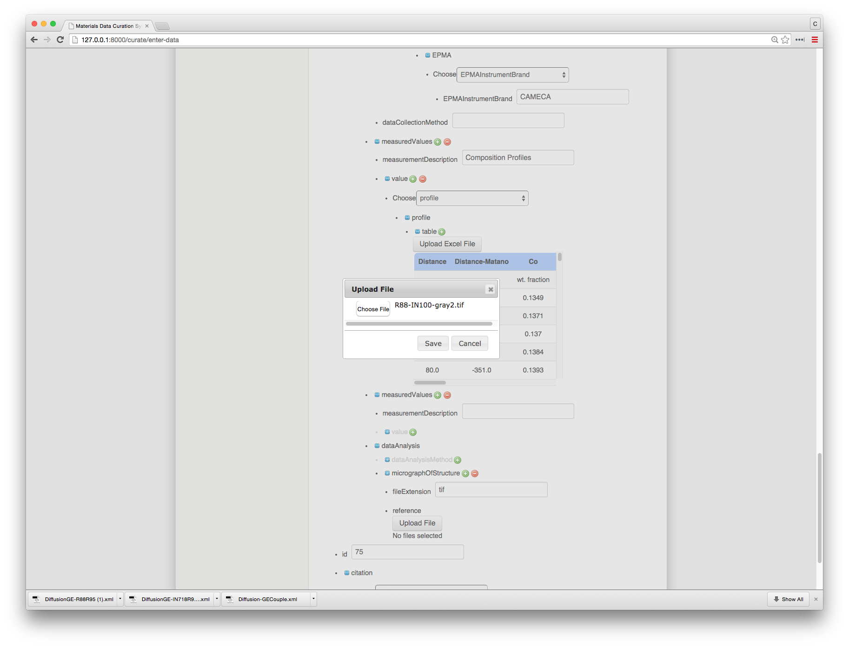

Once the file is upload, you should see a handle reference where the image is stored.

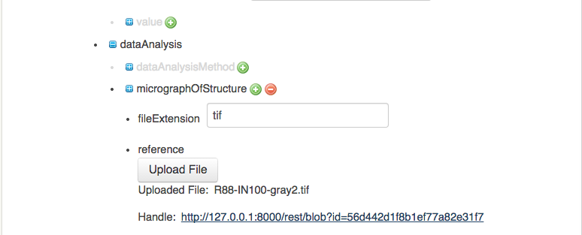

Enter a sample id and chose a citation reference:

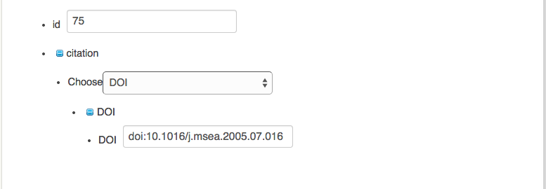

Now you can “View Data” (from the top left hand side menu) and chose to save it to the repository.

