Preliminary
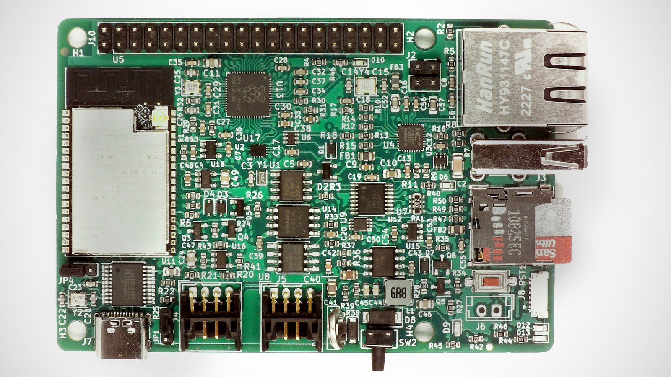

EsPiFF is an ESP32 in a Raspberry Pi 4 form factor, capable of utilizing nearly every Pi 4 enclosure and HAT. EsPiFF packs an additional punch with wired and wireless Ethernet, an SD card socket, and a RP2040 co-processor.
EsPiff is particularly well suited to measurement, control, and automation projects where the current consumption and heat generation of a Pi—or the potential instability of its SD card—could be problematic.

Features & Specifications
- ESP32-WROVER with 8 MB PSRAM and 16 MB Flash in a Raspberry Pi 4 form factor
- Wi-Fi connectivity (requires an external U.FL antenna)
- 10/100 wired Ethernet via IP101 PHY
- PoE header, to use Raspberry Pi PoE HATs. EsPiFF can be powered from a HAT or can power the HAT
- Micro SD card socket for storage
- Up to 3 UARTs
- USB Type-C connector on CH340 USB-UART for programming as well as power draw up to 5 V / 3 A for power-hungry HATs
- 40-pin Rasperry Pi header, compatible with all Raspberry Pi HATs
- RP2040 co-processor to emulate the Pi on the 40 pin connector, with 8 MB Flash
- External realtime clock, watchdog, and supervisor for high-availability, 24/7 applications
- On-board supercap to keep the realtime clock running for days, even without power. The supercap has, in contrast to a battery, a practically infinite lifetime
- USB-Host on the USB Type-A connector
- BOOT button for the RP2040, to switch between USB-Programming and USB-Host/Device
- ESP32 reset button and three user LEDs

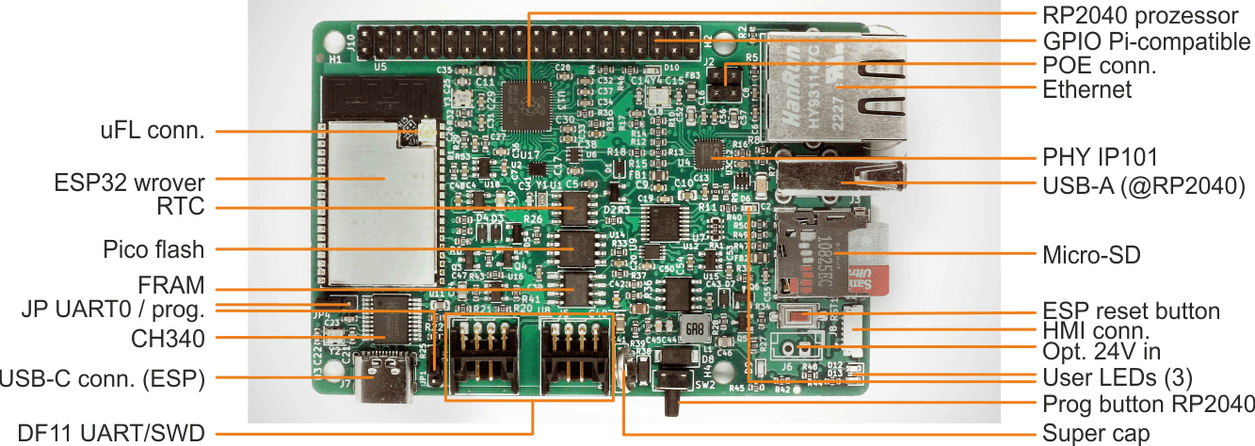

Specifications | Value | Remarks
Dimensions | 86 * 56mm | RasPi 4 compatible
Power supply | 5V, up to 3A via USB 3 connector
 | Optional 24V input via Pin Header
Connectivity
Ethernet | RJ45
Wifi | External uFL antenna connector | PCB antenna not usable
Serial | 2 DF11 connector with a total of 3 UART (TTL 3.3V) | Cable assemblies available (Mouser etc.)
Programming ESP32 | USB-C (CH340 USB to UART)
Programming RP2040 | USB-A
USB-Host/device | USB-A
Raspberry Pi HAT | 40 pol pin header
UART TFT display (HMI) | 6 pol JST
ESP32-WROVER specs
Dual core LX6 MCU | 240 MHz
Flash | 16 MByte (W25Q128JVSIQ)
PSRAM | 8 MByte
Pi Pico RP2040 specs
Dual core M0+ MCU | 133 MHz
Flash | 16 MByte
ESP32 – RP2040 connectivity | SPI or UART
Current consumption
Wi-Fi Tx packet 13dBm~21dBm | 170 to 295 mA | TBD
Wi-Fi/BT Tx packet 0dBm | 140 mA | TBD
Wi-Fi/BT Rx and listening | 85 to 115 mA | TBD
ESP32 modem sleep mode | 3 to 28 mA | TBD
No load current standard mode | 70 mA
Nuttx 11.0, no app | 115 mA
Sdcard | SPI mode
FRAM | FM25CL64B – 1 MByte
Supervisor | APX823
Real time clock | PCF8563T
Ethernet PHY | IP101
PoE header | 4 pol header | Identical to Pi 4
Supercap for real time clock | 220mF
Buttons
PROG button for RP2040 | On the position of the Pi audio connector | Can be operated when inside a Pi 4 enclosure
Reset button for the ESP32 | On the position of the Pi USB
Operating temperature | -20 to +70 degree Celsius
Storage temperature | -40 to +85 degree Celsius
Weight | 37g
CE/RoHS | compliant
FCC | pending

Pin outs

J4 – DF11
Pin number | Function | Remark
1 | +5V | Max. 2.7 A, when USB powered
2 | +5V | Max. 1.5A, when 24V powered
3 | GND
4 | GND
5 | UART0 RXD | Labled HF_MISO in schematic
6 | UART1 RXD | Labled TFT_MISO in schematic
7 | UART0 TXD | Labled HF_MOSI in schematic
8 | UART1 TXD | Labled TFT_MOSI in schematic

J5 – DF11
Pin number | Function | Remark
1 | +5V | Max. 2.7 A, when USB powered
2 | +5V | Max. 1.5A, when 24V powered
3 | GND
4 | GND
5 | UART2 RXD | Labled UHF_MISO in schematic
6 | Pico SWCLK | Debug clock pin for PicoProbe
7 | UART2 TXD | Labled UHF_MOSI in schematic
8 | Pico SWDIO | Debug data pin for PicoProbe

Cable assemblies for J4, J5: Hirose DF11-8DS-2C(17), Mouser No 798-DF11-8DS-2C17

J8 – SM06B-SURS-TF(LF)(SN)

Pin number | Function | Remark
1 | UART1 TXD | Labled TFT_MOSI in schematic
2 | UART1 RXD | Labled TFT_MISO in schematic
3 | GND
4, 5 | nc | Not connected
6 | +5V

Cable assemblies for J8: A06SUR06SUR32Wxxx (replace xxx with the cable length in mm).
For example, A06SUR06SUR32W305B, Digikey part number 455-2995-ND.

Jumper JP1 - U0TXD
1-2 | CH340 to ESP32 | position to program
2-3 | DF11 connector to ESP | To access the 3th UART

Jumper JP4 - U0RXD
1-2 | CH340 to ESP32 | position to program
2-3 | DF11 connector to ESP | To access the 3th UART

Pin mapping 40 pol Raspberry Pi HAT to RP2040 pins
HAT pin on 40 pol header | Pi HAT function | RP2040 | Remarks
1 | 3.3V (from EsPiFF to HAT) | - | HAT can take up to 150 mA
2 | 5V (both directions possible) | - | HAT can take up to 2.7 A
3 | Pi_GPIO2_SDA | IO10
4 | 5V (both directions possible) | -
5 | Pi_GPIO3_SCL | IO11
6 | GND | -
7 | Pi_GPIO4_CLK0 | IO23
8 | Pi_GPIO14_TXD | IO8
9 | GND | -
10 | Pi_GPIO15_RXD | IO9
11 | Pi_GPIO17 | IO6
12 | Pi_GPIO18_PWM0 | IO0
13 | Pi_GPIO27 | IO22
14 | GND | -
15 | Pi_GPIO22 | IO5
16 | Pi_GPIO23 | IO7
17 | 3.3V (from EsPiFF to HAT) | -
18 | Pi_GPIO24 | IO20
19 | Pi_GPIO10_MOSI0 | IO16
20 | GND | -
21 | Pi_GPIO9_MISO0 | IO19
22 | Pi_GPIO25 | IO3
23 | Pi_GPIO11_SCK0 | IO18
24 | Pi_GPIO8_nCS0 | IO17
25 | GND | -
26 | Pi_GPIO7_nCS1 | IO13
27 | Pi_GPIO0_ID_SD | Not connected to RP2040 | Connect to ESP32-I2C0
28 | Pi_GPIO1_ID_SC | Not connected to RP2040 | Connect to ESP32-I2C0
29 | Pi_GPIO5_CLK1 | IO24
30 | GND | -
31 | Pi_GPIO6_CLK2 | IO25
32 | Pi_GPIO12_PWM0 | IO1
33 | Pi_GPIO13_PWM1 | IO2
34 | GND | -
35 | Pi_GPIO19_MISO1 | IO15
36 | Pi_GPIO16 | IO4
37 | Pi_GPIO26 | IO21
38 | Pi_GPIO20_MOSI1 | IO12
39 | GND | -
40 | Pi_GPIO21_SCK1 | IO14

The I2C lines to read out the HAT EEPROM is not connected to the RP2040, but instead to the ESP32-WROVER.
To expose the HAT to the ESP, a open source project called Configurable Firmata (https://github.com/firmata/ConfigurableFirmata) can be used. At the time of writing, Configurable Firmata just support UART as transport between the EsPiFF and the RP2040. In a future version, SPI will be supported as transport, additional to UART.

ESP32 – RP2040 interconnection
To establish a SPI connection between the ESP32 and the RP2040, the IO expander PCA9557 need to set the line nSPI_PICO to low, additional to the SPI_nCS0 lines. While reading/writing to the RP2040, the ESP32 can not use the SDcard.
ESP32-WROVER |  | RP2040 | Remarks
GPIO14 | SPI_SCK | IO26
GPIO13 | SPI_nCS0 | IO29
GPIO15 | SPI_MOSI | IO28
GPIO2 | SPI_MISO | IO27

ESP32 – FRAM
To establish a SPI connection between the ESP32 and the FRAM, the nSPI_CS1 line (ESP32-GPIO12) is to use. The nSPI_CS1 chip select line is exclusive for the FRAM.

ESP32 – SDcard
To establish a SPI connection between the ESP32 and the RP2040, the IO expander PCA9557 need to set the line mSPI_SDcard to low, additional to the SPI_nCS0 lines. While reading/writing to the Sdcard, the ESP32 can not communicate with the RP2040.

Wifi antenna
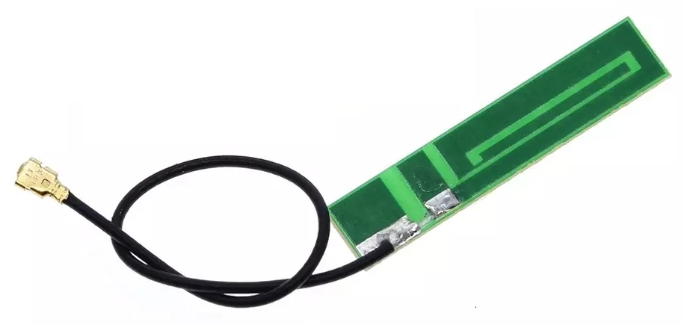

The EsPiFF is delivered with an external antenna. To use Wifi, connect the uFL connector of the antenna to the ESP32-WROVER and place the antenna to a suitable position for best signal strength.

Optional cable settings
An optional cable set for the EsPiFF is available. It consists of
- 2 Hirose DF11 female to DF11 female connectors with 30 cm color coded cable,
- 2 Hirose DF11 female to 8 individual Dupont headers with 30 cm color coded cable,
- 1 JST 06SUR female to 06SUR female connectors with 30 cm color coded cable,
- 1 JST 06SUR female to 6 individual Dupont headers with 30 cm color coded cable,

Attention: The color code will change in the next version 3.2: red will be +5V, black will be GND on all cables. The pinout will stay the same.
Pinout and color code DF11 to DF11 cable
pin | Wire color | Signal
1 | brown | +5V
2 | grey | +5V
3 | white | GND
4 | blue | GND
5 | red | UHF_MISO (U0RXD)
6 | yellow | TFT_MISO (U1RXD)
7 | black | UHF_MOSI (U0TXD)
8 | green | TFT_MOSI (U1TXD)

Pinout and color code DF11 to Dupont cable
pin | Wire color | Signal
1 | brown | +5V
2 | grey | +5V
3 | white | GND
4 | blue | GND
5 | red | UHF_MISO (U0RXD)
6 | yellow | TFT_MISO (U1RXD)
7 | black | UHF_MOSI (U0TXD)
8 | green | TFT_MOSI (U1TXD)

Pinout and color code 06SUR to 06SUR
pin | Wire color | Signal
1 | blue | TFT_MOSI (U1TXD)
2 | green | TFT_MISO (U1RXD)
3 | yellow | GND
4 | white | SCL
5 | red | SDA
6 | black | +5V

Software development

ESP32-WROVER
Important notice for Ubuntu/Linux users:
Ubuntu identify the CH340 USB to UART chip as braille device. To make the EsPiFF be recognized by Ubuntu need to disable the braille support.
systemctl stop brltty-udev.service
sudo systemctl mask brltty-udev.service
systemctl stop brltty.service
systemctl disable brltty.service

Espressif IDF
Please follow the instructions on https://docs.espressif.com/projects/esp-idf/en/latest/esp32/get-started/index.html

Arduino
Please follow the instructions on https://espressif-docs.readthedocs-hosted.com/projects/arduino-esp32/en/latest/getting_started.html

uPython
Please follow the instructions on https://docs.micropython.org/en/latest/esp32/tutorial/intro.html

Javascript
For Espruino, please follow the instructions on https://www.espruino.com/ESP32. There are other Javascript interpreters for ESP32, you might check out:
- https://github.com/marcelkottmann/esp32-javascript
- https://github.com/Moddable-OpenSource/moddable
- https://www.neonious-iot.com/lowjs/
to name a few.

Rust
Please follow the instructions on https://github.com/espressif/rust-esp32-example

RP2040

Raspberry Pi Pico SDK
Please follow the instructions on https://github.com/raspberrypi/pico-sdk

Arduino – Pico
If you have the Arduino IDE installed, add the board support package for the Raspberry Pi Pico RP2040. At the time of writing, you have to add under settings, additional board URL,

https://github.com/earlephilhower/arduino-pico/releases/download/global/package_rp2040_index.json

Then in boards, boards manager, select “Raspberry Pi Pico”. From here on, you can follow all tutorials from the Raspberry Pi Foundation for the Pi Pico and/or Arduino-Pico tutorials.

Version history
Document version | Author | changes | Date
0.1 | Michael Schmid | Initial version | 01.11.2022
0.2 | Michael Schmid | Added external antenna info | 03.11.2022
0.3 | Michael Schmid | Added color codes in cables | 09.11.2022

