Mini Project Report (KCS-554)
on
UNIT CONVERTER
Submitted in partial fulfilment for award of
BACHELOR OF TECHNOLOGY
Degree In
COMPUTER SCIENCE & ENGINEERING


2022-23
Submitted By:
MD REHAN (2000330100132)
MD DANISH (2000330100133)
JITENDRA KUMAR (20003301000115)
Under the Guidance of:
Mr. Vineet Shrivastava
Assistant Professor

DEPARTMENT OF COMPUTER SCIENCE & ENGINEERING
RAJ KUMAR GOEL INSTITUTE OF TECHNOLOGY
DELHI-MEERUT ROAD, GHAZIABAD

Affiliated to Dr. A.P.J. Abdul Kalam Technical University, Lucknow
November 2022

TABLE OF CONTENTS

CHAPTER NO. PAGE NO.
1. INTRODUCTION 3
1.1 ABSTRACT 4
1.2 PROBLEM DEFINITION 4
1.3 OBJECTIVE 5
1.4 SCOPE OF STUDY 5

2. HARDWARE AND SOFTWARE REQUIREMENTS 6
2.1 SOFTWARE REQUIREMENTS 6
2.2 HARDWARE REQUIREMENTS 6

3. DATA FLOW DIAGRAM 7
4. PROJECT MODULE DESIGN 8
5. SNAPSHOTS 12
6. LIMITATION 15
7. FUTURE SCOPE 16
8. CONCLUSION 17
9. REFERENCE 18

CHAPTER 1
INTRODUCTION

Unit Converter is a digital device application developed for cell phones and android tablets. This app is for the conversion of one unit of physical quantity to another equivalent unit; for example, conversion from degree Celsius to Kelvin or other equivalent units. Using this Unit Converter application, the occurrence of an error in unit conversion can be rooted out. The application establishes an easy and effective platform for unit conversion in Android devices.

Although the SI unit is universally accepted, science and engineering works are not measured with the same units all over the world. Some nations’ code specifies meter as a unit of length and some as feet. It means that measurement units are not the same in all parts of the world.

In the manual system of unit conversion, there is a high chance of the occurrence of the error, and it is not user-friendly. Further, it is tedious and time-consuming. Only experts or educate a person are capable of unit conversion. But it doesn’t need any skilled person to use this Unit Converter application. Anybody can convert any unit to desired equivalent unit easily and accurately.

  - ABSTRACT
Unit Converter is a quick, easy and powerful tool for converting various measurement units. The unit converter can convert different units of measure viz. Acceleration, Angle, Area, Current/Electric Current, Data or Bits & Bytes, Density, Energy, Force, Fuel consumption, Frequency, Length, Light-Illumination, Light-Luminance, Power, Pressure, Sound, Speed, Temperature, Time, Torque, Volume, Weight/Mass and etc.

  - PROBLEMS DEFINITION:
- Connecting with API.
- Fetching data from API.
- Implementing buttons their functions using loops.
- Designing buttons.

  - OBJECTIVE
Mathematics has been an integral part of human life starting from simple measurements in the medical sciences to complex computations in space science. Devices for computation also, have evolved in the long run along with the advancements in Science and Technology. Though there are various computing devices with a varying range of memory, different levels of speed and appropriate features, each one has its own disadvantage.

The main objective of our project is to minimize the disadvantages of existing calculators by combining the operations of physical scientific calculators and calculator application programs. Appropriate methods have been employed to reduce the disadvantages of the existing calculators. Our project, ‘Unit Converter’ is a menu-driven interactive Python application with a lot of new features.

  - SCOPE OF STUDY
The most important feature that we have planned to implement is that. The GUI (Graphical User Interface). A simple user interface has been created to use the calculator. GUI provides better interaction with users rather than consoles. The accuracy will also be increased by increasing the precision. 150-digit precision will be implemented. But, since such a huge data type is not available in a programming language like Java, each digit will be stored in an array index. 4 X 4 Matrix will be implemented. Matrix operation will be enhanced by having each element as complex. Solving the 4th-degree equation will be implemented. Computation of algorithm table and computation of date and time.

CHAPTER 2
HARDWARE AND SOFTWARE REQUIREMENTS
2.1 SOFTWARE:
- WINDOWS 10.
- Python 2.7 or later
- VS Code, PyCharm, Spyder

  - HARDWARE:
- Intel® Celeron®
- Ram 512MB or more

CHAPTER3
DATA FLOW DIAGRAM
Select Unit from list box
Select Unit to list box.
Enter the Value in entry field
Press Convert Button

CONNECTING
WITH API

OUTPUT in Entry Widget

Fig 3.1

CHAPTER 4
PROJECT MODULE DESIGN
In Python, object-oriented Programming (OOPs) is a programming paradigm that uses objects and classes in programming. It aims to implement real-world entities like inheritance, polymorphisms, encapsulation, etc. in the programming. The main concept of OOPs is to bind the data and the functions that work on that together as a single unit so that no other part of the code can access this data.
In this application, OOPs are used to

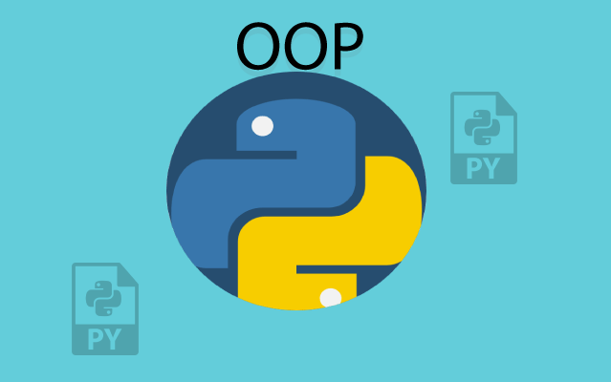
Fig 4.1
PYTHON TKINTER GUI
Tkinter programming
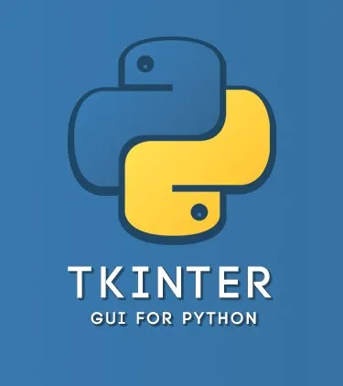
Fig 4.2
Tkinter is the standard GUI library for Python. Python when combined with Tkinter provides a fast easy way to create GUI applications. Tkinter provides a powerful object-oriented interface to the Tk GUI toolkit.

Creating a GUI application using Tkinter is an easy task. All you need to do is perform the following steps-
- Import the Tkinter module.
- Create the GUI application main window.
- Add one or more of the above-mentioned widgets to the GUI application.
- Enter the main event loop to take action against each event triggered by the user.

PYTHON IMAGE LIBRARY
Python Imaging Library is a free and open-source additional library for the Python programming language that adds support for opening, manipulating, and saving many different images file formats. It is available for Windows, Mac OS X and Linux.


Fig 4.3
The Python image library is used to create button images of each and every unit converter.

NUMPY PYTHON
NumPy is a library for the Python programming language, adding support for large, multi-dimensional arrays and matrices, along with a large collection of high-level mathematical functions to operate on these arrays. It is the fundamental package for scientific computing with Python. It is open-source software.
It contains various features including these important ones:
- A powerful N-dimensional array object.
- Useful linear algebra, Fourier transform, and random number capabilities.

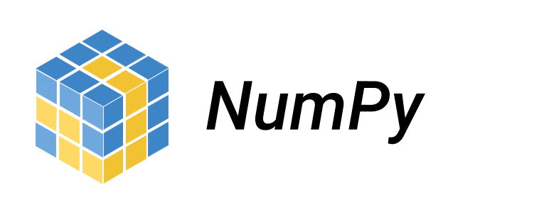
NumPy can also be used as an efficient multi-dimensional container of generic data. Arbitrary data types can be defined using NumPy which allows NumPy to seamlessly and speedily integrate with a wide variety of databases.

Fig 4.4
PYTHON ITERTOOLS
Itertools is a module in Python, it is used to iterate over data structures that can be stepped over using a for-loop. Such data structures are also known as iterables.
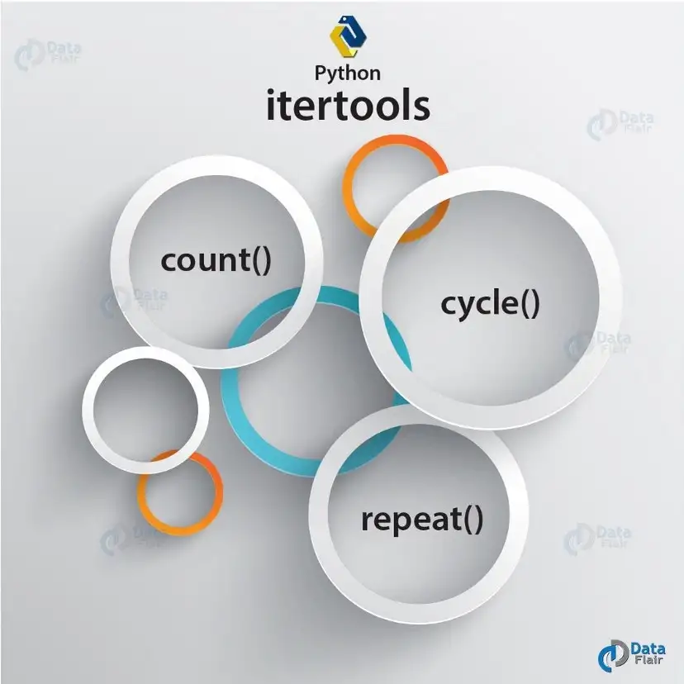
Fig 4.5
This module works as a fast, memory-efficient tool that is used either by itself or in combination to form iterator algebra. In simple words, the number of iterators can together create 'iterator algebra' which makes it possible to complete the complex task.

API (Application programming interface)
Application Programming Interface which is a collection of communication protocols and subroutines used by various programs to communicate between them. A programmer can make use of various API tools to make its program easier and simpler.
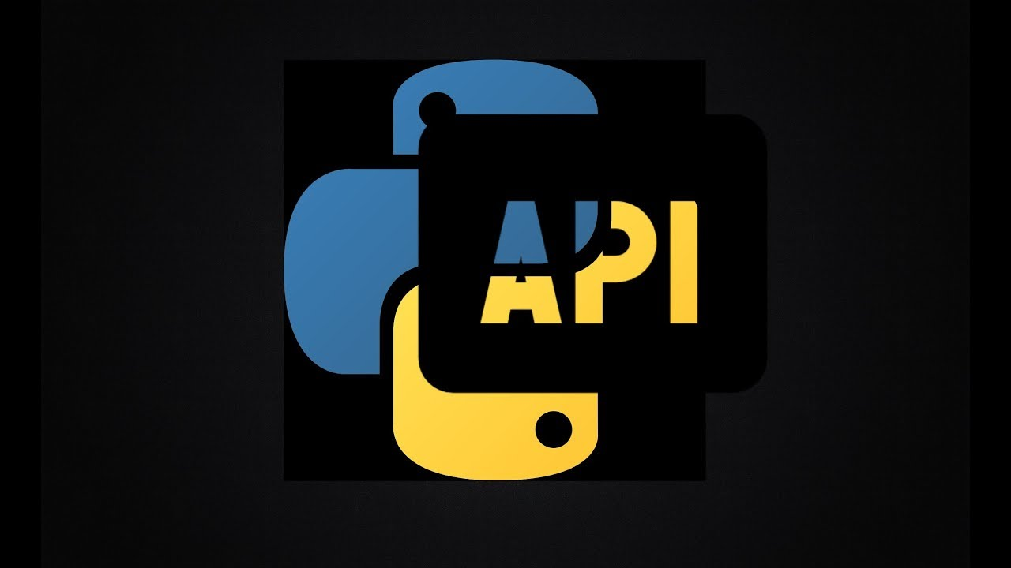
Fig 4.6
An API is similar to a GUI (Graphical User Interface) with one major difference. Unlike GUI, an API helps the software developers to access the web tools while a GUI helps to make a program easier to understand for the users. Rapid API is used to fetch the data of another website for further use in application.

CHAPTER 5
PROJECT SNAPSHOT
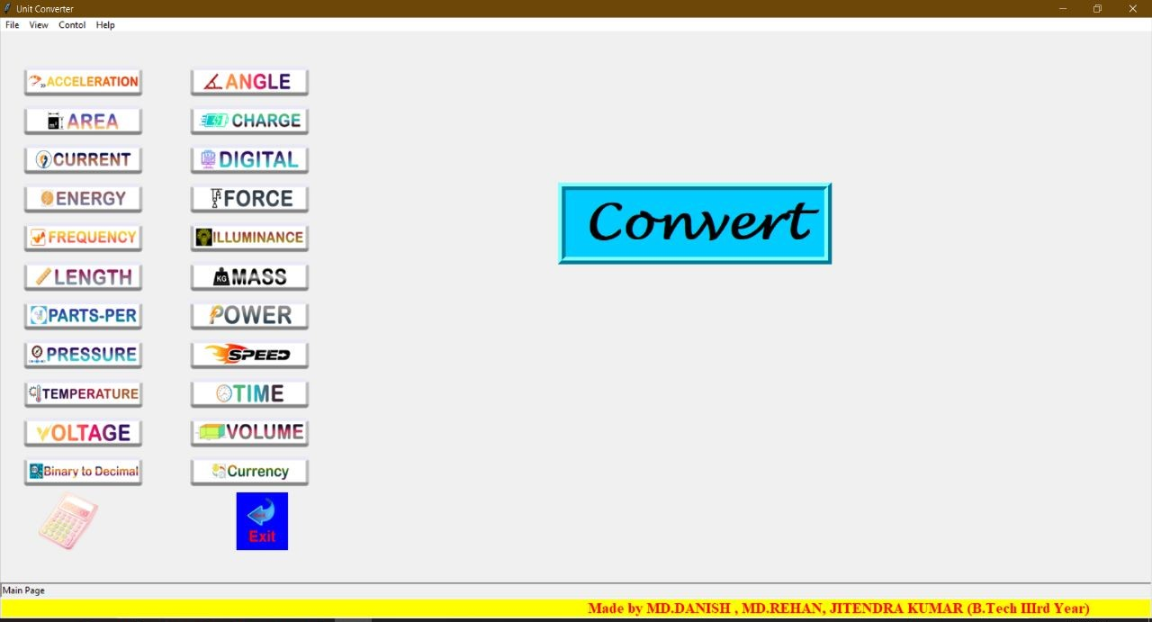
Front-Screen: -
Fig 5.1
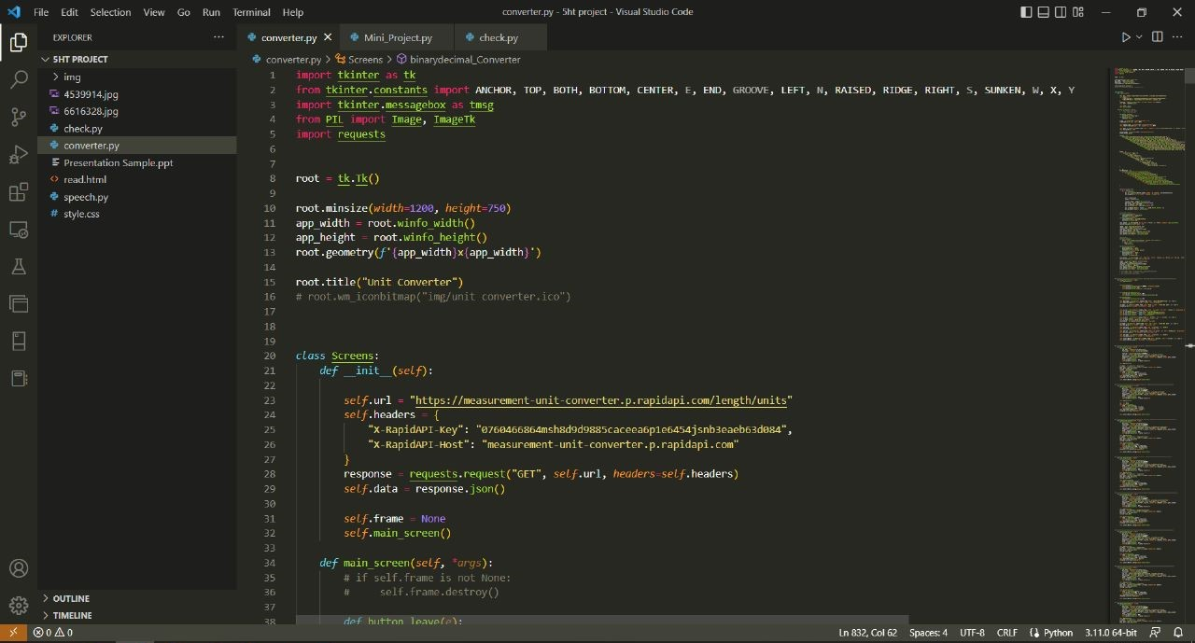
Function Code: -
Fig 5.2
Calculator screen: -
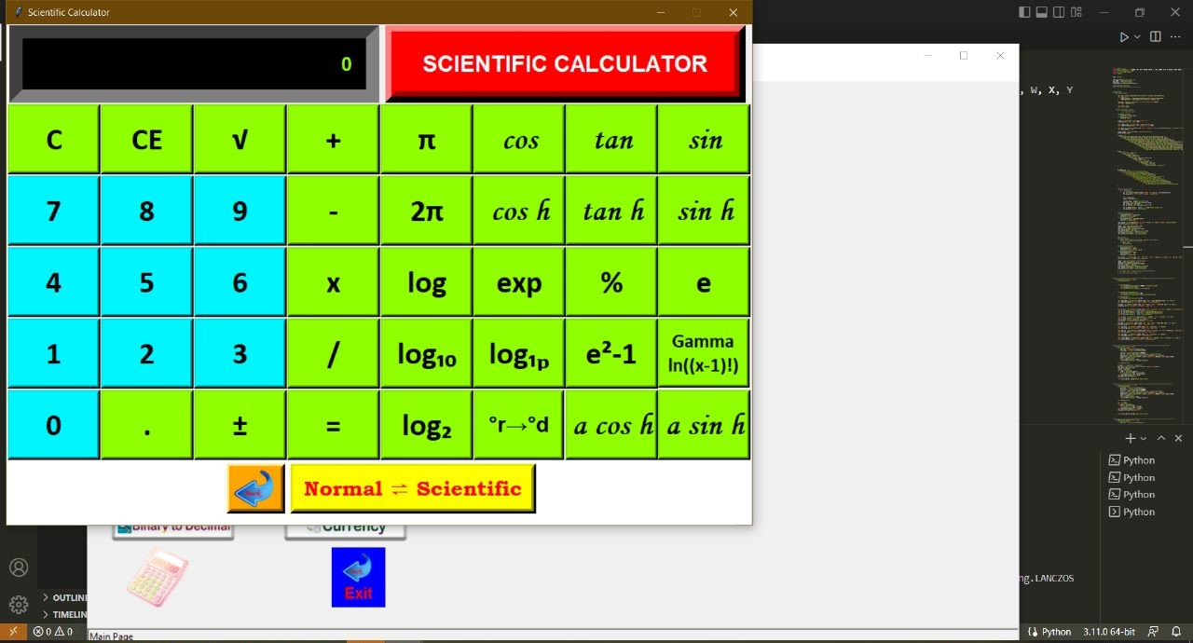
Fig 5.3
Binary Conversion Screen: -
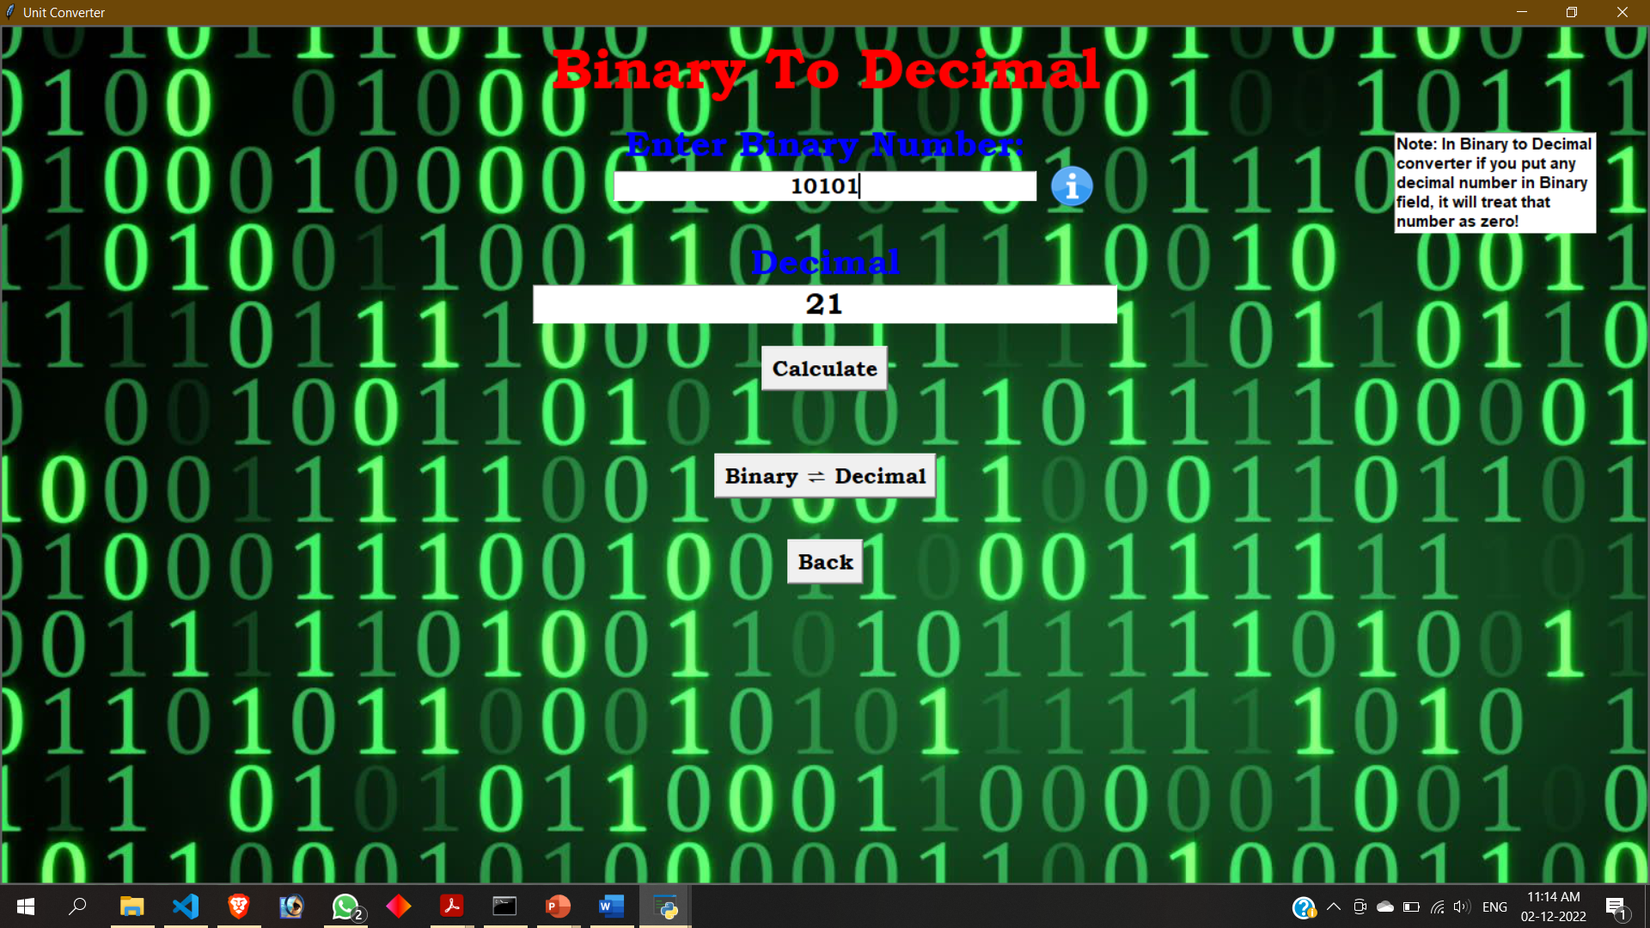
Fig 5.4
Unit Converting Screens
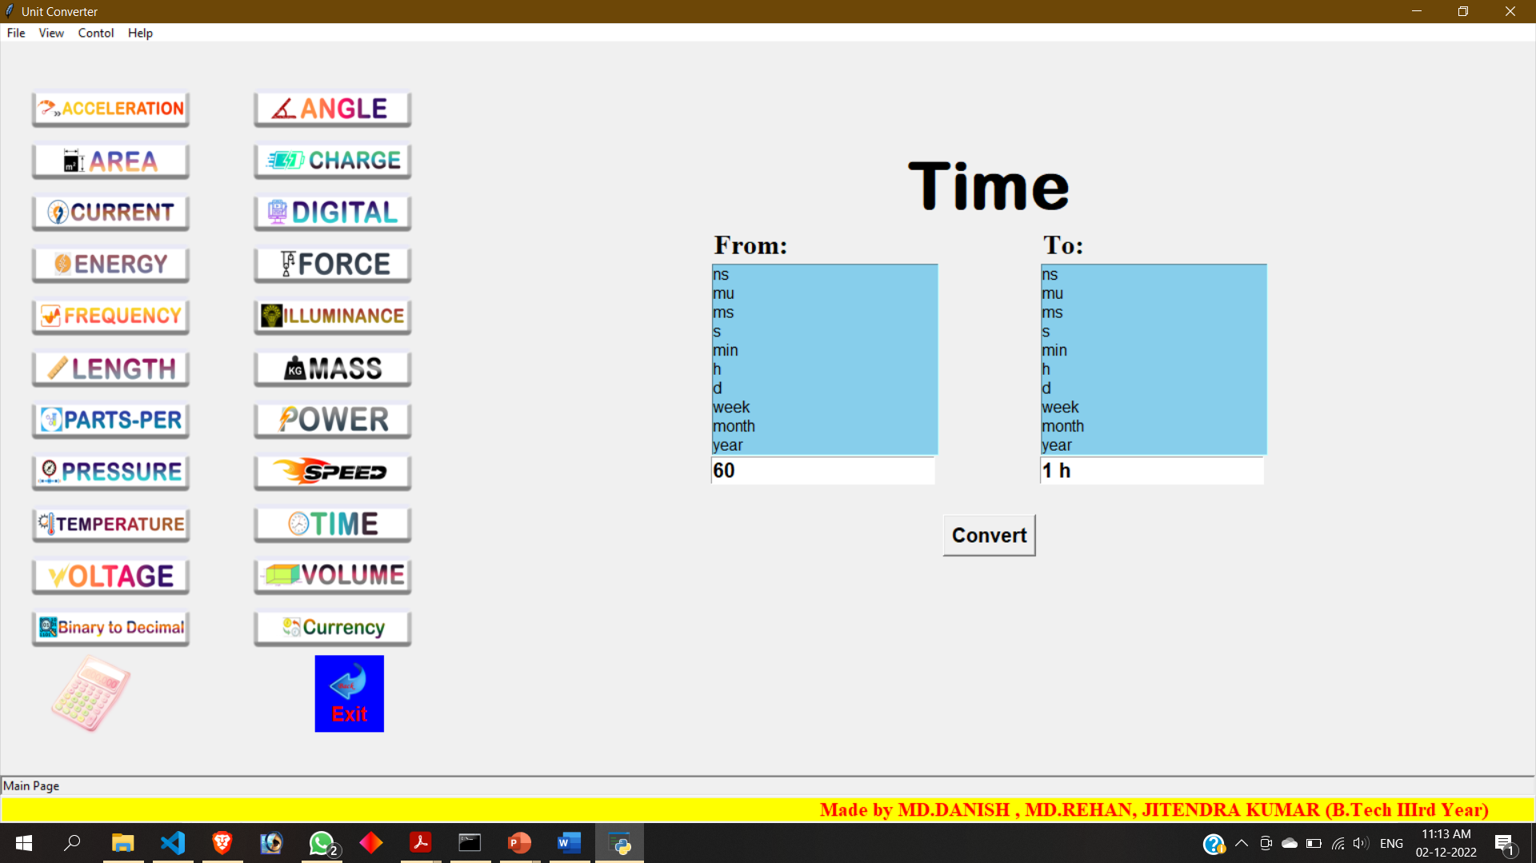
Time:
Fig 5.5
Frequency:
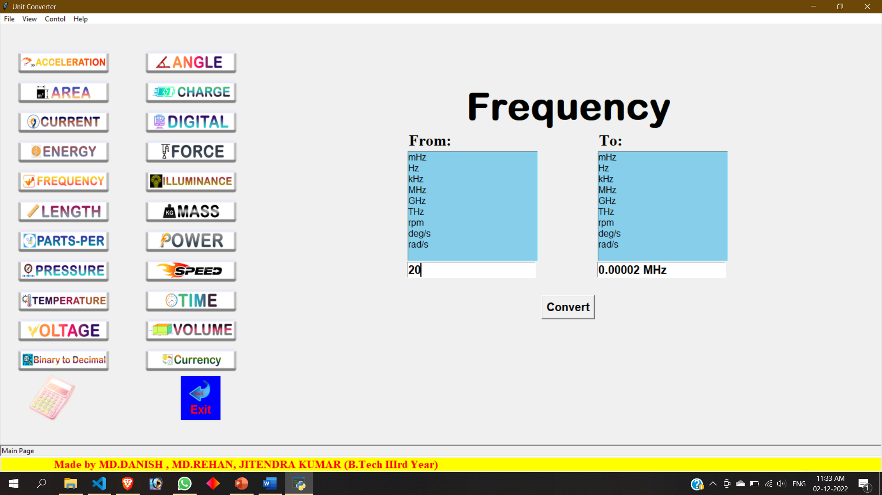
Fig 5.6
CHAPTER 6
LIMITATION
There are a wide variety of limitations in unit converters. Here is a list as follows;
- Memory limitation: This application doesn’t have history tracking of different computations in the
converter due to a lack of memory space management.
- No complex number manipulations: As it is known, a complex number system includes all the other
numbers within itself. But the calculator applications do not provide facilities for performing complex operations.
- No equation solving: In many real-time applications, we need the solving equations. But, though we
have an advanced system, it does not provide option for solving equations.
- No matrix operations: Matrices have a wide variety of applications such as solving linear equations
But there is no option for him just having the calculator applications in the System.

CHAPTER 7
FUTURE SCOPE
7.1 Enhancement on interface: The most important feature that we have planned to implement is that the GUI (Graphical User Interface). A simple user interface has been created to use the calculator. GUI provides better interaction with users rather than consoles.
7.2 Enhancement on precision: The accuracy will also be increased by increasing the precision. 150 digit precision will be implemented. But since such a huge data type is not available in a programming language like Java, each digit will be stored in an array index.
7.3 Enhancement on Matrix: 4 X 4 Matrix will be implemented. Matrix operation will be enhanced by having each element as complex.
7.4 Enhancement on Equation: Solving the 4th-degree equation will be implemented.
7.5 NEW OPERATIONS: computation of algorithm table and computation of date and time.

CHAPTER 8
CONCLUSION
In this project, we have developed a calculator application for exact real number computation using appropriate methods and algorithms. Compared to the normal calculator, our application is designed in such a way that the efficiency is much better. We have successfully experimented with the implementation.
This project has really been faithful and informative. It has made us learn and understand the many trivial concepts of the Python Language. We used python Tkinter as a GUI it provides various controls, such as buttons, labels and text boxes to build a user-friendly application. The fast-growing use of the internet confirms the good future and scope of the proposed project. Finally, it has taught us a valuable lifelong lesson about improvements and working and interacting in a group.

CHAPTER 9
REFERENCES

[1] Béla Bodó; Colin Jones (26 June 2013). Introduction to Soil Mechanics. John Wiley & Sons. pp. 9–. ISBN 978-1-118-55388-6.

[2] Ogden, James (1999). The Handbook of Chemical Engineering. Research & Education Association. ISBN 978-0-87891-982-6.

[3] https://rapidapi.com/

[4]https://i2.wp.com/iot4beginners.com/wp-content/uploads/2020/04/65dc5834-de21-4e2e-bd4d-5e0c3c6994dd.jpg?fit=375%2C422&ssl=1

[5] https://medium.com/@vignesh_jeyaraman/magic-of-itertools-in-python-2c611742bdc6

[6]https://i.ytimg.com/vi/mYaybCj-E0M/maxresdefault.jpg

[7] https://i0.wp.com/www.ozgurozkok.com/wp-content/uploads/2019/12/numpy-python.png?fit=765%2C306&ssl=1

