1. **Rule-Based Approach**

**Figure 1.** Actual Code of BPMN Model

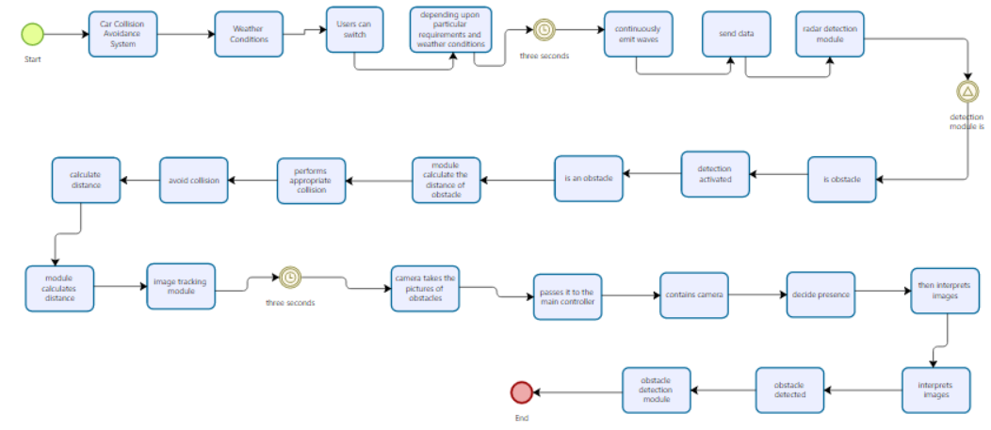

**Figure 2.** Rule-Based Diagram in Bizagi Tool

**Actual Model’s Results**->

Events = 5 (start, end, 2 timers, and 1 signal event)

Tasks = 24, Sequence Flow = 28, No Gateway found.

1. **Large-Language Models**

**Used Prompt in All LLMs:** XPDLVersion is 2.2 and Generate bpmn model in xpdl format from the following text: "Car Collision Avoidance System comprises of the two primary modules for obstacles detection i.e. radar detection and image tracking. Due to both approaches, the user can switch to any of the technique depending upon particular requirements and weather conditions. The radar detection module continuously emits waves and send data to the main controller after every three seconds. Whenever there is an obstacle in the vehicles path, obstacle detection module is activated. Then the module calculates the distance of obstacle and performs appropriate actions in order to avoid collision. On the other hand, image tracking module exploit the image processing techniques for the detection of obstacles. It contains camera, that camera takes the pictures of obstacles and passes it to the main controller after every three seconds. The main controller then interprets the images to decide the presence of obstacle. Once the obstacle is detected, the control is passed to the obstacle detection module for further processing in order to avoid collision."

* 1. **Results of LLMs:**

1. **Deep Seek**

**Figure 3. Prompt Used in Deep Seek**

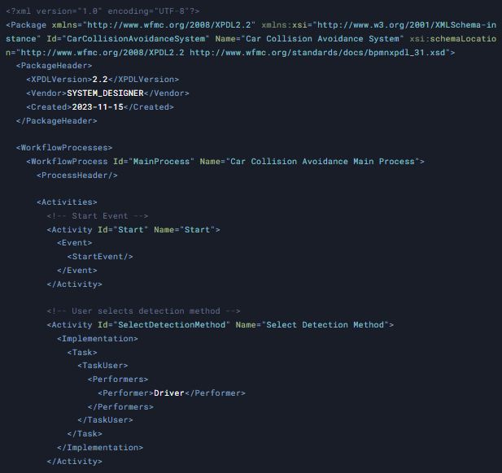

**Figure 4.** Generated XPDL file by Deep Seek

**Figure 5.** Diagram By Deep Seek in Bizagi Tool

Formula for Precision, Recall, and accumulative results

**Table 1.** Results of DeepSeek

|  |  |  |  |  |  |  |  |  |
| --- | --- | --- | --- | --- | --- | --- | --- | --- |
| **Sr.** | **Events** | **Task** | **Sequence Flow** | **Gateway** | **Total** | **Precision**  Correct ÷ (Correct + Incorrect) | **Recall**  Correct ÷ (Correct + Missing) | **Over Specification**  Extra ÷ (Correct + Missing) |
| **Correct** | 2 | 4 | 0 | 0 | 6 | 100% | 10.52% | 10.52% |
| **Incorrect** | 0 | 0 | 0 | 0 | 0 |
| **Missing** | 3 | 20 | 28 | 0 | 51 |
| **Extra** | 0 | 1 | 5 | 0 | 6 |

**Task** = 4 Correct 🡪 Radar detection, Obstacle detection, Image Tracking, perform avoid collision, 1 is Extra -> Select detection Method (not defined in Actual Model)

**Event** = 2 (Start, End are given), Missing are 3 (2 timer and 1 signal event is missing)

**Sequence Flow**= 4 (such flow not mentioned in Actual Model), 1 is extra which is defined in **Image Tracking** (that is self sequence flow) . No gateway.

1. **ChatGPT:**

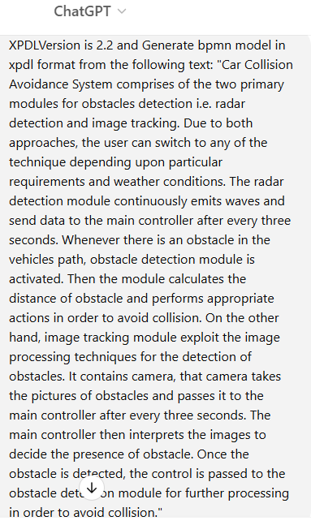

**Figure 6.** Prompt Used in ChatGPT

**Figure 7.** Generated XPDL file by ChatGPT

**Figure 8.** Diagram By ChatGPT in Bizagi Tool

**Table 2.** Results of ChatGPT

|  |  |  |  |  |  |  |  |  |
| --- | --- | --- | --- | --- | --- | --- | --- | --- |
| **Sr.** | **Events** | **Task** | **Sequence Flow** | **Gateway** | **Total** | **Precision**  Correct ÷ (Correct + Incorrect) | **Recall**  Correct ÷ (Correct + Missing) | **Over Specification**  Extra ÷ (Correct + Missing) |
| **Correct** | 0 | 4 | 0 | 0 | 4 | 66.666% | 7.27% | 10.9% |
| **Incorrect** | 0 | 2 | 0 | 0 | 2 |
| **Missing** | 3 | 20 | 28 | 0 | 51 |
| **Extra** | 0 | 0 | 6 | 0 | 6 |

**Task** = 2 (incorrect including start and end) and 4 are Correct 🡪 Radar detection, Obstacle detection, Image Tracking, avoid collision.

**Event** = Missing are 3 (2 timer and 1 signal event is missing)

**Sequence Flow** = 6 are EXTRA (such flow not mentioned in Actual Model). No gateway

1. **Gemini:**

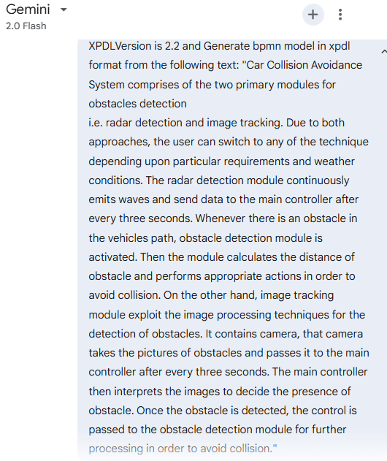

**Figure 9.** Prompt Used in Gemini

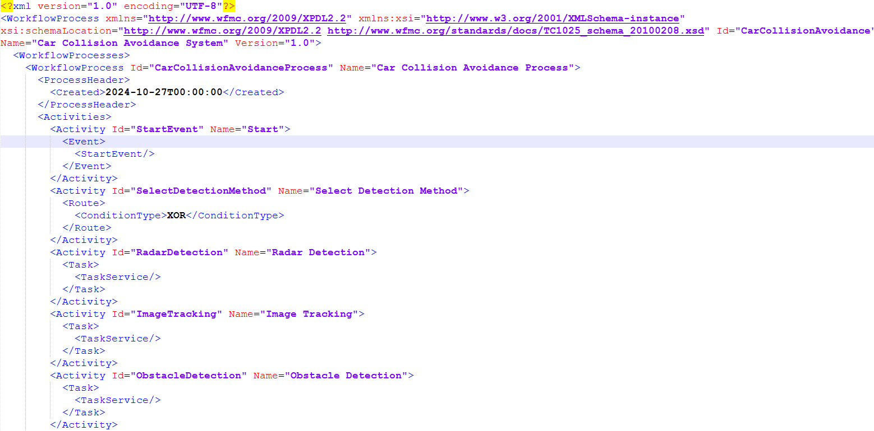

**Figure 10.** Generated Gemini Code

**Figure 11.** Diagram Generated by Gemini in Bizagi Tool.

**Task** = 4 are Correct 🡪 Radar detection, Obstacle detection, Image Tracking, avoid collision.

**Event** = 2 are correct including start and end and Missing are 3 (2 timer and 1 signal event is missing)

**Sequence Flow** = 7 are Incorrect (such flow not mentioned in Actual Model).

Gateway = 1 is extra (Not defined in Actual Model)**.**

**Table 3.** Results of Gemini

|  |  |  |  |  |  |  |  |  |
| --- | --- | --- | --- | --- | --- | --- | --- | --- |
| **Sr.** | **Events** | **Task** | **Sequence Flow** | **Gateway** | **Total** | **Precision**  Correct ÷ (Correct + Incorrect) | **Recall**  Correct ÷ (Correct + Missing) | **Over Specification**  Extra ÷ (Correct + Missing) |
| **Correct** | 2 | 4 | 0 | 0 | 6 | 100% | 10.52% | 14.03% |
| **Incorrect** | 0 | 0 | 0 | 0 | 0 |
| **Missing** | 3 | 20 | 28 | 0 | 51 |
| **Extra** | 0 | 0 | 7 | 1 | 8 |

**Event =** 2 (correct including start and end), 3 are missing (2 are timers and 1 is signal).

**Task =** 4 are correct (Radar detection, Obstacle detection, Image Tracking, avoid collision)

**Sequence Flow =** 7 are extra (not defined in the actual model).

**Gateway=1** is extra (select detection method) (not defined in the actual model).

1. **Summary**

**Table 4. Accumulative Results**

|  |  |  |  |
| --- | --- | --- | --- |
| **Sr.** | **Large Language Models** | | |
| ***DeepSeek*** | ***ChatGPT*** | ***Gemini*** |
| Precision | 100% | 66.666% | 100% |
| Recall | 10.52% | 7.27% | 10.52% |
| Over Specification | 10.52% | 10.9% | 14.03% |

To test the novelty of the proposed approach, we explored the capabilities of various large language models, such as DeepSeek, ChatGPT, and Gemini. Overall, the results of LLMs indicate that they are extremely ineffective in generating the constructs of BPMN diagrams from the requirements. For example, such LLMs are incompetent at generating the events, including timer and signal events. Furthermore, such LLMs are insufficient to correctly generate the entire constructs of BPMN diagrams, including transitions and activities. Apart from the generation of constructs, these LLMs restrict the file from being imported in the Bizagi Modeler tool due to the wrong declaration of the package. Table 5. shows the accumulative results of the LLMs. It is noted from Table 5 that ChatGPT attained 66.66% accuracy, outperforming DeepSeek and Gemini. In contrast, IMFESDA is highly effective in generating the entire constructs of BPMN diagrams from requirements, and it can be employed to generate the constructs of other types of UML diagrams, like UML Profile.