MARYLAND JUDICIARY
Operational Plan
Master Documentation
Project Description • Architecture & Technical Design • Deployment Guide • Administrator & User Manuals • SharePoint Data Dictionary
Power Apps | SharePoint | Power Automate | Power BI

Table of Contents

1. Project Description & Overview 2
1.1 Background & Executive Summary 3
1.2 Project Objectives 3
1.3 Key Features 3
1.4 Technology Stack 3
1.5 Project Team & Roles 4
1.6 Risks & Mitigation 4
1.7 Project Deliverables 4
2. Project Architecture & Technical Documentation 4
2.1 Solution Overview & System Architecture 5
2.2 Architecture Dataflow Diagram 5
2.3 Canvas App Overview 5
2.4 SharePoint Sites by Environment 6
2.5 Environment Variables Reference 6
2.5.1 Canvas App URLs (EnvURLApp) 7
2.6 Power Automate Flows 7
2.6.1 Flow.OpPlan.AddUserPermission (FlowOpPlanAddUserPermission) 7
2.6.2 FlowOpPlanSendOperationalPlanEmail 7
2.6.3 FlowOpPlanApproval 7
2.6.4 Flow.OpPlan.CreateNextYearPlan (FlowOpPlanCreateNextYearPlan) 7
2.6.5 Flow.OpPlan.RefreshReportDataset 8
2.7 Power BI Reporting & Refresh Configuration 8
Admin Report 8
Operational Plan Intranet Report 8
Refresh Configuration 8
3. End-to-End Deployment Guide 8
3.1 Introduction 8
Prerequisites for Deployment 9
Deployment Process Overview 11
Deployment Validation 11
3.2 Step 1: SharePoint Data Infrastructure Setup 12
3.2.1 Prerequisites & Environment Setup 12
3.2.2 File Preparation & Placement 12
3.2.3 Configure the Target SharePoint Site URL 12
3.2.4 Execute the Script & Authenticate 13
3.2.5 Automated List Provisioning & Completion 14
3.3 Step 2: Power BI Analytics Setup 14
3.3.1 Open the Template Files 14
3.3.2 Configure the Data Parameter 14
3.3.3 Publish the Dashboards 16
3.4 Step 3: Power Platform Solution Installation 18
3.4.1 Solution Import & Connection Authentication 18
3.4.2 Mapping the Environment Variables 19
4. Administrator & User Manuals 25
Introduction 26
User Manual Overview 26
4.1 Administrator User Manual 27
4.1.1 Home Page for Administrators 27
4.1.2 User Administration Dashboard 27
4.1.3 Organization 28
4.1.4 Generate Report By Year 28
4.1.5 Sync Reports 30
4.1.6 Create Next Year's Plan 31
4.2 Chair / Designee User Guide 32
4.2.1 Login Screen 32
4.2.2 Operational Plan List 33
4.2.3 Operational Plan Details & Projects 33
4.2.4 End-to-End Process: Submission, Approval & Power BI Staging 34
5. SharePoint Lists & Data Types (Data Dictionary) 36
5.1 Operational Plan Admin 37
5.2 Organization 37
5.3 Operational Plans 37
5.4 Project Plan 38
5.5 OpPlan Approved Staging List 38

1. Project Description & Overview

1.1 Background & Executive Summary
In 2024, the Administrative Office of the Courts (AOC) updated its Strategic Plan to refine its strategic initiatives and operational priorities. As part of this effort, an annual Operational Plan was introduced. While the Strategic Plan outlines the guiding principles and areas of focus, the Operational Plan serves as an annual action plan that tracks the projects identified to achieve the goals of the Strategic Plan.
In 2025, the AOC produced its first Operational Plan, which identified 203 projects. The process for collecting and updating projects was initially manual; in the latter part of 2025 it was automated using Microsoft SharePoint, Power Apps, Power Automate, Power BI, and the Judiciary intranet site.
The Maryland Operational Plan Automation project streamlines the collection, tracking, and approval of operational and project plans across departments for the current fiscal year. The solution automates manual workflows, ensures accountability through role-based permissions, and integrates approval mechanisms for seamless plan publishing and reporting. The solution is also packaged as a standardized, portable application suite (a PnP PowerShell SharePoint blueprint, parameterized Power BI templates, and an unmanaged Power Platform solution) that can be deployed and operated independently by other judicial jurisdictions.

1.2 Project Objectives
- Automate Operational Plan Data Collection: Gather annual operational and project plans from responsible stakeholders using a centralized Power Apps interface connected to SharePoint.
- Enable Mid-Year Updates: Allow departments to submit updates or revisions mid-year, ensuring data remains current.
- Implement Role-Based Permissions: Control user access and editing rights using SharePoint and Office 365 security groups.
- Approval Workflow Before Publishing: Use an automated approval flow for validation and final publishing of the Operational Plan.
- Power BI Reporting Integration: Enable leadership to visualize and analyze status, progress, and completion metrics using Power BI dashboards.

1.3 Key Features
- Role-based experience for Administrators and Chairs/Designees.
- User access management synced with the OperationalPlanUserGroup Office 365 group.
- Automated plan submission, approval, and publishing flow.
- Dynamic filtering by Year, Organization, Status, and Chair/Designee.
- Power BI integration for analytics and performance insights.
- Automated email notifications through Office 365 Outlook.
- Year-over-year rollover of incomplete projects into the next year's plan.

1.4 Technology Stack
Component | Technology Used
Frontend / UI | Power Apps (Canvas App: Maryland Operational Plan)
Backend / Database | SharePoint Online Lists (5 lists)
Workflow Automation | Power Automate (Permission, Notification, Approval, Sync, and Next-Year Rollover flows)
Reporting & Analytics | Power BI (Admin Report & Operational Plan Intranet Report)
Authentication & Permissions | Office 365 / Microsoft Entra ID security group (OperationalPlanUserGroup)
Deployment Tooling | PnP PowerShell (Blueprint.xml), Power BI templates (.pbit), Power Platform solution (.zip)

1.5 Project Team & Roles
Role | Responsibility
Project Owner | Oversees project execution and sign-off
Power Platform Developer | Builds Power Apps, workflows, and integrations
SharePoint Admin | Configures lists, permissions, and data structures
Data Analyst | Develops Power BI dashboards
End Users / Contributors | Submit and update operational plans

1.6 Risks & Mitigation
Risk | Impact | Mitigation
Incorrect user role mapping | Low | Cross-verify user roles with HR/AD list before go-live
Workflow delays | Low | Optimize Power Automate triggers and approvals
Data integrity issues | Low | Implement validation rules in Power Apps

1.7 Project Deliverables
- Power Apps application for data entry and management.
- Configured SharePoint backend with secure access and a PnP PowerShell / XML provisioning blueprint.
- Automated approval, notification, permission, sync, and rollover workflows.
- Power BI dashboards (.pbit templates) for leadership insights and intranet reporting.
- Technical documentation, deployment guide, and administrator/user manuals (this document).

2. Project Architecture & Technical Documentation

2.1 Solution Overview & System Architecture
The Operational Plan solution consists of a Power Apps Canvas App supported by multiple Power Automate flows and SharePoint-based environment variables. The flows handle automation logic such as code generation, permissions management, email notifications, approval processing, dataset refreshes, and year-over-year plan creation.
- Power Apps is the main user interface for data entry, plan submission, administration, and review.
- SharePoint hosts the relational data lists for Operational Plans, Project Plans, Organization, Approved Staging, and User Roles.
- Power Automate runs workflows for user permissions, submission notifications, approval and staging, next-year plan creation, and Power BI refreshes.
- Power BI connects to SharePoint through a dedicated service account for reporting and progress dashboards.
- Office 365 provides secure, role-based access and automated email notifications.

2.2 Architecture Dataflow Diagram
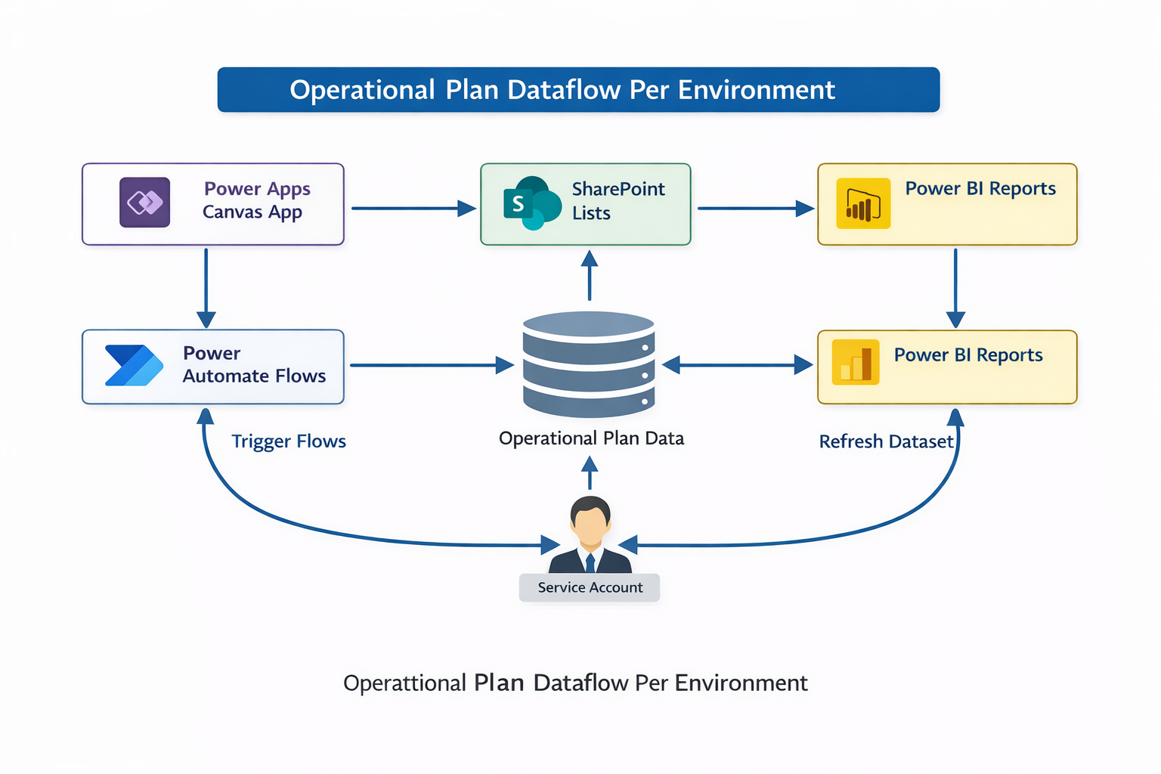
Figure 1: Operational Plan dataflow per environment

2.3 Canvas App Overview
- Canvas App Name: Maryland Operational Plan
- Purpose: Supports operational plan creation, project entry, mid-year updates, administrative management, approval, and routing based on the connected workflows and environment variables.

2.4 SharePoint Sites by Environment
Environment | SharePoint Site URL
Development (DEV) | /StrategicCampaign2024-2029/StrategicPlan_Dev
User Acceptance Testing (UAT) | /StrategicCampaign2024-2029/StrategicPlan_tst
Production (PROD) | /StrategicCampaign2024-2029

2.5 Environment Variables Reference
Environment variables route the Canvas App and cloud flows to the correct SharePoint site, lists, Power BI assets, and notification targets in each environment without code changes.
Environment Variable | Points To | Description / Values
EnvSiteOpPlan | SharePoint site | SharePoint site hosting all related lists (selected according to the app location: DEV / UAT / PROD).
EnvListOpAdmin | Operational Plan Admin | SharePoint list Operational Plan Admin.
EnvListOperationalPlan | Operational Plans | SharePoint list Operational Plans.
EnvListOpPlanApprovedStaging | OpPlan Approved Staging List | SharePoint list OpPlan Approved Staging List.
EnvListOrganization | Organization | SharePoint list Organization.
EnvListProjectPlan | Project Plan | SharePoint list Project Plan.
EnvVarName | Text | Indicates which environment is being used (Development / Production).
EnvURLApp | Canvas App URL | Application URL; differs per environment (see table 2.5.1).
EnvDatasetIDOperationalPlan | Power BI dataset ID | Operational Plan (Intranet) report dataset.  UAT: a692ec0b-578f-46de-9e9b-28fa20d3b68a  PROD: 6111ea55-2b70-4359-92fd-8bb48268927a
EnvDatasetReport | Power BI dataset ID | Admin report dataset.  UAT: 6e4815a2-591d-4d8f-9d36-e30b9b9c73a4  PROD: 0393d412-599a-4627-abf1-e3bdeb0d1024
EnvWorkspaceIdPowerBi | Power BI workspace ID | Workspace where the reports are published.  Workspace ID: f21d9359-1cdd-4b79-a3da-ce81c90766ba
EnvReportURL | Power BI report URL | Full web address of the Operational Plan Admin report in the Power BI portal.
EnvMicrosoftEntraIDGroup | Entra ID group Object ID | Object ID of OperationalPlanUserGroup (e.g., 35109a25-4686-4550-a38c-c51797d3cd18).
EnvGroupEmail | Email address | Admin/team mailbox for automated notifications (e.g., svc_ops_plan@mdcourts.gov).

2.5.1 Canvas App URLs (EnvURLApp)
Environment | App URL
DEV | https://apps.gov.powerapps.us/play/e/45e6261c-7548-e603-9231-11f0846f12ed/a/a45db9a2-8a13-48e7-9dfb-7cfe78237a34?tenantId=2be0e635-355c-4ebd-a05f-937800f269e9
UAT | https://apps.gov.powerapps.us/play/e/4ed3ea0b-ea88-e74c-b385-cb90018861d6/a/49b1889e-d529-45c7-8a25-6f58a253e5d5?tenantId=2be0e635-355c-4ebd-a05f-937800f269e9
PROD | https://apps.gov.powerapps.us/play/e/0f57df7c-2312-e70a-a000-f2b8e3e63410/a/69cc5faa-bd56-4aea-a188-0fe6f6d856ba?tenantId=2be0e635-355c-4ebd-a05f-937800f269e9

Power BI workspace URL: https://app.powerbigov.us/groups/f21d9359-1cdd-4b79-a3da-ce81c90766ba/list?ctid=2be0e635-355c-4ebd-a05f-937800f269e9

2.6 Power Automate Flows

2.6.1 Flow.OpPlan.AddUserPermission (FlowOpPlanAddUserPermission)
Description: Automatically grants permissions to users when a new user is added to the application.
- Connection references: Office 365 Groups, Office 365 Users, and SharePoint.
- Definition: Triggered when a new user is added to the Operational Plan Admin list. The flow adds the user to the OperationalPlanUserGroup and assigns the permissions needed to use the application and its SharePoint lists.

2.6.2 FlowOpPlanSendOperationalPlanEmail
Description: Sends an email to the Admin shared mailbox (svc_ops_plan@mdcourts.gov) whenever a user submits an Operational Plan for review.
- Connection references: SharePoint and Office 365 Outlook.
- Definition: Triggered when a user submits an Operational Plan through the Power App; notifies the Admin group that the plan is ready for review.

2.6.3 FlowOpPlanApproval
Description: When an Admin approves an Operational Plan, all related Project Plan records are copied to the Staging List and the Power BI dataset is refreshed.
- Connection references: SharePoint and Power BI.
- Definition: Triggered when an Operational Plan is submitted and the Approve column is set to true. All associated Project Plan items are copied into the OpPlan Approved Staging List, then the Power BI report is refreshed.

2.6.4 Flow.OpPlan.CreateNextYearPlan (FlowOpPlanCreateNextYearPlan)
Description: Creates the next year's Operational Plan by copying the current year's plan along with all Project Plan items that are not completed.
- Connection references: SharePoint and Office 365 Outlook.
- Definition: Triggered when the Admin runs Create Next Year's Plan. The flow retrieves the current year's plan, filters Project Plan items to those not marked completed, creates the new plan record, copies the filtered items, and emails the Admin group inbox when done.

2.6.5 Flow.OpPlan.RefreshReportDataset
Description: Refreshes the Power BI report datasets on demand from the app.
- Connection references: Power BI.
- Definition: Triggered by the Sync Reports button on the Administration Form. Limited to five refreshes per day due to licensing.

2.7 Power BI Reporting & Refresh Configuration
Two Power BI reports support internal administration and organizational transparency.

Admin Report
Intended exclusively for administrators. Provides full access to download and review the Operational Plan and Project Plan datasets.
- Export capability (.xlsx) for yearly operational plan data.
- Detailed project-level information for audit and analysis.

Operational Plan Intranet Report
An internal Judiciary report that showcases organizational progress and performance with a summarized, interactive view of operational and project activities.
- High-level organizational metrics.
- Progress tracking for initiatives and projects.
- Year-over-year comparison of operational goals.
- Accessible to all users in the organization.

Refresh Configuration
All Power BI reports connect through a dedicated service account, ensuring secure and consistent access to the underlying datasets. Reports refresh automatically through Power Automate whenever an Operational Plan is approved, and Admins can also refresh the datasets directly from the app (Sync Reports). This keeps both reports up to date.

3. End-to-End Deployment Guide

3.1 Introduction
This section provides a comprehensive, step-by-step guide for developers and technical administrators to deploy the Maryland Judiciary Operational Plan application in a new environment or tenant. The solution is built using Microsoft Power Apps, SharePoint Online, Power Automate, and Power BI. It is designed to support deployment across different environments using standardized deployment scripts, templates, and a Power Platform solution package. Before beginning the deployment, developers must ensure that all required software, access permissions, deployment files, and environment-specific configuration details are available. The following prerequisites and deployment instructions will help ensure a consistent and successful installation of the complete Operational Plan solution.

Prerequisites for Deployment
1. Microsoft 365 and Power Platform Access
- Access to the target Microsoft 365 tenant.
- Access to the Power Platform environment where the application will be deployed.
- Appropriate permissions to import Power Platform solutions, configure connections, and manage Power Automate flows.
- Access to the required Microsoft 365 services, including Office 365 Users, Office 365 Groups, and Office 365 Outlook.
2. SharePoint Online Access
- An existing SharePoint Online site in the target environment.
- Site Owner (Full Control) permissions to create and configure SharePoint lists.
- The complete SharePoint site URL where the Operational Plan data will be stored.
3. PowerShell and Development Tools
Ensure the following tools are installed on the developer's machine:
- PowerShell 7.x (Core).
- PnP PowerShell module for SharePoint provisioning.
- Visual Studio Code or another suitable PowerShell script editor.
4. Power BI Access
- Power BI Desktop installed on the developer's machine.
- Access to the target Power BI workspace.
- Appropriate permissions to publish reports and configure semantic models.
- Access to a service account or authorized account for SharePoint data connectivity and report refresh.
5. Microsoft Entra ID Configuration
- Access to an existing Microsoft Entra ID security group, such as OperationalPlanUserGroup, or an appropriately configured group in the target tenant.
- The Object ID of the security group.
- Appropriate permissions to manage group membership and configure user access.
6. GitHub Repository – Deployment Files and Documentation
All deployment files, scripts, templates, and supporting documentation will be maintained in a centralized GitHub repository.
Developers should access the repository and download the latest approved deployment package before starting the installation.
GitHub Repository URL: [Insert GitHub Repository URL Here]
Repository Branch/Version: [Insert Branch Name or Release Version Here]
The repository will contain the following deployment files:
File | Description
deploy_blueprint.ps1 | PowerShell script used to deploy SharePoint lists and configurations.
Blueprint.xml | SharePoint list structure, columns, and relationship definitions.
Power BI Templates (.pbit) | Templates for the Operational Plan Admin Report and Intranet Report.
Power Platform Solution (.zip) | Unmanaged solution containing the Power Apps application, Power Automate flows, and related components.
Deployment Documentation | Installation instructions, technical documentation, and supporting reference materials.
Ensure that you have the necessary GitHub repository access permissions and download all required files before proceeding.
7. Environment Configuration Information
The following information should be collected before starting the deployment:
- Target SharePoint site URL.
- Target Power Platform environment.
- Power BI workspace ID.
- Power BI report URLs and semantic model (dataset) IDs.
- Microsoft Entra ID security group Object ID.
- Administrator or shared mailbox email address for automated notifications.
- Appropriate connection credentials for SharePoint, Office 365, and Power BI.
These values will be required when configuring the environment variables during the Power Platform solution installation.

Deployment Process Overview
The deployment process is organized into three main phases. Developers should complete each phase in the specified order to ensure that all application components are correctly configured and connected.
Step 1: SharePoint Data Infrastructure Setup
Deploy the SharePoint backend using the provided PnP PowerShell script and XML blueprint.
This step creates the five required SharePoint lists, including their columns, choice fields, and lookup relationships.
Step 2: Power BI Analytics Setup
Configure the Power BI Admin and Intranet Report templates to connect to the newly deployed SharePoint lists.
Publish both reports to the target Power BI workspace and collect the required workspace, report, and dataset information for application configuration.
Note: It is recommended to complete the Power BI setup before importing the Power Apps solution (Step 3), as the Power BI Workspace ID, Report URL, and Dataset IDs are required for environment variable configuration. However, the Power BI reports do not need to be fully functional at this stage. The required IDs can be used to complete the initial configuration. If the Power BI setup is skipped or postponed, ensure that the corresponding environment variables are updated with the correct values once the reports are published.
Step 3: Power Platform Solution Installation
Import the unmanaged Power Platform solution into the target environment.
Configure the required connection references and environment variables to connect the Power Apps application and Power Automate flows to the SharePoint lists, Power BI reports, and Microsoft Entra ID security group.

Deployment Validation
After completing all three deployment phases, developers should verify that:
- All five SharePoint lists have been created successfully.
- Both Power BI reports are published and connected to the correct SharePoint site.
- The Power Platform solution has been imported successfully.
- All connection references and environment variables point to the target environment.
- Power Automate flows are configured and enabled as appropriate.
- The Power Apps application opens successfully and can access the required SharePoint data.
- User permissions, plan submission, approval workflows, email notifications, and report refresh functionality operate as expected.
Once these validations are complete, the Operational Plan application is ready for user acceptance testing and deployment sign-off.
The following sections provide detailed instructions for each deployment phase, including configuration steps, screenshots, and validation guidance.

3.2 Step 1: SharePoint Data Infrastructure Setup
Deploy the backend SharePoint schema using PnP PowerShell and the XML structural blueprint.

3.2.1 Prerequisites & Environment Setup
- PowerShell version: Install and run the latest PowerShell 7.x (Core).
- PnP PowerShell module: Install the module and set the execution policy in an elevated terminal:
Install-Module -Name PnP.PowerShell -Scope CurrentUser -Force
Set-ExecutionPolicy -ExecutionPolicy RemoteSigned -Scope Process -Force

- SharePoint permissions: The executing account must hold Site Owner (Full Control) on the target SharePoint Online site collection.

3.2.2 File Preparation & Placement
Place both deployment package files together in the same directory (e.g., your Desktop):
- deploy_blueprint.ps1: execution script
- Blueprint.xml: schema and column relationship template

3.2.3 Configure the Target SharePoint Site URL
- Open deploy_blueprint.ps1 in Visual Studio Code or your preferred editor.
- Locate line 3: $TargetUrl = "" # Enter the Targeted SharePoint Site.
- Enter the full URL of your target SharePoint site inside the quotation marks.
# 1. Connect to the target Government SharePoint site
$ClientId = "9bc3ab49-b65d-410a-85ad-de819febfddc" # Pre-approved SharePoint Online Management Shell Client ID
$TargetUrl = "" # Enter the Targeted SharePoint Site

$BlueprintPath = Join-Path $PSScriptRoot "Blueprint.xml"

try {
Write-Host "Clearing existing SharePoint connections..." -ForegroundColor Gray
Disconnect-PnPOnline -ClearPersistedLogin -ErrorAction SilentlyContinue | Out-Null
Write-Host "Connecting to target SharePoint Online site: $TargetUrl..." -ForegroundColor Cyan
Connect-PnPOnline -Url $TargetUrl -DeviceLogin -ClientId $ClientId -ErrorAction Stop

# 2. Apply the exact replica blueprint of the lists
Write-Host "Applying lists template from $BlueprintPath..." -ForegroundColor Cyan
Invoke-PnPSiteTemplate -Path $BlueprintPath -ErrorAction Stop
Write-Host "Lists replication and deployment completed successfully!" -ForegroundColor Green
}
catch {
Write-Error "An error occurred during deployment: $_"
}

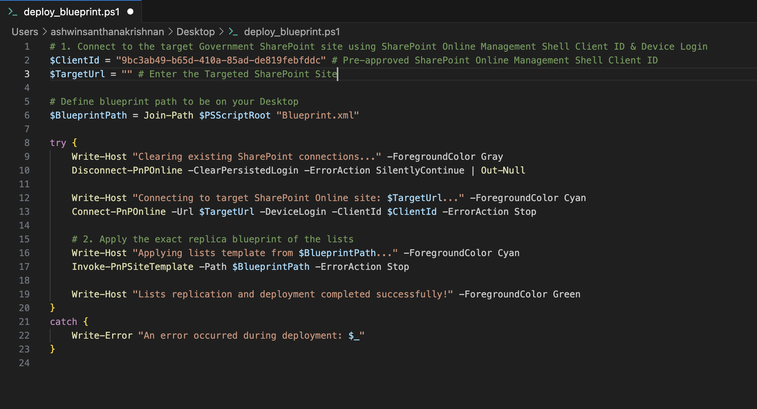
Figure 2: deploy_blueprint.ps1 open in VS Code with $TargetUrl on line 3

3.2.4 Execute the Script & Authenticate
- Go to Run and click Run Without Debugging.
- The script opens a browser for device-login authentication and copies an alphanumeric verification code to your clipboard.
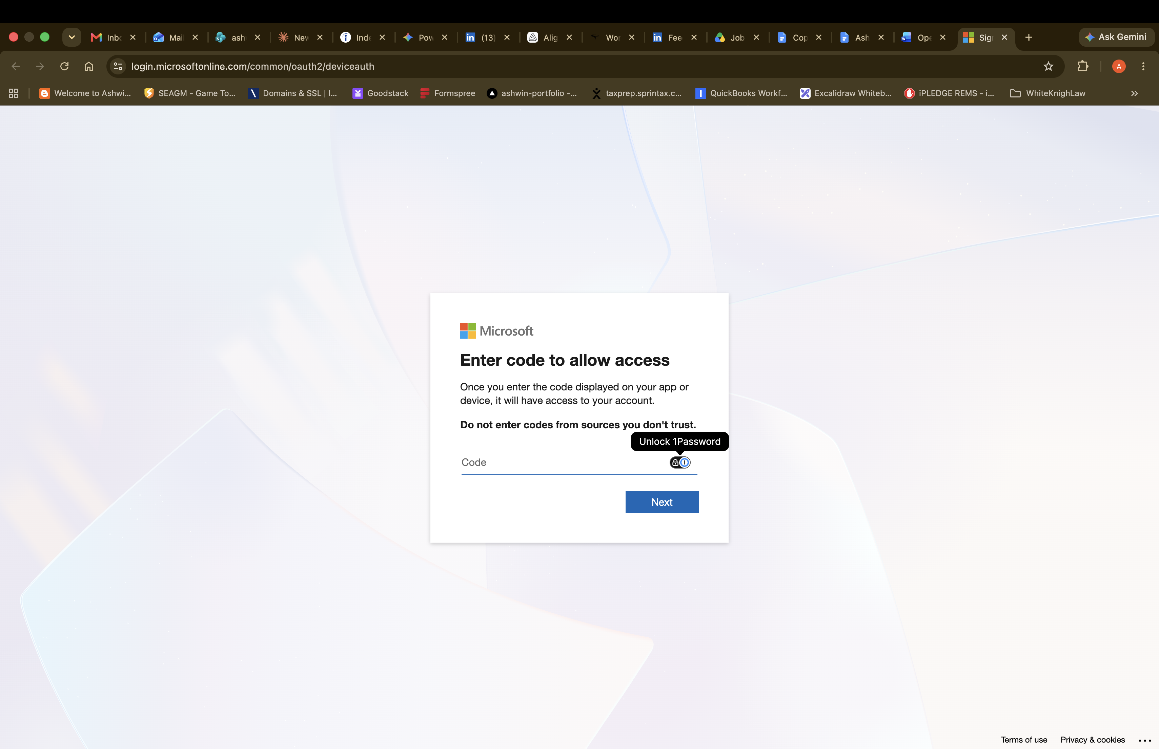
Figure 3: Microsoft device login: Enter code to allow access
- Paste the code, click Next, and sign in with your SharePoint Site Owner credentials.

3.2.5 Automated List Provisioning & Completion
- Return to the terminal. Once authentication completes, the script runs automatically.
- Wait while the template creates all five lists (Operational Plan Admin, Operational Plans, OpPlan Approved Staging List, Organization, Project Plan), choice fields, and lookup columns.
- The terminal shows Lists replication and deployment completed successfully! when finished.

3.3 Step 2: Power BI Analytics Setup

3.3.1 Open the Template Files
- Locate the Power BI Template (.pbit) files for the Admin Report and the Operational Plan Intranet Report in the deployment package.
- Double-click each file to open it in Power BI Desktop.

3.3.2 Configure the Data Parameter
Connect the templates to your newly deployed SharePoint site:
- Launch Power Query: Click Transform data on the Home ribbon to open the Power Query Editor.
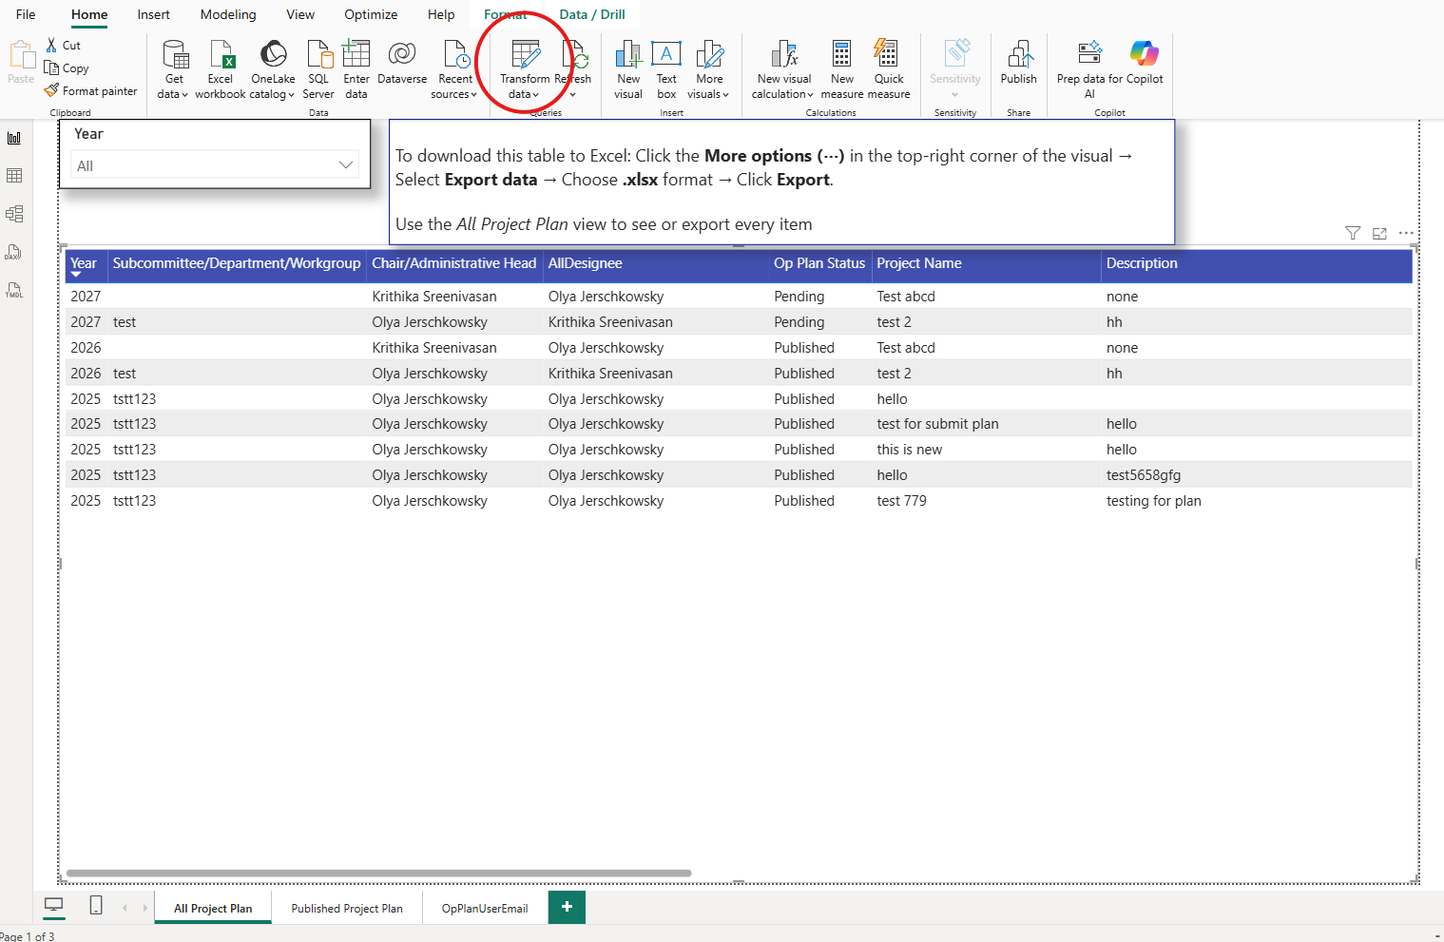
Figure 4: Transform data on the Power BI Desktop Home ribbon
- Select the parameter: In the left-hand Queries pane, click SharePoint_Site_URL.
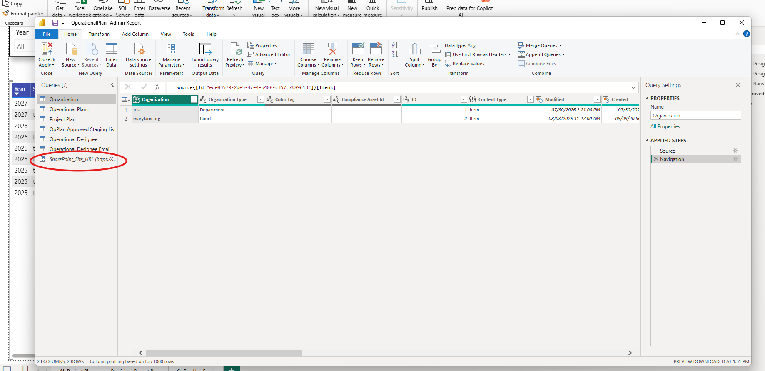
Figure 5: SharePoint_Site_URL parameter in the Queries pane
- Update the target URL: Click Manage Parameters, paste your SharePoint site URL into Current Value, and click OK.
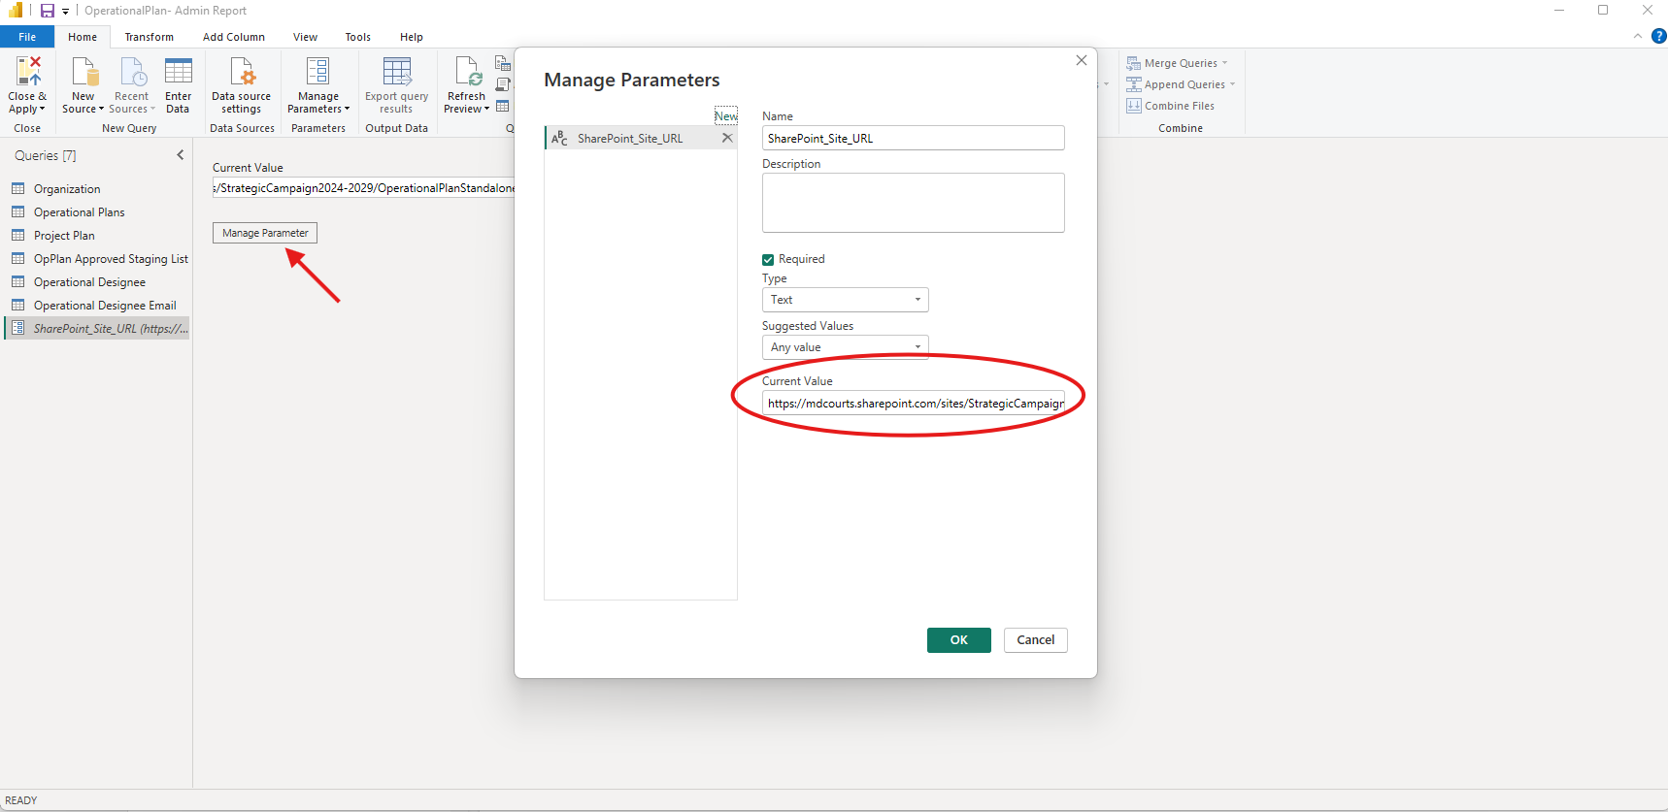
Figure 6: Manage Parameters dialog, Current Value field
- Refresh the connection: Click Refresh Preview on the Home ribbon to pull data from your SharePoint lists.
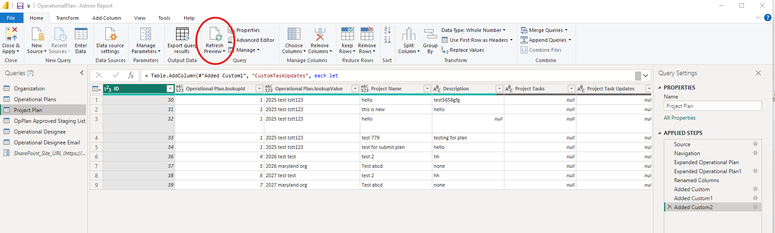
Figure 7: Refresh Preview
- Finalize and load: Click Close & Apply (top-left) to save the parameter and load the data into the visuals.
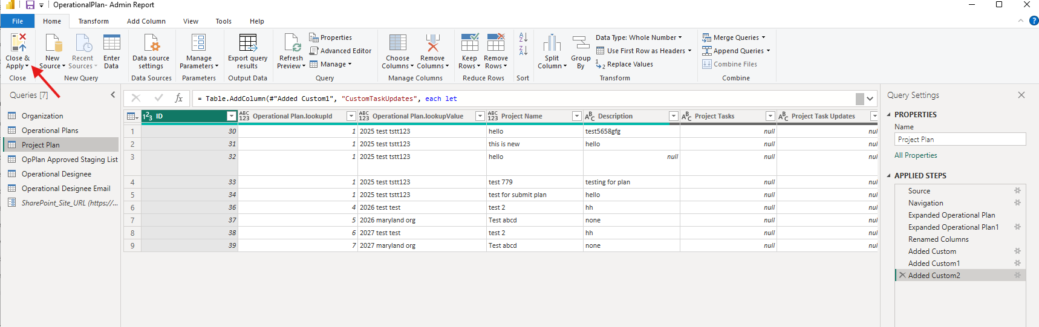
Figure 8: Close & Apply
- Repeat this sequence for both the Admin Report and the Intranet Report.

3.3.3 Publish the Dashboards
- Save the file and click Publish on the Power BI Desktop ribbon.
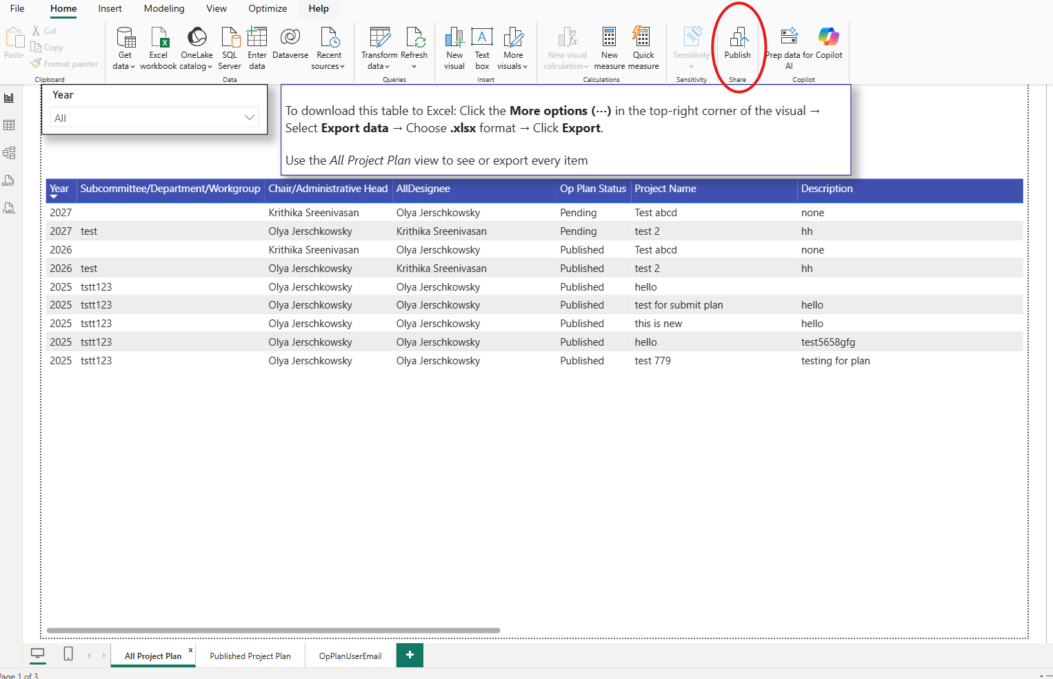
Figure 9: Publish button in Power BI Desktop
- Select your target workspace (e.g., OperationalPlan) for both reports.
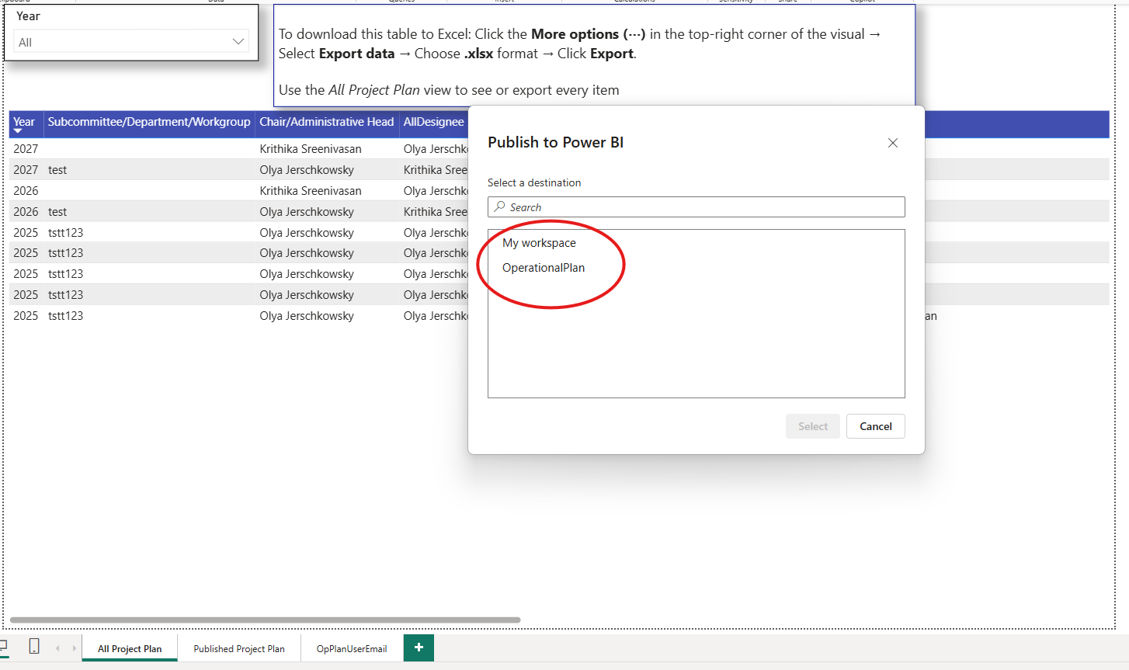
Figure 10: Publish to Power BI: workspace selection
- Confirm both reports and their semantic models appear in the workspace in the Power BI online portal.

3.4 Step 3: Power Platform Solution Installation
This final phase wires the Canvas App and cloud flows to your new SharePoint lists and Power BI reports.

3.4.1 Solution Import & Connection Authentication
- Import the solution: In Power Apps, select your target environment, go to Solutions > Import solution, and upload the unmanaged solution .zip file.
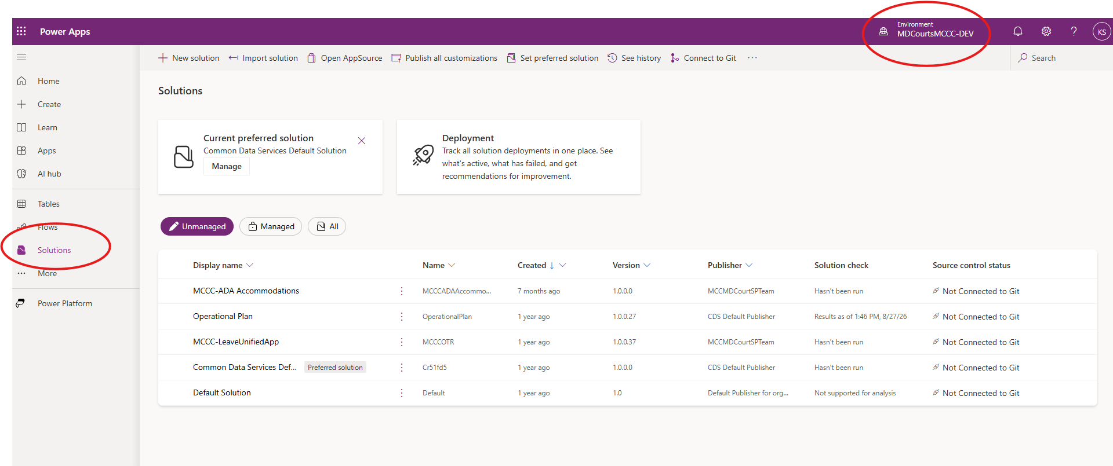
Figure 11: Power Apps Solutions area and environment picker
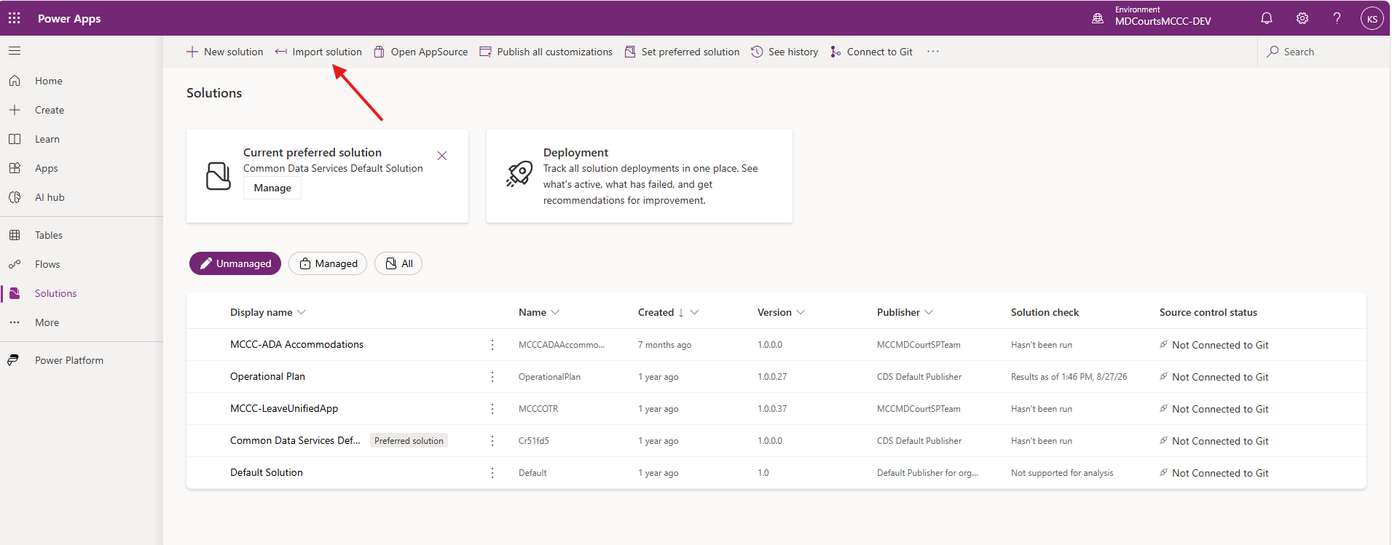
Figure 12: Import solution command
- Authenticate connections: The wizard prompts you to sign in to the connection references (Office 365 Users, Office 365 Groups, Office 365 Outlook, SharePoint, and Power BI). Sign in until each shows a green check, then click Next.
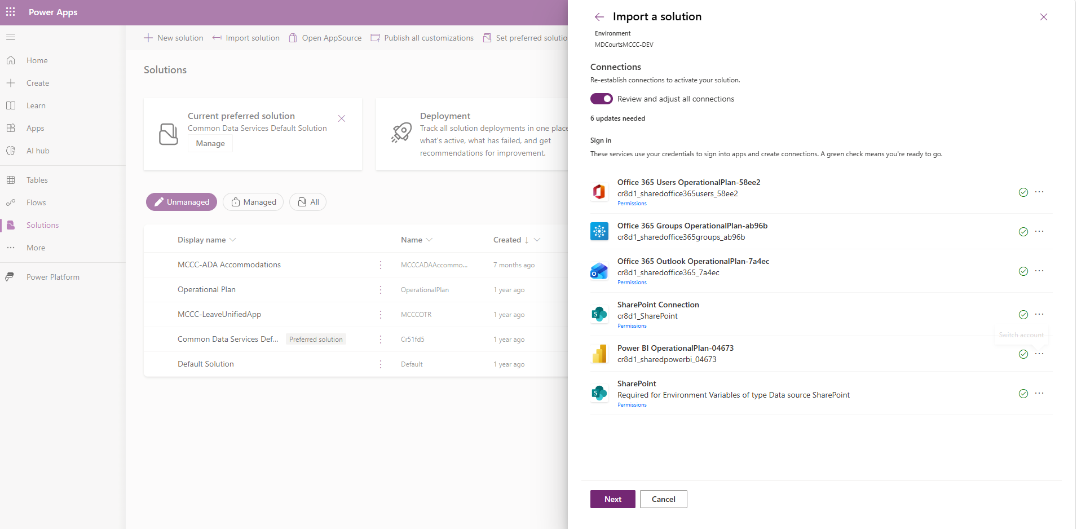
Figure 13: Import a solution: Connections, all signed in

3.4.2 Mapping the Environment Variables
Map each environment variable in the import wizard as follows:
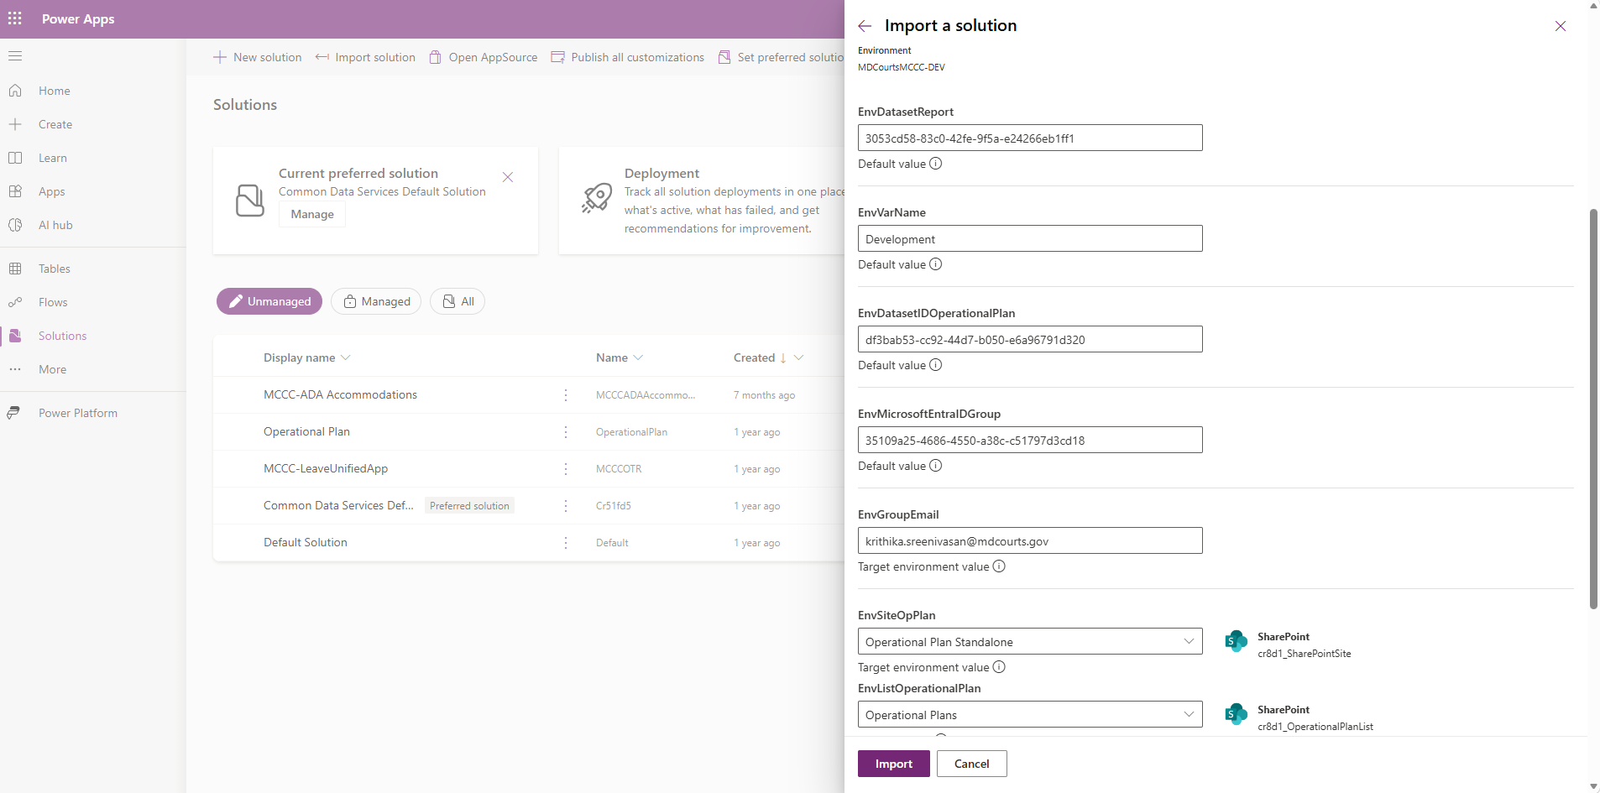
Figure 14: Import a solution: Environment Variables (part 1)
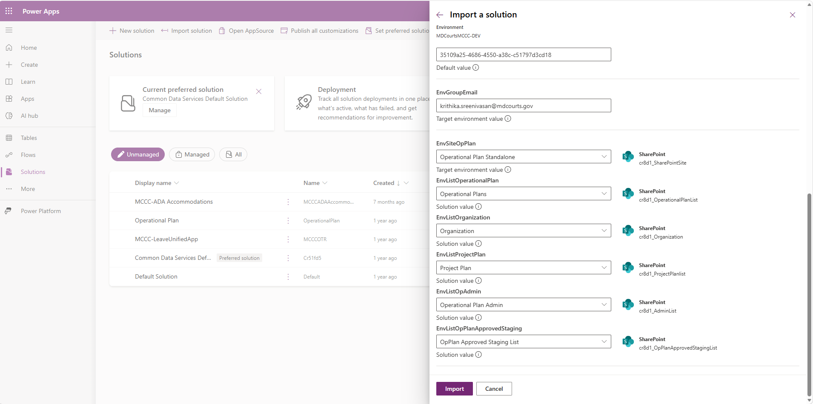
Figure 15: Import a solution: Environment Variables (part 2)
- EnvWorkspaceIdPowerBi: Open your workspace in Power BI online and copy the ID that follows groups/ in the URL.
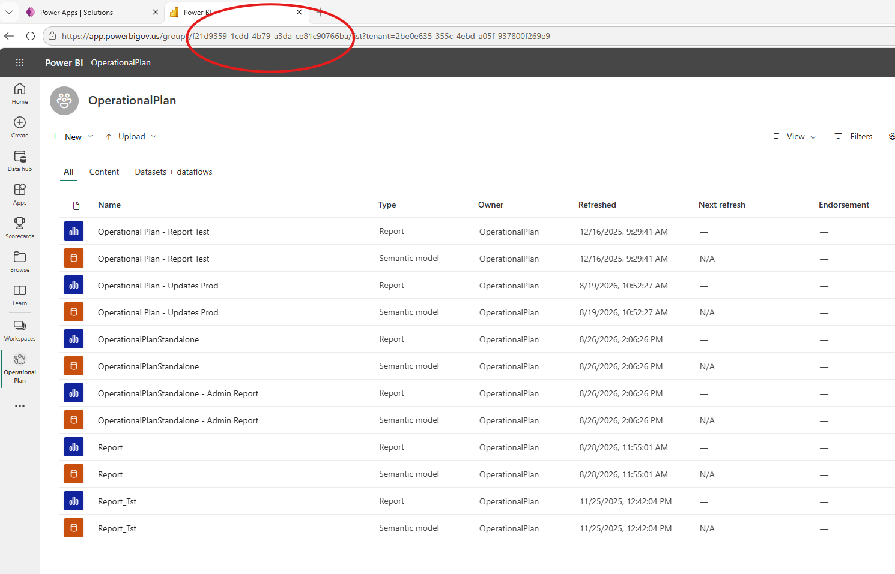
Figure 16: Workspace ID in the Power BI URL
- EnvReportURL: Open the Operational Plan Admin report in Power BI online and copy the full browser URL.
- EnvDatasetReport: Open the semantic model (dataset) of the Admin Report and copy the ID that follows /datasets/ in the URL.
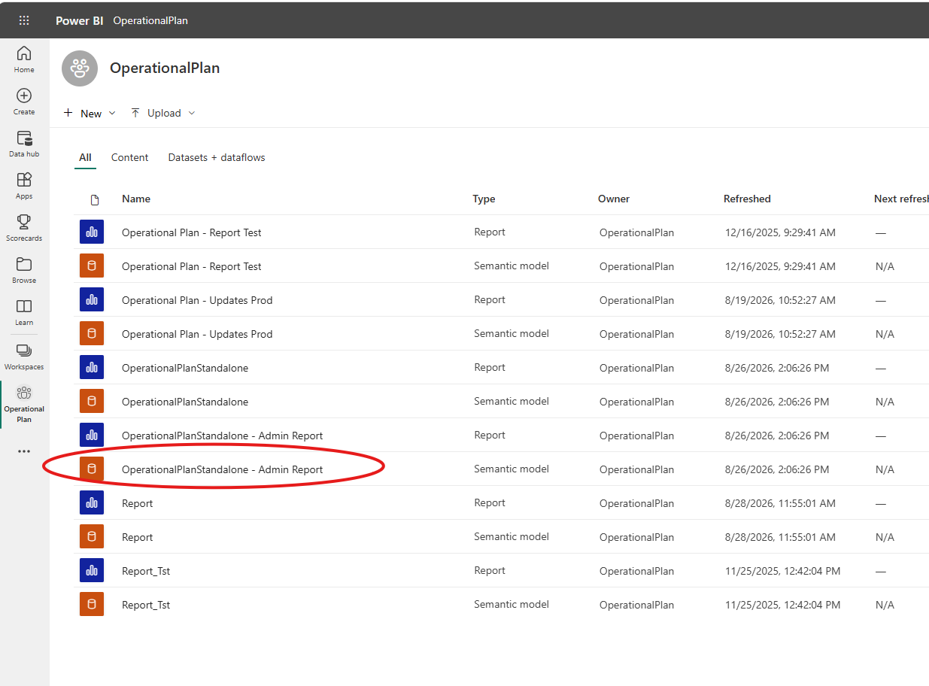
Figure 17: Selecting the Admin Report semantic model
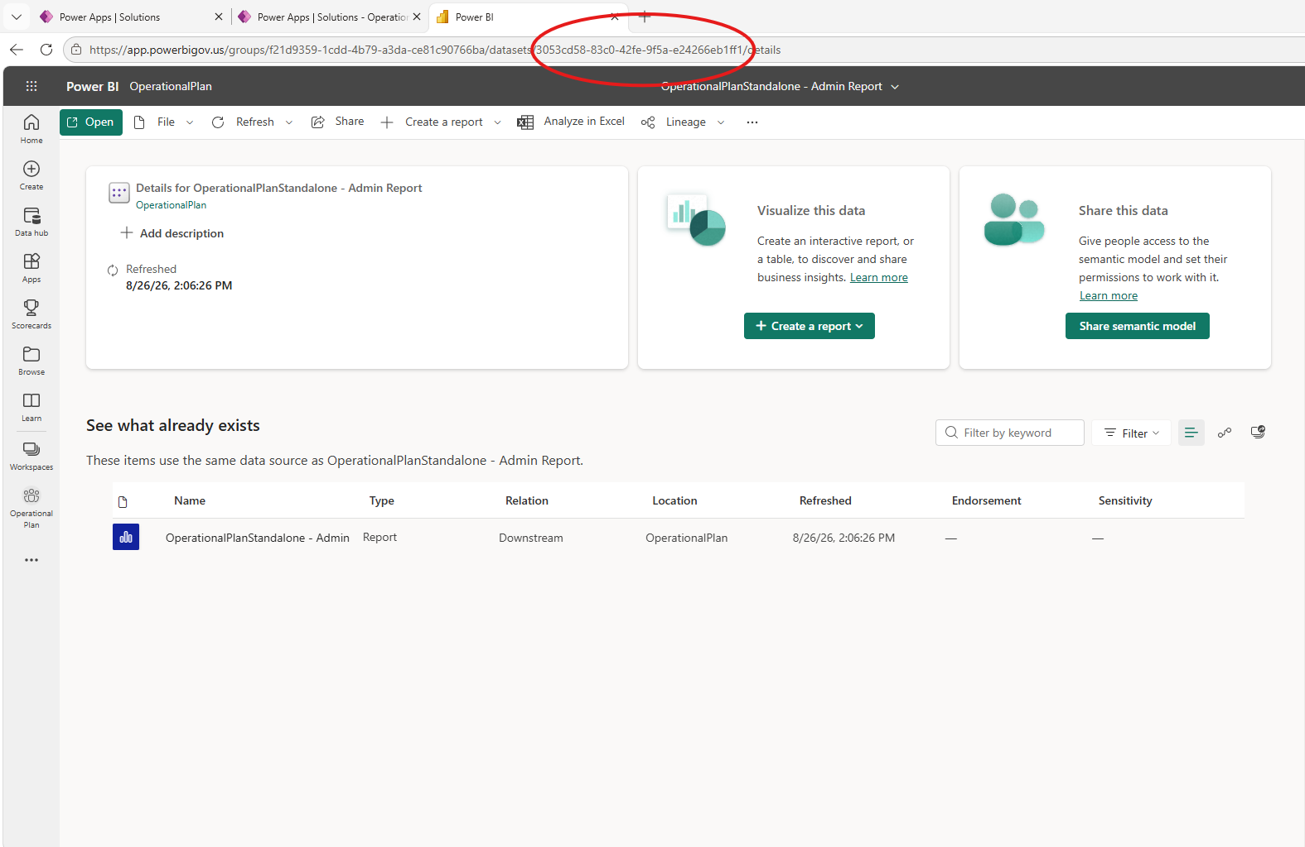
Figure 18: Admin Report dataset ID in the URL
- EnvDatasetIDOperationalPlan: Repeat for the OperationalPlanStandalone (Intranet Report) semantic model and copy the ID after /datasets/.
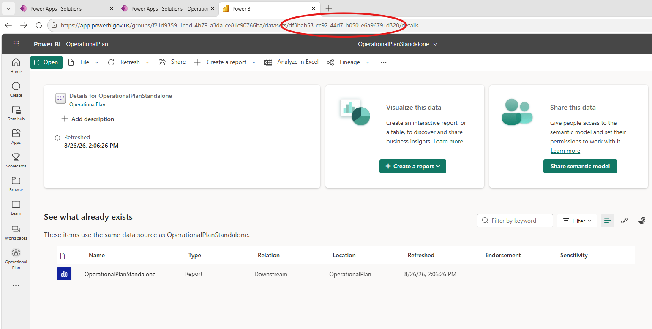
Figure 19: Intranet Report dataset ID in the URL
- EnvMicrosoftEntraIDGroup: Sign in to the Azure Portal (https://portal.azure.com), open Microsoft Entra ID, search for your group (e.g., OperationalPlanUserGroup), and copy its Object ID.
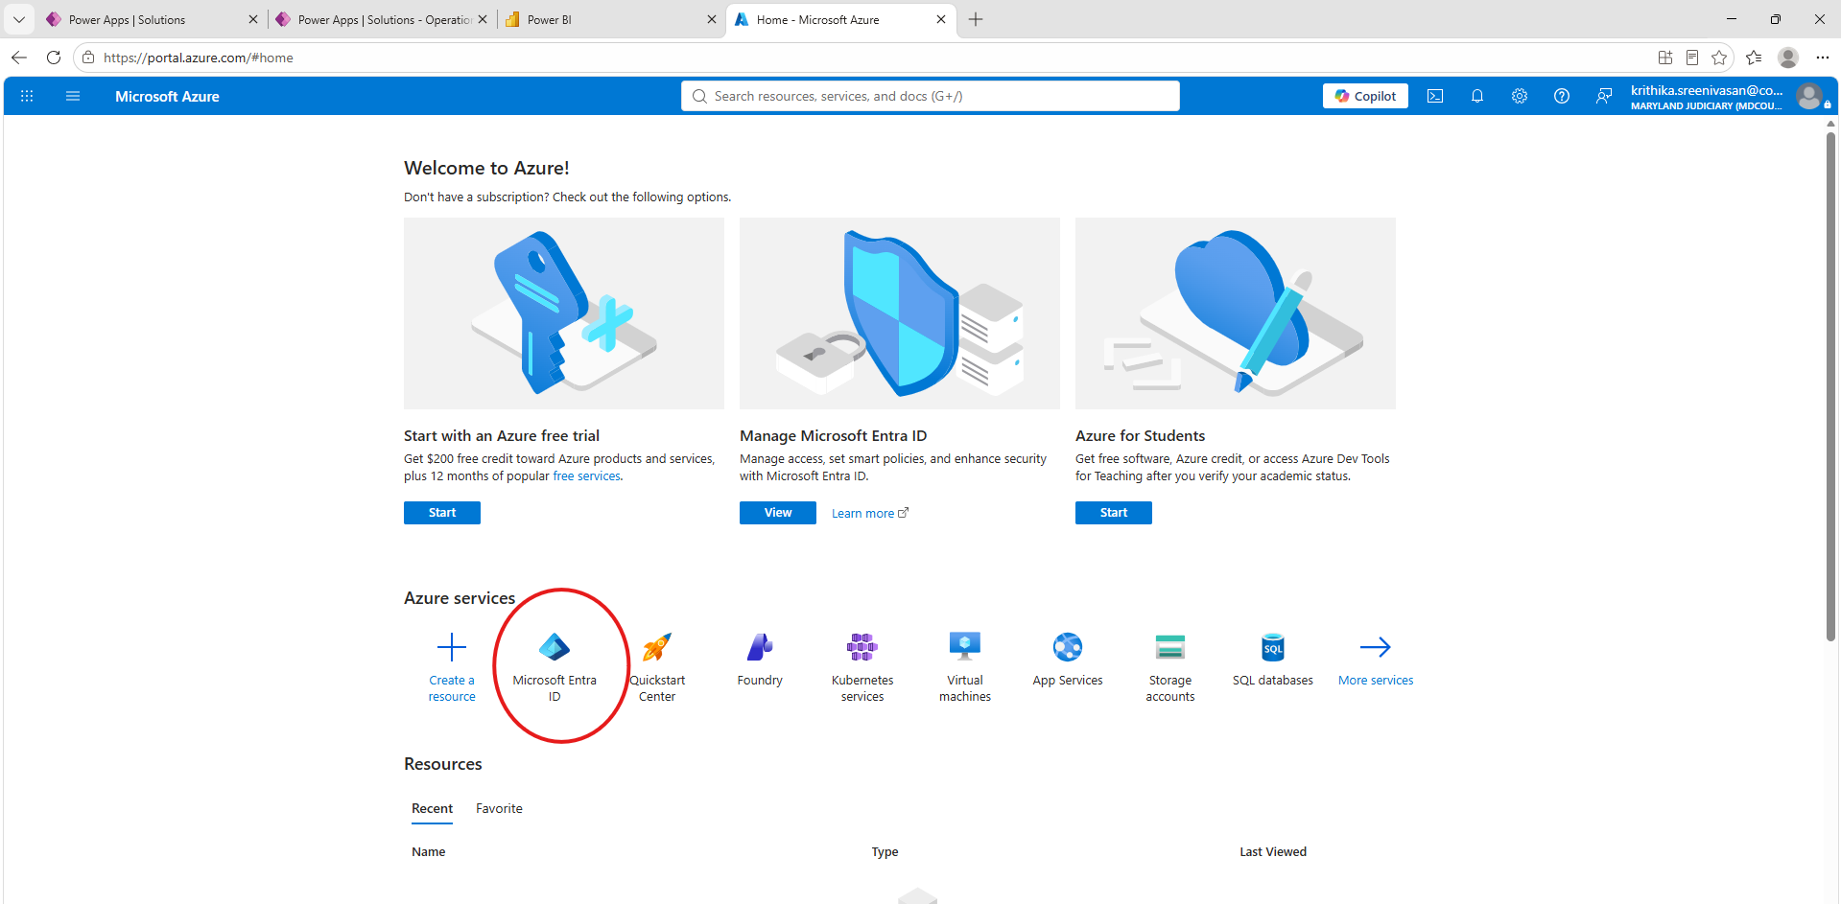
Figure 20: Microsoft Entra ID in the Azure Portal
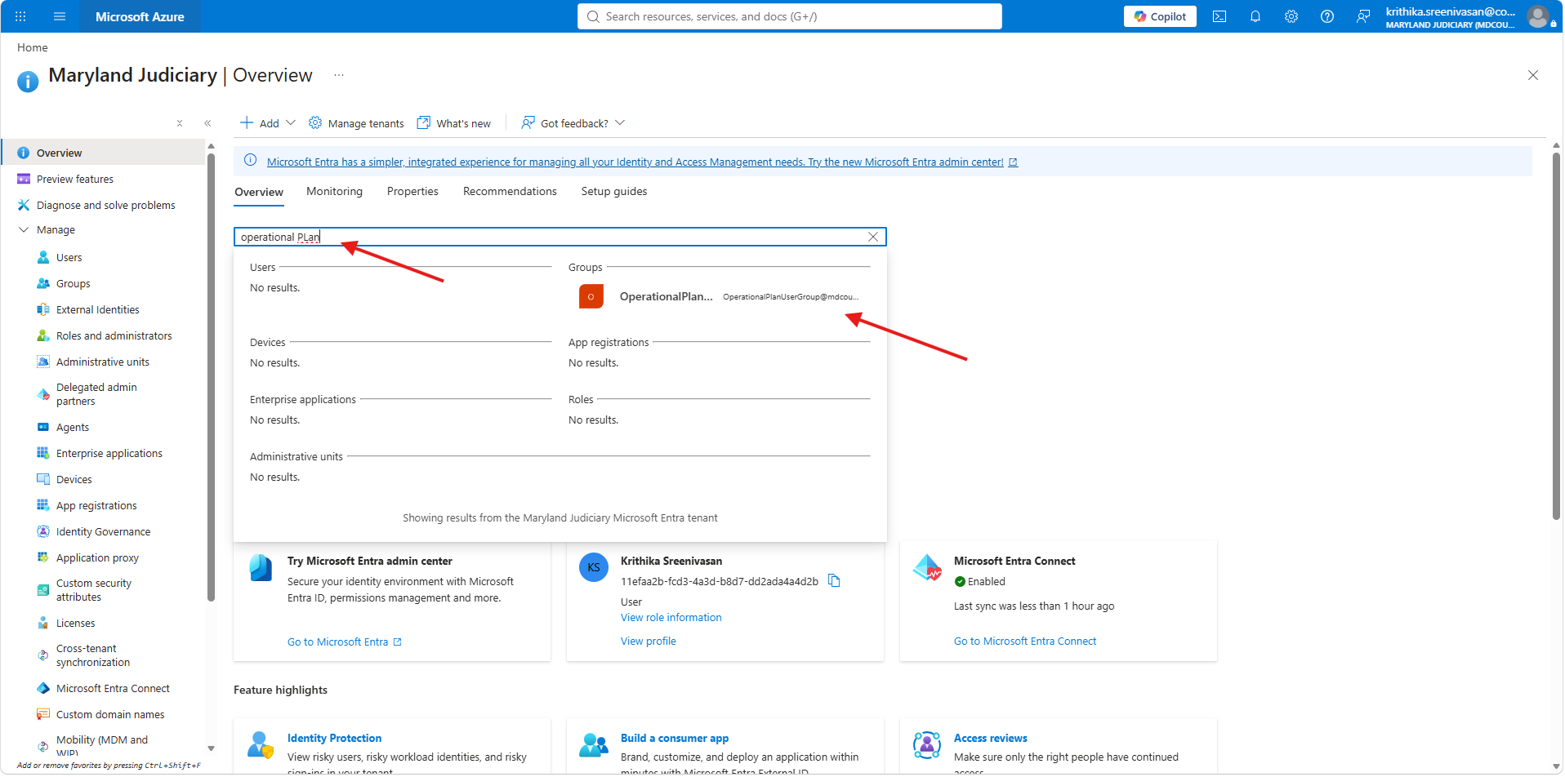
Figure 21: Searching for OperationalPlanUserGroup
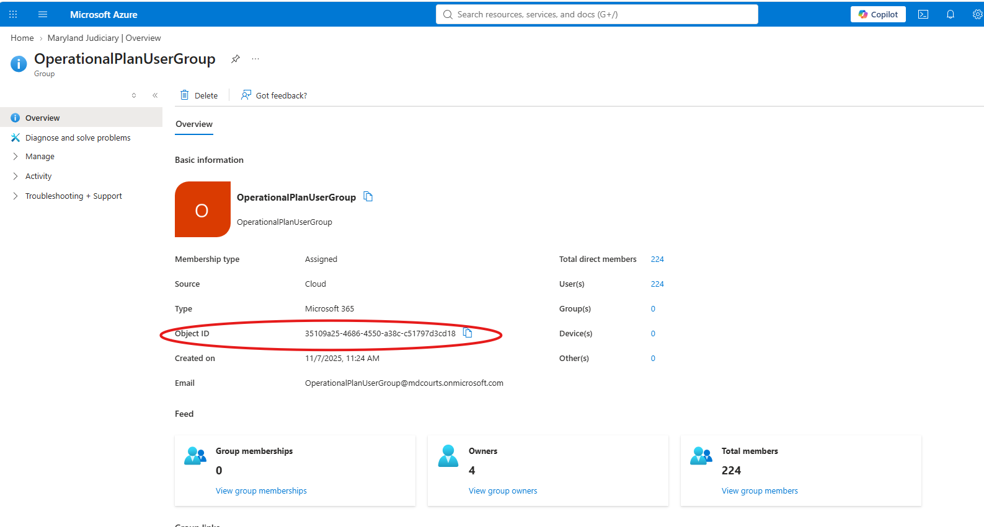
Figure 22: Group overview showing the Object ID
- EnvGroupEmail: Enter your team or admin mailbox so notifications route correctly.
- EnvSiteOpPlan: Select the SharePoint site where the backend lists were deployed.
- SharePoint list variables (EnvListOperationalPlan, EnvListOrganization, EnvListProjectPlan, EnvListOpAdmin, EnvListOpPlanApprovedStaging): select the matching list from each dropdown.
Click Import to complete the installation.

4. Administrator & User Manuals

Introduction
This section provides instructions for the different types of users who interact with the Maryland Judiciary Operational Plan application. The application supports role-based access, ensuring that users can perform activities based on their assigned responsibilities.
The application has two primary user roles:
1. Administrator (Admin)
Administrators are responsible for managing and overseeing the Operational Plan application. Their responsibilities include:
- Adding and managing application users and assigning appropriate roles.
- Managing organizations and operational plans.
- Reviewing and approving submitted Operational Plans.
- Monitoring project progress and plan submissions.
- Refreshing Power BI reports and accessing administrative reporting.
- Creating the next year's Operational Plan.
2. Chair / Designee (User)
Chairs and Designees are responsible for creating, submitting, and maintaining Operational Plans for their assigned organizations. Their responsibilities include:
- Creating and updating Operational Plans.
- Adding and managing projects associated with their Operational Plans.
- Submitting Operational Plans for administrator review and approval.
- Providing mid-year updates and tracking project progress.
- Reviewing the status of their submitted plans.

User Manual Overview
The following sections provide detailed instructions for each user role:
- Section 4.1 – Administrator User Manual: Explains the administrative functions, including user management, plan approvals, reporting, and other administrative activities.
- Section 4.2 – Chair / Designee User Guide: Provides instructions for creating, updating, and submitting Operational Plans and managing associated projects.
Users should refer to the section corresponding to their assigned role for step-by-step instructions on using the application.

4.1 Administrator User Manual

4.1.1 Home Page for Administrators
To make a user an Administrator, add the user with Role = Admin. All regular users should have their role set to User.
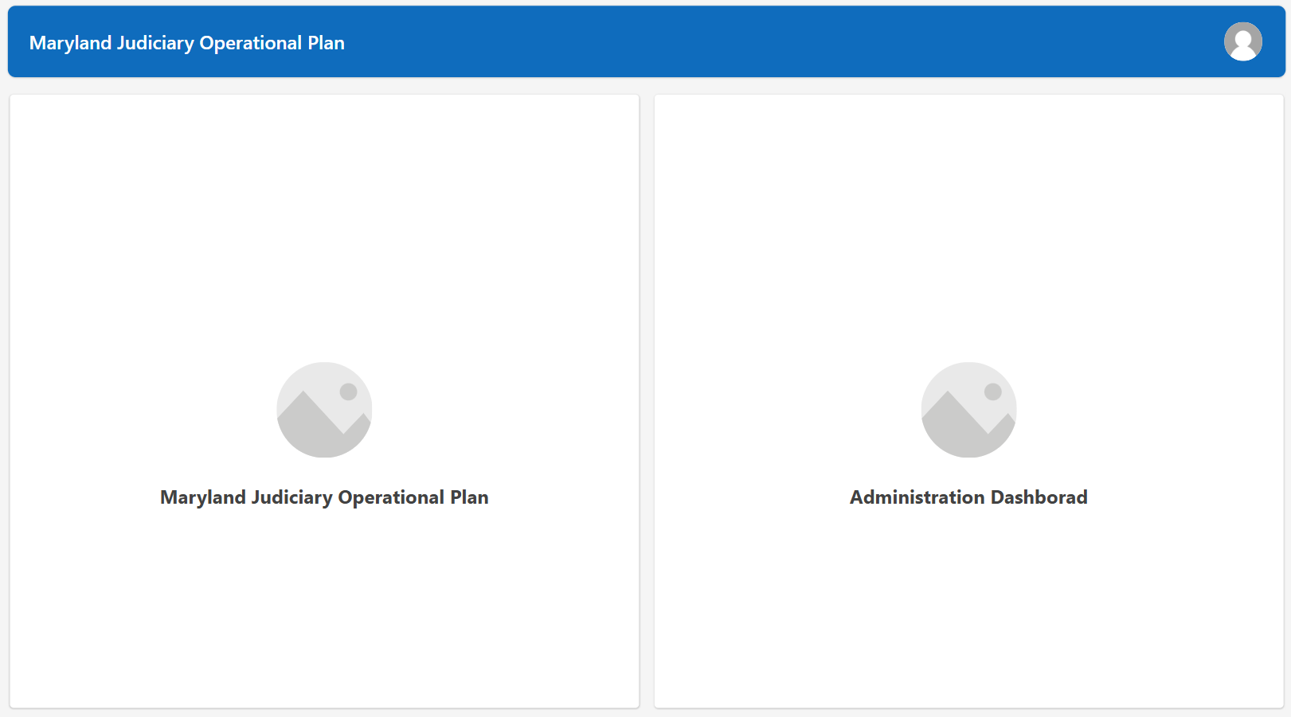
Figure 23: Administrator home screen

4.1.2 User Administration Dashboard
Open the Administration Dashboard to add or update users. When a new user is created, Flow.OpPlan.AddUserPermission automatically adds them to the OperationalPlanUserGroup Office 365 group, giving them access to the application and its SharePoint lists. The user list is linked to the Operational Plan Admin SharePoint list.
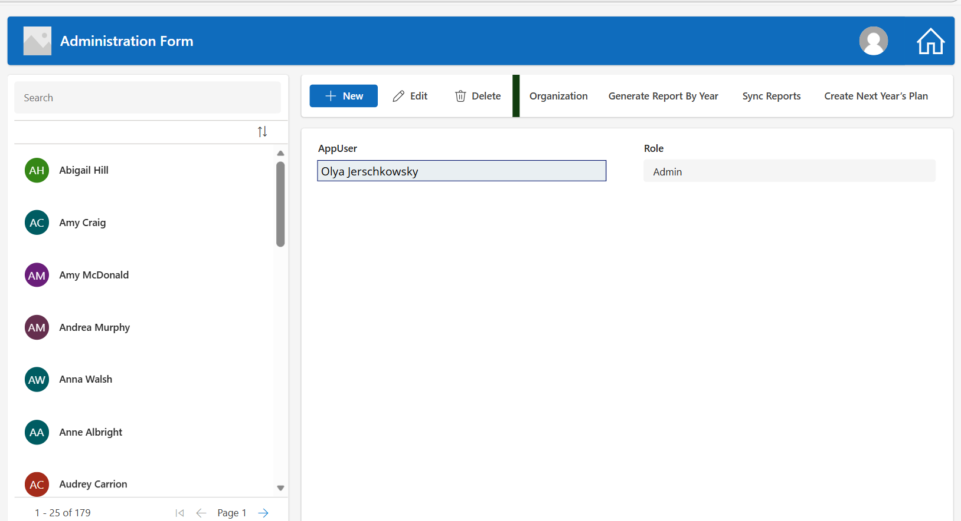
Figure 24: Administration Form: user management

4.1.3 Organization
Click Organization to open the Organization screen, where you can add or update organization data. This screen is connected to the Organization SharePoint list.
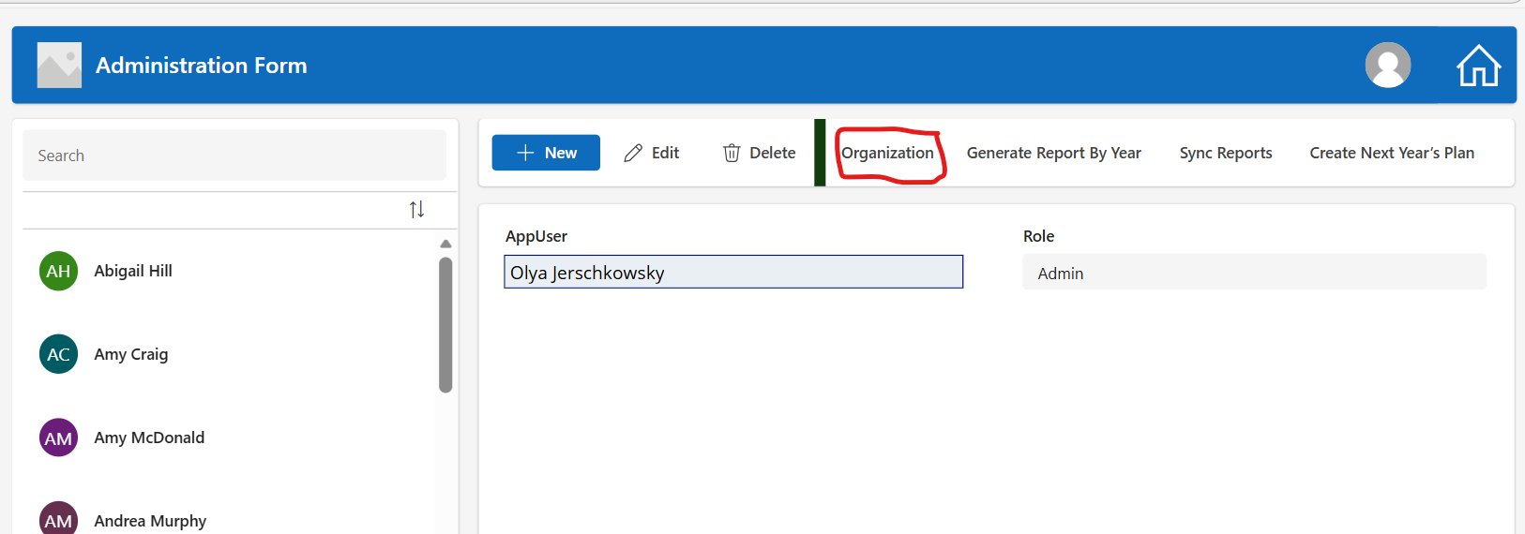
Figure 25: Organization button on the Administration Form

4.1.4 Generate Report By Year
To download an Operational Plan and its project data in Excel format, click Generate Report By Year. This opens a Power BI report page, connected to the Operational Plan and its projects, where you can filter by year and export the data to Excel.
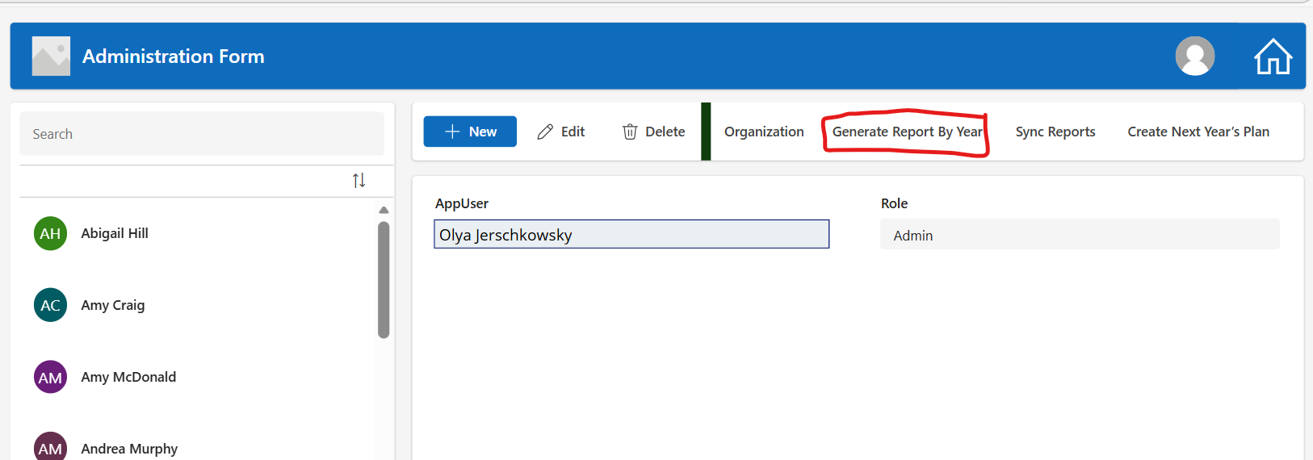
Figure 26: Generate Report By Year button
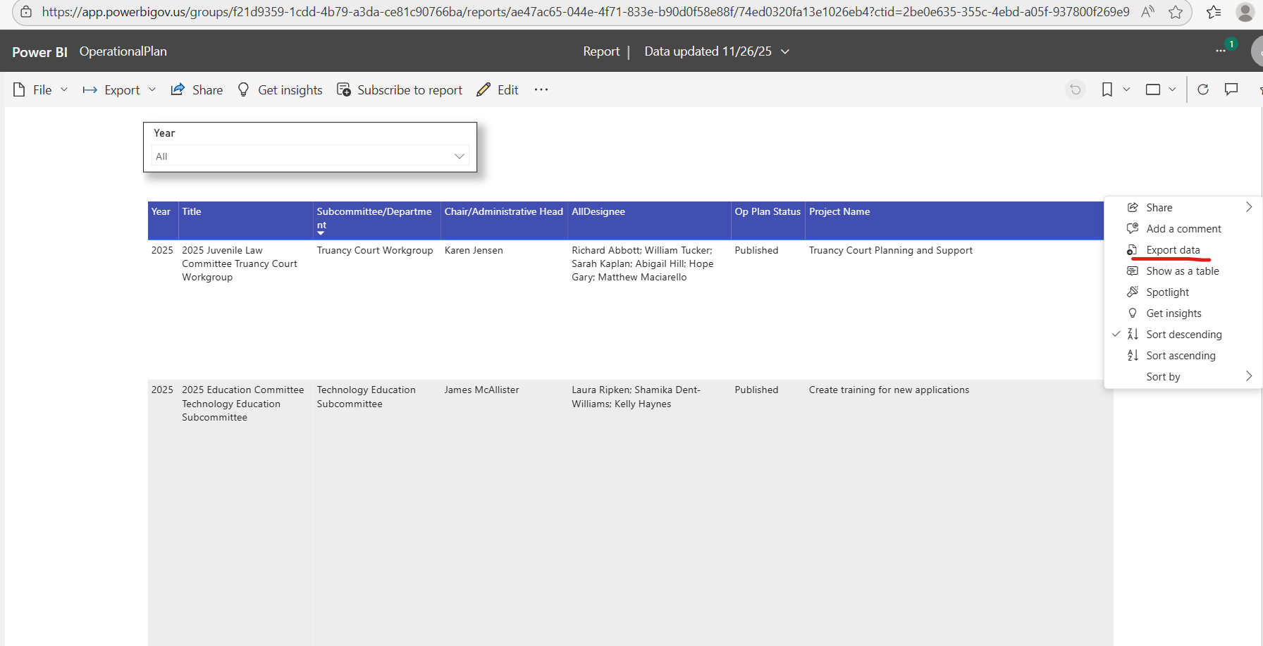
Figure 27: Exporting report data from Power BI
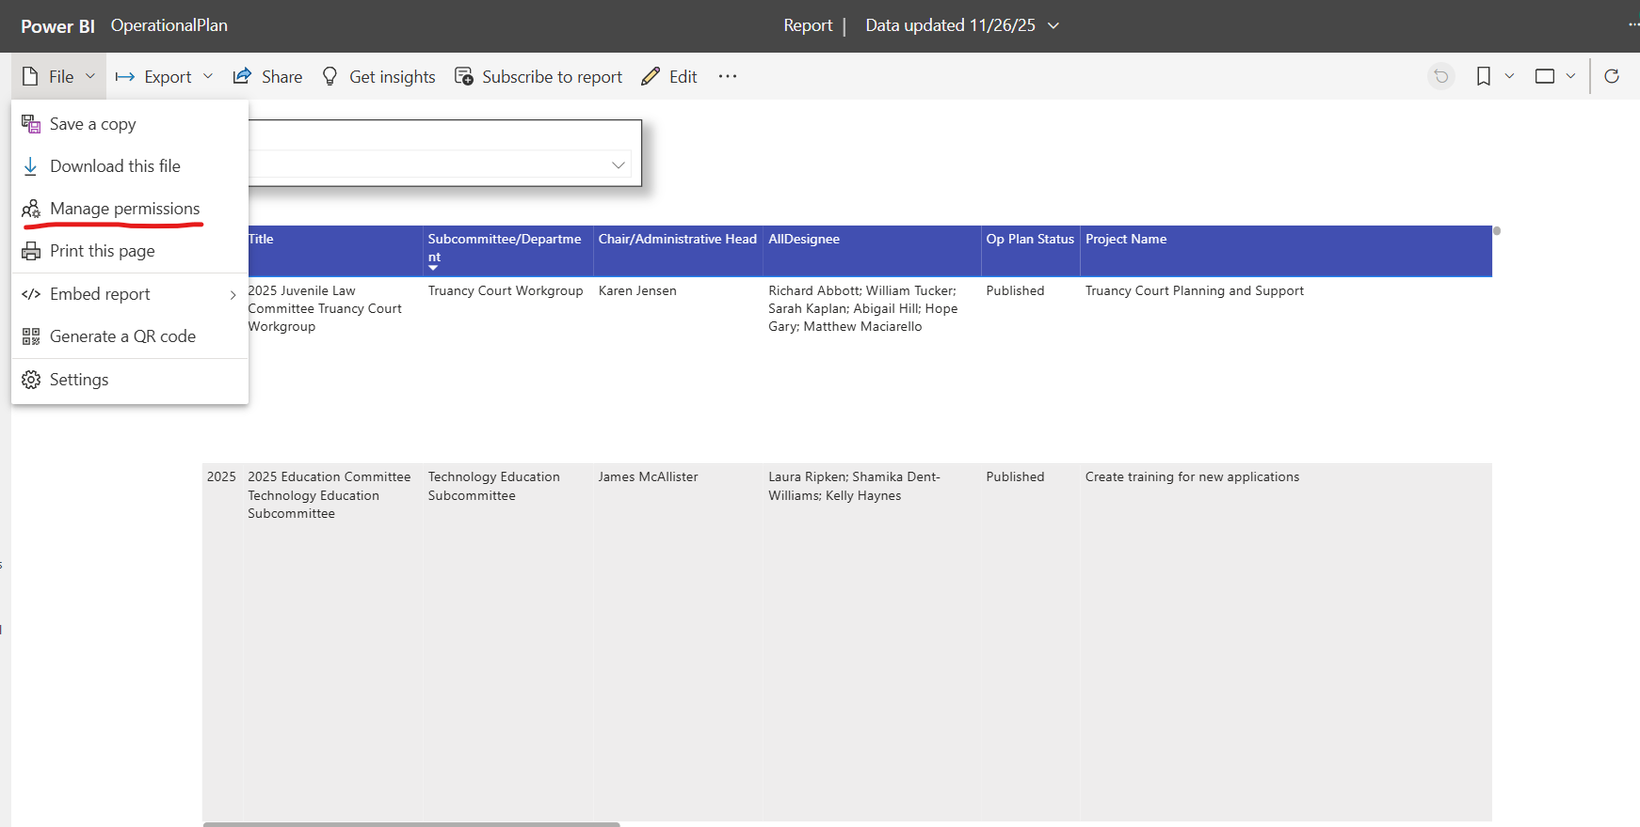
Figure 28: Manage permissions in the Power BI report
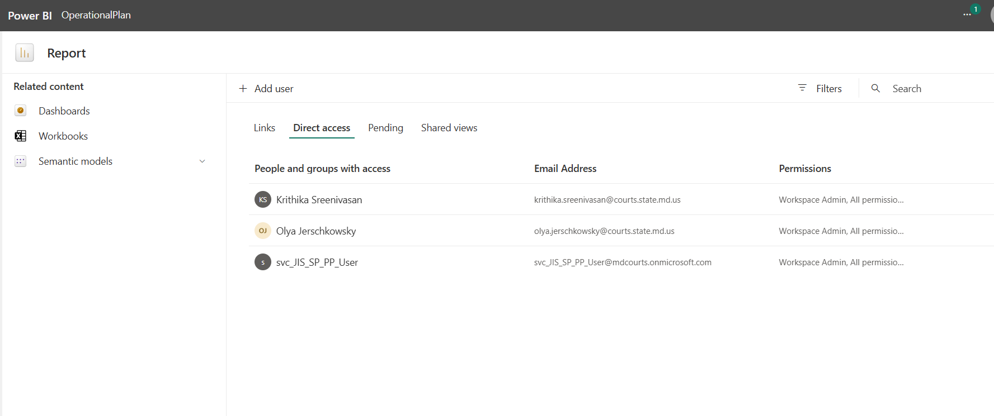
Figure 29: Direct access permissions list
All administrators should have access to this report. Click Manage permissions and add the user through Direct access.

4.1.5 Sync Reports
Sync Reports refreshes all reports from within the application, handled in the backend by Flow.OpPlan.RefreshReportDataset. Due to licensing limits, reports can be synced a maximum of five times per day through the app.
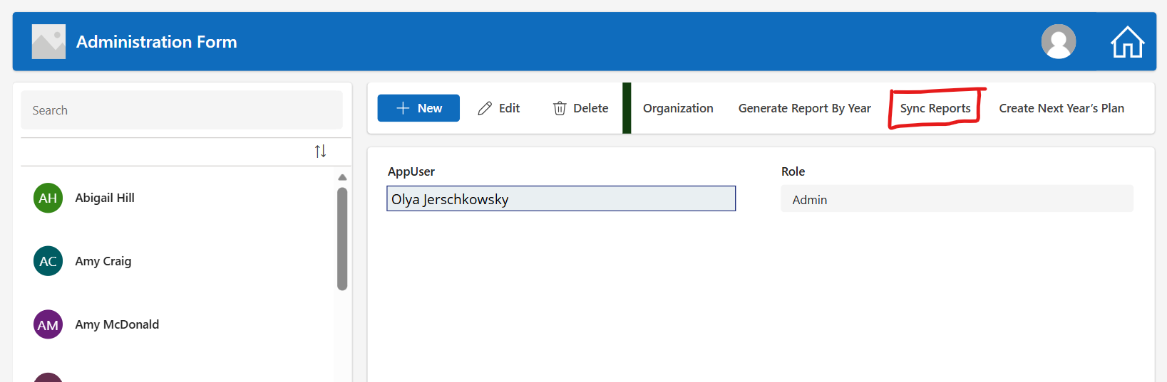
Figure 30: Sync Reports button
Alternative option: You can also refresh a dataset in the Power BI workspace by clicking Refresh now on its semantic model.
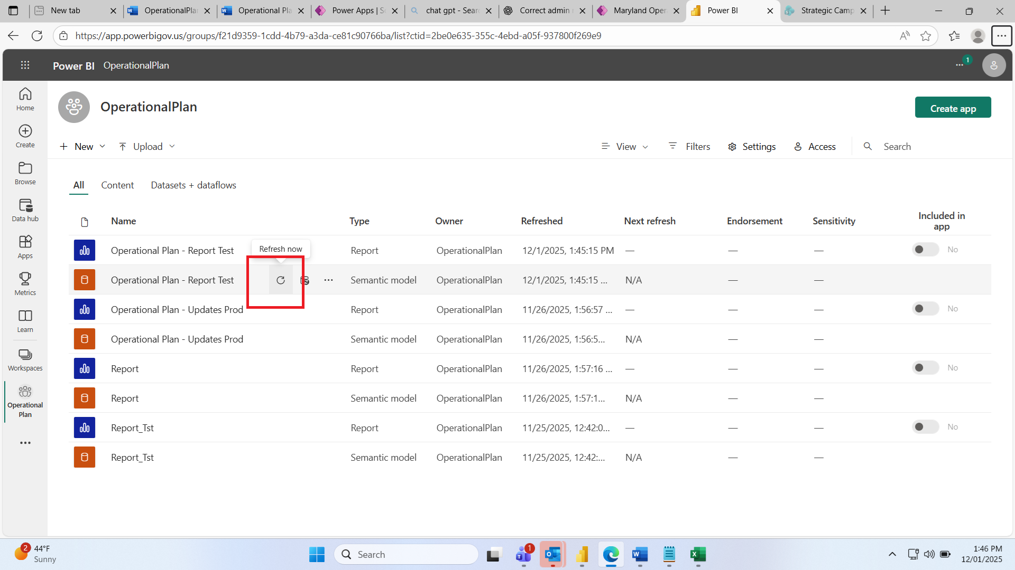
Figure 31: Refresh now on the semantic model in the Power BI workspace

4.1.6 Create Next Year's Plan
Administrators can generate the next year's Operational Plan from the existing year. For example, selecting 2025 creates the 2026 Operational Plan and copies any incomplete 2025 projects into it. This is handled by Flow.OpPlan.CreateNextYearPlan; an email is sent to the Admin group inbox when it completes.
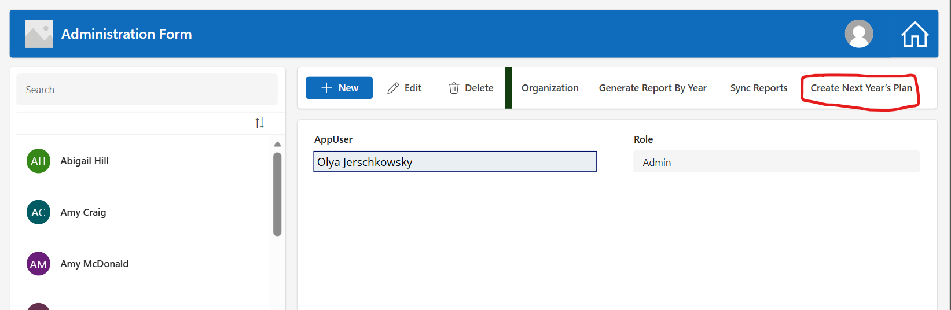
Figure 32: Create Next Year's Plan button
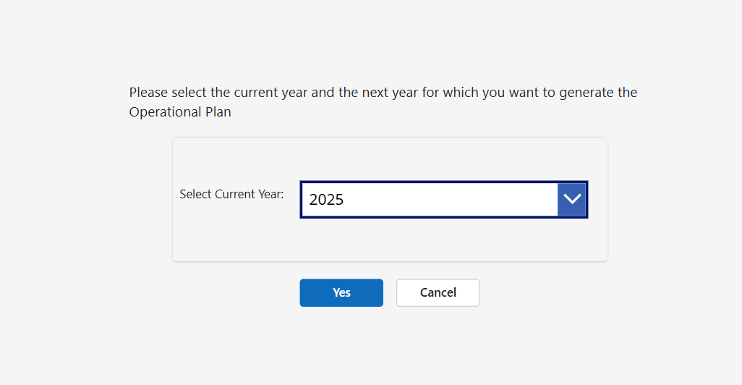
Figure 33: Select the current year to generate the next year's plan

4.2 Chair / Designee User Guide

4.2.1 Login Screen
When a Chair or Designee opens the application URL, they see the Maryland Judiciary Operational Plan entry tile.
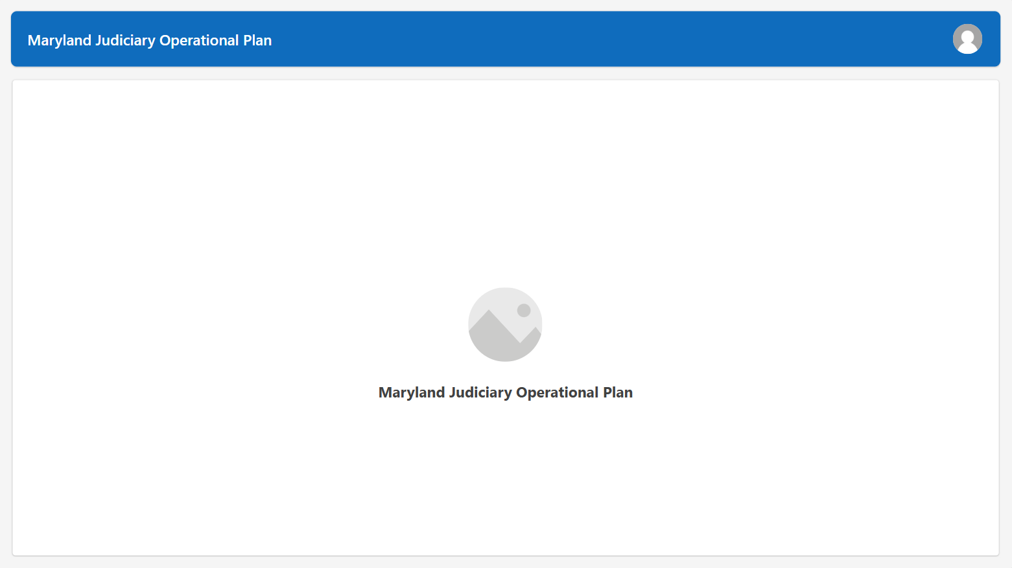
Figure 34: Chair/Designee login screen

4.2.2 Operational Plan List
After entering, users see the list of their Operational Plans for the current year, sorted by Year, Organization, and Subcommittee/Department, with filters for Year, Organization, Status, and Chair/Designee.
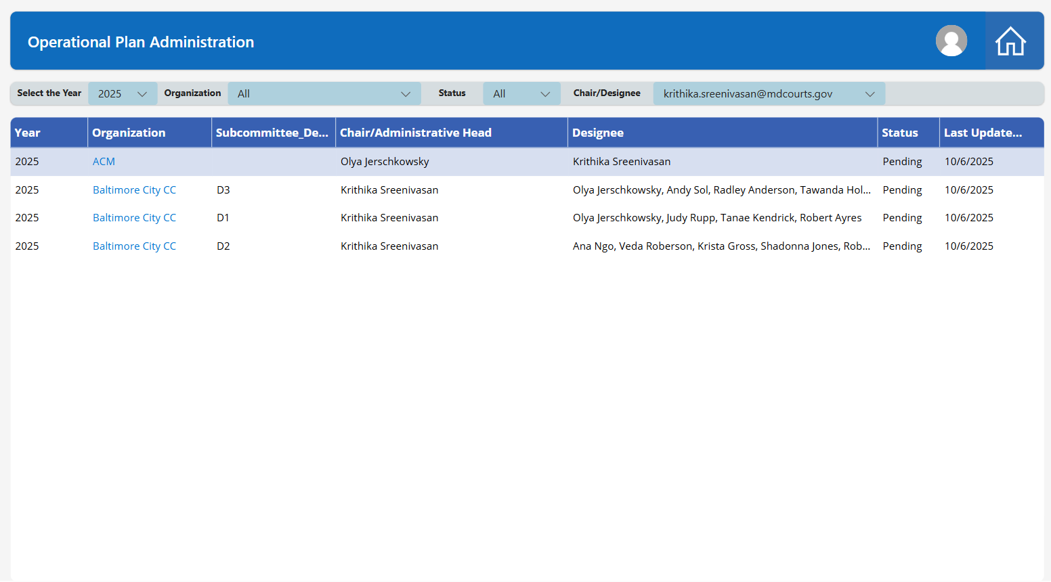
Figure 35: List of the user's Operational Plans

4.2.3 Operational Plan Details & Projects
Selecting a plan opens its details (Year, Organization, Subcommittee/Department, Chair/Administrative Head, Designees, Status, Last Updated Date, Admin Notes) and its project table. Use + New Project to add projects. The screenshot below shows the screen a Chair/Designee sees when the plan has no projects yet.
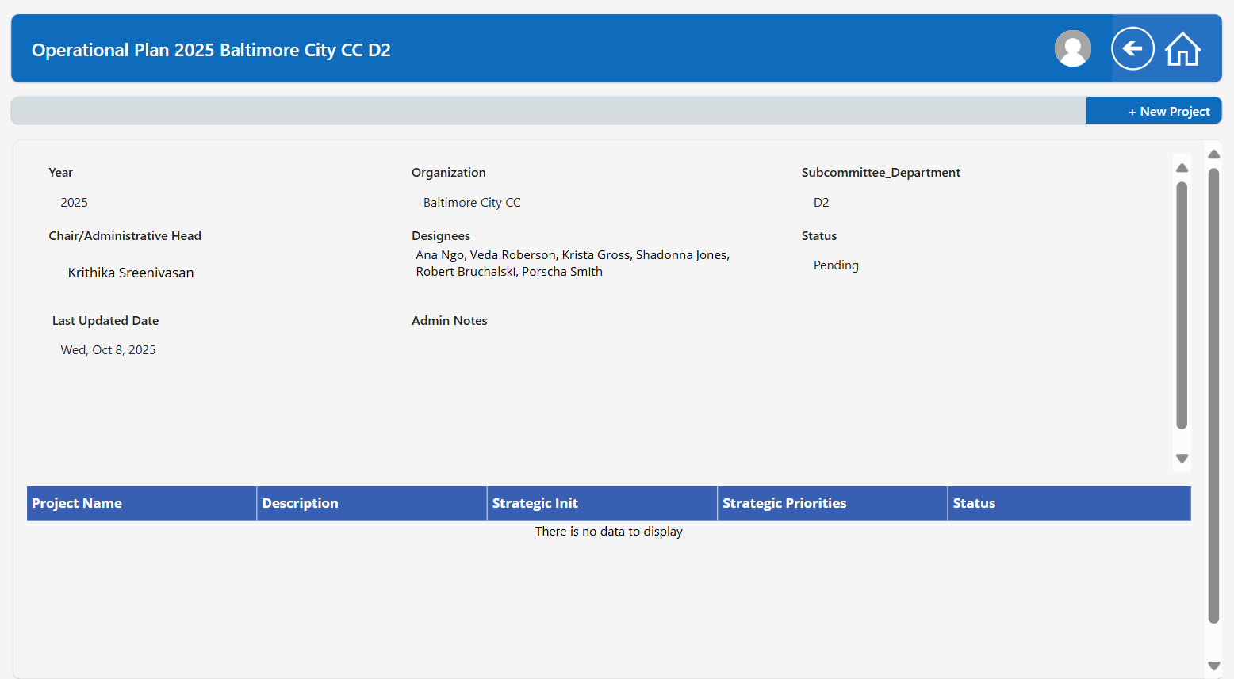
Figure 36: Plan detail screen with no projects yet

4.2.4 End-to-End Process: Submission, Approval & Power BI Staging
This section describes the complete process from the moment a Chair/Designee adds or edits data to the moment it appears in the Power BI reports. Only data approved by an Administrator reaches the live reports.
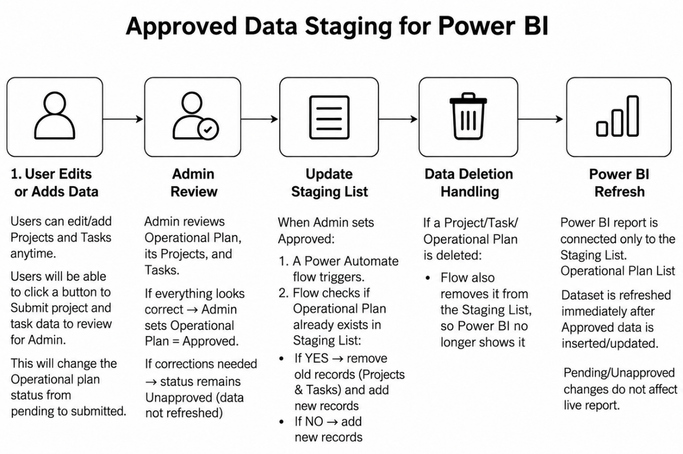
Figure 37: Approved data staging for Power BI: end-to-end process
Lists and roles involved
List / Role | Purpose
Operational Plan (parent list) | Holds the plan record, including Status (Pending / Submitted / Completed) and Approved (Yes/No).
Project list (child of Operational Plan) | Projects that belong to an Operational Plan.
Task list (child of Project) | Tasks and task updates that belong to a project.
Staging List | Flat table combining projects and tasks with their Operational Plan ID, containing only Approved data, used for Power BI reporting.
Users (Chair / Designee) | Add and update projects and tasks. The Approved value always defaults to No until an Admin turns it on.
Admin | Reviews and approves data, and controls what flows into Power BI.

Step 1: User edits or adds data
- Users can add or edit projects and tasks at any time.
- When ready, the user clicks Submit to send the project and task data to the Admin for review. This changes the Operational Plan status from Pending to Submitted.
- The Operational Plan is automatically marked as Unapproved (if it is not already).
- A Power Automate flow (FlowOpPlanSendOperationalPlanEmail) sends a notification to the Admin mailbox that new or changed data needs review.
Step 2: Admin review
- The Admin reviews the Operational Plan, its projects, and its tasks.
- If everything is correct, the Admin sets the Operational Plan to Approved.
- If corrections are needed, the status remains Unapproved and the report data is not refreshed.
Step 3: Update the Staging List
When the Admin sets Approved:
- A Power Automate flow (FlowOpPlanApproval) triggers.
- The flow checks whether the Operational Plan already exists in the Staging List. If yes, the old records (projects and tasks) are removed first; if no, the flow proceeds.
- The flow inserts the new approved data (Operational Plan, projects, and tasks) into the Staging List.
Step 4: Data deletion handling
- If a project, task, or Operational Plan is deleted, the flow also removes it from the Staging List so Power BI no longer shows it.
Step 5: Power BI refresh
- The Power BI reports are connected only to the Staging List and the Operational Plan list.
- The dataset is refreshed immediately after approved data is inserted or updated.
Pending or unapproved changes do not affect the live report. Users can keep working on their plan while the published report continues to show the last approved version.

5. SharePoint Lists & Data Types (Data Dictionary)
The backend consists of five SharePoint lists provisioned by Blueprint.xml and referenced through environment variables. Column names and data types below are taken from the SharePoint Column List workbook.

5.1 Operational Plan Admin
Environment variable: EnvListOpAdmin
Purpose: Application users and role assignments (Admin / User). New items trigger Flow.OpPlan.AddUserPermission.
# | Column Name | Data Type
1 | AppUser | Person or Group
2 | Role | Choice
3 | Name | Single line of text

5.2 Organization
Environment variable: EnvListOrganization
Purpose: Master lookup list of organizations (courts, departments, committees).
# | Column Name | Data Type
1 | Organization | Single line of text
2 | Organization Type | Choice

5.3 Operational Plans
Environment variable: EnvListOperationalPlan
Purpose: Annual Operational Plan header records by organization and subcommittee/department, including leadership and approval state.
# | Column Name | Data Type
1 | ID | Number (system, auto-generated)
2 | Operational Plan | Single line of text
3 | Year | Choice
4 | Organization | Lookup (Organization list)
5 | Subcommittee/Department/Workgroup | Single line of text
6 | Chair/Administrative Head | Person or Group
7 | Designees | Person or Group
8 | Status | Choice
9 | Last Updates Date | Date and Time
10 | Admin Notes | Multiple lines of text *
11 | Approved | Yes/No
12 | Last Approved Date | Date and Time
13 | ProjectPlanCode | Single line of text
14 | Organization:Organization | Lookup (projected field)
15 | Organization:ID | Lookup (projected field)

5.4 Project Plan
Environment variable: EnvListProjectPlan
Purpose: Individual projects, tasks, and task updates linked to an Operational Plan.
# | Column Name | Data Type
1 | ID | Number (system, auto-generated)
2 | Operational Plan | Lookup (Operational Plans list)
3 | Project Name | Single line of text
4 | Description | Multiple lines of text
5 | Project Tasks | Multiple lines of text
6 | Project Task Updates | Multiple lines of text
7 | Strategic Initiative | Choice
8 | Strategic Priorities | Choice
9 | Project Status | Choice
10 | Task Updated Date | Date and Time
11 | Targeted Date | Date and Time
12 | LockedOn | Date and Time
13 | LockedBy | Single line of text

5.5 OpPlan Approved Staging List
Environment variable: EnvListOpPlanApprovedStaging
Purpose: Populated by FlowOpPlanApproval when a plan is approved; the approved data source for Power BI reporting.
# | Column Name | Data Type
1 | Project Name | Single line of text
2 | Operation Plan | Lookup
3 | Project Tasks | Multiple lines of text
4 | Project Task Updates | Multiple lines of text
5 | Description | Multiple lines of text
6 | Strategic Initative | Single line of text
7 | Strategic Priorities | Single line of text
8 | Project Status | Single line of text
9 | Project Last Modified Date | Date and Time
10 | Project Plan | Lookup
11 | Project Plan Modified | Lookup
12 | Target Completion Date | Date and Time

