**The Effect of Larval Density on Ageing in *Nicrophorus vespilloides***



Michael Jardine

University of Edinburgh

Zoology Honours

22/04/2015

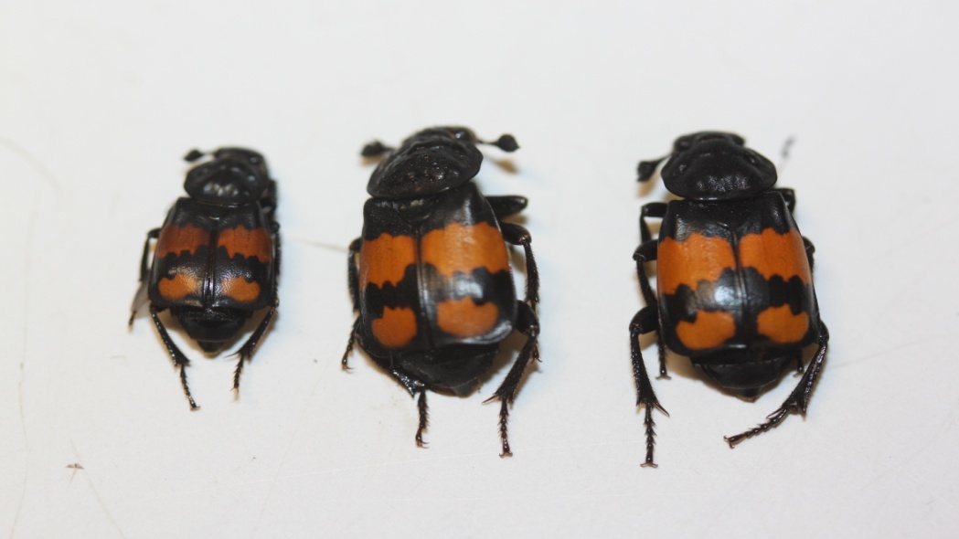

**Contents**

Page Number

Abstract........................................................................................................................3

1. Introduction..............................................................................................................4

1.1 Theories of Ageing and the Knowledge Gap...............................................4

1.2 Larval Density..............................................................................................6

1.3 The Study Species – *Nicrophorus vespilloides*............................................7

1.4 Manipulations and Predictions.....................................................................9

2. Materials and Methods...........................................................................................11

2.1 Stock Beetles Population............................................................................11

2.2 Density Treatment Set-up and Pre-adult Survival.......................................11

2.3 Adulthood Mortality Track...........................................................................14

2.4 Statistical Methods.....................................................................................15

2.4.1 Experimental Set-up.....................................................................15

2.4.2 Pre-adult Survival.........................................................................15

2.4.3 Size..............................................................................................15

2.4.4 Mortality Analysis.........................................................................16

3. Results....................................................................................................................18

3.1 Experimental Set-up..................................................................................18

3.2 Pre-adult Survival.......................................................................................18

3.3 Size............................................................................................................19

3.4 Mortality Analysis.......................................................................................20

4. Discussion..............................................................................................................25

4.1 Pre-adult Survival.......................................................................................25

4.2 Adulthood Mortality....................................................................................26

4.3 Relation to Predictions...............................................................................29

4.4 The Effect of Size......................................................................................30

4.5 Application to Ageing.................................................................................32

4.6 Future Perspectives...................................................................................33

4.7 Conclusion.................................................................................................35

Acknowledgements....................................................................................................36

References.................................................................................................................36

Appendix....................................................................................................................45

**The Effect of Larval Density on Ageing in *Nicrophorus vespilloides***

**Abstract**

Ageing is deleterious as it limits lifetime fitness. Two theories have been proposed to explain ageing: mutation accumulation and antagonistic pleiotrophy but how ageing has evolved in response to environmental influences is less well understood. An environmental influence that could be important is larval density, a measure of competition experienced during early life. Larval density of *Nicrophorus vespilloides* larvae was manipulated to create high, medium and low density broods to answer the question of what effect density has on patterns of mortality which could impact on the evolution of ageing. Survival to adulthood, size and lifespan were recorded and Cox proportional hazards model used for analysis. The experiment found that high density beetles were smaller than medium and low density beetles. High and medium density beetles did not differ in mortality risk but low density beetles showed greater mortality as adults. Selection in high and medium densities removed the weak during the larval stage resulting in only stronger beetles with low risk of mortality living to adulthood. Low density beetles had not experienced the same selective pressure, therefore weak beetles survived to adulthood. Low density beetles suffered from low pre-adult survival due to mould which killed off whole broods. It was found that larval density alters the pattern of age specific mortality and thereby the strength of selection which can potentially alter how ageing evolves. Environmental impacts, such as larval density, can therefore lead to changes in how ageing evolves and explain the incredibly varied patterns seen in nature. Future expansions could measure the deterioration of beetle physiology and use of antifungal treatments could prevent mould.

**1. Introduction**

Death is an evolutionary paradox (Partridge and Barton 1993). Long life provides more opportunities to reproduce and hence achieve greater fitness, yet natural selection has given rise to finite life-spans in the majority of species (Priest *et al.* 2002; Williams 1957). Limited life is not determined by wear and tear but by intrinsic genetic effects that should be removed by selection (Kenyon 2010; Ljubunic and Reznick 2009). What is more, death is usually preceded by “intimations of death” (Partridge and Barton 1993) where an organism experiences a marked intrinsic decline in reproductive and physiological function and an increase in the likelihood of mortality with age (Partridge and Gems 2002). This phenomenon is known as ageing or senescence.

Ageing is deleterious, as it negatively impacts on other aspects of life history, such as reproduction, and reduces the maximum potential lifetime fitness of an individual (Bonsall 2006). Despite this, all animals experience ageing, apart from a few specific cases such as the hydra (Martinez 1998; Metcalf and Pavard 2006). Ageing is clearly under the influence of selection due its common occurrence in nature, large variation between species, and the contrast of multi-cellular animals to unicellular organisms that show no signs of ageing (Charlesworth 2000; Kenyon 2010). Indeed, if primordial replicators experienced ageing then multicellular life would never have evolved (Dawkins 2006; Partridge and Barton 1993). The peculiar nature of ageing has long captured the interests of evolutionary biologists who seek to explain why ageing occurs and to understand the selective influences that have led to the incredibly diverse patterns of ageing seen in nature (Charlesworth 2000; Jones *et al.* 2014).

1.1 Theories of Ageing and the Knowledge Gap

Evolutionary theories of ageing are based on the principle that the strength of selection declines with age (Hamilton 1966). Even in the absence of ageing the strength of selection declines over time since individuals die due to stochastic environmental effects: the likelihood of surviving to age A is greater than to age A+1 (Williams 1957). The strength of selection also depends on reproductive potential since any gene expressed after reproduction will be less strongly influenced by selection as genes have already been passed on (Fisher 1930; Partridge and Barton 1996). Therefore, a deleterious mutation expressed at a young age will have a greater impact on the fitness of an organism than one expressed late in life because most carriers of the gene have already died or reproduced (Hamilton 1966; Williams 1957). To explain the occurrence of ageing, two main, non-exclusive theories have developed from this pattern of selection:

1) Mutation accumulation (MA) (Medawar 1952)

2) Antagonistic pleiotropy (AP) (Williams 1957).

MA postulates that, given selection weakens with age, genes with deleterious effects will be less efficiently purged from the population at later ages and will build up (Bonsall 2006). AP implicates the work of pleiotropic genes, which have beneficial effects early in life, but consequently have negative effects later in life (Williams 1957). Ageing then results from the preference of selection for fitness-enhancing effects during youth is at the price of deleterious consequences at an older age (Williams 1957). An example of such a gene is the insulin-like growth factor homologue (daf2) of *Caenorhabditis elegans,* the alleles of which display a negative correlation between early life fecundity and longevity (Gems *et al.* 1998) a common feature of AP (Leroi *et al.* 2005; Ljubunic and Reznick 2009).

Research based mainly on *Drosophila melanogatser* and *C. elegans* has produced support for both MA (Hughes and Charlesworth 1994) and AP (Hsin and Kenyon 1999). Although more examples of AP have been described, so have attempts to detect it (Bourke 2007; Partridge 2010). Examples outside these species are limited with scant knowledge of their effect in the wild (Leroi *et al.* 2005). Much of the research into ageing has focused on differentiating between the two theories based on the effects of single genes (Kenyon 2010; Moorad and Promlisow 2010). However, less is known about how the diverse patterns of ageing have evolved in response to environmental factors relevant to species ecology (Bonsall 2006; Carey and Judge 2001; Jones *et al.* 2014). Changes in mortality risk caused by the biological environment experienced, both competitive and cooperative, could alter how selection acts over time and lead to the evolution of varied ageing patterns (Bourke 2007; Graves and Mueller 1993). Selection will affect organisms differently depending on the environment that they experience, especially during early life (Zwaan *et al.* 1991). Organisms within a population also differ in countless ways (Vaupel and Yashin 1985) meaning that some are intrinsically more likely to succumb to the effects of selection (Williams and Day 2003). Therefore, ageing within a population is likely to be affected by selection caused by ecologically important environmental influences experienced by the members of the population early in life (Arking 1987; Ljubunic and Reznick 2009). An insightful approach to study the evolution of ageing would therefore be to observe how the environment experienced early in life leads to a response in mortality later in life (Bonsall 2006).

1.2 Larval Density

An important influence that could affect patterns of mortality later in life is the degree of competition (Bourke 2007). With a finite amount of resources, competition is inevitable (Smiseth and Moore 2002). This can lead to trade-offs in resource investment which impacts growth, reproduction and survival. For example, high investment in features that give a competitive advantage, such as weaponry, direct resources away from future investment in offspring or survival (van Noordwijk and de Jong 1986; Smiseth *et al*. 2014). However, individuals vary in their competitive ability, meaning that some are predisposed to be more susceptible to selective pressures than others (Williams and Day 2003). High competition early in life may lead to weaker organisms being selected out leaving only those more competitive ones to take advantage of the space left by others (Metcalf and Pavard 2006; Vaupel and Yashin 1985). This is known as viability selection (Zwaan *et al*. 1991). Competition is mediated by the density of organisms, with high density leading to higher levels of competition (Clare and Luckinbill 1985). Density is predicted to affect ageing, either through resource trade-offs, or through selection for competitive individuals (Graves and Mueller 1993; Zwaan *et al.* 1991), but the exact effect of density is unclear.

One aspect of density that is of particular interest in understanding how competition affects ageing is larval density (Clare and Luckinbill 1985): a measure of the number of larvae sharing a finite resource. Larval density is an early life environmental factor (Schrader *et al.* 2015) and therefore likely to lead to condition dependent selection or resource trade-offs thought to affect ageing (Bonsall 2006; Ljubunic and Reznick 2009). Previous studies have looked at the effect of larval density on various life history traits. Scott (1994) created high and low density environments for tadpoles of the salamander *Ambystoma opacum*. Those from high density suffered greater larval mortality, grew more slowly, and so took longer to reach adulthood. They were also less likely to reproduce and older at first reproduction than low density individuals (Scott 1990, 1994). All these factors impact greatly on lifetime fitness but the effect of density on longevity is unknown. Most studies, however, have been carried out using *D. melanogaster*, which shows that increased larval density leads to an increase in lifespan (Lints and Lints 1969; Miller and Thomas 1958). A similar effect has been reported in the mosquito *Aedes sierrensis* (Hawley 1985). Low larval density in *D.* *melanogaster* produces adults with greater fecundity early in life, with 22-24% more eggs laid (Leips and Mackay 2000; Clare and Luckinbill 1985), indicating a trade-off between longevity and reproduction. Clare and Luckinbill (1985) suggest that this response to low density is to take advantage of uncompetitive conditions. High larval density also results in smaller adults (Zwaan *et al.* 1991; Leips and Mackay 2000) and is correlated with decreased starvation resistance, leading to lower longevity for higher densities that suffer these conditions as adults (Baldal *et al*. 2005).

There are several problems with these studies. None of the above mentioned studies looked specifically at ageing but rather, made conclusions based on lifespan alone. Ageing is an increase in the age specific mortality risk with age (Partridge and Gems 2002) with studies generally detecting changes in the baseline risk of mortality due to treatments rather than a change in rate (Maklakov *et al.* 2007). This study, therefore, will assess differences in larval densities according to patterns and rates of mortality risk rather than lifespan. *D. melanogaster* may also be a poor species to use in order to examine ageing, due to its peculiar selective history caused by many years in the laboratory and conditions that promote shorter life-spans, increased fecundity, and inbreeding (Partridge and Barton 1993).

1.3 The Study Species – *Nicrophorus vespilloides*

The species used in this study is the burying beetle *Nicrophorus vespilloides* Herbst from the family [*Silphidae*](http://en.wikipedia.org/wiki/Silphidae) (Figure 1). *N. vespilloides* offers better opportunities than *D. melanogaster* to study the evolution of ageing because the populations used have not suffered the effects of a continual lab environment, and they also share many ecological and behavioural traits with other species, making the findings in this species more generally informative than previous studies (Scott 1998; Smiseth *et al.* 2005, 2007). Breeding methods also prevent inbreeding and do not impose any selection on lifespan or the timing of reproduction. Recent work on *N. vespilloides* (e.g. Smiseth et al. 2005, 2007, 2014) has greatly increased our knowledge of this species, making studies easier than ever before.

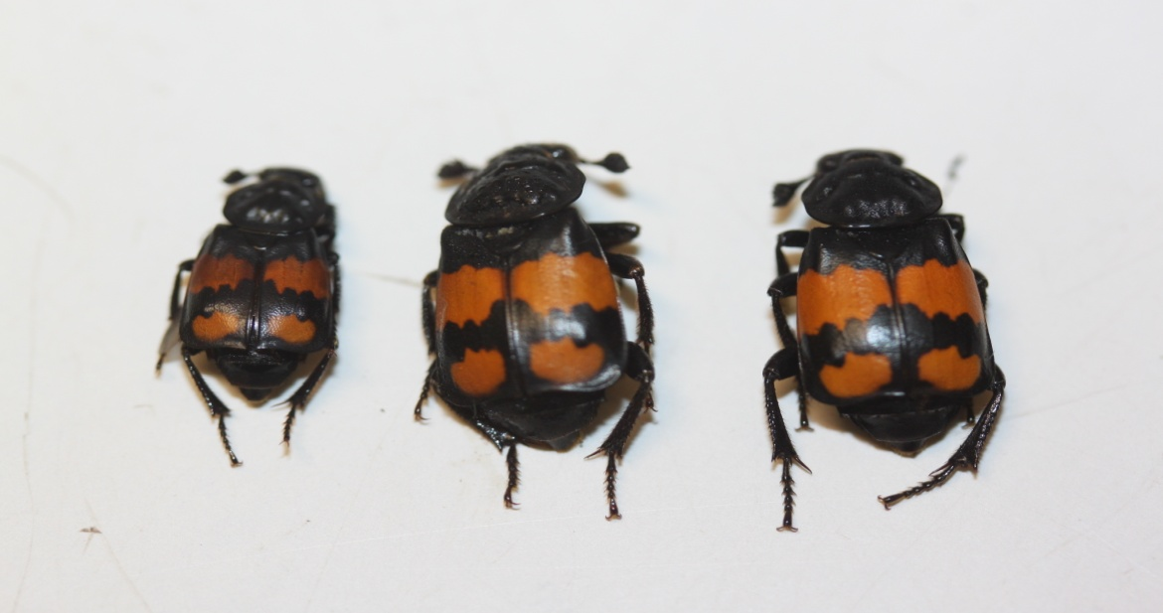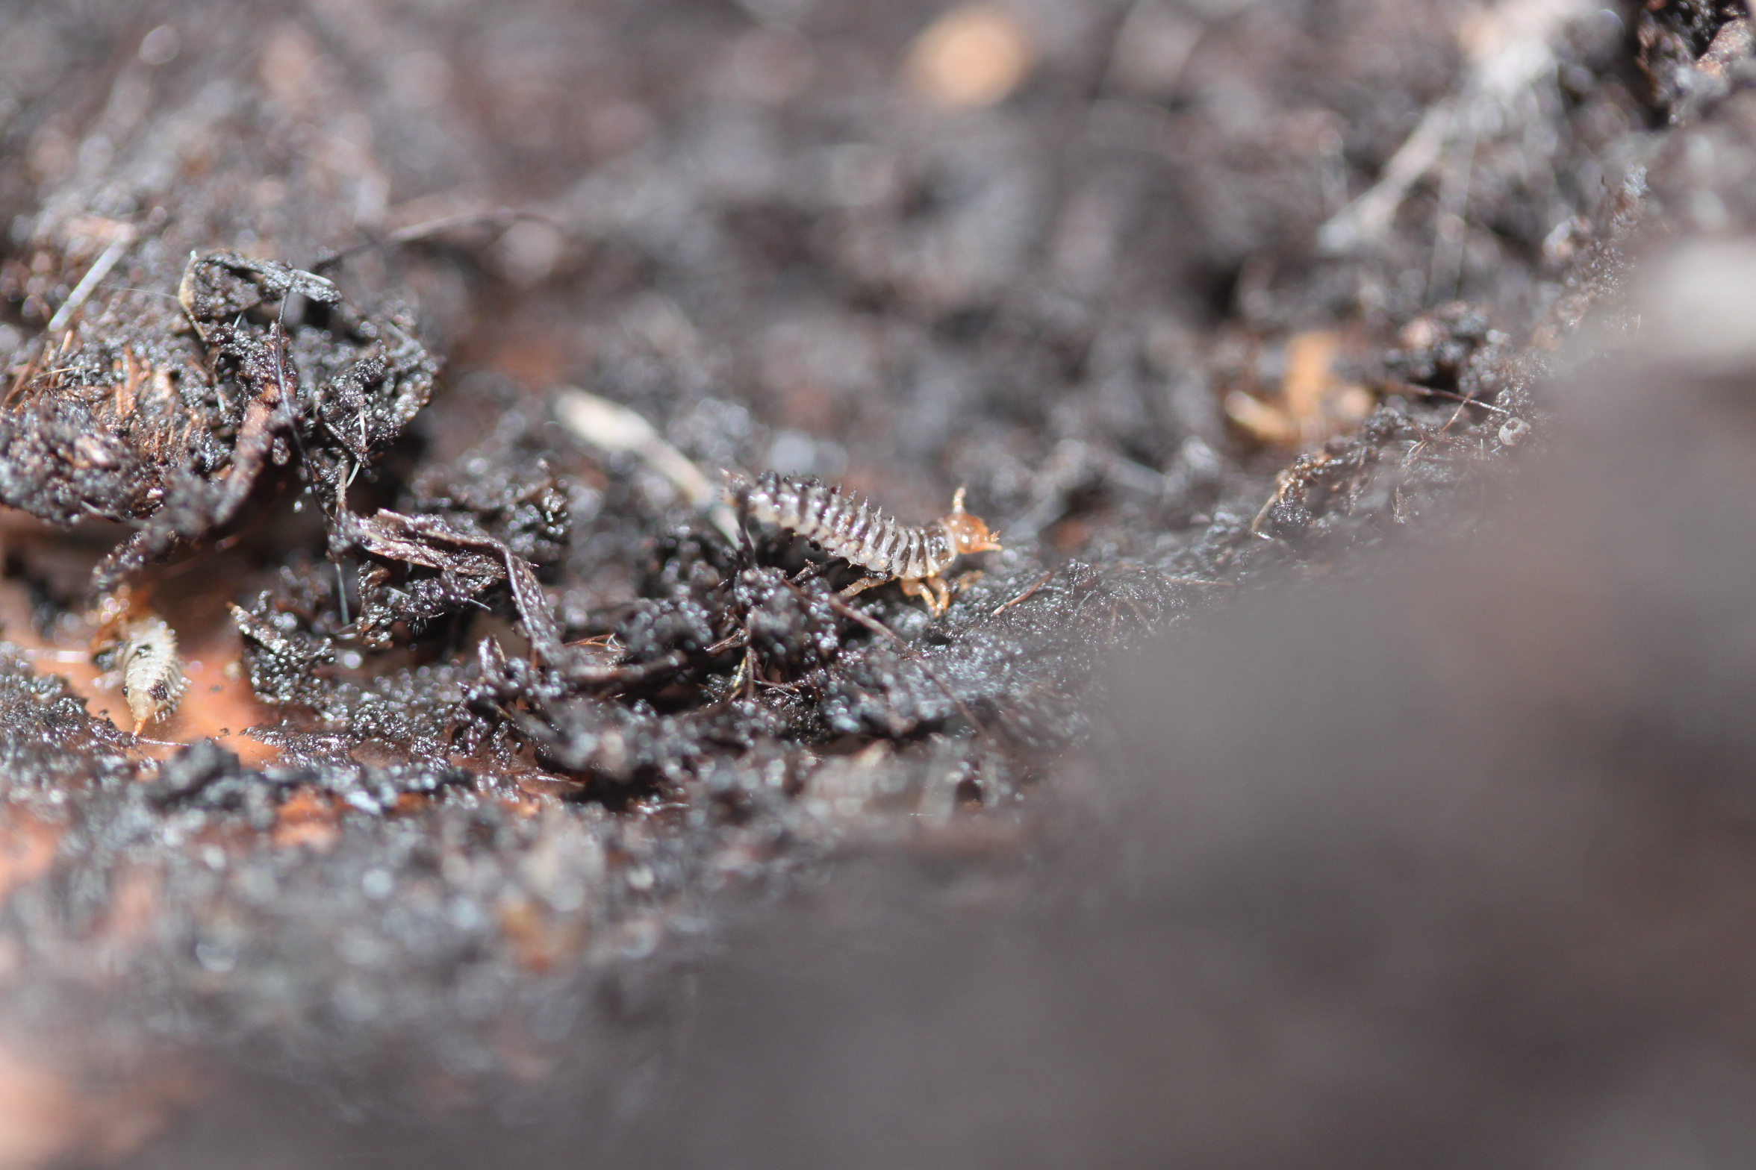

Figure 1 – adult male *N. vespilloides* (right) and first instar larvae (left). Both photos taken by M. Jardine (right: 31/03/2015; left: (03/02/2015).

*N. vespilloides* is a common species found across North-western Europe (Scott 1998). Adults fight for possession of a small vertebrate carcass, which a male and female then bury in the soil (Pukowski 1933). The carcass is then prepared by stripping it of fur or feathers and covering it with secretions to slow the rate of decomposition (Arce *et al.* 2012). Eggs are laid in the surrounding soil before the larvae hatch and make their way to the carcass (Pukowski 1933). The carcass represents the sole source of food for the larvae (Müller *et al.* 1990) so is crucial for the beetle’s reproduction. Unusually for insects, both parents help to feed the larvae although one parent can rear larvae just as effectively (Eggert *et al.* 1998; Smiseth *et al.* 2005). Larvae spend only 6-7 days on the carcass before dispersing to pupate in the soil over about three weeks before emerging as adults (Pukowski 1933). *N. vespilloides* practices the peculiar behaviour of filial cannibalism (Bartlett 1987). Parents often kill larvae if there are too many for the carcass to sustain, therefore maximising the use of the limited food resource while controlling the level of competition that the larvae experience (Trivers 1974; Schrader *et al.* 2015; Smiseth *et al.* 2007). This natural tendency of parents to manipulate larval density illustrates its significance for the species and makes *N. vespilloides* an ideal species with which to study the effects of larval density.

1.4 Manipulations and Predictions

In this study the density of *N. vespilloides* larvae has been manipulated to produce populations of beetles raised under one of three density treatments: high density, low density, and medium density, to act as a control. Larvae were raised without parents to prevent any control of density by filial cannibalism. Previous work has shown that larvae are still able to survive and reach adulthood in the absence of parents (Bartlett 1987; Eggert *et al.* 1998). Larval survival from each treatment was measured and each individual beetle followed from eclosion until death to measure lifespan, which was then converted to mortality rate. A Gompertz function (Gompertz 1825) was used to test for the increase in mortality with age. A Cox proportional hazard (PH) model (Cox 1972) and mortality plots were used to precisely identify where differences in mortality lay and examine possible causes. Size is a very important trait in *N. vespilloides* (Bartlett 1988) and has been shown to respond to density (Hawley 1985). Some studies have also detected an effect of body size on longevity (Fox *et al.* 2004) and therefore adult size was also measured.

The aim is to manipulate larval density to observe how this impacts on mortality risk throughout the life of the population. Comparing the differences in mortality risk between different larval densities will answer the question of what effect larval density has on adulthood mortality in this species. This will provide better information as to how ageing has evolved in response to environmental influences such as competition, and improve the understanding of the evolution of ageing.

A number of potential scenarios can be envisaged. These potential outcomes are not mutually exclusive, but they will help to interpret the results of this study.

1) Frailty and heterogeneity

Individuals differ in their ability to compete on the carcass with some being naturally stronger than others. Stronger competitors will not only survive the larval stage but will live longer as a result of naturally being fitter while the weak perish during the larval stage (Vaupel and Yashin 1985; Zwaan *et al.* 1991). Higher larval density will result in greater larval mortality but also in reduced adult mortality risk. Low density beetles will display higher mortality risk earlier as they have not endured the harsh selective pressures of high density, therefore naturally weaker individuals will make it to adulthood, but die early.

2) Competitive costs

Competition while a larva may lead to costs that have detrimental effects on survival later in life. There are two ways this may manifest: a resource trade-off or a genetic trade-off. A resource trade-off comes from investment in competitive actions while a larva leaves fewer resources to invest in later life (van Noordwijk and de Jong 1986). A genetic trade-off is based on Williams (1957) AP theory where fitter larva would make poorer adults due to pleiotropic gene effects in different somatic environments. Both predict that treatments with the highest larval mortality will show the highest rates of adulthood mortality since they have experienced the greatest costs of competition. A resource trade-off will see increased mortality across the adult lifespan whereas an AP scenario will see an elevated risk of mortality in the early adult stages for those that experience high larval mortality. Size will also be affected with a negative correlation between density and size.

3) Dietary restriction

It has been observed in many animal species that a reduction in the amount of food consumed leads to increased longevity (Mair *et al.* 2005). Therefore, restrictions in food available due to competition while a larva may reduce mortality in adulthood (Baldal *et al.* 2005). If this occurs in the beetles no difference in larval mortality is expected between treatments, but high density will lead to a reduced risk of mortality through adulthood. Size and density will show a negative relationship.

4) Trade-offs of other traits

It is possible that larval density will have no effect on ageing at all. Body size is well documented as being important in *N. vespilloides* ecology and vitality important to fitness (Bartlett 1988; Scott 1998; Trumbo 1990a). Competition will cause an inverse relationship between density and body size, with no difference in ageing between the three larval density treatments.

**2. Materials and Methods**

2.1 Stock Beetle Population

Parental beetles were taken from an out-bred lab population kept at the University of Edinburgh. The lab population is composed of crossbred descendants from three collections of wild caught beetles from: Corstorphine Hill, Edinburgh; Craiglockhart Hill, Edinburgh; and Warmond, the Netherlands. Mating in the lab population was strictly controlled to prevent inbreeding; only unrelated individuals were allowed to mate. Beetles were housed individually in transparent plastic containers, 12x8x2cm, with a lining of damp soil 1cm deep. They were kept at 200C in constant light, and fed small (<0.2cm3) cubes of raw organic beef twice a week.

2.2 Density Treatment Set-up and Pre-adult Survival

The study was established with four replicate blocks (A-D) each starting with 25 pairs of parental beetles. The blocks were set up at roughly weekly intervals. The methods detailed below were applied to each block with any deviation between blocks noted.

50 virgin beetles (25 males and 25 females) were chosen from the lab population to serve as parents. Beetles were chosen from across the range of beetles available with no more than two sibling beetles from each stock family used in the whole study in order to maximise the genetic variation. Male and female beetles were paired up and their histories checked to avoid inbreeding. Each pair was then presented with a fresh mouse carcass in a transparent plastic box, 17x12x6cm, lined with 1cm of damp soil (Figure 2). The mass of each mouse carcass was recorded to standardise mass around 20g (mean 20.6±0.718g; range=19.35-21.67), similar to the mass used in other studies (Smiseth *et al.* 2005, 2007; Steiger 2013). This process produced 25 boxes of paired beetles, each with a 20g mouse carcass. Parents then proceeded to mate, lay eggs, and prepare the carcass. Boxes were checked regularly over the next 2-3 days until first instar larvae appeared, at which point the parents were removed from the boxes. This was to prevent filial cannibalism by parents (Bartlett 1987) and prevent any confounding effects from parental feeding (Smiseth and Moore 2004) but the time in the box with the carcass was long enough for parents to create a hole in the carcass, which is essential for larval feeding (Eggert *et al.* 1998).

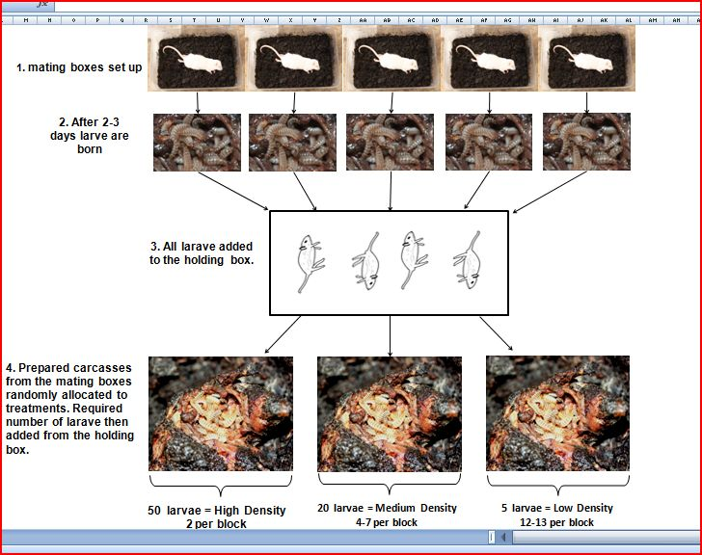

Figure 2 – layout of methods used to set up the density treatments. The diagram above shows 5 mating boxes in step 1 but in each block 25 were used. Prepared carcasses came from the mating boxes with their surrounding soil replaced. All photos by M. Jardine (13/02/2015)

First instar larvae were removed from the prepared mouse carcasses with a paintbrush and placed onto thawed fresh mice in a ‘holding box’ (Figure 2). The holding box was lined with moist paper towel to prevent larvae drying out (Lock *et al.* 2007; Smiseth *et al.* 2007), and the fresh mice were cut open to provide a source of food. All larvae were less than 16 hours old and spent a maximum time of 1 hour in the ‘holding box’. The carcasses of breeding attempts which had failed to produce any larvae at this stage, were removed and no longer used. After all larvae from carcasses were removed and placed in the ‘holding box’, the soil from each mating box where the carcass had been successful in producing larvae was replaced to remove un-hatched eggs, as these could alter numbers on the carcass later in the experiment. Each prepared mouse carcass was then randomly assigned to be the host to one of three larval density treatments:

* high density of fifty larvae per carcass;
* medium density of twenty larvae per carcass
* low density of five larvae per carcass.

The medium density acted as a control based on the average number of larvae expected to be raised on a 20g carcass when density is controlled by parents (Bartlett and Ashworth 1988; Müller *et al.* 1990). The high and low density treatments are extremes of variation seen in the lab (Smiseth and Moore 2002). In each block the treatments were allocated thus: 2 high density carcasses; 4-7 medium density carcasses; 11-13 low density carcasses. Although the numbers of each treatment differed it was predicted, based on previous lab work, that these numbers would produce a similar number of adult beetles (Eggert *et al.* 1998; Schrader *et al.* 2015). The number of each treatment varied slightly between each block of the experiment, depending on the number of successful mouse carcasses and the number of larvae available (Table 1).

Table 1 - set up of the number of each larval density treatment within each block.

|  |  |  |  |  |
| --- | --- | --- | --- | --- |
| **Block** | **High** | **Medium** | **Low** | **Total carcasses used** |
| A | 2 | 7 | 12 | 21 |
| B | 2 | 6 | 11 | 19 |
| C | 2 | 4 | 13 | 19 |
| D | 2 | 5 | 13 | 20 |

Once the treatment for each carcass had been decided, the appropriate number of larvae from the holding box was added to create a mixed artificial brood. Attempts were made to separate siblings to prevent them all being added to the same carcass as this would confound genetic effects with that of the treatment. Since siblings tended to huddle together, when allocating larvae to treatments, larvae were taken from across the box rather than from any one area. Once all larvae were added, the boxes were labelled with the treatment that had been applied to the brood. All broods were raised in the absence of parents and were left for 5-7 days until the larvae stopped feeding and dispersed from the carcass. The larvae were then removed and the number that survived till dispersal was recorded. Not all carcasses were successful in producing larvae due to them being overrun with mould. Therefore, it was noted how many larvae survived to dispersal from each carcass and if the carcass was infected by mould. Larvae from each brood were then placed into new plastic boxes measuring 18x12x7cm, filled to the top with damp soil and left for 21 days to pupate.

2.3 Adult Mortality Track

After this time the beetles began to eclose as adults. The number of beetles surviving to this stage was recorded to give both a measure of survival to adulthood for each brood and density. Every beetle was then sexed before being placed in its own individual transparent plastic box measuring 12x8x2cm, with a 1cm layer of damp soil. Beetles were then assigned an ID number, which specified its block, the larval density treatment it experienced, the replicate of that treatment, the number assigned to that beetle within its brood, its sex, and the date of eclosion.

Adult beetles were kept in constant light at 200C. Boxes were placed randomly onto shelves within each block to control for any effects due to position. All beetles were checked for survival three times a week at intervals of 2, 2, and 3 days. On 2 of these days they were fed a small (<0.2cm3) cube of organic beef. Any mould was removed and dry boxes were re-moistened with water from a spray bottle. If a beetle was found dead, it was removed from its box and placed in an Eppendorf tube with the beetle’s ID label and date of death added to the outside. The date of death was recorded for each beetle and the tubes placed in the freezer. Adult lifespan was calculated as the number of days between eclosion and the day the beetle was found dead.

Frozen beetles were later removed from the freezer for measuring. Freezing made the beetles easier to measure and allowed large numbers to be measured at once, therefore minimising measurement errors between days. Using a pair of digital callipers, the length of the beetle’s pronotum was recorded. This is a measurement of total beetle’s size (Bartlett 1988; Steiger 2013).

2.4 Statistical Methods

All statistics were carried out in R version 3.1.3 (R Core Team 2015). A number of different statistical analyses were performed to investigate the following aspects.

2.4.1 Experimental Set-up

The carcass mass data from the study was analysed to check that neither the treatments nor the four blocks differed systematically in the way they were set up. Since density is measured as the number of larvae per gram of carcass (Müller *et al.* 1990) it was essential that carcass mass did not differ across treatments or blocks. A general linear model (Glm) was used including Block and Density as factors along with their interaction. Also included was whether the carcass was successful in producing at least one larva that lived to adulthood or whether the carcass was overcome with mould and all larvae died. Once the maximal model had been produced, it was simplified by removing the most non-significant term each time until the minimal model was produced.

2.4.2 Pre-adult Survival

Not all larvae survived to adulthood. A Chi-square test was performed to check if survival to adulthood differed between density treatments. The test counted the number originally allocated to each treatment compared to the number that eclosed as adults. Those missing were counted as dead. Another Chi-square test was used to analyse whether a particular density treatment was more likely to succumb to the effects of the fungus than others. This counted the number of infected versus non-infected carcasses per treatment.

2.4.3 Size

Using pronotum length as a proxy for size, a Glm analysed the variance of size across larval density treatments, blocks, and between males and females. All these factors were included as terms in the model, along with their interactions. If a term was found to be non-significant, it was removed until the minimal model was attained.

2.4.4 Mortality Analysis

A Cox proportional hazards model (Cox 1972) was used to detect and describe differences in mortality caused by larval density and the other variables in the study: sex, length, and block. The population must show an increase in age specific mortality risk with age (ageing) and proportional hazards (PH) for this model to be appropriately applied (Grambsch and Therneau 1994). The data was right censored since not all beetles died within the study period. A Chi-square test was used to check that the number of males and females did not differ from 50:50.

First, a mortality plot was created for all beetles to test for the occurrence of ageing. A simple Cox PH model was created for lifespan incorporating censoring with no explanatory variables. A Kaplan-Meier function (Kaplan and Meier 1958) was then applied in order to produce a survival curve for the data. From this, Lx (proportion of the total population surviving to each age class) was calculated, which was, in turn used to calculate the age specific mortality, Px (the proportion of those alive at age A surviving to age A+1). Mortality rate, µx, was then calculated using the formula -ln (Px) and plotted on a log scale against lifespan in weeks to create a mortality plot. To test for ageing in this population of beetles the fit of exponential (no increase in mortality risk with age) and Gompertz (increase in mortality risk with age) (Gompertz 1825) models were compared using their Akaike information criterion (AIC) values (Akaike 1974). The slope of the Gompertz function provided the rate of ageing.

A preliminary Cox PH model was used to detect factors that caused differences in mortality. Larval density, block, length, and sex were all included in the model applied to lifespan and censoring. If a term was found to be non-significant it was removed from the model until a minimal model was produced. The results of this model revealed which factors caused differences in mortality risk and ageing.

Mortality plots were constructed the same way as above for each larval density treatment. Again these were tested for ageing by comparing the fit of the exponential and Gompertz functions. These mortality curves graphically illustrated both the pattern of mortality risk and where it differed between densities across the lifespan of the beetles. The mortality plots of each density were then tested for PH (Grambsch and Therneau 1994) referred to later as a PH test. To analyse differences in ageing caused by density between specific pairs of treatments, and resolve the issue of non-proportional hazards, a series of paired comparisons were carried out. Each paired comparison was executed using the Cox PH model, which included larval density treatment as an explanatory variable for lifespan, and each time a violation of PH was also tested for. These models revealed whether the two densities differed systematically in their mortality risk and whether this result violated the model’s assumptions of PH. For high-low and medium-low combinations the population was split into those that died when 4 weeks or younger (young) or those older than 4 weeks (old). This was to analyse the differences between density treatments in mortality risk seen in the mortality plots. Finally, due to problems of power in some of these paired comparisons, high and medium density beetles were pooled together and compared to low density beetles in the same way as before. This analysed the specific difference in mortality risk of low density beetles compared to high and medium density beetles.

**3. Results**

Out of a total of 100 matings, 79 produced 1st instar larvae that could be used in the study. The 79 mouse carcasses from these matings became host carcasses for larval density treatment. The number of carcasses that could be used in each block was approximately equal with blocks A-D producing 21, 19, 19, and 20 carcasses respectively (Table 1). In total, 1090 larvae were allocated to treatments.

3.1 Experimental Set-up

The average carcass mass was 20.6±0.718g (range=19.35-21.67). The mouse carcass mass did not differ between blocks (Glm, block main effect: F3, 66 = 2.096, p = 0.109) or the three larval density treatments (Glm, density main effect: F2, 66 = 0.077, p = 0.926) and there was no interaction between density or block (Glm, density block interaction: F6, 66=1.093, p=0.376). The success of a carcass to produce at least one offspring did not alter with carcass mass either (Glm, success difference: F1, 66=0.73, p=0.394).

3.2 Pre-adult Survival

Larval density affected how many larvae survived to adulthood (Chi-square, survival to adulthood: X2=62.686, df=2, p<0.0005) (Table 2). Those larvae from the low density treatment were the least likely to survive to adulthood (64.4% survival) followed by larvae from the high density treatment (75.75% survival). The greatest likelihood of survival was in larvae from the medium density treatment (89.95% survival). Low density carcasses were more likely to succumb to infection by mould (Chi-square, mould infection: X2=7.824, df=2. p=0.02). Mould infection caused all or all but one larva to die before adulthood and only low density carcasses were infected.

Table 2 – larval survival from each larval density treatment showing the number alive at adulthood compared to those that died.

|  |  |  |  |
| --- | --- | --- | --- |
| **Density** | **No. Alive** | **No. Dead** | **% Survival** |
| High | 303 | 97 | 75.75 |
| Medium | 394 | 46 | 89.95 |
| Low | 158 | 87 | 64.4 |

3.3 Size

Data on size were available from the 730 beetles that died during the study period. Pronotum length varied between beetles (range: 2.41-4.5mm) with an average size of 3.78±0.375mm. Beetles from the high larval density treatment were smaller as adults than those beetles from medium or low density treatments who did not differ (Glm, density main effect: F2, 717=129.374, p=<0.0005) (Figure 3) (mean pronotum length: high= 3.528±0.363mm; medium=3.918±0.261mm, low=3.938±0.317mm). The males are larger than females (Glm, sex main effect: F1, 717=7.028, p=0.008) (males=3.825±0.395mm; females=3.753±0.349mm) (Figure 4). The effect of sex did not vary depending on the density (Glm, sex density interaction: F2, 712=0.054, p=0.948) or block (Glm, sex block interaction: F3, 717=0.756, p=0.519). Block had an effect on size (Glm, block main effect: F3, 717=9.341, p<0.0005) with block B beetles the smallest and block D beetles the largest (mean pronotum length: A=3.778±0.381mm; B=3.721±0.363mm; C=3.814±0.38mm; D=3.876±0.395mm; range=0.155mm) (Figure 5). Differences in size between density treatments were marginally non-uniform across blocks (Glm, density block interaction: F6, 717=2.12, p=0.049).

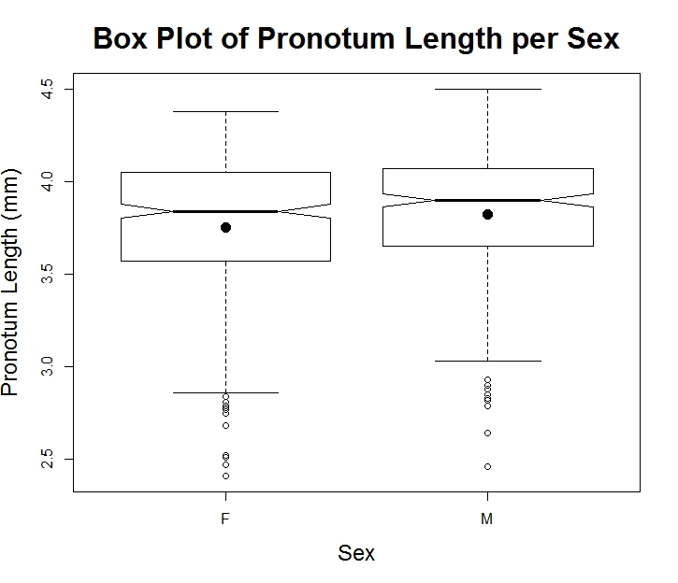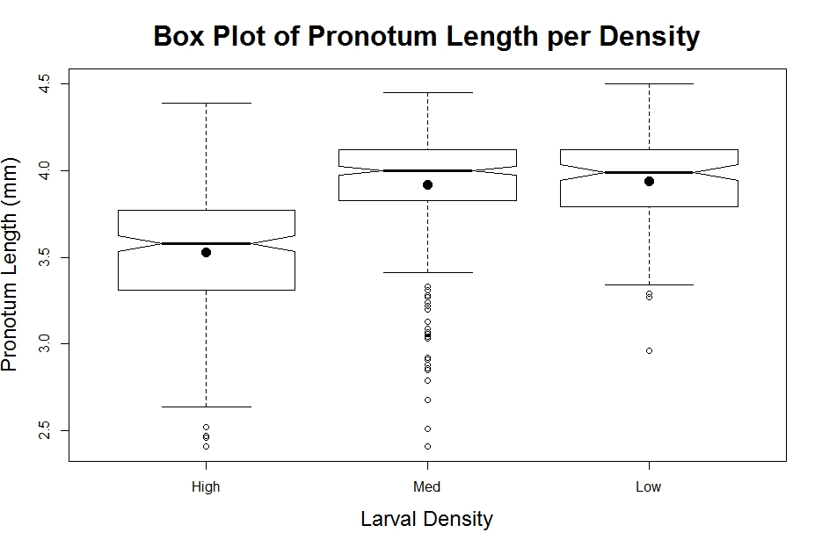

Figure 4 – box plot of pronotum length for the two sexes. Black dots are the means for each sex. Although not too dissimilar, males have larger pronotum lengths than females.

Figure 3 – box plot of pronotum length for each larval density treatment. Black dots are the means of each density. From the means and notch overlap, pronotum length of high density beetles is smaller than the other two densities which are of roughly equal size.

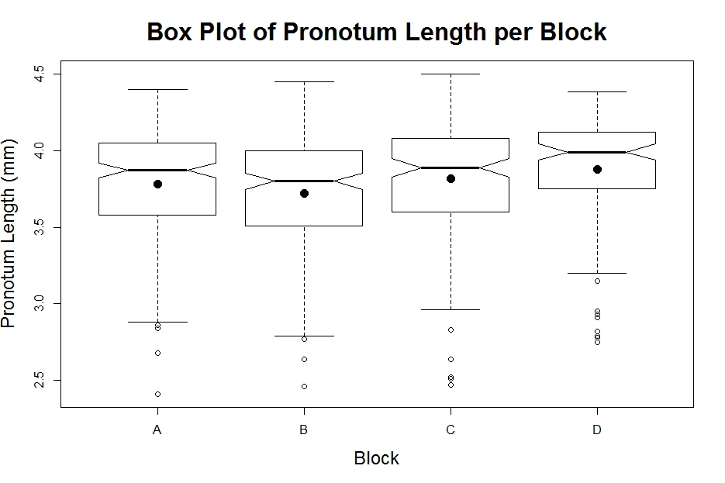

3.4 Mortality analysis

Figure 5 – box of pronotum length for each block. Black dots are the means for each block. Beetles from all blocks are similar sizes although block D beetles are slightly larger and block B beetles smaller.

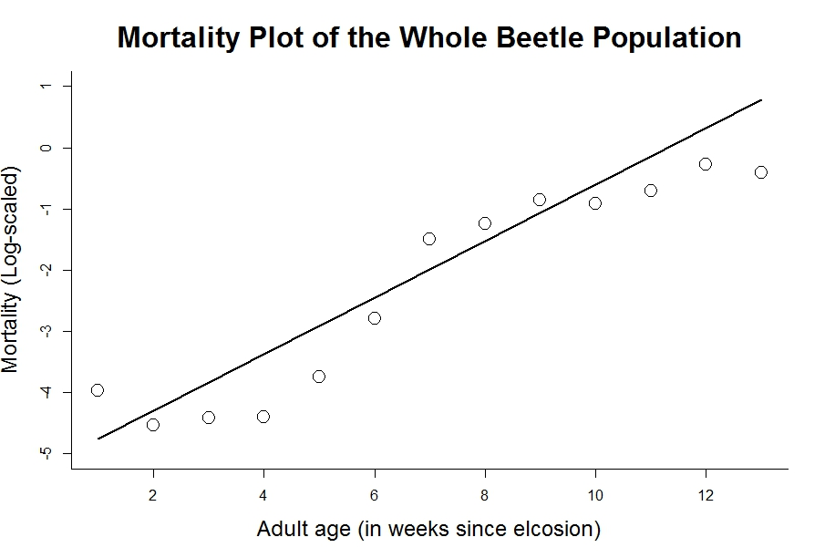855 beetles survived to adulthood and were included in the mortality track (high=303 beetles; medium=394beetles; low=158 beetles). The proportion of males and females did not differ from equality (Chi-square, sex difference: X2=2.368, df=1, p=0.124) (405 males and 450 females). From the original population, 730 (85.4%) beetles died within the study period of 91 days; 7 escaped; and 118 were still alive. There was an increase in mortality risk with age in the beetle population (Figure 6). Comparing exponential and Gompertz models showed a better fit for the Gompertz model (exponential: AIC=4796.929; Gompertz: AIC=3643.072).

Figure 6 – mortality plot for all beetles over thirteen weeks since eclosion. The solid line is a Gompertz function fitted to the data. Mortality is calculated from the –ln of Px, the age specific risk of mortality. The increase in mortality over time and the fit of the Gompertz function show that the population is ageing.

The Cox PH model compares the levels of each factor to a reference level (Muenchow 1986). Where comparisons are made the reference level of the comparison is stated first. The hazard ratio is the difference in mortality risk of one level compared to the reference level, with the reference level being equal to 1. The initial Cox PH model (Table 3) showed no effect of length (Cox PH, length: Hazard ratio=1.047, 95%CI=0.812-1.349, p=0.723), or of sex (Cox PH, Female-Male: Hazard ratio=0.964, 95%CI=0.832-1.116, p=0.656) on patterns of mortality. Hence, these factors were not included in any further models or analysis. Low density beetles had higher mortality than both high density (Cox PH, high-low: Hazard ratio=1.399, 95%CI=1.134-1.728, p=<0.002) and medium density (Cox PH, medium-low: Hazard ratio=1.302, 95%CI=1.064-1.593, p=0.01) beetles. Medium and high density beetles did not differ in their mortality risk (Cox PH, high-medium: Hazard ratio=1.075, 95%CI=0.913-1.267, p=0.386). Mortality risk differed between blocks. While beetles from blocks A and C did not differ (Cox PH, A-C: Hazard ratio=0.891, 95%CI=0.724-1.095, p=0.271), block B had a greater mortality risk (Cox PH, A-B: Hazard ratio=1.224, 95%CI=1.015-1.475, p=0.034) and block D a lower mortality risk (Cox PH, A-D: Hazard ratio=0.537, 95%CI=0.429-0.67, p<0.0005). The results of this model are summarised in Table 3. A full description of pair-wise block differences is provided in the Appendix.

Table 3 – detailed statistics of the initial Cox PH model. The left hand column provides the explanatory variable of the mortality observed. Where appropriate a comparison is given for the variable with the reference level given first. Only a subset of block comparisons is included for the differences to be shown. For a full description see the Appendix. P-values <0.05 are indicated by *

|  |  |  |  |  |
| --- | --- | --- | --- | --- |
| **Explanatory variable of mortality** | | **Hazard Ratio** | **95% Confidence Intervals** | **p-value** |
| Pronotum Length | | 1.047 | 0.812-1.35 | 0.723 |
| Sex | Female-Male | 0.964 | 0.832-1.116 | 0.656 |
| Male-Female | 1.034 | 0.892-1.198 | 0.6577 |
| Density | High-Low | 1.399 | 1.302-1.728 | <0.002* |
| High-Medium | 1.075 | 0.913-1.267 | 0.386 |
| Medium-Low | 1.302 | 1.064-1.593 | 0.01* |
| Block | A-B | 1.224 | 1.0154 – 1.475 | 0.034* |
| A-C | 0.891 | 0.7244 – 1.095 | 0.271 |
| A-D | 0.537 | 0.429 – 0.67 | <0.0005* |

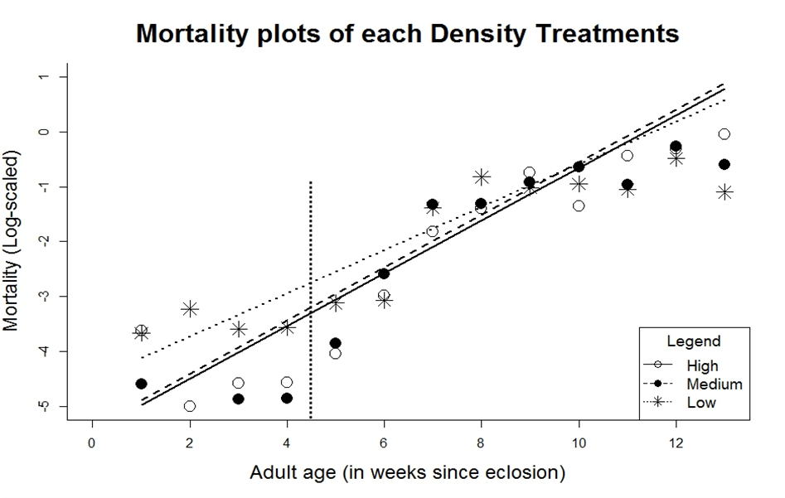 Mortality curves constructed for each density are shown in Figure 7. Each density showed an increase in mortality risk with age and produced a better fit for the Gompertz rather than the exponential functions (High: exponential AIC=1681.478, Gompertz AIC=1267.633; Medium: exponential AIC=2255.733, Gompertz=1667.033; Low: exponential AIC=862.388, Gompertz=704.263). A test for proportional hazards showed that PH were not present between the three density treatments (PH test, high-medium-low: X2=6.609, df=2, p=0.037). Although high and low densities did show PH (PH test, high-medium: X2=0.713, df=1, p=0.399) the deviation from PH came from the low density treatment (PH test, high-low: X2=6.498, df=1, p=0.011; medium-low: X2=3.963, df=1, 0.047).

Figure 7 – mortality plots of each of the three larval density treatments. All show an increase in mortality over time and have been fitted with a straight line of a Gompertz function. Low density beetles show an elevated mortality early in life compared to the other two but all have similar rates late in life. The dotted line at around 4 weeks is the boundary between the young and old beetles used in later comparisons.

In light of the results of Figure 7, and the violation of PH assumptions, each pair of density treatments was analysed separately. As before the high and medium treatments did not differ in their mortality risk (Cox PH, high-medium: hazard ratio=1.137, 95%CI=0.966-1.337, p=0.123) and showed PH (PH test, high-medium: X2=0.861, df=1, p=0.354). A comparison between low and medium density displayed no difference in mortality (Cox PH, low-medium: hazard ratio=0.85, 95%CI=0.696-1.039, p=0.11) but these two densities had marginally non-proportional hazards (PH test, low-medium: X2=3.97, df=1, p=0.046). Splitting this comparison into young (<31 days) and old beetles (>30 days) led to PH being restored in the old beetles (PH test, old low-old medium: X2=0.232, df=1, p=0.63) with no difference in mortality (Cox PH, old low-old medium: hazard ratio=0.949, 95%CI=0.767-1.175, p=0.633). The same was true for young beetles with no effect of density on mortality (Cox PH, young low-young medium: hazard ratio=0.881, 95%CI=0.442-1.755, p=0.718) and PH (PH test: X2=0.009, df=1, p=0.923). The comparison of high and low density beetles revealed a higher mortality for low density beetles (Cox PH, high-low: hazard ratio=1.334, 95%CI=0.108-1.647, p=0.007) but this came with a violation of PH (PH test: high-low: X2=6.32, df=1, p=0.012). Splitting into young and old age categories resolved PH for young beetles (PH test, young high-young lowX2=0.265, df=1, p=0.607) with no effect of density on mortality (Cox PH, young high-young low: hazard ratio=0.575, 95%CI=0.295-1.121, p=0.104). The situation for old beetles was less clear with both the effect of density (Cox PH, old high-old low: hazard ratio=1.25, 95%CI=0.998-1.564, p=0.052) and the presence of PH (PH test, old high-old low: X2=3.86, df=1, p=0.049) around the significance threshold of 0.05. Pooling high medium density beetles to compare them to low density beetles showed that those of low density had a greater mortality risk (Cox PH, high/medium-low: hazard ratio=1.246, 95%CI=1.032-1.503, p=0.0219) with only a slight violation of PH (PH test, high/medium-low: X2=3.87, df=1, p=0.049). A summary of all the various comparisons and their supporting statistics are shown in Table 4.

Table 4 – a summary of the Cox PH model results run to test for differences in mortality between pair-wise comparisons between density treatments and of the test of PH in those models. Results that indicate a difference are shown in italics. Those with a * are p-values <0.05 and those with ** are marginal results.

|  |  |  |  |  |  |  |
| --- | --- | --- | --- | --- | --- | --- |
|  | | **Cox proportional hazards model** | | | **Test for proportional hazards** | |
| **Comparison** | | **Hazard Ratio** | **95% Confidence intervals** | **p-value** | **X2 ratio** | **p-value** |
| high-medium | | 1.137 | 0.966-1.337 | 0.123 | 0.861 | 0.354 |
| low-medium | Total | 0.85 | 0.696-1.039 | 0.11 | 3.97 | 0.046* |
| Young | 0.881 | 0.442-1.755 | 0.718 | 0.009 | 0.923 |
| Old | 0.949 | 0.767-1.175 | 0.633 | 0.232 | 0.63 |
| high-low | Total | 1.334 | 1.081-1.647 | 0.007* | 6.32 | 0.012* |
| Young | 0.575 | 0.295-1.121 | 0.104 | 0.265 | 0.607 |
| Old | 1.25 | 0.988-1.564 | 0.052** | 3.86 | 0.049** |
| high/medium-low | | 1.246 | 1.032-1.503 | 0.022* | 3.87 | 0.049** |

**4. Discussion**

Since no difference was observed in carcass mass across either densities or blocks, it is concluded that the procedure of allocating carcasses to treatments was appropriate and consistently applied. Such a process prevented any confounding effects due to differences in carcass mass, and made measurements of larval density consistent across treatments. Carcass mass can affect the number and size of eggs laid (Bartlett 1987; Fox and Czesak 2000), with egg size positively correlated with fitness in *N. vespilloides* (Monteith *et al.* 2012). The average mass of 20.6±0.718g is similar to that used in previous studies (Smiseth *et al.* 2007, Steiger 2013) and to the mass of carcasses buried in nature (Scott 1998; Trumbo 1990b). Therefore, acknowledging the influence of carcass mass in *N. vespilloides* reproduction results here are comparable to those from other studies, and to the wild (Bartlett and Ashworth 1988).

4.1 Pre-adult Survival

The survival of larvae to adulthood was found to be different between the three larval density treatments (Table 2). High density beetles displayed lower pre-adult survival than those from the medium density treatment. Most likely, this was caused by greater competition for food, resulting in weaker larvae being outcompeted and starving (Mock and Parker 1998). The carcass is a finite resource. Any increase in density results in less food being available for all, and therefore in selection for the strongest competitors (Graves and Mueller 1993; Zwaan *et al.* 1991). An unexpected result was the far lower survival from the low density treatment. This cannot be explained as a result of competition but is more likely a consequence of the absence of sibling cooperation (Mathevon and Charrier 2003; Schrader *et al.* 2015).

The main determinant of low survival in the low density treatment was the presence of mould on the carcass, which led to some broods being unsuccessful in producing any adults. Only low density broods were affected by mould causing all, or all but one larva to die. Thus, most larval deaths in low densities were due to the infection of the carcass by mould, which took over and killed off all or nearly all of the larvae. If broods infected by mould were excluded from the analyses, the survival of larvae from low density exceeds that of the medium density treatment. Preventing the growth of mould is very important for adult burying beetles (Halffter *et al.* 1983; Wilson and Fudge 1984) and parents secrete substances across the carcass to prevent its growth (Arce *et al.* 2012). Larvae produce the same substances (Arce *et al.* 2013), therefore more larvae are better able keep the carcass clear of mould, forming a kind of social immunity where larvae benefit from the presence of others (Cotter and Kilner 2010). Thus, the larvae have a mutually beneficial effect on each other (West *et al.* 2007). Eggert *et al.* (1998) observed that larvae that huddle together have a better chance of survival. This can explain why the survival of low density beetles was so poor in the larval stage. Recently, Schrader *et al.* (2015) uncovered a shift from cooperation at low densities to competition at high density in *N. vespilloides*. While competition is low in low density, larvae also suffer from a lack of cooperation to prevent the external effect of mould wiping out the entire brood. Therefore, those that survived did not suffer from competition, as did beetles from the other two densities. Medium density beetles experience a balance between cooperation and competition, therefore, they have the greatest larval survival rates.

4.2 Adulthood Mortality

The better fit to the data of the Gompertz model over the exponential model showed that the risk of mortality increased with age (Figure 6). It can therefore be concluded that ageing occurs in this population of beetles, since mortality risk increases with time (Hamilton 1966; Metcalf and Pavard 2006). The log mortality rate flattens off and increases only gradually after 10 weeks. This is seen in other insects, such as mosquitoes (Clements and Paterson 1981), and is caused by most beetles having died by this stage, leaving only a few beetles living to such great ages (Vaupel *et al.* 1979; Zens and Peart 2003). The Gompertz function also produced a better fit for each density when plotted separately, illustrating that ageing was present in all treatments (Figure 7).

The initial Cox PH model using data from all beetles showed no effect of pronotum length on mortality (Table 3), and the result concurs with previous measures of longevity in *N. vespilloides* (Bartlett and Ashworth 1988). However, studies in other species often find a positive relationship between size and longevity (Fox *et al.* 2004; Hawley 1985; Leips and Mackay 2000). This may represent a species difference or it could be because other studies measured lifespan, whereas here, age specific mortality risk was used. The lack of any effect of sex on mortality was expected because of the absence of sexual dimorphism and because both parents care for the offspring (Bourke 2007, Lee 2003). Block effects were surprising, since all were set up identically. These could be the result of environmental effects, such as temperature, or differences in genetic variation between parent beetles in each block, or a combination of both of these. However, since the effect of block did not affect that of density, conclusions about the effect of density are not confounded.

The Cox PH model showed that low density beetles had a far higher risk of adulthood mortality than medium or high density beetles. There was no difference between high and medium density beetles. The mortality plots in Figure 7 provide information about when the differences in mortality occur. Low density beetles have higher mortality in their first 4 weeks of adult life. Mortality was similar at later ages, indicating a maximum rate of death in the population, but by this stage, very few low density beetles were still alive. From Figure 7, we see that the mortality rate does not differ between the density treatments from 6 weeks onwards, indicating a similar rate of ageing. This trend of similar ageing rates but with a difference in the level of baseline mortality is seen in other insect species (Jones *et al.* 2014; Maklakov *et al.* 2007). The straight lines of the Gompertz model, however, were fitted across the entire 13 week period of adult life rather than from the onset of ageing at 5-6 weeks, which gives the appearance of a slightly lower overall rate of ageing in the low density beetles (Figure 7). This led to a lack of PH between all three densities across their lifetime and therefore the assumptions of the Cox model were violated (Grambsch and Therneau 1994).

In an attempt to resolve this result, and to quantify the differences in mortality, pair-wise comparisons of density treatments were carried out using the Cox PH model. High and medium groups showed PH and confirmed previous results with no difference in mortality due to density. The sample size of the high-medium comparison (697 beetles) was high enough to give confidence in this result. Comparing low and medium beetles showed no effect of density on mortality, while high and low beetles did show a difference caused by density but with a violation of PH. This result seems very odd given that high and medium are almost identical in their mortality trajectories in Figure 7, and showed no difference when they were compared. There are fewer low density beetles, so this problem arises from splitting the population into smaller groups for comparisons and thereby decreasing the total sample size, which results in a loss of statistical power. The ability of the models to then detect an effect is compromised and the risk of a type 2 error is high. For this same reason, when comparisons of high-low and medium-low were split into young and old categories to analyse the difference in low density mortality, seen in Figure 7, the sample sizes were too small for the Cox PH model to give any faith in the results. For example, only 11 beetles from medium density died before 5 weeks. This explains the contradictory outputs from these comparisons but means that little confidence can be put in the outputs (Table 4). To combat this, high and medium beetles were combined into a single class, since they don’t differ in mortality risk, to compare them to the low density treatment. Low density beetles were shown to have a mortality risk 1.246 times greater than the other two treatments with only a marginal violation of PH. This violation is so small, and the model robust enough from using so many beetles, that we can be confident in the assertion that low larval density led to higher mortality in adult beetles.

From these results, it can be concluded that beetles that experience low larval density have a greater risk of mortality as adults, and therefore will have a lower expected longevity than medium or high density beetles. This finding is supported by previous work on *Drosophila* that showed that flies from high density larval groups had greater longevity (Leips and Mackay 2000; Lints and Lints 1969; Miller and Thomas 1958). Longevity is predicted to be related to fitness because the longer an organism lives, the greater fitness it can attain through reproduction (Partridge and Barton 1993; 1996). Since *N. vespilloides* is multivoltine (Scott 1998), this assumption is likely to be valid. Given that beetles from low density treatments are more likely to die earlier than beetles from high and medium density, and that it can take a long time to find and secure a carcass (Scott 1998; Trumbo 1990a), low density beetles will have a reduced chance of finding one in their lifetime. They will also be less likely to survive to raise a brood in this time. Therefore, beetles raised under low density larval conditions will suffer from reduced fitness.

4.3 Relation to Predictions

The data most strongly supports prediction 1 that differences in mortality and patterns of ageing are the result of larval frailty and heterogeneity. The basis for this is evident when comparing high density beetles to the medium control. High density beetles suffer greater losses while larvae as individuals compete for limited food. Some larvae will be better competitors than others so that weaker larvae will starve and be selected out of the population as result of viability selection (Graves and Mueller 1993; Zwaan *et al*. 1991). The strong ones then live to adulthood. A once heterogeneous population of strong and weak individuals now only contains the stronger ones that are intrinsically fitter and thus persist for a long time with a low risk of mortality (Vaupel and Yashin 1985). Medium density also resulted in some selection for stronger larvae, though not as intense as high density broods. High and medium beetles, therefore, have very similar patterns of ageing as a result of getting rid of their weakest individuals (Figure 8) (Metcalf and Pavard 2006).

Figure 8 – diagram of the fitness distributions versus numbers of the three larval density treatments. Fitness ranges from high (+) to low (-) with fitter individuals having a lower intrinsic likelihood of mortality. Points H and M are the cut off points of selection during the larval stage for high and medium densities respectively. Those beetles represented to the left of points H and M e are very unfit beetles that would have died early in adulthood anyway. Low density does not have this selective pressure and therefore weak beetles survive to adulthood.

Low density beetles that survive to adulthood have not suffered this competitive environment, thus weaker individuals can become adults (Vaupel and Yashin 1985; Zens and Peart 2003). They then suffer from a greater risk of intrinsic mortality while young adults (Zwaan *et al.* 1991) (Figure 7). However, low density beetles also show low larval survival, a fact that contradicts the idea of selection against the frail. As discussed above, this is because of a lack of cooperation to prevent whole broods being destroyed, so that, those that do survive, have not experienced competition. If failed broods had similar rates of larval survival to the successful broods then the survival rate of the low density treatment would have exceeded that of the medium density treatment. Hence, the reduced survival of the low density larvae was due to a lack of social immunity against mould (Cotter and Kilner 2010) and not competition. Therefore, the conclusion that the different patterns of mortality between beetles raised under different larval densities results in overall greater mortality risk for beetles from low density, is due to selection against frail individuals in higher density treatments, is one that is consistent with these data (Graves and Mueller 1993; Williams and Day 2003). The lower fitness of low density broods appears to be an Allee effect. An Allee effect is a situation where density is correlated with fitness (Stephens *et al.* 1999) which here describes the difference between low and medium densities.

4.4 The Effect of Size

It would seem logical therefore for *N. vespilloides* to evolve a larval density similar to that of the high density treatment as this would produce more larvae (Bourke 2007; Trivers 1974) at no cost of higher adulthood mortality and increased effect of ageing (Priest *et al.* 2002). However, ageing is only one aspect of fitness (Bonsall 2006; Ljubunic and Reznick 2009). An important result from the study is that beetles from the high density treatment tend to eclose as smaller adults (see Figures 3 and 9). The main determinant of size at adulthood is the food attained by the larvae (Lock *et al.* 2007). Therefore, beetles from high density suffered a much higher level of competition and consumed less food per individual. There was no difference in size between medium and low density beetles, which were 11.07% and 11.6% larger than the high density beetles, respectively (Figures 3 and 9). The greater competition experienced by the medium density beetles did not prevent their final adult size reaching that of the low density. There was still plenty carcass remaining for low density beetles to eat at dispersal, indicating that food availability was not restricted for these larvae. The medium and low density beetles are at the upper limit of the size range observed in laboratory studies (Bartlett 1988; Steiger 2013), so that the investment of any more resources into size may be constrained, and both medium and low density beetles were able to reach the same size despite differences in competition. A sex difference in size had not previously been reported for this species (Bartlett and Ashworth 1988; Smiseth and Moore 2004) though sexes do differ for other traits,such as parental care (Eggert *et al.* 1998; Smiseth *et al.* 2005). However, since the difference was very small (<0.1mm; Figure 4) and fights only occur between members of the same sex (Pukowski 1933) this is unlikely to be of much relevance. Similarly, block effects on size is so small (range=0.1555mm, Figure 5) that no difference is predicted in their ability to win fights and carcasses (Bartlett 1988; Trumbo 1990a).

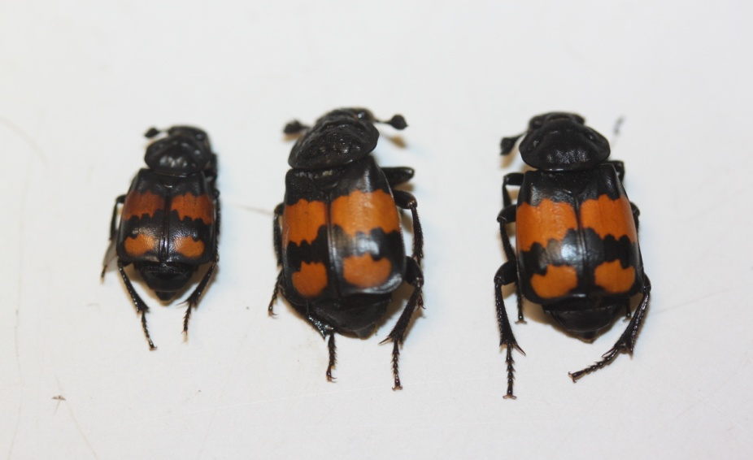

Figure 9 – photo of single beetles from each density treatment. Beetles are from left to right: high, medium and low densities. The high density beetle is much smaller than the other two. Photo by M. Jardine (31/03/2015)

Body size is the dominant factor for *N. vespilloides* reproduction (Bartlett and Ashworth 1988). Breeding is limited by finding corpses on which to breed, with fierce competition to take control of these (Pukowski 1933; Scott 1998). Fights are almost exclusively won by the larger individual, so that, smaller beetles may never be able to reproduce, as they cannot secure a carcass for long enough (Bartlett 1988; Müller *et al.* 2007). This situation leads smaller beetles to adopt alternative tactics to reproduce, such as sneaker males and parasitic females, which both lead to lower fitness than larger resident beetles (Müller *et al.* 2007). Even if they can secure a carcass this will be because of perseverance rather than competitive ability, thus beetles will likely be older. Age is linked to the ability of beetles to provide adequate parental care with older beetles being less effective than the younger ones (Lock *et al.* 2007). Smaller females lay fewer (Bartlett and Ashworth 1988) and smaller eggs (Steiger 2013), an effect seen in many insect species (Fox and Czesack 2000). Egg size is correlated with increased fitness in *N. vespilloides* (Monteith *et al.* 2012). A recent study by Steiger (2013) has also shown that larger mothers are better at caring for offspring by increasing larval mass and thereby improve larval survival and fitness.

The detrimental effects on fitness that come with small size mean that those beetles from high density are likely to be less fit than those from medium density despite similar rates of mortality. It is therefore important to consider other traits as well as ageing. From a combination of mortality risk and selection on size the medium density beetles are most likely to be fittest under natural conditions. They do not suffer from the high levels of mortality as low density beetles do but they are also large enough not to suffer from the costs of small body size. This density was chosen as it approximates to the average brood size raised when parents are present (Smiseth and Moore 2002; Smiseth *et al.* 2007). By managing larval density through filial cannibalism (Bartlett 1987; Trumbo 1990b) parents can manage their offspring to become larger while also allowing selection against poor competitors to minimise adulthood mortality and maximise fitness (Clare and Luckinbill 1985; Trivers 1974; Zwaan *et al.* 1991). Larval density can thereby influence the evolution of ageing by altering the patterns of adulthood mortality.

4.5 Application to Ageing

Ultimately, ageing is caused by genes with deleterious effects late in life that accumulate due to decreased selection strength over time (Hamilton 1966). However, ageing is expected to evolve in response to the environment affecting selection during early life (Bonsall 2006; Ljubunic and Reznick 2009). Larval density is such an environmental effect, important to species ecology, that can lead to differences in selection depending on the level of competition experienced (Graves and Mueller 1993). Here, competition amongst larvae removes weak competitors through viability selection leaving only the fitter individuals who also have reduced mortality risk as adults (Zwaan *et al.* 1991). Adults that have not experienced competition as larvae have not been subject to the same condition dependent selection and thus display an elevated risk of mortality (Metcalf and Pavard 2006; Vaupel and Yashin 1985). Low larval density alters the pattern of age specific mortality and thereby the strength of selection which can potentially alter the evolution of ageing (Bourke 2007; Hamilton 1966). By taking into account the differences between individuals, selection can alter patterns of mortality later in life, depending on the environment experienced early in life (Vaupel *et al.* 1979; Williams and Day 2003). Therefore, environmental impacts, such as larval density, can lead to changes in how ageing evolves (Clare and Luckinbill 1985) and explain the diverse patterns seen in nature (Partridge and Gems 2002), reflecting how influences experienced early in life at the level of the individual can determine patterns of mortality at the population level (Graves and Mueller 1993; Leips and Mackay 2000). It is not possible to arrive at such an insight by the study of single gene effects in model organisms (Kenyon 2010; Partridge 2010), nevertheless, potentially, it provides a better understanding of how the variation in patterns of ageing have evolved (Jones *et al.* 2014).

Previous work on model organisms has focused on the trade-off between reproduction and longevity to support a picture of antagonistic pleiotropy (AP) (Leroi *et al.* 2005). Less was known about how aspects of species ecology cause variation in age specific mortality and thereby the evolution of ageing (Bonsall 2006). This study builds on previous work of density and lifespan (Clare and Luckinbill 1985) to fill this gap and it creates a better understanding of how ageing has evolved (Partridge and Gems 2002). Most former studies have used typical lab organisms, such as *D. melanogaster* and *C. elegans* (Kenyon 2010), which have peculiar evolutionary histories and genetics (Partridge and Barton 1993). *N. vespilloides* has only recently been collected from the field and thereby more accurately represents the ageing response of a wild animal (Ljubunic and Reznick 2009). With more sophisticated social behaviour than *D. melanogaster*, *N. vespilloides* is more easily relatable to other species (Bourke 2007). Studying different species is insightful since the patterns of ageing may be uniquely different between species (Charlesworth 2000; Jones *et al.* 2014).

4.6 Future Perspectives

The work could be extended in future studies by resolving the issue of mould for low density carcasses, for example, by using an anti-fungal treatment. This would remove the potentially confounding effect of the mould, which destroys broods, and would also confirm that the conclusions reached in the present study are correct. Ageing involves deterioration in physiology and bodily function over time (Partridge and Barton 1993). To investigate this phenomenon, a series of experiments on *N. vespilloides* could measure the performance of adults over their lifetime to record how these will deteriorate with time (Reznick *et al.* 2004). An example of one such study, is a trial that was attempted involving measuring the speed with which beetles could re-bury themselves when placed in bright light, since beetles will naturally avoid light and dig into the soil. This experiment could not be effectively carried out during the time available, although it could be included in future studies to supplement the data on age specific mortality and create a better picture of ageing in this species. An interesting feature of previous work has been the interaction between larval density, body mass, and starvation resistance which show that detrimental effects of high larval density only come into effect when the population is stressed, for example, through lack of food (Baldal *et al.* 2005). This could be studied through food stressing the beetles during their adult life. Such a study could also look at the effects of dietary restriction more directly and examine how interactions between environmental factors affect ageing.

The location of the lab changed during the study period, and time was spent adjusting the new lab conditions to mirror those of the old lab. Since beetles were of different ages when they were moved, this factor could explain the differences in mortality observed between blocks. The beetles were kept in constant light at 200C but *N. vespilloides* is usually a nocturnal animal (Pukowski 1933) with a northern distribution (Scott 1998) where the temperature would only occasionally reach 200C, let alone be constant. Future experiments incorporating variation in temperature and more natural light conditions would address all of these noted issues, and could investigate whether they also have an impact on ageing. Hawley (1985) showed that the effect of larval density on lifespan in mosquitoes varied between the lab and the field, with a need for field studies on ageing acknowledged to make studies more widely applicable (Leroi *et al.* 2005; Ljubunic and Reznick 2009). As Trumbo documents, field-work with *N. vespilloides* is very challenging (1990a, b), and it limits our understanding of lab work with this species in a real-world context, although recent developments using molecular markers have shown field-work is possible and worthwhile exploring further in the future (Müller *et al.* 2007). Measurements of larval mass at dispersal and mass of the carcass remaining at this time would be good to record in future to gain a measurement of food consumption and more accurately quantify larval competition. Previous study (Clare and Luckinbill 1985) has also identified a trade-off between longevity and reproduction that could be investigated in *N. vespilloides* while also involving the effect of density. One final improvement to the current study to mention, is to simply replicate more blocks to increase the sample size. When the population was split to look for specific differences between groups the power of the statistical analysis dropped, dramatically increasingly the type 2 error rate. Having more beetles would increase the sample size and improve the confidence in our results.

4.7 Conclusion

The larval density of *N. vespilloides* on mouse carcasses was manipulated in order to test for its effect on ageing. Increased larval density led to more competition which in turn led to condition dependent viability selection being enforced on the beetles, which produced adults with a lower risk of intrinsic mortality. Low density beetles had not experienced the effects of competition, thus they suffered a greater baseline risk of mortality than high and medium density beetles (Figure 7). It is concluded that this was due to frailer beetles not being selected out at the larvae stage in low density treatments, and therefore becoming adults with a greater risk of intrinsic mortality and an implied lower fitness. As high density beetles are smaller, hence less fit as adults, it appears that selection has influenced larval density to create an optimal size approximately similar to the medium density treatment used in the experiment, where both ageing and size are optimized. By considering how environmental factors like larval density affect lifetime mortality through selection early in life, we can place ageing in a more practical framework that incorporates aspects of species ecology, both competitive and cooperative, to produce a better understanding of the evolution of ageing.

**Acknowledgements**

I would like to thank Dr Jacob Moorad for introducing me to the interesting field of the evolution of ageing, and for his attentive and helpful supervision of my research project. The project benefited from his help with the use of R and his constructive critical comments, particularly in respect of statistical analyses. I am indebted to Ashleigh Whiffin for introducing me to the beetles, and without whom I would not have been able to carry out the experiments. I was assisted in the project by numerous helpful discussions with zookeeper Lucy Carter, and I would like to record her assistance with R. Lastly, I wish to thank Lucy Ford and Ed Ivimey-Cook who helped to make the long hours in the lab bearable, and to thank them for their advice on all things beetles related.

**References**

Akaike, H. 1974. A new look at the statistical model identification. *Automatic Control, IEEE Transactions on* 19(6): 716–723

Arce, A. N., Johnston, P. R., Smiseth, P. T. and Rozen, D. E. 2012. Mechanisms and fitness effects of antibacterial defences in a carrion beetle. *Journal of Evolutionary Biology* 25: 930–937

Arce, A.N , Smiseth, P.T. and Rozen, D.E. 2013. Antimicrobial secretions and social immunity in larval burying beetles, *Nicrophorus vespilloides*. *Animal Behaviour* 86: 741–745

Arking, R. 1987. Successful selection for increased longevity in *Drosophila*: analysis of the survival data and presentation of a hypothesis on the genetic regulation of longevity. *Experimental Gerontology* 22: 199–220

Baldal, E.A., van der Linde, K., van Alphen, J.J.M., Brakefield, P.M. and Zwaan, B.J. 2005. The effects of larval density on adult life-history traits in three species of *Drosophila*. *Mechanisms of Ageing and Development* 126: 407–416

Bartlett, J. 1987. Filial cannibalism in burying beetles. *Behavioural Ecology and Sociobiology* 21: 179–183

Bartlett, J. 1988. Male mating success and paternal care in *Nicrophorus vespilloides* (Coleoptera: *Silphidae*). *Behavioural Ecology and Sociobiology* 23: 297–303

Bartlett and Ashworth, C.M. 1988. Brood size and fitness in *Nicrophorus vespilloides* (Coleoptera: *Silphidae*). *Behavioural Ecology and Sociobiology* 22: 429–434

Bonsall, M.B. 2006. Longevity and ageing: appraising the evolutionary consequences of growing old. *Philosophical Transactions of the Royal Society B* 361: 119–135

Bourke, A.F.G. 2007. Kin selection and the evolutionary theory of aging. *Annual Review of Ecology, Evolution, and Systematics* 38: 103–128

Carey, J.R. and Judge, D.S. 2001. Life span extension in humans is self-reinforcing: a general theory of longevity. *Population and Development Review* 27(3): 411–436

Charlesworth, B. 2000. Fisher, Medawar, Hamilton and the evolution of aging. *Genetics* 156: 927–931

Clare, M.J. and Luckinbill, L.S. 1985. The effects of gene-environment interaction on the expression of longevity. *Heredity* 55: 19–29

Clements, A.N. and Paterson, G.D. 1981. The Analysis of Mortality and Survival Rates in Wild Populations of Mosquitoes. *Journal of Applied Ecology* 18: 373–399

Cotter, S. C., and R. M. Kilner. 2010. Personal immunity versus social immunity. *Behavioural Ecology* 21: 663–666.

Cox. D.R. 1972. Regression models and life-tables (with discussion). *Journal of the Royal Statistical Society* *Series B* *(Methodological)* 34: 187–220

Dawkins, R. 2006. *The Selfish Gene*. 30th Anniversary Edition. Oxford University Press. Oxford pp. 13–20

Eggert, A., Reinking, M. and Müller, J.K. 1998. Parental care improves offspring survival and growth in burying beetles. *Animal Behaviour* 55: 97–107

Fisher, R.A. 1930. *The Genetical Theory of Natural Selection.* Oxford University Press, Oxford.

Fox, C.W. and Czesak, M.E. 2000. Evolutionary Ecology of Progeny Size in Arthropods. *Annual Review of Entomology* 45: 341–369

Fox, C.W., Czesak, M.E. and Wallin, W.G. 2004. Complex genetic architecture of population differences in adult lifespan of a beetle: nonadditive inheritance, gender differences, body size and a large maternal effect. *Journal of Evolutionary Biology* 17: 1007–1017

Gems, D., Sutton, A.J., Sundermeyer, M.L., Albert, P.S., King, K.V., Edgley, M.L., Larsen, P.L. and Riddle, D.L. 1998. Two pleiotropic classes of daf-2 mutation affect larval arrest, adult behavior, reproduction and longevity in *Caenorhabditis elegans*. *Genetics* 50: 129–155

Gompertz, B. 1825. On the nature of the function expressive of the law of human mortality, and on a new mode of determining the value of life contingencies. *Philosophical Transactions of the Royal Society of London* 115: 513–583

Grambsch, P.M. and Therneau, T.M. 1994. Proportional hazards tests and diagnostics based on weighted residuals. *Biometrica* 81(3): 515–526

Graves Jr, J.L. and Mueller, L.D. 1993. Population density affects on longevity. *Genetica* 91: 99–109

Halffter, G., Anduaga, S. and Huerta, C. 1983. Nidification de Nicrophorus. *Bulletin de la Société entomologique de France* 88: 648–666

Hamilton, W.D. 1966. The moulding of senescence by natural selection. *Journal of Theoretical Biology* 12: 12–45.

Hawley, W.A. 1985. The effect of larval density on adult longevity of a mosquito, *Aedes sierrensis*: epidemiological consequences. Journal of Animal Ecology 54(3): 955–964

Hsin, H. and Kenyon, C. 1999. Signals from the reproductive system regulate the lifespan of *C. elegans*. *Nature* 399: 362–366

Hughes, K.A. & Charlesworth, B. 1994. A genetic analysis of senescence in *Drosophila*. *Nature* 367: 64–66.

Jones, O.R, Scheuerlein, A., Salguero-Gómez, R., Camarda, C.G., Schaible, R., Casper, B.B., Dahlgren, J.P., Ehrlén, J., García, M.B., Menges, E.S., Quintana-Ascencio, P.F., Caswell, H., Baudisch, A. and Vaupel, J.W. 2014. Diversity of ageing across the tree of life. *Nature* 505: 169–173

Kaplan, E.L. and Meier, P. 1958. Nonparametric Estimation from Incomplete Observations. *Journal of the American Statistical Association* 53(282): 457–481

Kenyon, C.J. The genetics of ageing. *Nature* 464: 504–512

Lee, R.D. 2003. Rethinking the evolutionary theory of aging: transfers, not births, shape senescence in social species. *PNAS* 100(16): 9637–9642

Leips, J. and Mackay, T.F.C. 2000. Quantitative trait loci for life span in *Drosophila melanogaster*: interactions with genetic background and larval density. *Genetics* 155: 1773–1788

Leroi, A.M., Bartke, A., Benedictis, G.D., Franceschi, C., Gartner, A., Gonos, E., Feder, M.E., Kivisild, T., Lee, S., Kartal-O¨ zer, N., Schumacher, M., Sikora, E., Slagboom, E., Tatar, M., Yashin, A.I., Vijg, J. and Zwaan, B. 2005. What evidence is there for the existence of individual genes with antagonistic pleiotropic effects? *Mechanisms of Ageing and Development* 126: 421–429

Lints, F.A. and Lints, C.V. 1969. Influence of preimaginal environment on fecundity and ageing in *Drosophila melanogaster* hybrids. I. Preimaginal population density. *Experimental Gerontology* 4: 231–244.

Ljubuncic, P. and Reznick, A.Z. 2009. The Evolutionary Theories of Aging Revisited – A Mini-Review. *Gerontology* 55: 205–216

Lock, J.E., Smiseth, P.T., Moore, P.J. and Moore. A.J. 2007. Coadaptation of prenatal and postnatal maternal effects. *The American Naturalist* 170(5): 709–718

Mair, W., Piper, M.D.W. and Partridge, L. 2005. Calories do not explain extension of life span by dietary restriction in *Drosophila*. PLoS *Biol* 3(7): e223

Maklakov, A.A., Fricke, C. and Arnqvist, G. 2007. Sexual selection affects lifespan and aging in the seed beetle. *Aging Cell* 6: 739–744

Martinez, D.E. 1998. Mortality patterns suggest a lack of senescence in Hydra. *Experimental Gerontology* 33: 217–225

Mathevon, N. and Charrier, I. 2003. Parent–offspring conflict and the coordination of siblings in gulls. *Proceedings of the Royal Society of London B* 271:S145–S147

Medawar, P.B. 1952. *An unsolved problem in Biology.* H.K. Lewis. London.

Metcalf, C.J.E and Pavard, S. 2006. Why evolutionary biologists should be demographers. *TRENDS in Ecology and Evolution* 22(4): 205–212

Miller, R.S. and Thomas, J.L. 1958. The effects of larval crowding and body size on the longevity of adult *Drosophila melanogaster*. *Ecology* 39: 118–125.

Mock, D.W. and Parker, G.A. 1998. Siblicide, family conflict and the evolutionary limits of selfishness. *Animal Behaviour* 56:1–10

Monteith, K.M., Andrews, C. and Smiseth, P.T. 2012. Post‐hatching parental care masks the effects of egg size on offspring fitness: a removal experiment on burying beetles. *Journal* *of Evolutionary Biology* 25: 1815–1822.

Moorad, J.A. and Promislow, D.E.L. 2009. What can genetic variation tell us about the evolution of senescence? *Proceedings of the Royal Society B* 276: 2271–2278

Muenchow, G. 1986. Ecological use of failure time analysis. *Ecology* 67: 246–250

Müller, J.K., Eggert, A. and Furlkroger, E. 1990. Clutch size regulation in the burying beetle *Necrophorus vespilloides* Herbst (Coleoptera: *Silphidae*). *Journal of Insect Behaviour,* Vol. 3(2): 265–270

Müller, J.K., Braunisch, V., Hwang, W. and Eggert, A. 2007. Alternative tactics and individual reproductive success in natural associations of the burying beetle, *Nicrophorus vespilloides*. *Behavioural Ecology* 18: 196–203

Partridge, L. 2010. The new biology of ageing. *Proceedings of the Royal Society B* 365: 147–154

Partridge, L. and Barton, N.H. 1993. Optimality, mutation and the evolution of aging. *Nature* 362: 305–311

Partridge, L. and Barton, N.H. 1996. On Measuring the Rate of Ageing. *Proceedings of the Royal Society London B* 263(1375): 1365–1371

Partridge, L and Gems, D. 2002. Mechanisms of aging: Public or Private? *Nature Reviews* 3: 165–175

Priest, N.K., Mackowiak, B. and Promislow, D.E.L. 2002. The role of parental age effects on the evolution of aging. *Evolution* 56(5): 927–935

Pukowski, E. 1933. Ökologische Untersuchungen an *Necrophorus* F. *Zeitschrift fur Morphologie und Oekologie der Tiere* 27(3): 518–586

R Core Team. 2015. R: A language and environment for statistical computing. R Foundation for Statistical Computing, Vienna, Austria. URL http://www.R-project.org/

Reznick, D.N., Bryant, M.J., Roff, D., Ghalambor, C.K. and Ghalambor, D.E. 2004. Effect of extrinsic mortality on the evolution of senescence in guppies. *Nature* 431: 1095–1099

Schrader, M., Jarrett, B.J.M. and Kilner, R.M. 2015. Parental care masks a density-dependent shift from cooperation to competition among burying beetle larvae. *Evolution* doi:10.1111/evo.12615

Scott, D.E. 1990. Effects of larval density in *Ambystoma opacum*: an experiment in large-scale field enclosures. Ecology 71: 296–306.

Scott, D.E. 1994. The effect of larval density on adult demographic traits in *Ambystoma opacum. Ecology* 75(5): 1383–1396

Scott, M.P. 1998. The ecology and behaviour of burying beetles. *Annual Review of Entomology* 43: 595–618

Smiseth, P.T. and Moore, A.J. 2002. Does resource availability affect offspring begging and parental provisioning in a partially begging species? *Animal Behaviour* 63: 577–585

Smiseth, P.T. and Moore, A.J. 2004. Behavioral dynamics between caring males and females in a beetle with facultative biparental care. *Behavioural Ecology* 15(4): 621–628

Smiseth, P.T., Dawson, C., Varley, E. and Moore, A.J. 2005. How do caring parents respond to mate loss? Differential response by males and females. *Animal Behaviour* 69: 551–559

Smiseth, P.T., Lennox, L. and Moore, A.J. 2007. Interaction between parental care and sibling competition: parents enhance offspring growth and exacerbate sibling competition. *Evolution* 61(10): 2331–2339

Smiseth, P.T., Andrews, C.P. Mattey, S.N. and Mooney, R. 2014. Phenotypic variation in resource acquisition influences trade-off between number and mass of offspring in a burying beetle. *Journal of Zoology* 293: 80–83

Steiger, S. 2013. Bigger mothers are better mothers: disentangling size-related prenatal and postnatal maternal effects. *Proceedings of the Royal Society B* 280: 20131225

Stephens, P.A., Sutherland, W.J. and Freckleton, R.P. 1999. What Is the Allee Effect? *Oikos* 87: 185–190

Trivers, R. L. 1974. Parent-offspring conflict. *American Zoologist* 14: 249–64

Trumbo, S.T. 1990a. Reproductive benefits of infanticide in a biparental burying beetle *Nicrophorus orbicollis.* *Behavioural Ecology and Sociobiology* 27: 269–273

Trumbo, S.T. 1990b. Regulation of Brood Size in a Burying Beetle, *Nicrophorus tomentosus* (Silphidae) *Journal of lnsect Behavior,* 3(4): 491–500

van Noordvijk, A.J. and de Jong, G. 1986 Acquisition and allocation of resources: their influence on variation in life history tactics. *American Naturalist* 128: 137–142

Vaupel, J.W. and Yahsin, A.I. 1985. Heterogeneity's ruses: some surprising effects of selection on population dynamics. *The American Statistician* 39(3): 176–185

Vaupel, J.W., Manton, K.G. and Stallard, E. 1979. The impact of heterogeneity in individual frailty on the dynamics of mortality. *Demography* 16(3): 439–454

West, S. A., Griffin, A.S. and Gardner. A. 2007. Social semantics: altruism, cooperation, mutualism, strong reciprocity and group selection. *Journal of Evolutionary Biology* 20: 415–32

Williams, G.C. 1957. Pleiotropy, Natural Selection and the Evolution of Senescence. *Evolution* 11: 398–411

Williams, P.D. and Day, T. 2003. Antagonistic pleiotrophy, mortality source interactions, and the evolution of senescence. *Evolution* 57(7): 1478–1488

Wilson, D.S. and Fudge, J. 1984. Burying beetles: intraspecific interactions and reproductive success in the field. *Ecological Entomology* 9: 195–203

Zens, M.S. and Peart, D.R. 2003. Dealing with death data: individual hazards, mortality and bias. *TRENDS in Ecology and Evolution* 18(7): 366–373

Zwaan, B.J., Bijlsma, R. and Hoekstra, R.F. 1991. On the developmental theory of ageing. I. Starvation resistance and longevity in *Drosophila melanogaster* in relation to pre-adult breeding conditions. *Heredity* 66: 29–39

**Appendix**

Full block comparisons from the initial Cox PH model, table 3, page 21.

Table A1 – presentation of block comparisons from the initial Cox PH model that tested for differences in mortality between blocks. Comparisons are made to a reference level which is sated first in the comparison. For the reversed comparison the values are inversed. P-values with a * are <0.05 and thereby significant.

|  |  |  |  |
| --- | --- | --- | --- |
| **Block Comparison** | **Hazard Ratio** | **95% Confidence Intervals** | **p-value** |
| A-B | 1.224 | 1.015-1.475 | 0.034* |
| A-C | 0.891 | 0.724-1.095 | 0.271 |
| A-D | 0.537 | 0.429-0.67 | <0.0005* |
| B-C | 0.728 | 0.59-0.898 | 0.003* |
| B-D | 0.438 | 0.35-0.549 | <0.0005* |
| C-D | 0.62 | 0.474-0.767 | <0.0005* |