MDMC
Software architecture
Version 0.1
2005-8
(Updated prior to pre-release Aug 2017)

Table of Contents
1 Introduction 2
2 Code Overview 2
2.1 The mdmc component and the MDMC job file 3
2.2 The XML handlers component 5
2.3 The readers component 5
2.4 The algorithms component 5
2.5 The core component 7
3 References 15

Introduction
This technical document describes aspects of the design of the MDMC framework for version 0.1 of this code that was written 2005-2008.

MDMC stands for Molecular Dynamics Monte Carlo.

Although the framework as of this writing has only been tested with liquid Argon data, the framework was designed to be modular and extendable and to handle the analysis of, in theory, any material describable by a molecular dynamics potential and where a user wishes to optimise such a potential against dynamical structure factor information.

One thing to reconsider when applying this framework to more complex materials is the Molecular Dynamics (MD) engine used by the software. It is based on the book (Rapaport, 2004) and it may be all that is needed. However, since this code was written, better Open Source MD projects may now be available. The MDMC code design is modular and therefore the framework can be tested with other MD engines.

Code Overview
The figure below shows the setup of the framework.
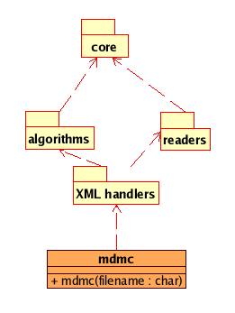
Figure 1 MDMC framework

The subsections below describe the components in the above figure.

The mdmc component and the MDMC job file
The MDMC framework works by accepting an MDMC job file that describes the job you want it to execute.

The mdmc component in figure 1, simply consists of the file mdmc.f90 which calls methods in the XML handler component.

A job file is tied to one of the algorithms in the algorithm component. The primary algorithms of the MDMC framework run a combination of a Monte Carlo approach and Molecular Dynamics simulations. However, the framework may also be used to run MD simulations and Monte Carlo approaches on their own. One algorithm, md_control, runs an MD simulation on its own and an example of a job file using this algorithm is shown in Figure 2.
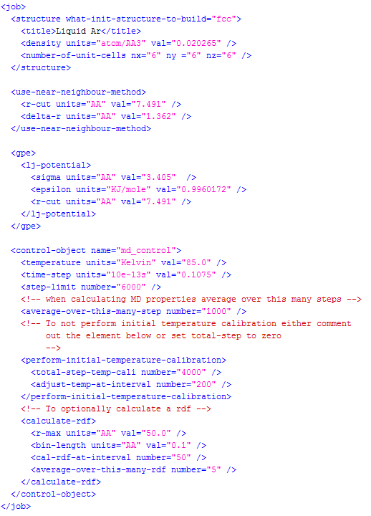
Figure 2 Example MDMC job file, in this case a job file for the md_control algorithm.

A job file consists of a sequence of top level (XML) elements and a job file must contain the following such elements:

- <control-object>. This controls how the specified algorithm is run. With reference to Figure 2, the value of attribute ‘name’ must be one of the algorithms in the algorithm package, more specifically one of the filenames (minus the .f90 extension) in the source code location: src/algorithm.
- <structure>. This describes the structure of the atomistic model. Either by specifying a filename or as shown in Figure 2 information about a structure that is then sufficient to build a structure in code.

A number of job files can be found in the source code location: src/input and see also the user manual for this release: user_manual_release_v0.1.docx.

Other examples of top level elements include:

- <gpe>. This specifies the generalised potential energy used by the MD engine.
- <fom>. This specifies the figure-of-merit function.
- <use-near-neighbour-method>. This element allows you to control how the nearest neighbour method is executed.
- <constraint>. This specifies constraints (a feature which as of this writing is not fully implemented although designed for in the software)

The XML handlers component
This component currently consists of two files handler.f90 and handler_structure_part.f90.

These are not only parsing the content of an MDMC job file, but also act on its content. When it finishes reading the <control-object> XML element it will start the user selected algorithm.

The main handler file is handler.f90.

The readers component
This component contains various files that read and creates/populates memory structures. The source code location for these is: src/readers.

The algorithms component
This component consists of fairly short .f90 files, which implement the data analysis algorithms of this software. These algorithm files make heavy used of the API provided by the core component. The source code location for these is: src/algorithms.

The job file is used to select which algorithm is used by the MDMC framework. A code section from one of these algorithms is shown in the figure below where calls to Core API functionality are highlighted in yellow.

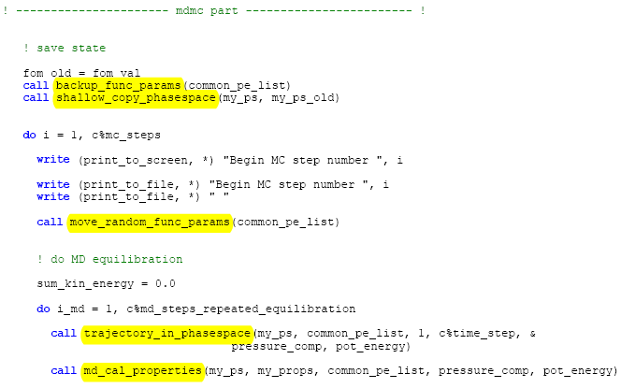
Figure 3 Section of code from mdmc_control.f90
An activity diagram of the algorithm implemented in mdmc_control is shown in the figure below.

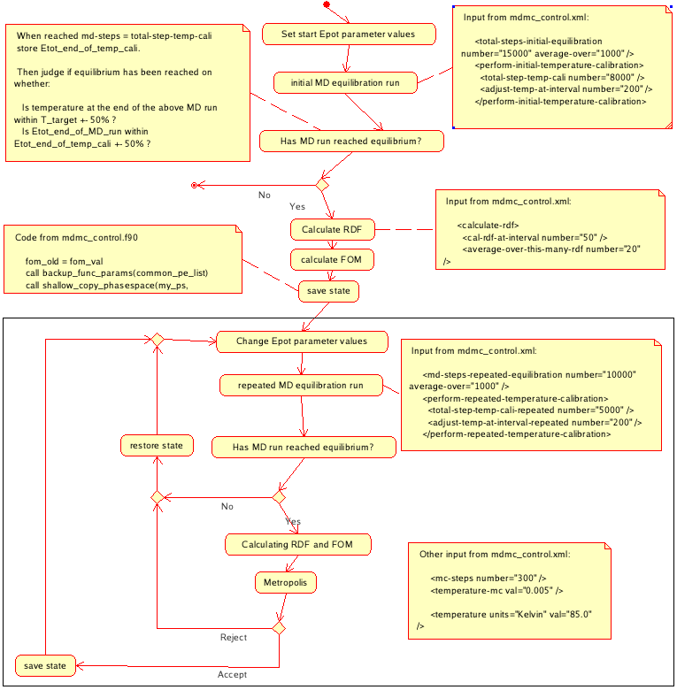
Figure 4 Activity diagram of the algorithm: mdmc_control

The core component
Provides the core functionality which is used by the algorithms component and readers component. An overview of the core component is shown in the figure below.

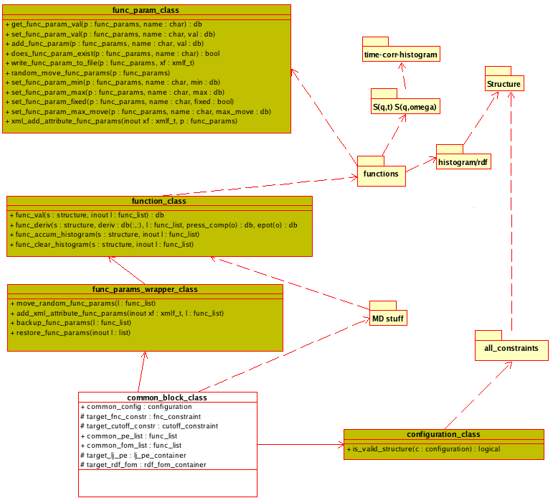
Figure 5 Overview of Core component

Fortran-90 is not a fully object oriented programming language. The methods and attributes with a + sign in the figure above are accessible from the algorithms component. The attributes with a # sign are public but # means that they must not be directly accessed by the algorithms component and does not form part of the core component’s API.

The core component covers the scope of defining constraints, data types, molecular dynamics engine and functions.

The diagram above defines a function interface with the methods func_val and func_derived in the function class (function_class). Implementations of functions are located in src/functions and in Figure 5 these are collectively shown as the functions component. A function is either a potential energy function or a figure-of-merit function.

The diagram in the figure below provides further details as to how the data types (histogram and rdf) of the histogram/rdf component of Figure 5 are used by functions and how the two func_list attributes in common_block_class are populated.
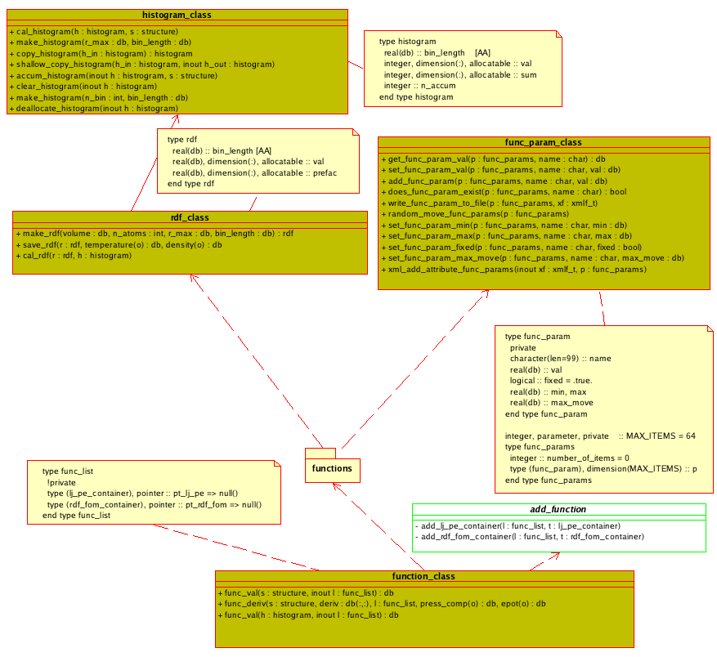
Figure 6 Shows details of how the data types in the histogram/rdf component of Figure 5 are used by functions.
More detailed information about a specific function is shown in the diagram below. The sign - in front of a method name means it is private to that class, and methods with the symbol # should not be called directly but instead through the function_class interface.
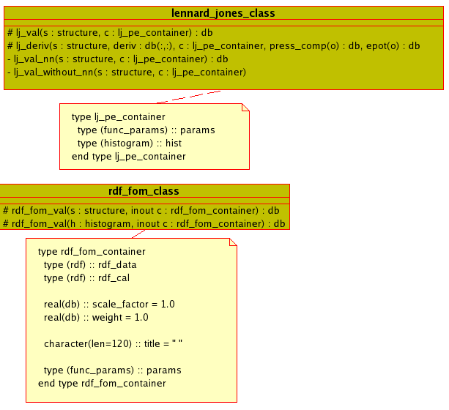
Figure 7 An example of a function implementation

The diagram below expands part of the right-hand side of Figure 5, showing in more detail the relationship between the structure class and constraints.

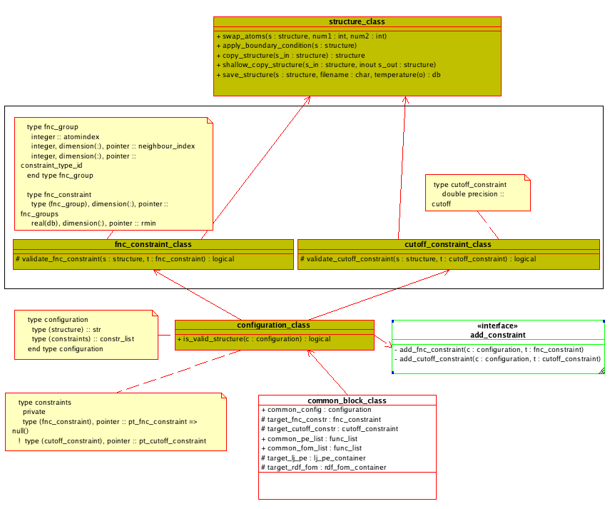
Figure 8 A more detailed view of the relationship between constraints and the structure class. The content in the black rectangle shows in more detail the content of the all_constraints component in Figure 5.

An expansion of the Structure component in Figure 5 is shown in the diagram below.
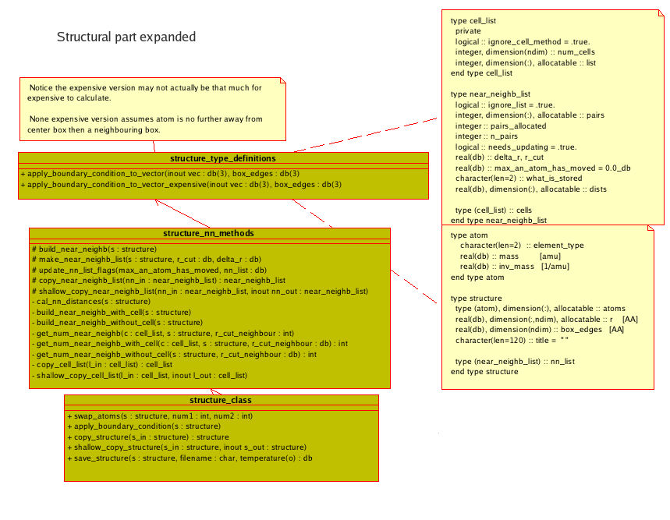
Figure 9 Details of the Structure component of Figure 5.

The MD stuff component in Figure 5 is expanded in the figure below, where as a reminder MD stands for Molecular Dynamics.
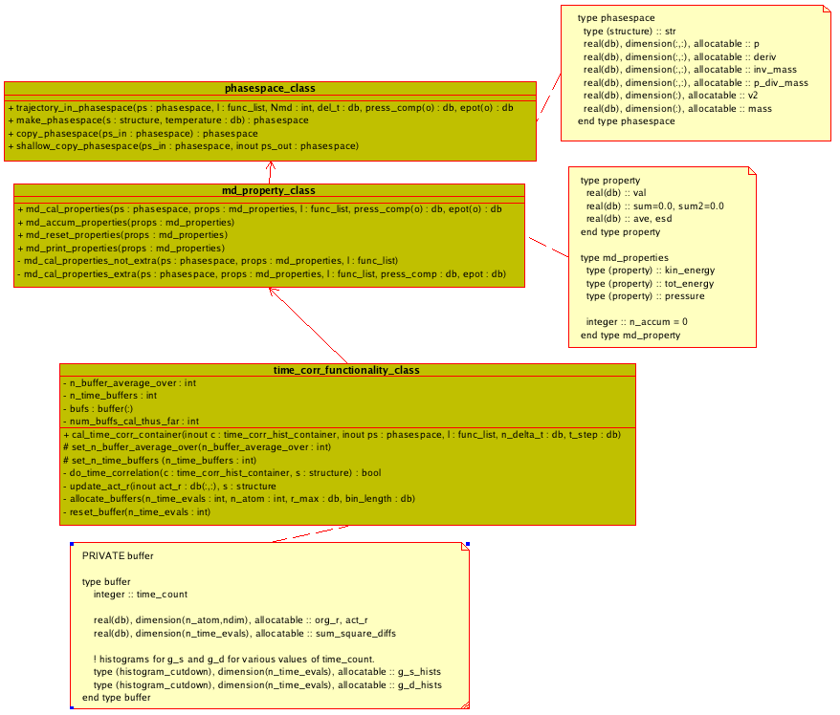
Figure 10 Show in more detail the content of the MD stuff component in Figure 5.

The time-corr-histogram component in Figure 5 is expanded in the figure below.

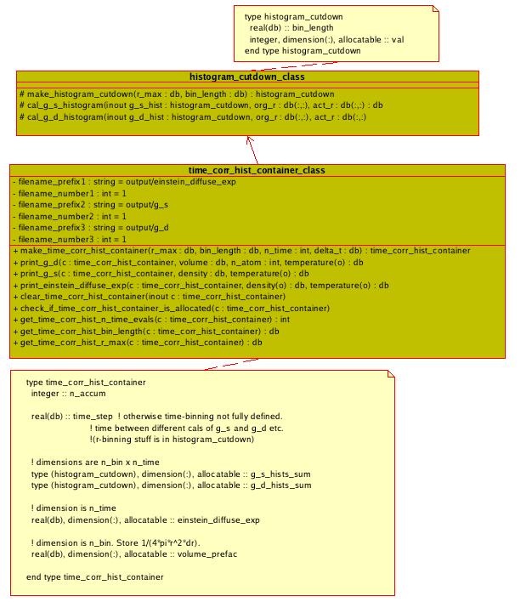
Figure 11 Shows in more detail the content of the time-corr-histogram component in Figure 5.
The S(q,t) S(q,omega) component in Figure 5 is expanded in the figure below.

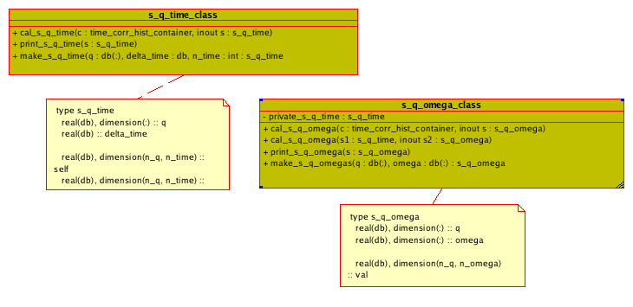
Figure 12 Shows in more detail the content of the S(q,t) S(q,omega) component in Figure 5.

References
Rapaport, D. C. (2004). The art of molecular dynamics simulation. Cambridge University Press.

