MDMC

Architectural design document

1 Introduction
This document describes the design of the MDMC framework.

2 Definition of Terms

3 System Overview
The figure below shows the basic setup of the framework.
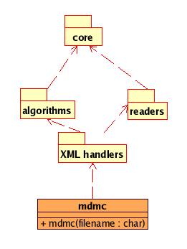
Below is a description of each of the components in the above figure.

3.1 mdmc
The MDMC framework works by accepting as input a filename of a XML job file, which specifies the job you want MDMC to execute and this driver file is required to have the following basic format:
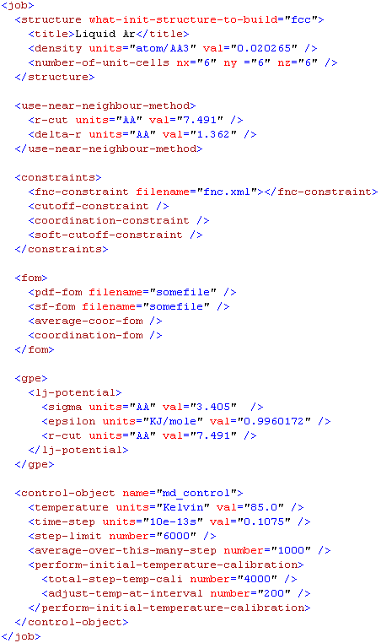

The job file consists of:

- A description of the structure under study either specified by a number of parameters as in the job file above or by reading in an initial starting structure from a file.
- A <use-near-neighbour-method> optional component which is your change to control how the nearest neighbour method is executed.
- A <constraint> component which can be used for specifying constraints.
- A <fom> component where the figure-of-merit function is specified.
- A <gpe> component where the generalised potential energy is specified.
- A finally the <control-object name=”md_control”> component which is used to specified the actually algorithm you want to use for analysing your data; in this case the algorithm is named “md_control”, and values for parameters to control this algorithm.

3.2 XML handlers package
Consists of .f90 files that handles the input job file.

3.3 Readers package
Consists of .f90 files for reading various data format.

3.4 Algorithm package
Fairly short .f90 files that implement various data analysis algorithms. These algorithm files may used of the API from the core package.

3.5 Core package
Provides the core API which is used the algorithm packages.

4 lsdjkfadslkf
Dsfadf.

