HandsMen Threads: Elevating the Art of Sophistication in Men's Fashion

# ABSTRACT:

The project titled "HandsMen Threads: Elevating the Art of Sophistication in Men's Fashion" focuses on transforming traditional business operations in the fashion retail industry through Salesforce. By implementing a custom-built Salesforce application, the project aims to streamline customer data management, automate business processes, and enhance communication across departments. Key features include automated order confirmations, proactive low-stock alerts, loyalty program automation, and scheduled bulk order processing. The system ensures high data integrity, improved operational efficiency, and better customer satisfaction. Through custom objects, flows, email templates, and Apex code, this solution creates a centralized and scalable CRM platform tailored to fashion business needs.

# OBJECTIVE:

The primary objective of the project “HandsMen Threads: Elevating the Art of Sophistication in Men's Fashion” is to leverage Salesforce to build a centralized,

automated, and scalable CRM system tailored to the specific needs of a fashion retail business. The goal is to eliminate fragmented data handling and manual processes by implementing a unified platform that ensures real-time data accessibility, integrity, and operational efficiency.

The system is designed to manage customer information, product details, order tracking, inventory levels, and marketing campaigns in a structured and secure manner. A major objective is to automate repetitive tasks—such as sending order confirmation emails, monitoring stock levels, and updating loyalty statuses—to save time and reduce human error.

Additionally, the project aims to enhance user experience and decision-making through clean UI interfaces, role-based access controls, and timely alerts. The overall goal is to provide a smart backend system that supports better customer service, business forecasting, and long-term growth through improved digital infrastructure.

# TECHNOLOGY DESCRIPTION:

* Salesforce Lightning Experience:

A modern, user-friendly UI provided by Salesforce for building responsive and dynamic business applications with drag-and-drop components.

* Custom Objects and Fields:

Used to represent business entities like Customers, Products, Orders, Inventory, and Campaigns, enabling tailored data storage beyond standard Salesforce features.

* Lightning App Builder:

Used to create a custom app called *HandsMen Threads* with relevant tabs for easy navigation and access to all business modules.

* Flows (Flow Builder):

No-code automation tool used to create processes like sending order confirmations, stock alerts, and updating loyalty status based on customer purchases.

* Apex Classes and Triggers:

Server-side programming language in Salesforce used to define custom logic, automate bulk processing at midnight, and perform inventory and financial adjustments.

* Email Templates:

Pre-designed messages used to send automated and personalized emails for various scenarios like order confirmation and low-stock alerts.

* Profiles, Roles, and Permission Sets:

Security controls to define who can access, edit, or view specific data, ensuring role-based data integrity and compliance.

* Scheduled Jobs (Apex Scheduler):

Used to run background tasks such as processing bulk orders and updating inventory on a daily schedule.

# EXECUTION OF PROJECT PHASES:

* Phase 1: Requirement Gathering

Identified key business needs, data entities (customers, orders, inventory, etc.), and required automations for efficient workflow.

* Phase 2: Data Modeling

Created custom objects and fields representing business processes. Defined relationships and ensured proper data structure.

* Phase 3: UI and App Configuration

Built the *HandsMen Threads* Lightning App with custom tabs for easy access and navigation of objects.

* Phase 4: Security Setup

Configured user profiles, roles, and permission sets to manage access control based on department and responsibilities.

* Phase 5: Email and Communication Setup

Designed email templates for order confirmations, stock alerts, and loyalty updates for enhanced customer interaction.

* Phase 6: Automation Implementation

Used Flow Builder for order-related automations and Apex code for scheduled bulk order processing and custom logic.

* Phase 7: Testing and Validation

Validated flows, triggers, and email actions using test data. Ensured security and access controls were correctly enforced.

* Phase 8: Deployment and Review

Finalized the app setup, deployed it for internal use, and reviewed the entire system for functionality and performance.

# EXPLANATION OF PROJECT WITH REAL WORLD EXAMPLE:

Let’s consider a real-world scenario where a customer named *Rahul* visits the HandsMen Threads website to purchase a men’s designer shirt. Here's how the complete Salesforce-based system handles this process from start to finish:

1. Customer and Order Creation

As soon as Rahul places an order, the data is captured and stored in Salesforce under the HandsMen Customer and HandsMen Order custom objects. These objects were created during the data modeling phase with relevant fields like:

* + Customer Name, Email, Loyalty Status (in *HandsMen Customer*)
  + Product Ordered, Quantity, Order Date, and Total Amount (in *HandsMen Order*)

The HandsMen Product object holds product details such as product name, SKU, price, and available quantity, while the Inventory object tracks stock levels.

1. Automated Order Confirmation

Upon successful order creation, a Salesforce Flow is triggered. This flow checks the order details and sends a personalized email to Rahul confirming his purchase. The email is generated using a custom Email Template, ensuring consistent branding and messaging.

1. Inventory Update and Stock Check

The system reduces the product quantity in the Inventory object based on the order quantity. If the remaining stock for that product falls below 5 units, another Flow is activated. This flow automatically sends an email to the Warehouse Manager (user with inventory role), alerting them to restock the item, helping prevent future stockouts.

1. Loyalty Program Automation

Rahul’s order amount is added to his total purchase history stored in the *HandsMen Customer* object. A loyalty check flow evaluates his total spending and updates his Loyalty Status field to “Silver,” “Gold,” or “Platinum” depending on the threshold, e.g:-

* + Silver: ₹5000+
  + Gold: ₹10,000+
  + Platinum: ₹20,000+

This status helps in offering personalized discounts or early access to new collections in future campaigns.

1. Bulk Order Processing at Midnight

At the end of the day, the Apex Scheduler runs a job at 12:00 AM. It:

* + Reviews all the day’s orders marked as “Pending”
  + Updates their status to “Processed”
  + Adjusts related inventory quantities
  + Generates backend financial records (like sales value, tax, etc.)

This reduces manual work and ensures the business starts each day with up-to-date inventory and sales records.

1. Marketing Campaign Management

Using the Marketing Campaign object, Rahul is automatically added to a campaign for “Festive Offers.” The marketing team can later send targeted promotional emails or updates. Access to this data is controlled by profiles and permission sets created during the project.

1. User Access and Security

The whole system is governed by a defined role hierarchy:

* + Sales Executive – access to customer and order records.
  + Inventory Manager – access to stock data and alerts.
  + Marketing Specialist – access to campaigns and leads.
  + Admin – full access to all data.

Each user has a profile assigned and can be given extra access through permission sets when needed.

# SCREENSHOTS:

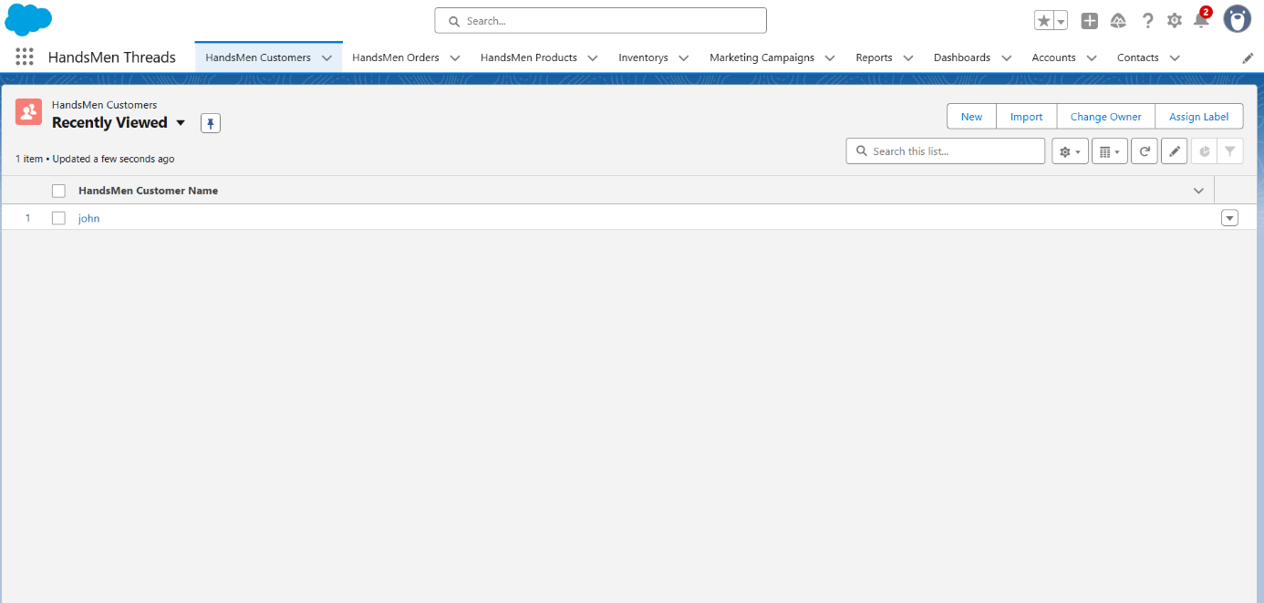

**Fig: Custom App HandsMen Threads**

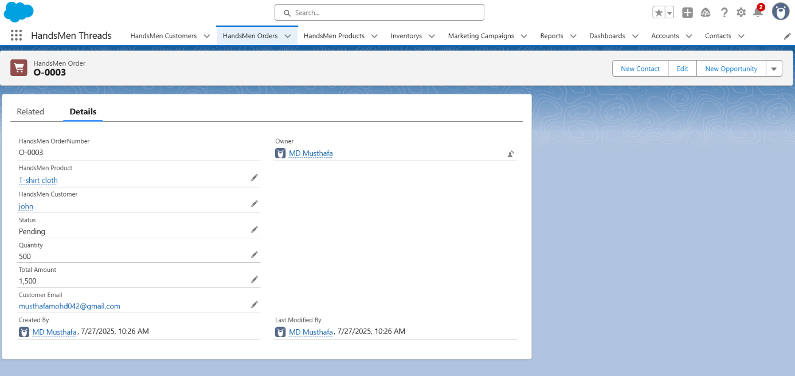

**Fig: HandsMen Orders**

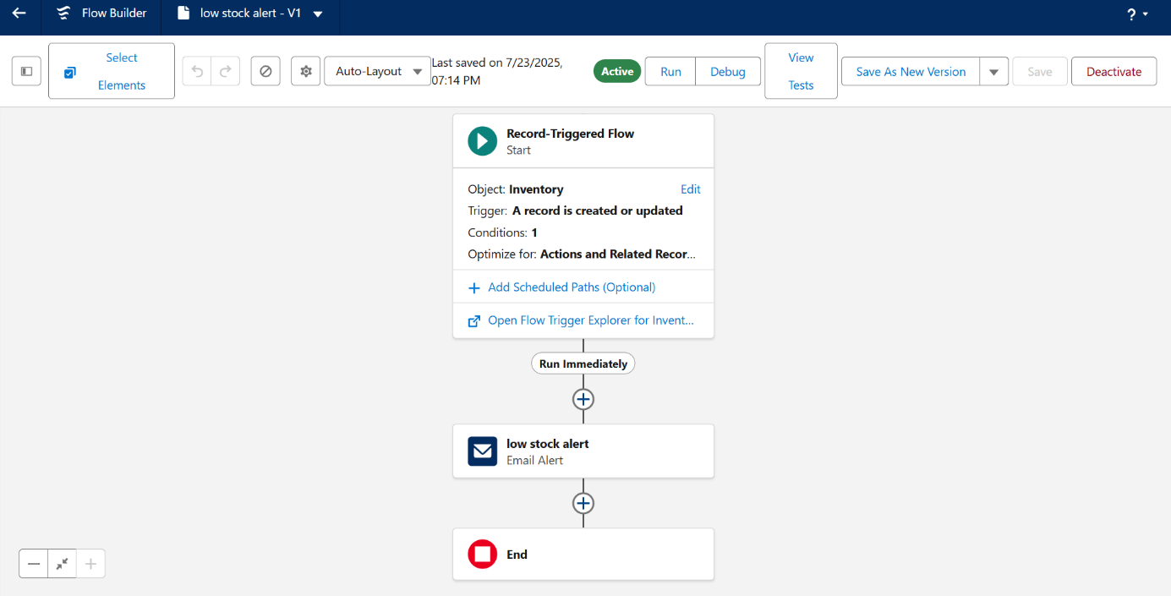

**Fig: Low Stock Alert Flow**

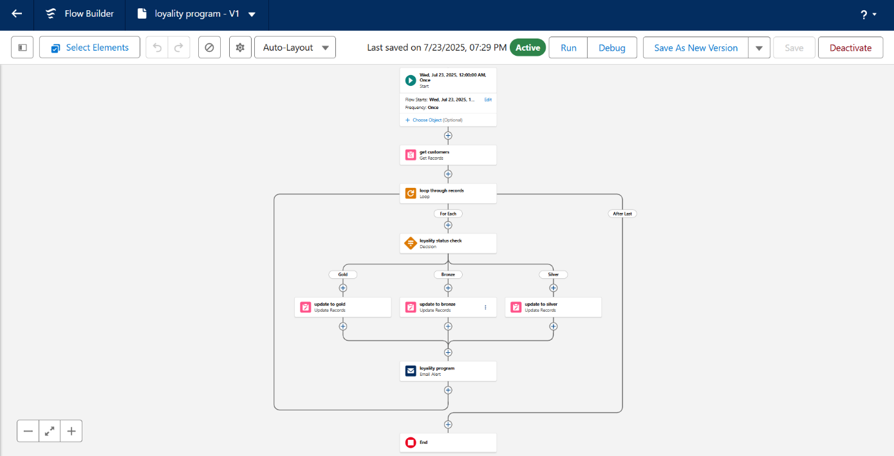

**Fig: Loyality Status Check - Flow**

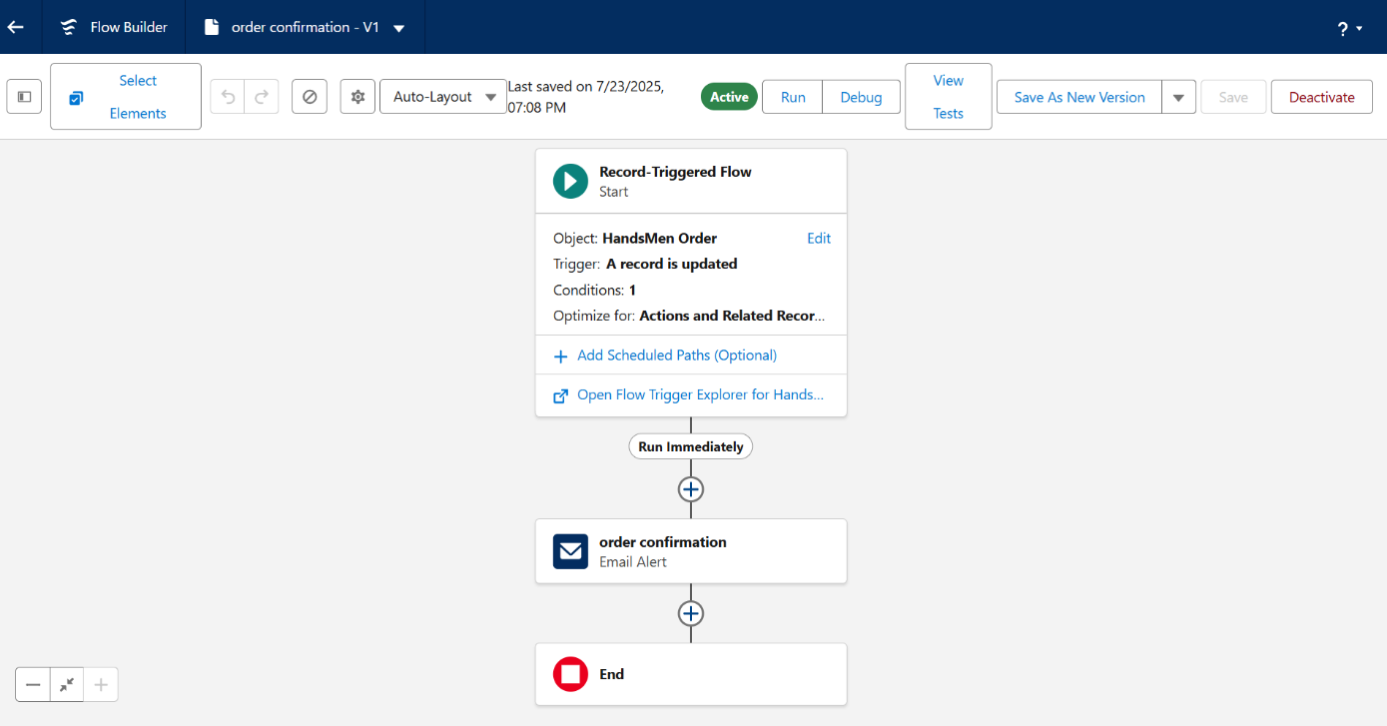

**Fig: Order Confirmation Flow**

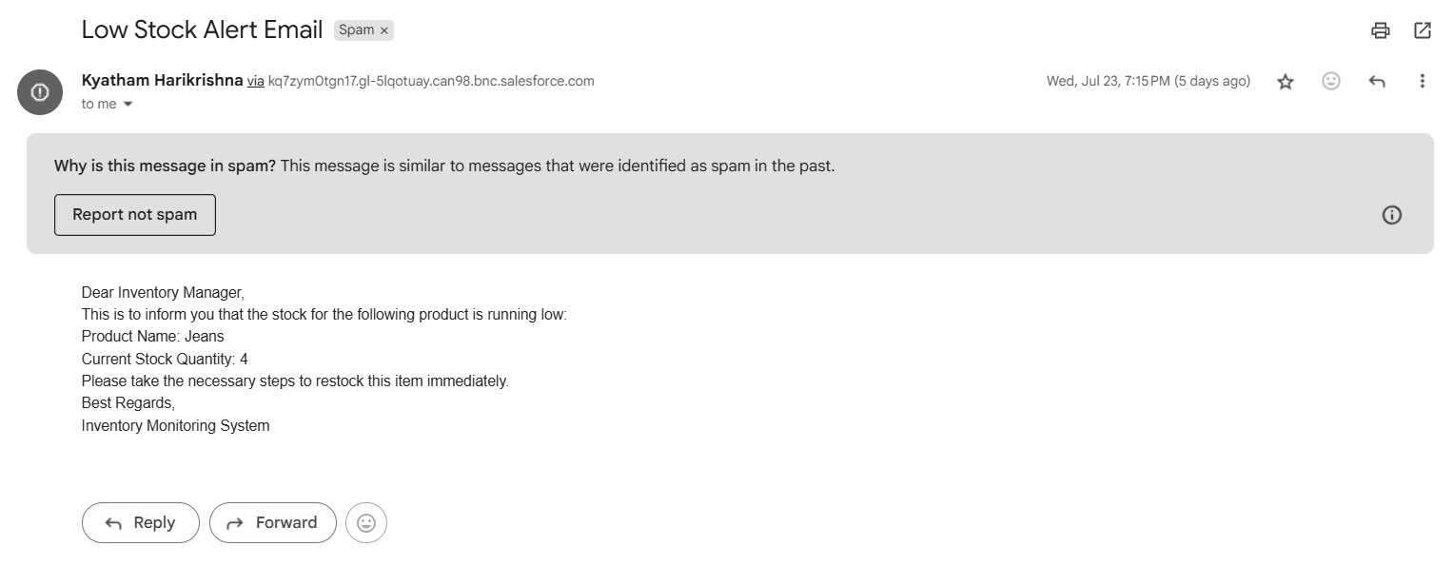

**Fig: Low Stock Alert Mail**

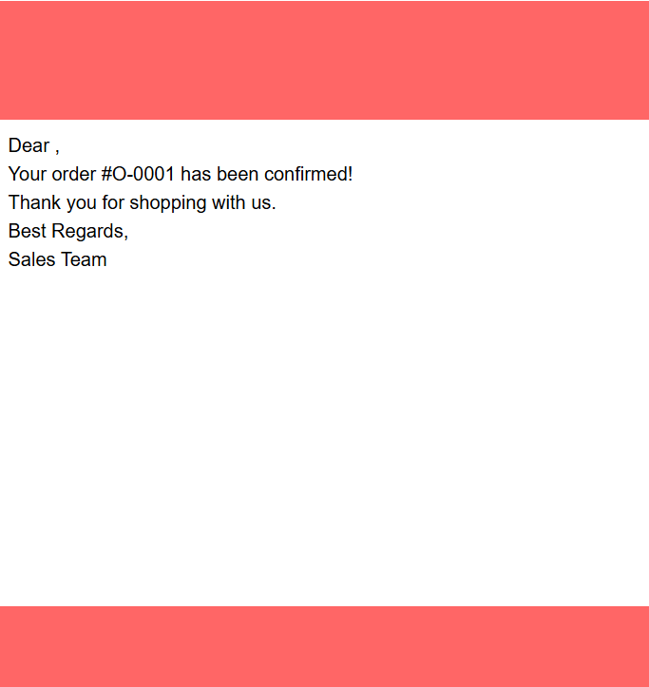

**Fig: Order Confirmation Mail**

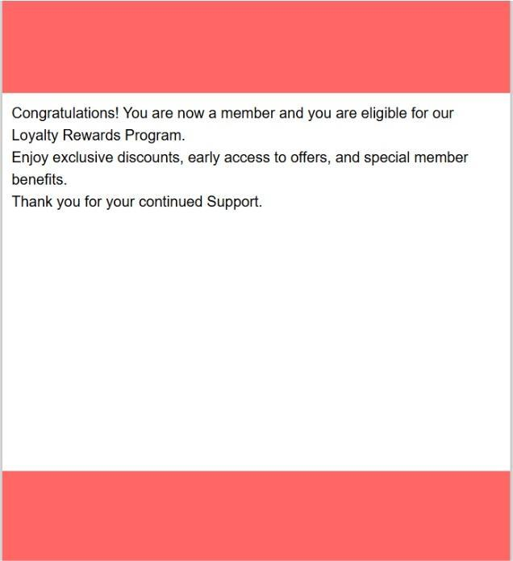

**Fig: Loyality Status Mail**

# CONCLUSION:

The Salesforce-based project for HandsMen Threads marks a significant milestone in transforming the brand’s operational efficiency and customer engagement strategies. By designing and implementing a centralized CRM system, the project successfully addressed various business challenges such as scattered data, delayed

communications, and manual inventory tracking. The introduction of custom objects for customers, products, orders, inventory, and marketing campaigns ensured that all business-critical data is stored in a structured and accessible manner.

Automation through Flows and Apex code has significantly reduced manual tasks, such as sending order confirmations, alerting low stock levels, updating loyalty statuses, and processing bulk orders at scheduled intervals. These features have not only enhanced internal efficiency but have also contributed to improved customer satisfaction through timely and personalized interactions.

Furthermore, the role-based access system ensures data security and integrity across departments. This project serves as a scalable foundation for HandsMen Threads'

future growth, making it easier to integrate advanced tools, AI-driven recommendations, and multi-channel marketing.

# FUTURE SCOPE:

The successful implementation of the Salesforce system for HandsMen Threads opens up several opportunities for future enhancements and scalability. As the business grows, the CRM solution can be expanded with the following features:

* E-commerce Integration:

Seamless integration with platforms like Shopify, Magento, or custom-built websites to automate real-time order, customer, and inventory syncing.

* Mobile Accessibility:

Development of a Salesforce Mobile App for sales and warehouse teams, enabling them to access and update records on the go.

* AI & Predictive Analytics:

Leveraging Salesforce Einstein AI to analyze customer behaviour, predict purchase trends, and provide intelligent product recommendations.

* Advanced Reporting & Dashboards:

Implementation of Salesforce CRM Analytics (Tableau CRM) for deeper insights into sales performance, inventory trends, and marketing ROI.

* Multi-Channel Marketing Automation:

Extend marketing campaigns to include SMS, WhatsApp, and social media for omnichannel engagement using tools like Salesforce Marketing Cloud.

* Customer Self-Service Portal:

Create a community portal where customers can view order history, track shipments, and manage their profiles.