M-DPP PROJECT
Delphi Stakeholder Consultation
Round 3 — Results & Final Analysis of the Full Delphi
Work Package 1 — Stakeholder Engagement & Compliance Requirements
Fashion Research & Technology — Amsterdam University of Applied Sciences (HvA)
2026
Structural caveat: N = 8, down from 11 in Round 2. Responses are anonymous, so individual respondents cannot be linked across rounds. The changing respondent numbers across the consultation (8 → 11 → 8) make clear that the panel composition changed between rounds: a Round 3 respondent may have skipped Round 2, or may have followed the questionnaires and analyses and contributed only now. Differences between Round 2 and Round 3 results may therefore reflect changed opinions, changed panel composition, or both — and the two cannot be separated. This limitation applies to every cross-round comparison in this report.
The Round 3 group distribution also differs from Round 2: Technology & Data is represented by 3 respondents (2 in Round 2), and two larger organisations (250–999 and 1,000+ staff) appear where the Round 2 panel was predominantly under 50 staff. Policy, Research & Civil Society remains represented by a single respondent, and Circularity & End-of-Life is down to one.

1. PANEL OVERVIEW — ROUND 3
Round 3 received 8 responses across all four stakeholder groups. Unlike Round 2, the panel is no longer uniformly small: one Supply Chain respondent works in a 250–999 person organisation and the Policy, Research & Civil Society respondent in an organisation of 1,000 or more.
Stakeholder group | N | Org size | Roles represented
Supply Chain | 3 | 10–49 to 250–999 | CSR / ESG, Design / Product Dev,  Founder, Finance
Technology & Data | 3 | 3–49 staff | Product Owner, CEO / Founder,  Researcher / Consultant
Circularity & End-of-Life | 1 | 10–49 staff | Design / Product Dev, CSR / ESG
Policy, Research & Civil Society | 1 | 1,000 or more | Researcher / Academic
All three Supply Chain respondents work in Tier 2 (subcomponent and component production — weaving, knitting, dyeing, finishing); one is additionally active in Tier 1 assembly. No brand or retailer answered the supply chain tier question in Round 3.

2. ROUND 3 RESULTS
Round 3 put four focused questions to the panel — one for each issue that Round 2 left genuinely unresolved. Each question showed the Round 2 result before asking for a position. Two of the four resolved; two did not.

R3-Q1 — Microfibre and nanoplastic data
Round 2 context: the only statement without majority normative agreement (6 yes / 5 no) — and the only one that no respondent found feasible by 2027. Round 3 replaced the binary format with a three-way choice to separate outright rejection from conditional acceptance.
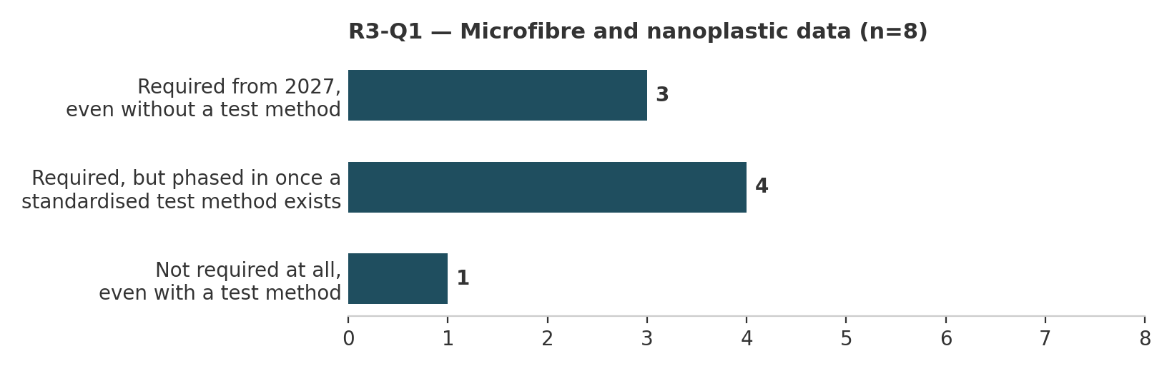
The three-way format resolves the Round 2 deadlock. 7 of 8 accept the requirement in some form: 4 want it phased in once a standardised test method exists, 3 want it required from 2027 using the best available approach. Only 1 respondent rejects the requirement outright — without an explanatory comment. This supports the Round 2 interpretation that most “No” votes meant “not until a test method exists” rather than “not at all”, though the changed panel composition means the comparison is indicative, not proof of opinion change.
The open comments place the burden on the regulator, not on companies: if the EU imposes the requirement, it must first make the accepted test methodology available — as other EU regulations under REACH already do. One respondent wants a scientific base with an easy, open testing method, outside NEN/ISO and free of lobby influence from either man-made or natural fibre interests. The Policy, Research & Civil Society respondent takes the most optimistic position: measurement is already technically feasible and only needs further development.
The ESPR mandates this data regardless of the panel's feasibility assessment. The finding is therefore about the implementation pathway: the panel's centre of gravity is conditional acceptance, with the standardised test method as the precondition.

R3-Q2 — Who should oversee independent verification?
Round 2 context: 8 of 11 said independent verification of DPP material claims should be mandatory, but votes on who should oversee it were spread across four bodies with no majority, and the feasibility rating was the most evenly distributed result in the Round 2 dataset.
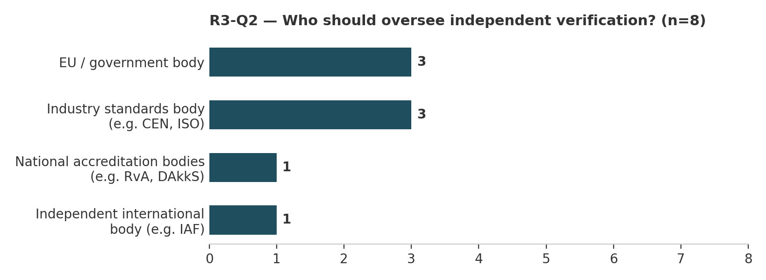
No governance consensus after three rounds. Votes consolidate into two three-vote camps — EU / government body and industry standards body (CEN / ISO) — with national accreditation bodies and an independent international body (IAF) receiving one vote each. Neither camp reaches a majority on a panel of 8.
The two rationales are internally coherent and pull in different directions. The EU / government camp values independence, transparency and proximity to the regulation itself — with one respondent adding, from direct MDR experience, that national accreditation and industry bodies are currently very expensive. The CEN / ISO camp values global adoption: ISO standards are accepted worldwide and already used by non-EU suppliers, which matters because EU regulation does not bind the non-EU part of the chain; and CEN / ISO / JRC standards are developed with industry, testing institutes and government, keeping them close to working practice. One respondent explicitly wants both levels — national and European agencies alike, with the body issuing the law providing the check and the standard.
Under the Delphi design this is a documented persistent disagreement, not a failure to converge: the panel agrees verification should be mandatory but does not agree who should govern it. The underlying trade-off — regulatory enforcement power versus global reach — is real and the panel reproduces it faithfully.

R3-Q3 — The recyclability timeline
Round 2 context: 9 of 11 said a shared recyclability assessment method should precede mandatory reporting, while 6 of 11 said that method is unlikely by 2027. Round 3 put the logical implication — that mandatory recyclability reporting is not realistic by 2027 — directly to the panel.
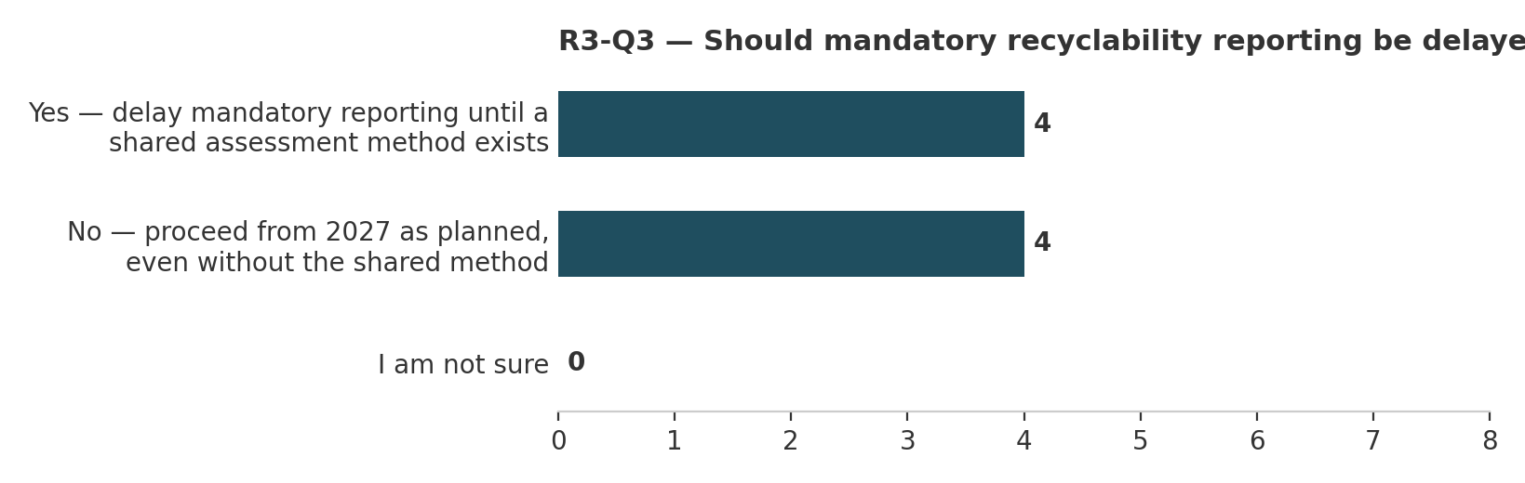
A dead split: 4 delay, 4 proceed. Notably, no respondent chose “I am not sure” — an option retained deliberately because acknowledging the tension without drawing the conclusion would itself have been informative. Instead, the panel divides cleanly on the conclusion rather than avoiding it.
The “proceed” camp shares one rationale across three separate comments: the obligation itself is what forces the missing method into existence — delay just means companies start later. One “proceed” respondent adds a nuance that partially bridges the camps: recyclability reporting should be mandatory but recycling targets should stay open, with the EU providing clear testing methods and research funding for manufacturer–university collaboration.
The “delay” camp includes the panel's only Circularity & End-of-Life respondent — the group closest to recycling practice — whose comment redirects the requirement itself: focus on inputs (fibre, yarn and fabric specifications) rather than on the finished garment.
This is the second persistent disagreement of the consultation. The panel does not dispute the Round 2 logic; it disagrees about what follows from it — whether the 2027 deadline should bend to the missing method, or the missing method should bend to the deadline.

R3-Q4 — Packaging data structure
Round 2 context: 9 of 11 said the EU should mandate one specific approach, but votes were spread across all five structural options with no majority. Round 3 narrowed the choice to the two leading options. Round 1 baseline: the strongest consensus in the entire first questionnaire was that packaging and product data should be kept clearly separate.
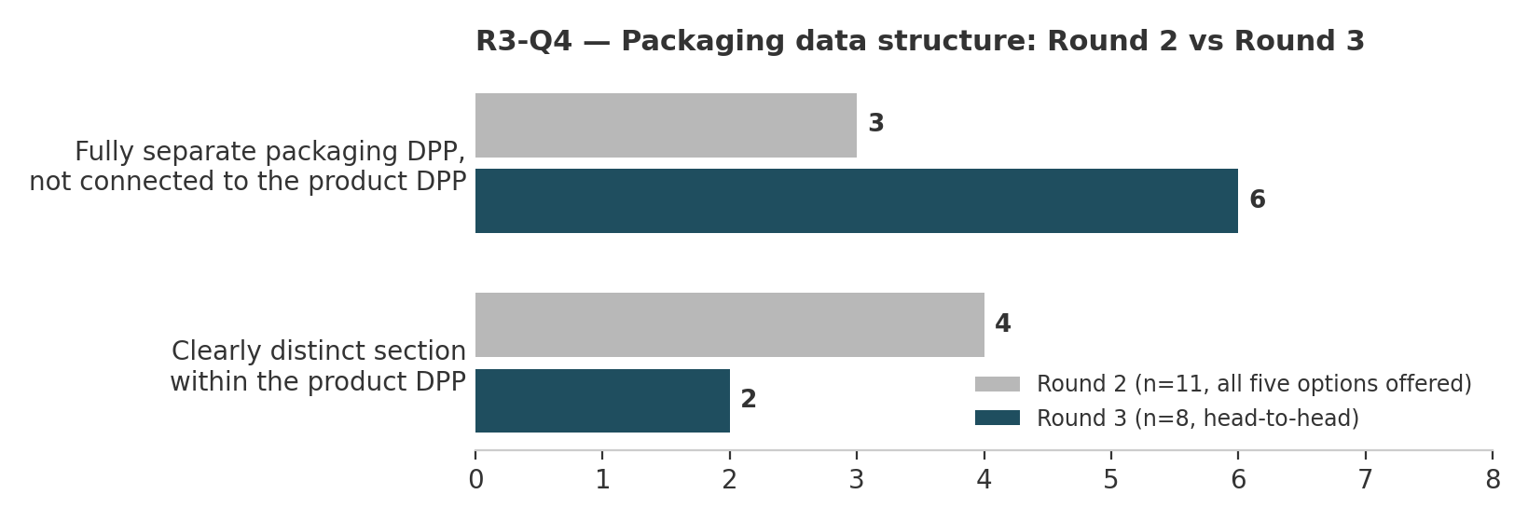
The clearest convergence of Round 3 — and a reversal. 6 of 8 choose a fully separate packaging DPP; 2 choose a clearly distinct section within the product DPP. In Round 2 the distinct-section option led 4 to 3. Round 3 re-aligns the panel with the Round 1 consensus on separation — and pushes it further, to the architectural rather than the structural level. The structural caveat applies with full force here: with a changed panel, the reversal cannot be attributed to opinion change alone.
The rationale, however, is consistent across all four open comments: packaging is a product in its own right, with its own process and product specifications, usually produced by different companies than the yarn, fabric or garment suppliers — so the material and recyclability knowledge sits with the packaging manufacturer, not the product manufacturer. One respondent extends this into a data-architecture principle: define products small and link multiple passports, a logic they note applies equally to sectors like construction. Another adds a practical condition: both labels should be clearly visible on the outside of the goods and clearly distinguishable from one another.
Combined with the Round 2 mandate finding (9/11 in favour of the EU mandating one approach), the panel's final position is: mandate it, and mandate full separation.

3. THE FULL DELPHI — FINAL ANALYSIS

3.1 Three rounds in brief
Round 1 (8 respondents) asked open questions across the five mandatory DPP data domains and, together with the Industry Living Lab workshop, produced twelve rateable statements. Round 2 (11 respondents) rated each statement on feasibility by 2027 and on whether it should be required — separating what the sector considers achievable from what it considers legitimate. Round 3 (8 respondents) returned the Round 2 results to the panel and asked four focused follow-up questions on the issues that remained genuinely unresolved.
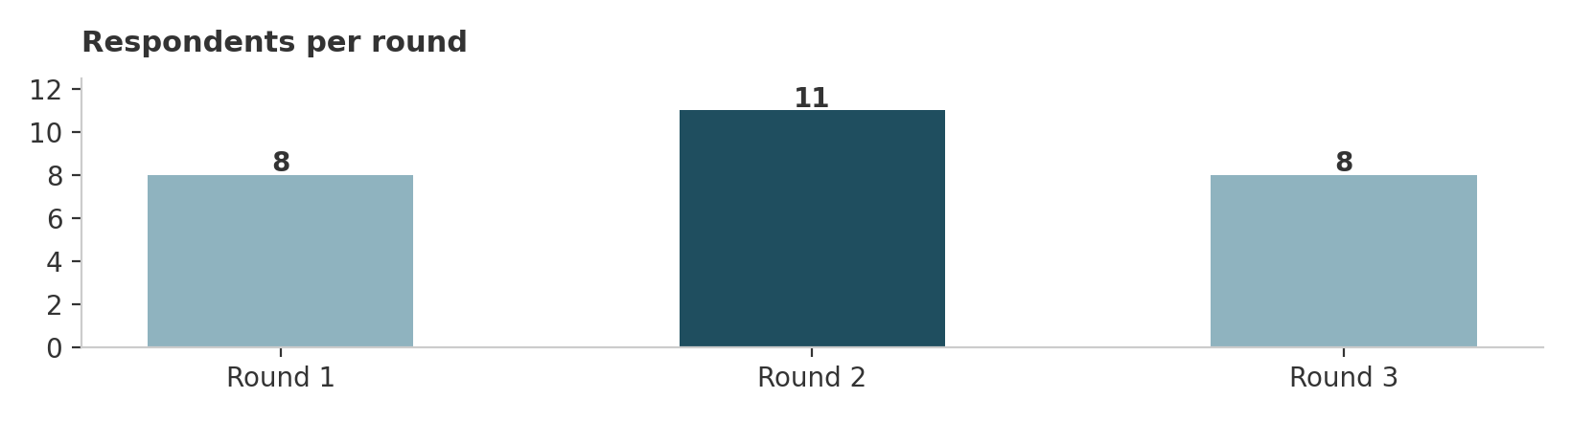
Panel change across rounds. The respondent numbers alone (8 → 11 → 8) show that the panel changed composition during the consultation. Because responses are anonymous, individuals cannot be tracked between rounds: some Round 3 respondents may have participated in all three rounds, some may have skipped Round 2, and some may be new panellists who followed the published questionnaires and analyses before contributing. All statements in this report about movement between rounds — including the R3-Q1 resolution and the R3-Q4 reversal — describe movement of the panel result, not verified movement of individual opinions.

3.2 What was settled, and when
Eight of the twelve Round 2 statements did not need a third round. They are settled in the sense the Delphi method intends: a clear panel result with no unresolved internal tension.
Settled in Round 2 | Panel result
Q1.1 — Product-level composition data | Unanimously required (11/11); feasibility by 2027 split
Q2.1 — Tier 1 traceability | Near-consensus (10/11 required, majority feasible)
Q2.2 — Shared open data standard | Unanimously wanted (11/11); majority doubt 2027; CEN/ISO plurality to lead
Q2.4 — Small-batch compliance pathway | Strong agreement (10/11)
Q3.2 — Data recyclers actually need | Strong agreement (9/11); feasibility leaning positive
Q3.4 — PRO / EPR reform as prerequisite | Majority agreement (8/11); likelihood dominated by “Uncertain”
Q5.1 — Location data over transport distance | Closest to full consensus in the dataset (9/11 on both scales)
Q5.2 — Estimated transport data acceptable | Clear majority (8/11), positive feasibility
The four remaining issues went to Round 3. Two resolved; two are documented as persistent disagreements.
Carried into Round 3 | Round 2 state | Round 3 outcome
Microfibre & nanoplastic data  (Q1.2 → R3-Q1) | 6/5 normative split;  nobody found it feasible | Resolved: 7/8 accept the requirement; plurality conditions it on a standardised test method
Verification governance  (Q1.3 → R3-Q2) | Mandatory verification wanted (8/11); governance spread across four bodies | Persistent disagreement: two 3-vote camps — EU/government vs CEN/ISO
Recyclability timeline  (Q3.1 → R3-Q3) | Standard should precede reporting (9/11); standard unlikely by 2027 (6/11) | Persistent disagreement: 4–4 on delaying vs proceeding; nobody unsure
Packaging structure  (Q4 → R3-Q4) | Mandate wanted (9/11); votes spread across all five options | Resolved: 6/8 for a fully separate packaging DPP, consistent with the Round 1 consensus

3.3 The central finding across all three rounds
The single most consistent pattern of the consultation is the gap between normative agreement and feasibility. Across Rounds 1 and 2, the panel repeatedly endorsed requirements — composition data, an open data standard, a recyclability method, microfibre data — while doubting they can be met by 2027. Round 3 sharpened what that gap means in practice: when forced to choose between the requirement and the timeline, the panel did not abandon the requirements. For microfibre data, the plurality conditions the start date on a standardised test method. For recyclability reporting, half the panel accepts slipping beyond 2027 and the other half wants the deadline kept precisely because the obligation forces the missing method into existence.
In both cases, the missing element is the same: standardised assessment methods. And in both cases the panel locates the responsibility for providing them with regulators and standards bodies, not with individual companies — stated most explicitly in the R3-Q1 comments (the REACH precedent: the EU specifies the accepted testing methodology before imposing the restriction) and implied in the R3-Q3 “proceed” nuance that the EU should provide clear testing methods and research funding.
A second recurring thread runs from the Round 2 open comments into R3-Q2: EU-only instruments do not bind the non-EU part of the textile supply chain. The argument for CEN / ISO — in Round 2 the clearest governance preference for the data standard (5/11), in Round 3 one of the two leading camps for verification oversight — rests on global adoption rather than regulatory authority. The panel never resolved whether enforcement power or global reach matters more; that trade-off is itself a finding.

3.4 Final map — convergence and persistent disagreement
Converged | Converged with feasibility doubt | Persistently contested
Packaging: fully separate DPP, EU-mandated (R1 consensus, confirmed R3 6/8)  Location data over transport distance (Q5.1)  Tier 1 traceability by 2027 (Q2.1)  Estimated transport data acceptable (Q5.2) | Composition data: required unanimously, 2027 timeline split (Q1.1)  Open data standard: wanted unanimously, 2027 doubted (Q2.2)  Microfibre data: requirement accepted 7/8, conditioned on a test method (R3-Q1)  Small-batch pathway (Q2.4); recycler-relevant data (Q3.2); PRO/EPR reform (Q3.4) | Verification governance: EU/government vs CEN/ISO, 3–3 (R3-Q2)  Recyclability timeline: delay vs proceed, 4–4 (R3-Q3)

3.5 Limitations
Panel size and representation. The panel ranged from 8 to 11 respondents across rounds. Policy, Research & Civil Society was represented by a single respondent in Rounds 2 and 3, and Circularity & End-of-Life by a single respondent in Round 3. Results for these groups are indicative only.
Panel composition change. The panel demonstrably changed between rounds (8 → 11 → 8 respondents). Anonymity prevents linking responses across rounds, so opinion change and composition change cannot be separated in any cross-round comparison. This particularly affects the interpretation of the R3-Q4 reversal and the R3-Q1 resolution.
Organisational skew. The Round 2 panel skewed toward small actors, with no large brand or multinational manufacturer represented. Round 3 includes two larger organisations (250–999 and 1,000+ staff), but the 1,000+ respondent is a researcher, not a brand — the absence of large commercial actors persists across the full consultation.
Self-selection. Panellists chose to participate in a DPP research project and are likely more engaged with the topic than the sector average. Persistent disagreements within this panel may understate disagreement in the wider sector.
On persistent disagreement. Under the Delphi principle of controlled convergence, the two unresolved questions are findings, not failures. Both are documented with the full rationales of each camp, which is the intended final output of the method: a map of where the sector converges, where it durably disagrees, and why.
This report concludes the WP1 Delphi stakeholder consultation. Its findings — the settled requirements, the two persistent disagreements, and the documented gap between normative agreement and the 2027 timeline — serve as input for the project's compliance-requirements reporting, where implications and recommendations are addressed separately.

