M-DPP Project
Delphi Stakeholder Consultation
Round 2 - Results & Analysis

Work Package 1 - Stakeholder Engagement & Compliance Requirements
Fashion Research & Technology - Amsterdam University of Applied Sciences (HvA)
2026
Structural caveat: N=11. Technology & Data and Circularity & End-of-Life are each represented by 2 respondents; Policy, Research & Civil Society by 1. Results for these groups are indicative only. The panel skews toward smaller actors - no large brand or multinational manufacturer is represented.

PANEL OVERVIEW
Round 2 received 11 responses across four stakeholder groups. All respondents represent small organisations: 8 of 11 have fewer than 50 staff.
Stakeholder group | N | Org size | Top roles
Supply Chain | 6 | Mostly 3-49 staff | Design / Product Dev
Technology & Data | 2 | 3-49 staff | CEO / CTO
Circularity & End-of-Life | 2 | 3-49 staff | CEO / CSR
Policy, Research & Civil Society | 1 | 3-9 staff | Director

TOPIC 1 - COMPOSITION & CHEMICAL SAFETY
Q1.1
By 2027, most textile companies can provide product-level material composition data - including fibre content and recycled material share - that is traceable to the supply chain partner who provided it.
How feasible is this by 2027?  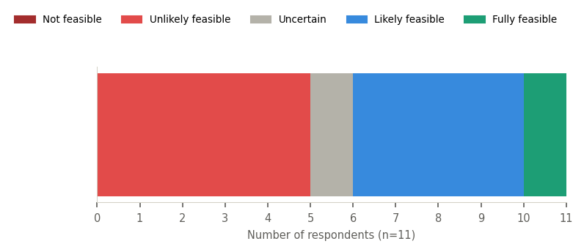 |  | Should this be required?  

Unanimous normative agreement (11/11 yes) but the feasibility picture is split - 5 say unlikely, 4 say likely, 1 uncertain, 1 fully feasible. The panel wants this required but is divided on whether the 2027 timeline is realistic. Round 1 framed the target as a "good enough" standard: declared composition traceable to the data provider - not full molecular precision per batch.

Q1.2
Providing data on plastic microfibre and nanoplastic release as part of the DPP is achievable for most textile companies by 2027.
How feasible is this by 2027?  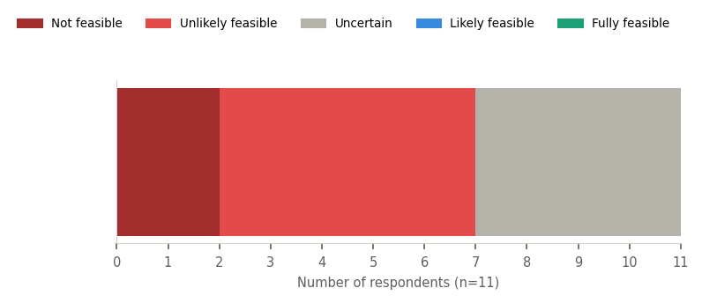 |  | Should this be required?  

The most contested statement in Round 2. No respondent finds it feasible by 2027 - not a single respondent chose Likely or Fully feasible. The normative question is split 6/5. Both Technology & Data respondents said No. The "No" votes most likely mean "not until a standardised test method exists" - a known gap flagged in Round 1. The EU's ESPR mandates this data regardless. Round 3 must directly address the distinction between "not required yet" and "not required at all."

Q1.3
Independent third-party verification of material composition claims in the DPP is currently too expensive, too opaque, and too easy to circumvent to be reliable across the textile value chain.
How feasible is this by 2027?  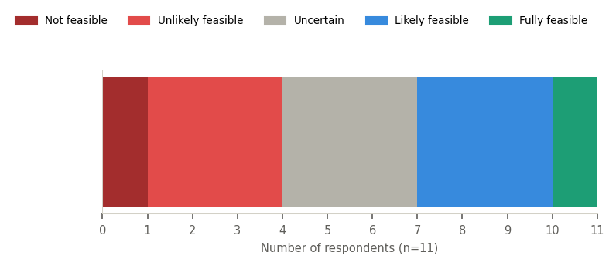 |  | Should verification be mandatory?  

If yes - who should accredit and oversee verification bodies? (n=8)
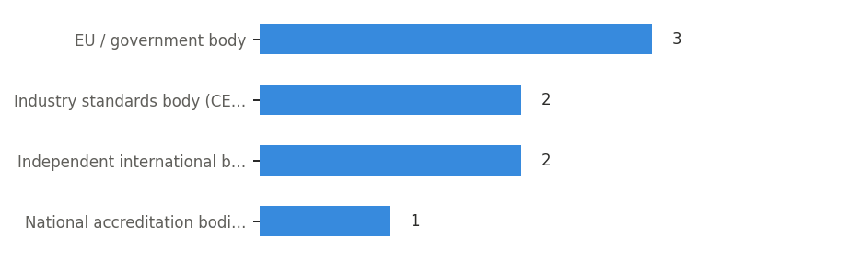

Majority normative agreement (8/11) but feasibility is the most evenly spread result in the entire dataset - almost flat across all five options. Note: the statement is phrased negatively - agreeing means agreeing the current system is broken, not that verification is wrong in principle. The 3 "No" votes are both Technology & Data respondents plus one Supply Chain. Governance is genuinely contested with votes spread across four different bodies.

TOPIC 2 - SUPPLY CHAIN TRACEABILITY
Q2.1
By 2027, most textile brands can reliably report where the main steps in making their products happened - such as where fabric was woven, dyed, and the garment was sewn together.
How feasible is this by 2027?  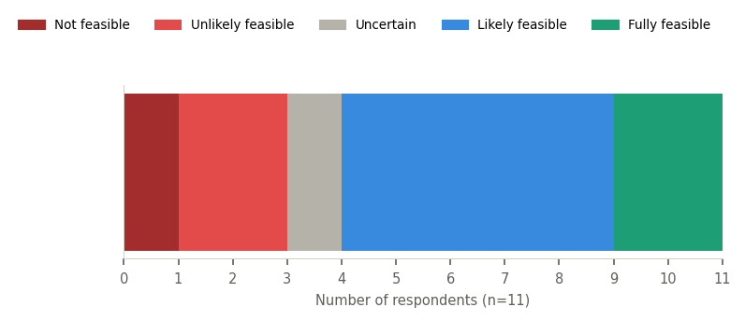 |  | Should this be required?  

Strong normative agreement (10/11) and a more positive feasibility picture than Topic 1 - a majority lean toward feasible. One of the cleaner findings in the dataset. The single "No" (Circularity & End-of-Life) is consistent with that respondent's open comment framing responsibility with brands and suppliers, not the DPP system. Round 1 consensus: Tier 1 visibility is the realistic 2027 target; beyond that is partial at best.

Q2.2
A shared, open and free-to-use data standard - so that suppliers only need to report their production information in one format, usable by all the brands they work with - does not yet exist. Creating and widely adopting such a standard is realistic by 2027.
How feasible is this by 2027?  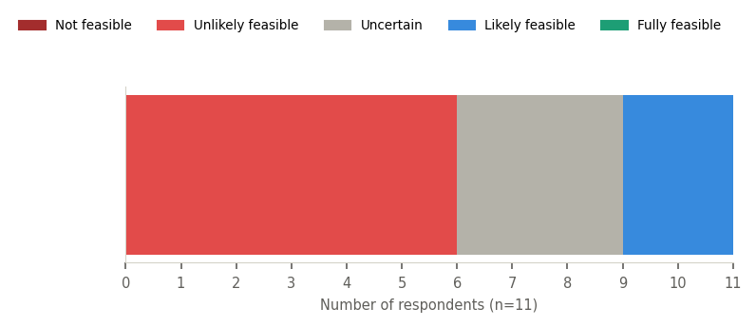 |  | Should this be developed?  

If yes - who should take the lead? (n=11)
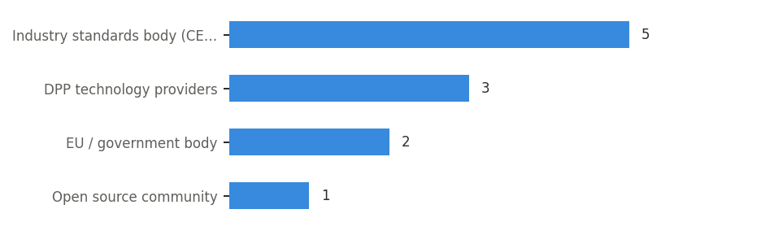

Second unanimous normative finding (11/11 yes), but a majority see it as unlikely feasible by 2027. The CEN/ISO plurality (5/11) is the clearest governance preference in the dataset - supported by the argument that ISO 9001/14001 are globally adopted, making them the only realistic vehicle for non-EU suppliers. "Plurality of 5 on a panel of 11" still warrants caution about overstating this as consensus.

Q2.4
Current certification models - which are designed for large-scale, repeatable production - do not work for companies producing in small batches or on demand. The DPP compliance framework as currently designed will place a disproportionate burden on these producers.
How feasible is this by 2027?  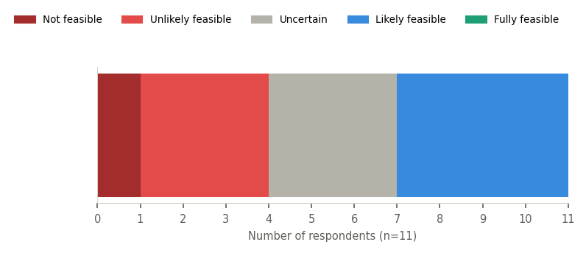 |  | Should the DPP include a small-batch pathway?  

Strong normative agreement (10/11). Feasibility is split but leans slightly positive (4 likely vs 3 unlikely vs 3 uncertain vs 1 not feasible). Derived from the Industry Living Lab workshop - the batch-certification incompatibility was identified as a systemic design flaw. The single "No" is the same respondent who said No to Q2.1: a consistent position, not an SME-specific objection.

TOPIC 3 - RECYCLABILITY
Q3.1
A shared and agreed method for assessing whether a product is recyclable - one that works across different recycling technologies - will be available in time for the 2027 DPP requirements.
How feasible is this by 2027?  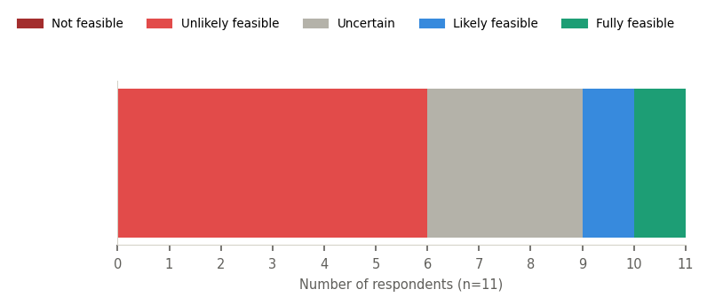 |  | Should this precede mandatory reporting?  

If yes - who should take the lead? (n=9)
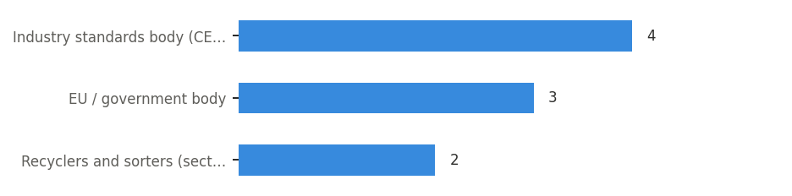

Strong normative agreement (9/11 yes: the standard should precede mandatory reporting) but clear feasibility pessimism (6/11 unlikely). This creates a policy paradox: if the standard is a prerequisite and is unlikely by 2027, then mandatory recyclability reporting is itself implausible by 2027. This implication should be surfaced explicitly in Round 3. Note: a Round 1 respondent actively sits on CEN TC248/WG39 - the exact working group tasked with developing this definition - and stated plainly they cannot produce a workable one.

Q3.2
By 2027, most brands can include the detailed product data that recyclers actually need in the DPP - such as material composition, construction type, and which chemical treatments like dyes and finishes were used.
How feasible is this by 2027?  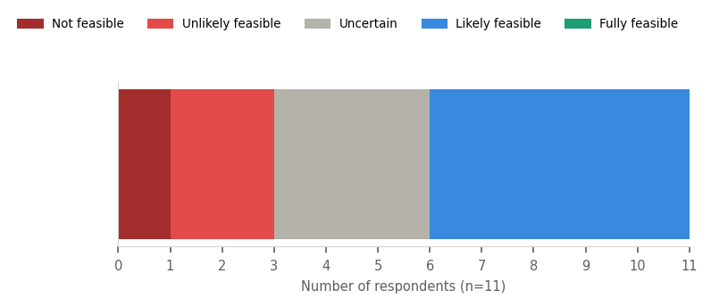 |  | Should this be required?  

Strong normative agreement (9/11) and a more optimistic feasibility picture than Q3.1 - the majority lean toward feasible. This creates a tension within Topic 3: the panel thinks the data itself is more achievable than the standard for assessing it. One open comment challenges the framing: "The DPP can only give transparency in the supply chain and help collect data - it will not help recycling itself." This mirrors the Round 1 position that recyclability indexes are only useful post-2030.

Q3.4
Without significant changes to how Producer Responsibility Organisations support the recycling sector economically, DPP recyclability requirements will have limited real-world impact on actual recycling rates.
How feasible is this by 2027?  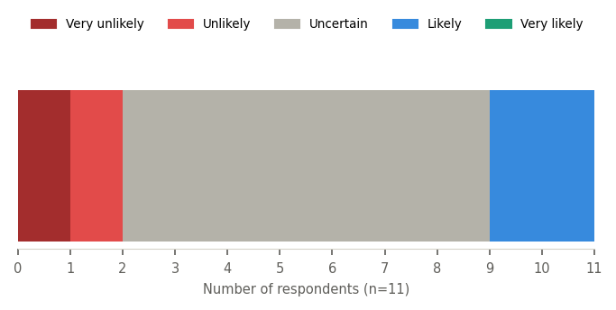 |  | Should PRO/EPR reform be a prerequisite?  

The most ambiguous statement in the dataset. Likelihood is dominated by "Uncertain" (7/11) - the panel does not feel equipped to call this. Normative agreement (8/11) is solid but the 3 "No" votes are distributed across groups (2 Supply Chain, 1 Technology & Data), not a group-specific position. This statement came exclusively from the Industry Living Lab workshop, not from Round 1 questionnaire evidence - which may partly explain why the panel struggles to assess likelihood.

TOPIC 4 - PACKAGING
Q4
Packaging data in the DPP should be structured as: [preference scale from fully separate to fully integrated]
Structural preference (n=11)
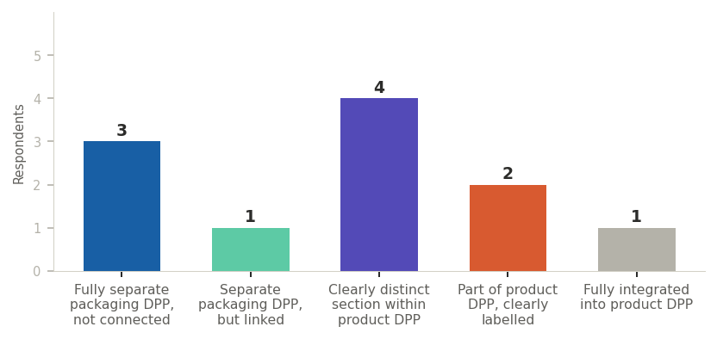

Should the EU mandate one specific approach?


Strong agreement to mandate (9/11) but votes spread across all five structural options - no option exceeds 4 respondents. The Round 1 baseline was clear: strong consensus for keeping packaging data separate from product data. Round 2 produces fragmentation, including 1 vote for "fully integrated" - the option most inconsistent with Round 1. The mandate vote obscures genuine disagreement about what to mandate. Round 3 must test the two leading options (fully separate vs. clearly distinct section) head-to-head.

TOPIC 5 - ENVIRONMENTAL FOOTPRINT
Q5.1
For the DPP, reporting which country or region each main production step took place in is more useful - and more achievable by 2027 - than collecting exact transport distances between those steps.
How feasible is this by 2027?  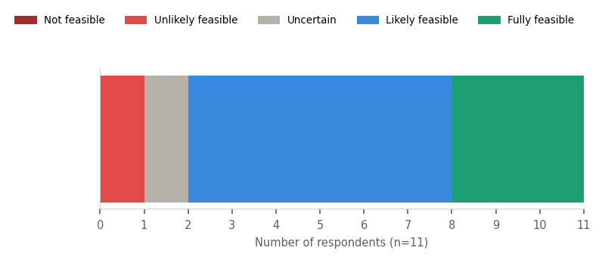 |  | Should this be required?  

The strongest feasibility finding in the dataset - 9/11 say likely or fully feasible. Combined with 9/11 saying it should be required, this approaches consensus. Consistent with Round 1 near-consensus: location data matters more than transport distance because country energy mixes drive carbon impact more than distance. One open comment locates responsibility with brands and suppliers rather than the DPP system.

Q5.2
Using estimated or average transport data - with clearly stated assumptions, and even when transport routes vary between production batches - is sufficient to meet the ESPR environmental footprint requirements for textiles by 2027.
How feasible is this by 2027?  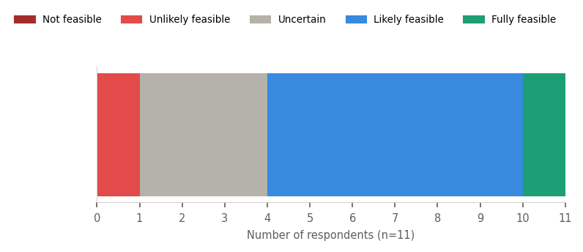 |  | Should this be accepted under the DPP?  

Majority in favour (8/11) with a positive feasibility picture. The 3 "No" votes are distributed across groups - not a group-specific objection. The "should this be accepted" phrasing was deliberate: this is a legitimacy question, not a capability question. Whether approximate data satisfies the ESPR's requirement for "accurate" environmental footprint data remains legally unresolved.

SUMMARY - FINDINGS BY TYPE
Across 12 statements and 11 respondents, three distinct patterns emerge.
Near-consensus | Normative agreement + feasibility doubt | Genuinely contested
Q5.1 - location data over transport distance (9/11 yes, strong positive feasibility) | Q1.1, Q2.2, Q3.1, Q2.4 - unanimous or near-unanimous "should happen" but majority doubts the 2027 timeline Q3.4, Q3.2, Q5.2 - solid majority with moderate feasibility uncertainty | Q1.2 - 6/5 normative split; nobody finds it feasible Q1.3 - majority wants mandatory verification but governance scattered across four bodies Q4 - 9/11 want EU to mandate, votes spread across all five options

KEY TENSIONS FOR ROUND 3
1. Normative agreement vs. feasibility pessimism
Across Q1.1, Q1.3, Q2.2, and Q3.1, the panel says "yes it should happen" but simultaneously doubts it can happen by 2027. Round 3 must address this directly: does the panel want these phased in after 2027, and if so, what are the preconditions?
2. Chemical safety data (Q1.2) - the contested outlier
The only statement without majority normative agreement. No respondent finds it feasible. Round 3 should confront the distinction between "not required yet" (no test method exists) and "not required at all."
3. Governance disputes on verification and standards
Q1.3 and Q2.2 show no dominant governance view. Round 3 should present the vote distribution for each governance option and ask respondents to reconsider.
4. The Q4 packaging paradox
Strong agreement to mandate one approach (9/11), no majority for any specific option. Round 3 should test the two leading preferences - fully separate DPP vs. clearly distinct section - head-to-head, and surface the Round 1 consensus for comparison.
5. The Q3.1 policy paradox
9/11 say a recyclability standard should precede mandatory reporting; 6/11 say that standard is unlikely by 2027. The logical implication - that mandatory recyclability reporting is itself implausible by 2027 - should be put directly to the panel in Round 3.
6. Open comments raising conceptual challenges
Two substantive positions emerged in open comments. First: the DPP can only provide transparency and data - it cannot itself make recycling happen. Second: EU-only standards fail because non-EU suppliers are not bound by EU regulation; ISO standards are global and already adopted. Both deserve structured consideration in Round 3.

