M-DPP Project
Delphi Stakeholder Consultation
Round 3 — Questionnaire Draft

Work Package 1 — Stakeholder Engagement & Compliance Requirements
Fashion Research & Technology — Amsterdam University of Applied Sciences (HvA)
2026
This document contains the full Round 3 questionnaire draft, including introduction text, group guidance, all four questions with result images, closing text, and a methodology note on question design decisions. It is structured for direct use in reporting and as a reference for building the Microsoft Forms version.

1. INTRODUCTION TEXT
The following text is shown to all participants at the start of Round 3, before the group guidance and questions.

Round 3 — Delphi Stakeholder Consultation
M-DPP Project — Work Package 1

This is the third and final round of the M-DPP Delphi consultation. Thank you for staying with us through the process.
In the first two rounds, you answered open questions about what a Digital Product Passport should require, and then rated the feasibility and desirability of twelve specific statements. Eleven people completed Round 2.
What we found overall
Three patterns came out of Round 2 clearly.
- Several requirements have near-unanimous support but serious feasibility doubts. The panel consistently said "this should happen" but doubted it can happen by 2027. This gap between what the sector considers necessary and what is realistic within the regulatory timeline is the central finding of Round 2.
- One requirement is genuinely contested. Microfibre and nanoplastic data (Q1.2) is the only statement where the panel split almost evenly on whether it should be required at all — and nobody found it feasible by 2027.
- Three questions produced no clear answer. Who should oversee verification (Q1.3), the recyclability timeline paradox (Q3.1), and the packaging structure choice (Q4) all need one further round of input before a final position can be documented.

How this round works
For each question, you will see the Round 2 results first — the chart shows how the full panel responded. Then we ask you one focused follow-up question. You may change your previous position or hold it. Both are equally valid.
This is a short round: four questions. It should take no more than ten minutes.

2. SCREENING QUESTIONS (S1, S2, S3, S3A)
Keep identical to Round 2. Same groups, same supply chain tiers, same role categories. No changes to the questions or answer options are needed. Confirm in Microsoft Forms that the routing logic still directs all four groups to the same set of questions, as there are no group-specific questions in Round 3.

3. GROUP GUIDANCE
The group guidance boxes appear after S3/S3a, before the first question. The structure and content of the four boxes are identical to Round 2, with only the opening sentence updated to acknowledge the round context.

Updated opening sentence (to replace the Round 2 version in all four boxes)
You are now in Round 3, the final round. Below you will see the results from Round 2 before each question. Please answer from your own experience and position — you do not need to align with what others said, but you may find it useful to see where opinions differ.

The remainder of each group guidance box — including the group-specific context and instruction — stays the same as Round 2. No other changes are required.

4. QUESTIONS
Round 3 contains four questions. Each question shows the relevant Round 2 result as an image (uploaded in Microsoft Forms), followed by a brief framing note, and then the question itself with answer options. An optional open text field follows each question.

R3-Q1 | Round 2 result shown above — Q1.2: Plastic microfibre and nanoplastic release data

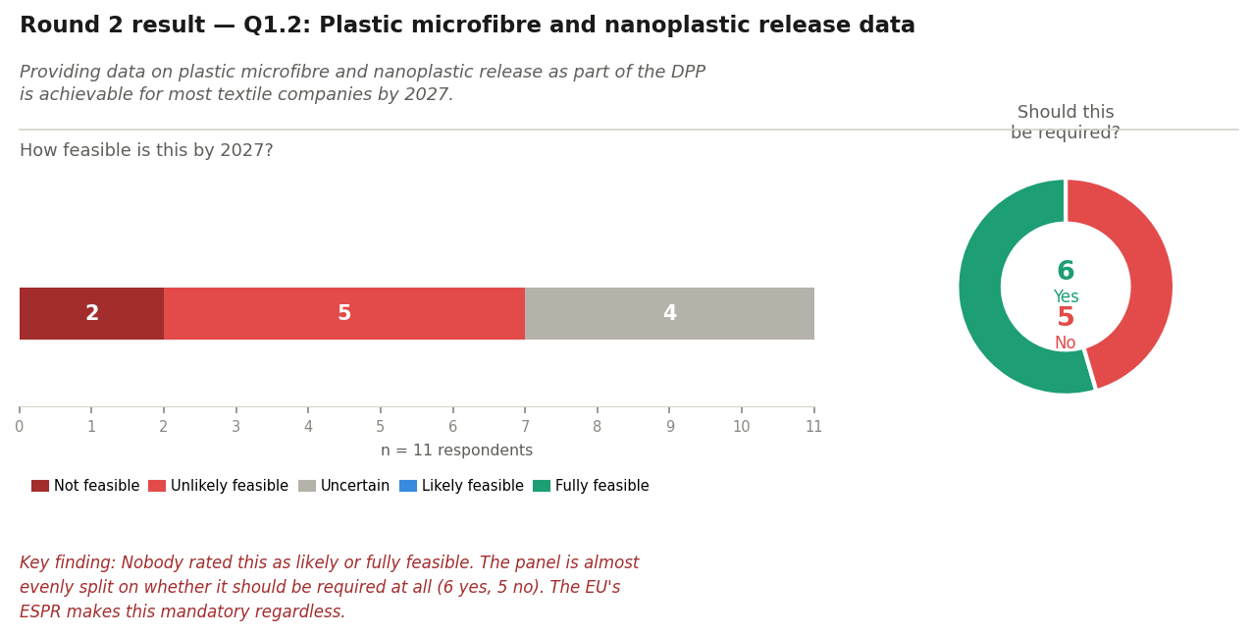

The EU's ESPR regulation makes microfibre and nanoplastic data mandatory in the DPP. No standardised test method currently exists. In Round 2, nobody found this feasible by 2027, and the vote on whether it should be required was almost even: 6 yes, 5 no.
Given that no standardised test method currently exists, which of these positions best describes your view?
- This should be required under the DPP from 2027, even without a standardised test method — companies should use the best available approach.
- This should be required under the DPP, but only once a standardised test method is in place — the requirement should be phased in.
- This should not be required under the DPP at all, even if a test method becomes available.

Is there anything that shaped your choice that you would like to add? [open text — optional]

R3-Q2 | Round 2 result shown above — Q1.3: Independent third-party verification

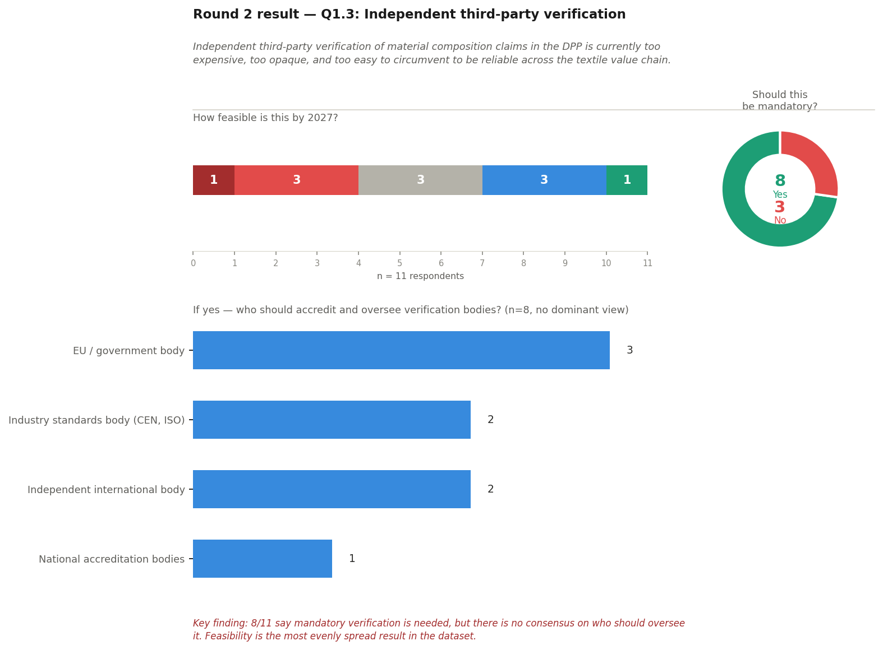

In Round 2, 8 out of 11 said independent verification of DPP material claims should be mandatory. But there was no dominant view on who should be responsible — votes were spread across four different options with no majority.
Looking at the four options below, which one do you think is most realistic by 2027?
- EU / government body — provides regulatory authority and enforcement power, but building accreditation capacity by 2027 would require significant new infrastructure.
- National accreditation bodies (e.g. RvA in the Netherlands, DAkkS in Germany) — already operational and legally recognised in member states, but coordination across borders would be needed.
- Industry standards body (e.g. CEN, ISO) — internationally recognised and already used by non-EU suppliers, but does not carry direct regulatory enforcement authority.
- Independent international body (e.g. IAF — International Accreditation Forum) — globally recognised and already accredits national bodies, but not specifically mandated within EU regulatory frameworks.

Why did you choose this option? Feel free to explain, especially if your view has changed since Round 2. [open text — optional]

R3-Q3 | Round 2 result shown above — Q3.1: A shared recyclability assessment method by 2027

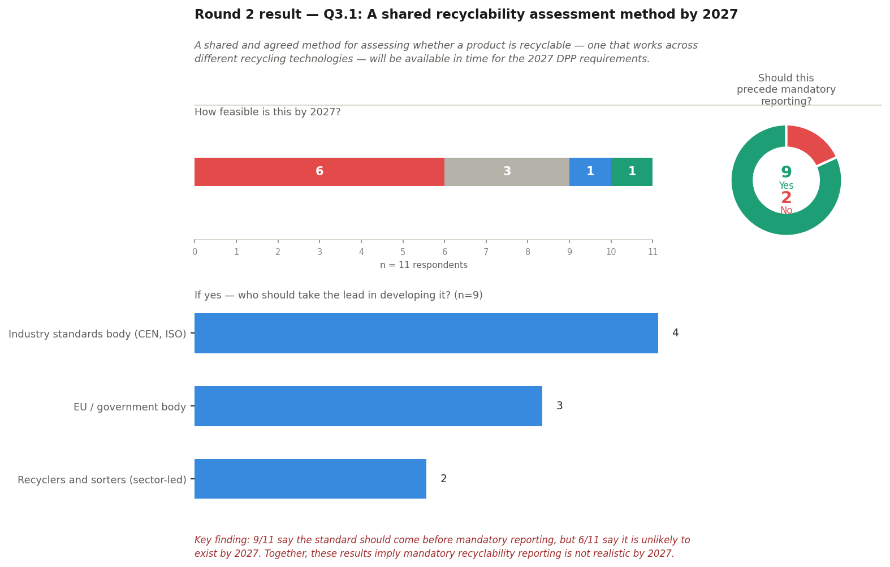

In Round 2, 9 out of 11 said a shared recyclability assessment method should exist before mandatory recyclability reporting begins — but 6 out of 11 said that method is unlikely to be ready by 2027. If both of those things are true at the same time, they imply that mandatory recyclability reporting under the DPP is not realistic by 2027.
Do you agree with that conclusion?
- Yes — mandatory recyclability reporting should be delayed until a shared assessment method is in place, even if that means going beyond 2027.
- No — mandatory recyclability reporting should proceed from 2027 as planned, even if the shared assessment method is not yet available.
- I am not sure.

Is there anything you would like to add about the recyclability requirements or the timeline? [open text — optional]

R3-Q4 | Round 2 result shown above — Q4: How should packaging data be structured in the DPP?

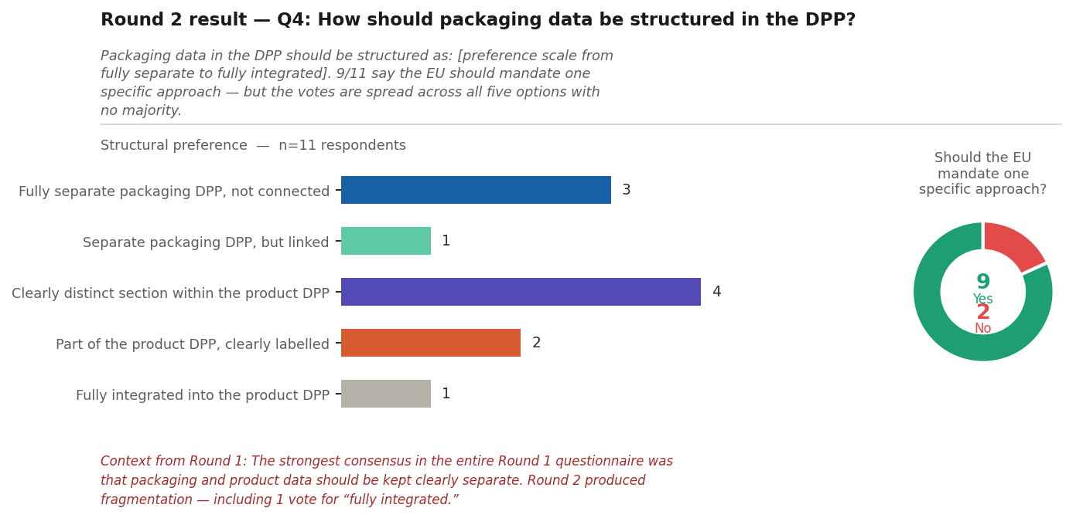

In Round 2, 9 out of 11 said the EU should mandate one specific approach for packaging data in the DPP — but the votes were spread across all five options with no majority. In Round 1, the clearest consensus in the entire questionnaire was that packaging and product data should be kept clearly separate.
Between the two most chosen options in Round 2, which do you prefer?
- Fully separate packaging DPP, not connected to the product DPP (chosen by 3 respondents in Round 2).
- Clearly distinct section within the product DPP (chosen by 4 respondents in Round 2).

Why do you prefer this option? [open text — optional]

5. CLOSING TEXT
The following text is shown to all participants after the final question.

Thank you — that completes Round 3.
Your response completes your participation in the M-DPP Delphi consultation. The results of all three rounds will be analysed together and will contribute directly to the project's work on compliance requirements for the textile Digital Product Passport.
A summary of the final findings will be shared with all participants after analysis is complete. If you have questions in the meantime, please reach us at mdpp-fdmci@hva.nl.
More about the project: m-dpp.nl | Outputs: m-dpp.nl/outputs/

6. QUESTION DESIGN — METHODOLOGY NOTE
This section documents the key decisions made in designing the Round 3 questions. It is intended for inclusion in the research reporting and methodology account of the Delphi process.

Scope: why four questions
Round 3 addresses only the questions that remained genuinely unresolved after Round 2. Several Round 2 statements — including Q2.1 (supply chain traceability), Q5.1 (location data over transport distances), and Q2.4 (small-batch compliance pathways) — showed strong normative agreement combined with reasonably positive feasibility ratings. There is no meaningful unresolved tension in these results that warrants further iteration. Including settled questions in Round 3 would increase respondent burden without analytical benefit.

Questions not carried forward | Q2.1 — near-consensus (10/11 yes, majority feasible). Q2.4 — strong agreement (10/11 yes). Q3.2 — solid majority with positive feasibility. Q3.4 — majority agreement but dominated by "Uncertain" on likelihood; not a dispute the panel can resolve. Q5.1 — closest result to full consensus in the dataset. Q5.2 — clear majority in favour.

Reserve pool (Appendix A): what was considered and why it was excluded
The reserve statement pool from Round 1 (Q2.3, Q2.5, Q3.3, Q5.3) was reviewed for potential inclusion in Round 3. None of the four reserve statements is included. Q2.3 (shared supplier data platform) is solution-specific enough that it risks generating debate about mechanism rather than principle; the underlying interoperability principle is already covered by Q2.2. Q2.5 (non-EU supplier DPP interoperability) is a significant open issue but was raised exclusively in the workshop without questionnaire support, making it unsuitable for a final round that aims to resolve existing disputes rather than introduce new ones. Q3.3 (brand responsibility for recyclability) is analytically useful but adds a fifth question in a round explicitly designed to be short. Q5.3 (traceability before footprint sequencing) is not included because Q5.1 already produced near-consensus.

R3-Q1 — question format change
In Round 2, the microfibre and nanoplastic question (Q1.2) used a binary yes/no format and produced a near-even 6/5 split that is difficult to interpret. Analysis of the Round 2 data suggests that several "No" votes most likely expressed the position "not until a standardised test method exists" rather than "this should never be required." A binary question asked again would most likely reproduce the same unresolvable split.
Round 3 therefore presents this as a three-way choice, making the "phased in once a test method exists" position explicit. This format allows the final analysis to distinguish between outright rejection of the requirement and conditional acceptance — a distinction that is directly relevant to regulatory engagement.

Note on ESPR mandate | The ESPR framework mandates microfibre and nanoplastic data regardless of feasibility assessments by this panel. The R3-Q1 question is therefore not a question about whether this data will eventually be required — it is a question about the appropriate implementation pathway and timing, which remains a genuine open policy question.

R3-Q2 — governance question
The Round 2 result for Q1.3 showed a clear majority (8/11) in favour of mandatory independent verification, but no dominant preference among the four governance options. The feasibility rating was the most evenly distributed result in the entire Round 2 dataset. Round 3 presents the four options directly and asks respondents to select the most realistic one, with an open field for reasoning. The aim is not to force consensus where none exists, but to allow respondents to see the spread and reconsider in light of it.

R3-Q3 — surfacing the logical implication
The Round 2 result for Q3.1 contains a logical tension that the question format alone could not resolve: 9/11 said a shared recyclability assessment method should precede mandatory reporting, while 6/11 said that method is unlikely to be available by 2027. These two positions together imply that mandatory recyclability reporting is not realistic by 2027 — but this conclusion was not put directly to the panel in Round 2.
Round 3 surfaces this implication explicitly and asks respondents to accept, reject, or express uncertainty about it. This is the most direct way to resolve the tension. The "I am not sure" option is retained deliberately: it is analytically informative if respondents acknowledge the tension but are not prepared to draw the conclusion, which itself tells a story about the limits of what the sector can currently say about the 2027 recyclability timeline.

R3-Q4 — head-to-head between the two leading options
Round 2 produced a fragmented result for the packaging structure question: 9/11 agreed the EU should mandate one approach, but votes were spread across all five options with no option receiving a majority. Presenting all five options again in Round 3 would most likely reproduce the same fragmentation.
The Round 3 question therefore narrows the choice to the two options that received the most votes in Round 2 ("fully separate packaging DPP, not connected" with 3 votes, and "clearly distinct section within the product DPP" with 4 votes). Both options are consistent with the Round 1 consensus on separation — the distinction is about whether that separation should be architectural (fully separate) or structural within the same document. Respondents who chose one of the three other options in Round 2 are not excluded: the open text field gives them the opportunity to explain why neither leading option reflects their position.

Round 1 context | The strongest consensus in the entire Round 1 questionnaire was that packaging and product data should be kept clearly separate. This context is surfaced explicitly in the R3-Q4 question framing to help respondents who may not have connected their Round 2 preference to the earlier round.

Panel size note
The Policy, Research & Civil Society group is represented by a single respondent in this consultation. This is noted for the methodology account: responses from this group will be included in the final analysis but should be interpreted with appropriate caution given the absence of within-group variation. This consideration does not require any change to the questionnaire design, but should be reflected transparently in the final report.

