Key Activity
Stakeholder Engagement & Policy Alignment: Conducting Delphi-method stakeholder consultations to establish compliance requirements while prioritizing process simplification

Delphi-method
The method rests on four key principles:
- Expert panel
A carefully selected group of experts with relevant, complementary knowledge.
- Anonymity
Experts do not know who gave which response.
→ Reduces authority bias, peer pressure, and reputational effects.
- Iteration with feedback
Multiple rounds of questioning are conducted.
After each round, participants receive a summary of the group’s responses.
- Controlled convergence
Experts are invited to revise or maintain their views in light of the group feedback.
→ The goal is reasoned convergence, not forced consensus.

Steps
1. Define the problem
The research team formulates a clear, bounded question, for example:
- Future scenarios
- Priority setting
- Risks and barriers
- Design requirements
- Policy options
2. Select experts
Experts are chosen based on:
- Domain knowledge
- Practical experience
- Stakeholder representation
Panels typically range from 10–40 participants, depending on scope.
3. Round 1 – Exploration
- Open-ended questions
- Experts provide independent views, assumptions, and arguments
- Responses are qualitatively analysed and synthesised
4. Round 2 – Structuring & evaluation
- Statements derived from Round 1 are presented
- Experts rate, rank, or comment (e.g. Likert scales)
- Statistical summaries are generated (median, range, disagreement)
5. Round 3 (and sometimes 4) – Refinement
- Experts see the aggregated results
- They may revise their answers or justify outliers
- Stability or convergence is assessed
6. Interpretation
The outcome is not “the truth” but:
- Areas of strong agreement
- Areas of persistent disagreement
- Rationales behind differing views

There is currently no shared, stakeholder-validated understanding of which requirements are essential for Digital Product Passports to be both regulatory-compliant and practically usable across the textile value chain.

This Delphi study aims to align expert perspectives on compliance-relevant requirements while identifying opportunities to simplify processes, in order to inform the development of the M-DPP system (WP2 and WP3).

Stakeholders across the textile value chain currently lack a shared understanding of what Digital Product Passports must actually require in order to be both compliant with emerging EU regulations and workable in everyday practice.
While regulatory frameworks such as the Ecodesign for Sustainable Products Regulation define what information must ultimately be available, there is far less clarity on how this information should be generated, verified, connected, and maintained across the product lifecycle—especially in ways that remain accessible to SMEs and do not introduce unnecessary complexity.
Perspectives differ significantly on acceptable levels of material verification, data granularity, system interoperability, governance, and cost. As a result, DPP development risks becoming overly complex, fragmented, or misaligned with real operational practices.

This Delphi study addresses that gap by systematically engaging stakeholders to define and prioritise compliance-relevant requirements, while explicitly identifying opportunities for process simplification.
The goal is to establish a shared, practice-grounded set of requirements that can guide the development of molecular material databases (WP2) and digital infrastructures (WP3).

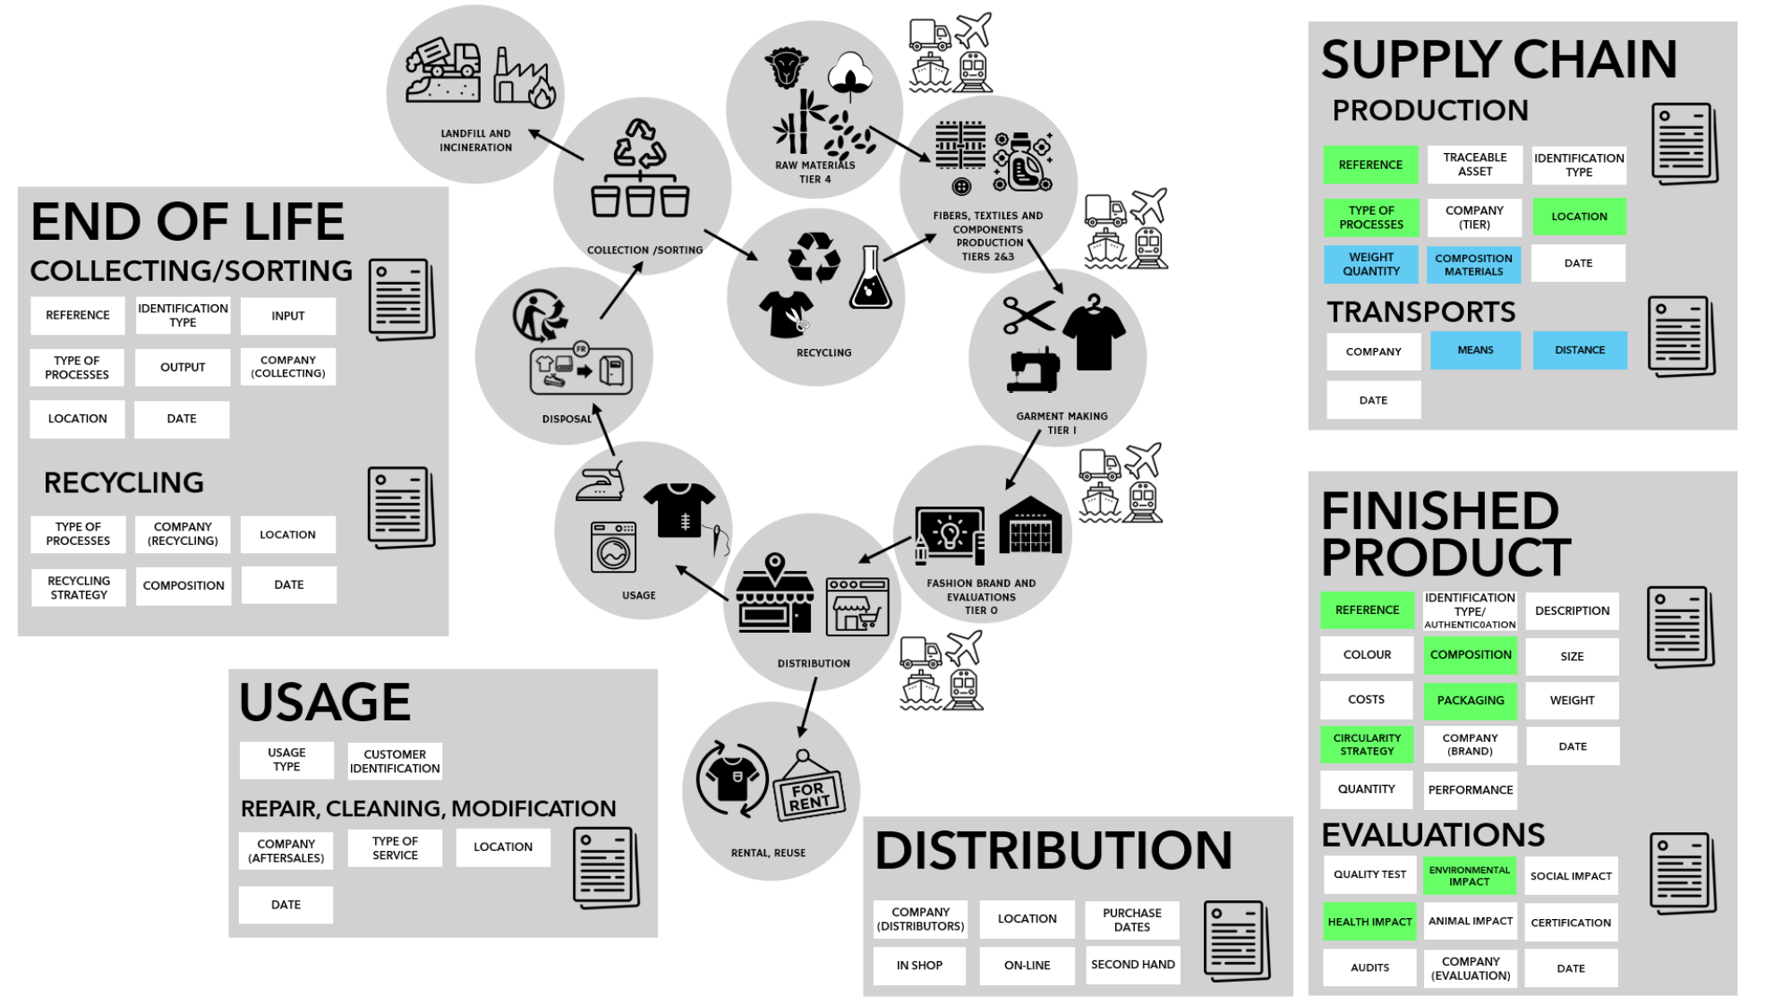
Figure 13 – Simplified DPP Model for phase 1

Step 2 – Selection of Experts for the questionnaire

EPSR Survey
• 35% Brands/Retailers (Tier 0)
• 28% Suppliers (Tiers 1–4)
• 12% DPP Tech Experts/Service Providers
• 12% NGOs/Associations
• 7% Recyclers/Sorters
• 5% Researchers/Academia

1. The Supply Chain (Producing Industry) 63% vs 34% >> min. of 50%
2. Circularity and End-of-Life Operators 7% vs 9%
3. Technology and Data Enablers 12% vs 8%
4. Governance, Policy, and Civil Society 17% vs 49% >> lets be more selective in who we will include

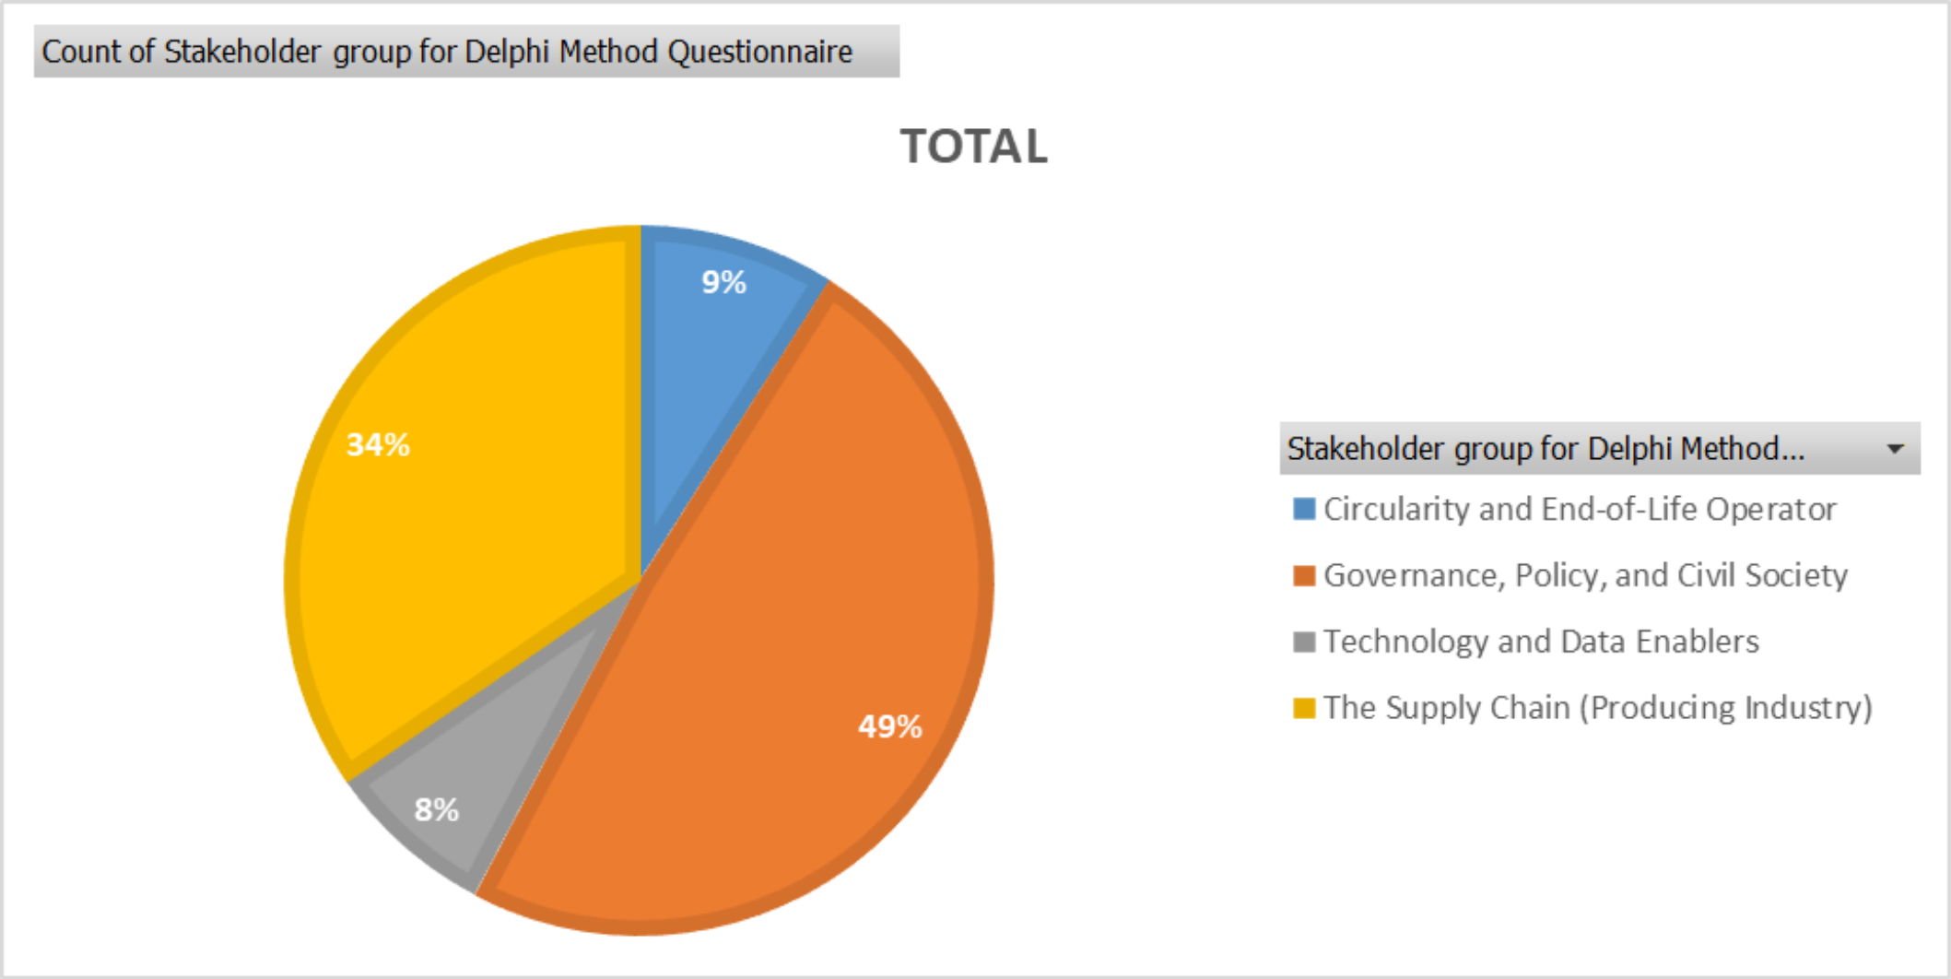

1. The Supply Chain (Producing Industry)
The documents frequently categorise these stakeholders by "Tiers" to distinguish their role in the production lifecycle. The EPRS study and CIRPASS-2 report break them down as follows:
• Tier 4 (Raw Material Producers): Entities responsible for extraction or farming (e.g., growers, breeders, chemical extractors),.
• Tier 2 & 3 (Processors and Component Manufacturers): Factories processing raw materials into intermediate goods (e.g., spinners, weavers, knitters, dyers, tannery operations),.
• Tier 1 (Finished Product Manufacturers): Companies that assemble the final product (e.g., garment workshops, furniture assemblers),.
• Tier 0 (Brands and Retailers): The brands placing products on the market, retailers, and distributors. This group often holds the "DPP role" and budget,.
◦ Specific Roles to Target: The EPRS survey highlights specific job titles to interview within these companies, including Heads of Sustainability/Circularity, CEOs, CTOs, CSR Managers, and Quality Experts,.
Note on Sectors: While the EPRS document focuses on textiles, the CIRPASS-2 survey (EWG5) explicitly included "Other Industries" such as electronics, batteries, construction, chemicals, furniture, and steel/mining,.

2. Circularity and End-of-Life Operators
To address the 2027 regulations regarding "recyclability" and "recycled content," the sources interviewed actors who manage the product after its primary use:
• Collection and Sorting Companies: Operators responsible for gathering used products and sorting them for reuse or recycling,.
• Recyclers: Companies processing waste into new materials,.
• Repair and Maintenance Services: Entities extending product life (e.g., repair shops, cleaning services),.
• Second-hand / Reuse Platforms: Distributors focused on resale and rental models.

3. Technology and Data Enablers
These stakeholders are critical for the "how" of the DPP (interoperability and data carriers). The CIRPASS-2 report classifies these as "Non-producing industry participants":
• DPP Service Providers & Tech Companies: Firms providing the software, identifiers (QR/RFID), and platforms for the passport,.
• Consultants: Experts advising on sustainability strategies and compliance.
• Certification and Assessment Bodies: Third-party auditors responsible for verifying claims (e.g., Oeko-tex, chemical compliance),.

4. Governance, Policy, and Civil Society
To ensure your questionnaire covers regulatory compliance and public interest, consider including:
• Public Authorities: Customs officials, policy makers, and market surveillance authorities,.
• NGOs and Industry Associations: Groups representing civil society or specific industrial interests.
• Researchers and Academics: Those studying the theoretical and impact aspects of DPPs,.
• Consumers (or Consumer Organizations): To gauge public understanding of transparency and the "willingness to scan",.

