**인공지능 로봇팔: 물건을 인식하여 집어서 분류**

블럭도

<https://drive.google.com/file/d/1AZA_HlnQqCGZRhArYxMdqzkAqBgoEwge/view?usp=sharing>

원본 모델 (참고자료)

[https://](https://www.youtube.com/watch?v=YZovpasZSjc)w[ww.youtube.com/watch?v=YZovpasZSjc](https://www.youtube.com/watch?v=YZovpasZSjc)

서보모터 MG996R

| <https://www.devicemart.co.kr/goods/view?no=12503489> |
| --- |

마이크로서보모터 SG90

| <https://www.devicemart.co.kr/goods/view?no=12503474&gclid=CjwKCAjwvfmoBhAwEiwAG2tqzNdgEGCin-QO2dGhbaPkMnyILwk3WOvcgjrnw3rtzcgYODKAt5lxihoCgicQAvD_BwE> |
| --- |

서보모터 드라이버

| <https://www.devicemart.co.kr/goods/view?no=1382245> |
| --- |

3D프린터 모델

<https://thangs.com/d> esigner/HowToMechatronics/3d-model/Robotic%20Arm%203D%20Model-38899

stm32를 이용한 모터제어

텐서플로우

open CV

물건 분류 모델

로봇팔 제어(좌표)

STM32와 모터 드라이버연결

[http://wiki.sunfounder.cc/index.php?title=PCA9685_16_Channel_12_Bit_PWM_Servo_Driver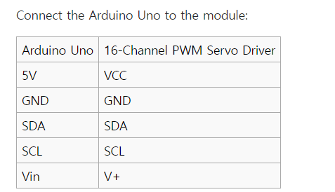](http://wiki.sunfounder.cc/index.php?title=PCA9685_16_Channel_12_Bit_PWM_Servo_Driver*)