Curriculum Vitae

Professional Qualifications: IsDB-BISEW Diploma
Module | Description | Course Duration  (Hours)
Module - 01 | Computer Fundamentals
Module - 02 | HTML,CSS3,Bootstrap
Module - 03 | JavaScript
Module - 04 | Database Driven Web Application using PHP, MySQL
Module - 05 | jQuery , WordPress
Module - 06 | React Js
Module - 07 | Laravel
Module - 08 | Vue.js

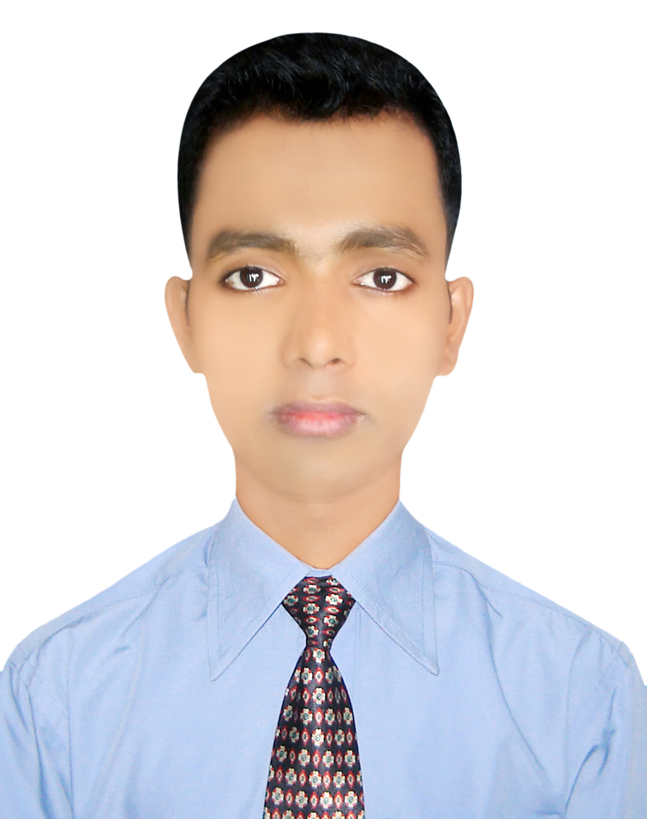
Md. Ramzan Ali

Contact

Mobile:
01559-075906
Address:
Prembagan, Dokkhinkhan, Uttora, Dhaka-1230.
Home Phone:
01822-976431
E-mail:
mdramzanaliisdbr59@gmail.com

Personal Info
Father’s Name:
MD ABDUL AZIZ
Mother’s Name:
ROHIMA BEGUM
Date of Brith:
15-12-1994
Gender:
Male
Marital Status:
UNMARRED
Nationality:
BANGLADESHI
Permanent Address:
Vill: Patachara, Post:Ramgarh, Thana: Ramgarh, Diss: Khagrachari.

