John Renz W. Bernardino 2024-12646
Doc. Mai 11/16/2024
CPE 0112-1.2 Score: _____

Test I: Multiple Choice

1. B. 11. D.
2. B. 12. B.
3. B. 13. C.
4. A. 14. B.
5. C. 15. C.
6. C. 16. C.
7. C. 17. B.
8. D. 18. A.
9. C. 19. A.
10. B. 20. B.

II. Coding
Case 1: Sum of Two Numbers
#include<stdio.h>
int main()
{
int num1, num2, sum;
printf("Enter a two numbers, and I'll add those two numbers together. \n");
printf("Please type your 1st number. \n");
scanf("%d",&num1);
printf("Please type your 2nd number. \n");
scanf("%d",&num2);
sum = num1 + num2;
{
printf("The sum of the given number is = %d",sum);
}
return 0;
}

Output
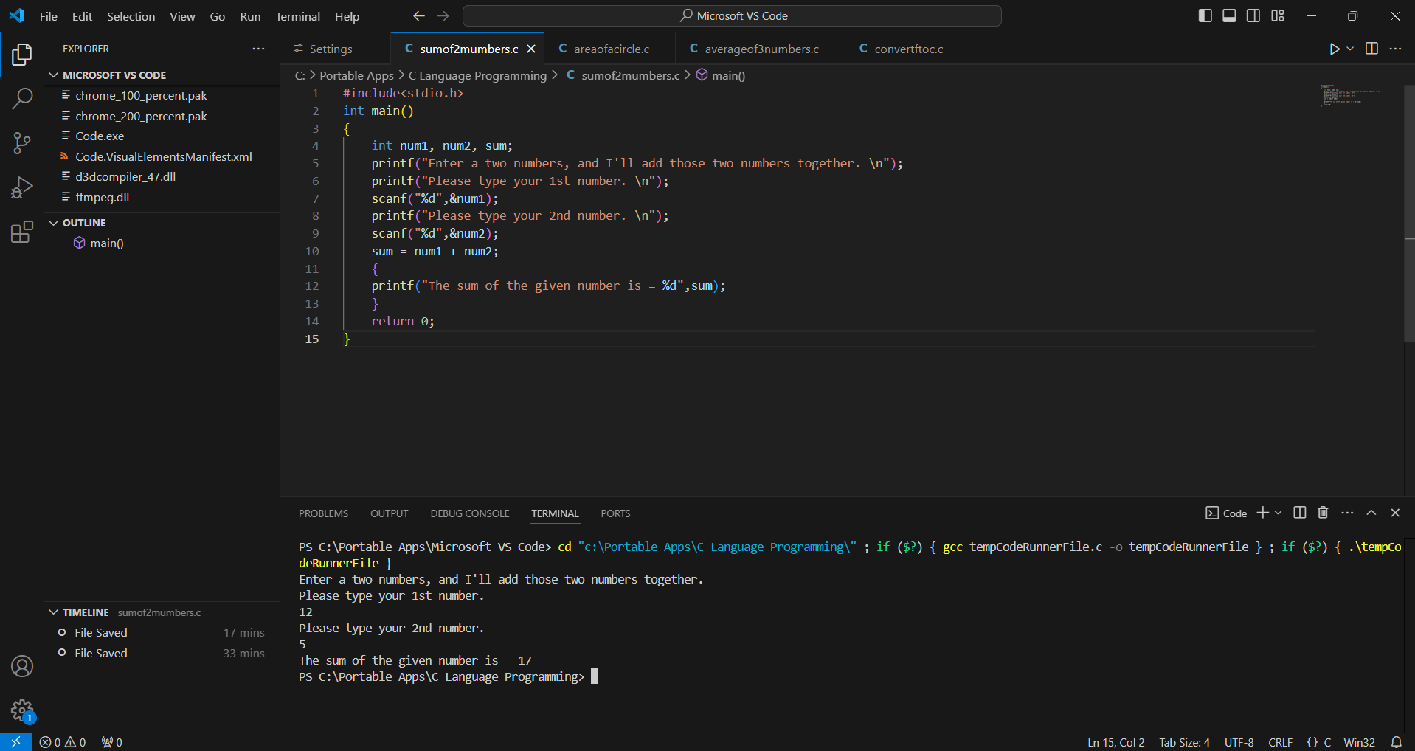

Case 2: Calculate the Area of a Circle
#include<stdio.h>
int main()
{
int radius;
const float pi = 3.14;
float area;
printf("Please enter the radius of a circle, and I'll compute its area. \n");
scanf("%d",&radius);
area = pi * radius * radius;
{
printf("The area of the circle is = %f", area);
}
return 0;
}

Output
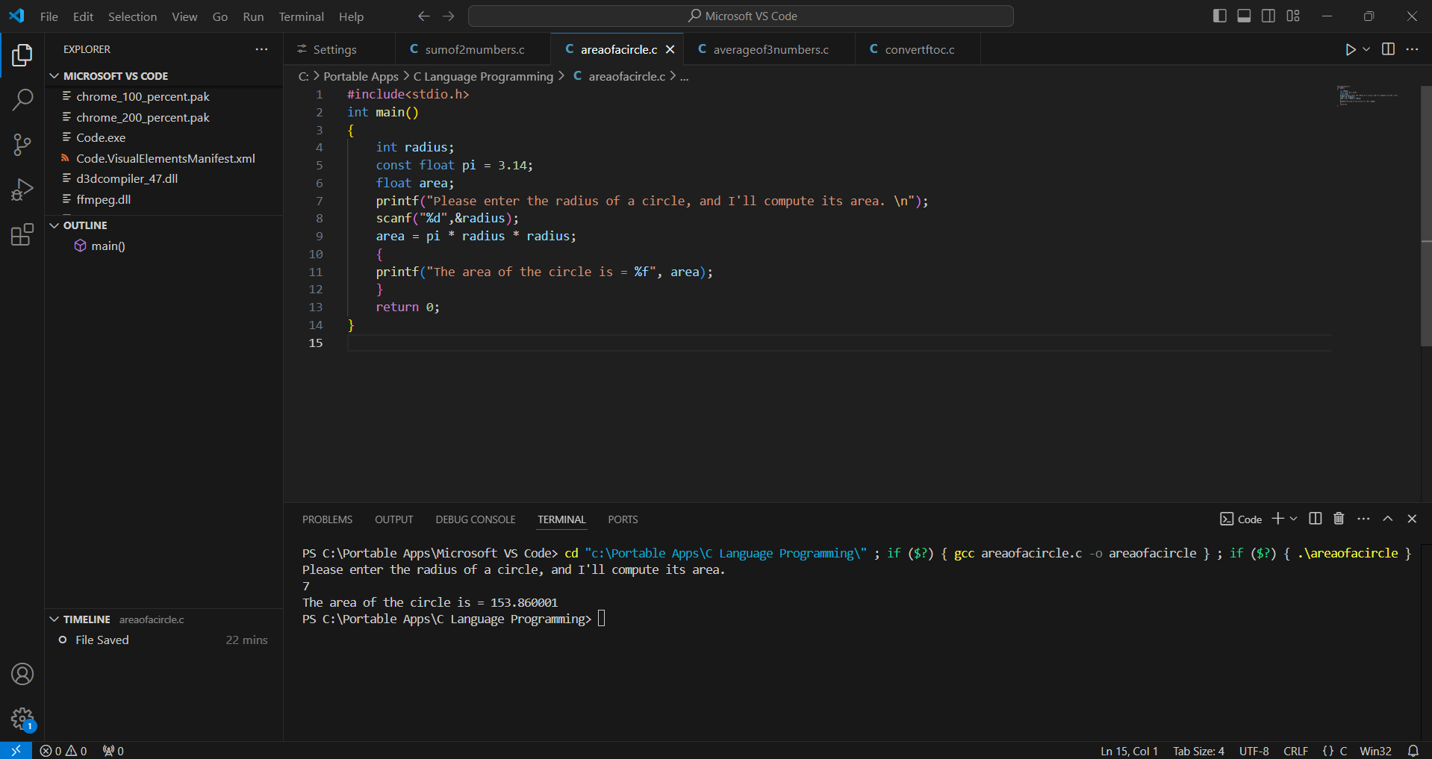

Case 3: Compute the Average of Three Numbers
#include<stdio.h>
int main()
{
int num1, num2, num3;
float ave;
printf("Please enter three numbers, and I'll get its average. \n");
printf("Enter your first number. \n");
scanf("%d",&num1);
printf("Enter your second number. \n");
scanf("%d",&num2);
printf("Enter your third number. \n");
scanf("%d",&num3);
ave = (num1 + num2 + num3) / 3;
{
printf("The average of the three numbers is = %f",ave);
}
return 0;
}

Output
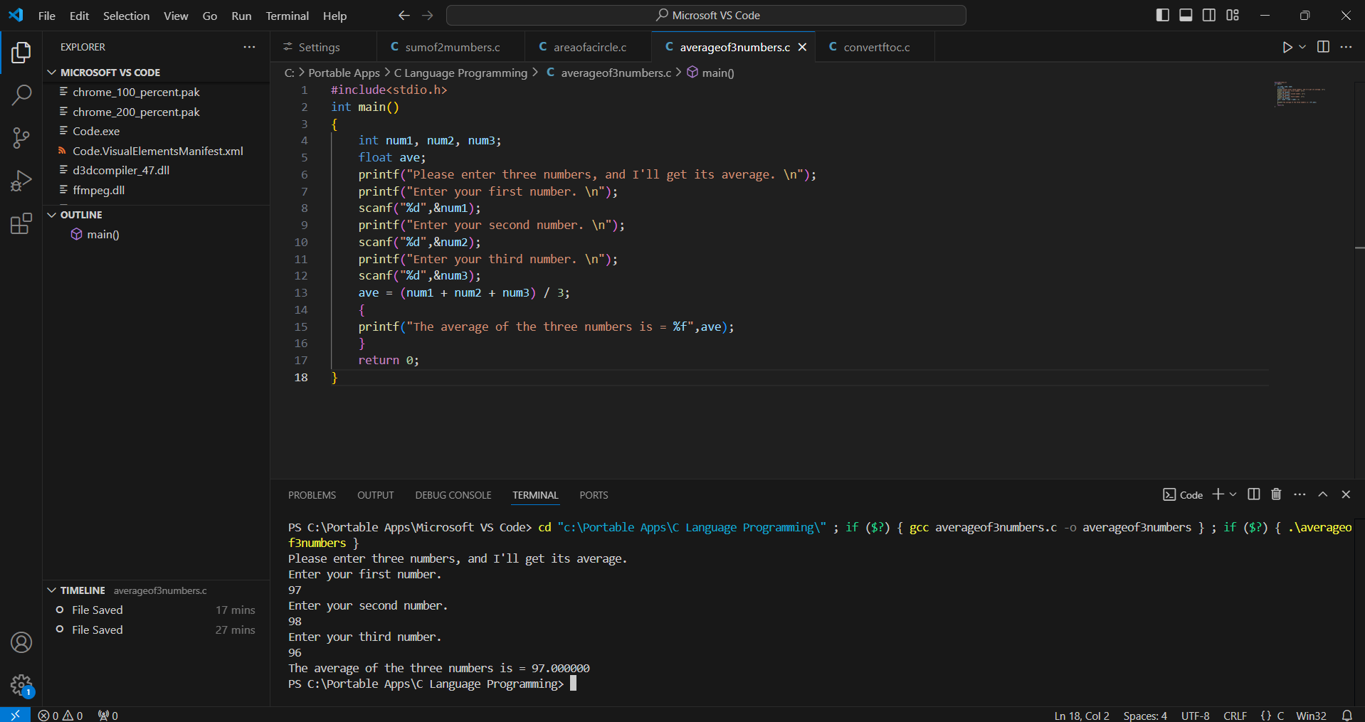

Case 4: Convert Fahrenheit to Celsius
#include<stdio.h>
int main()
{
float f, c;
printf("Enter a value of a Fahrenheit, and I'll convert it into Celsius. \n");
scanf("%f",&f);
c = (f - 32)*5/9;
{
printf("The input Fahrenheit is converted into %f Celsius.",c);
}
return 0;
}

Output
