PREMIER UNIVERSITY, CHITTAGONG
Department of Computer Science & Engineering


PROJECT REPORT
Course Name : Big Data Analytics Laboratory
Course Code : CSE 4346
Name of Report : Student Lifestyle, Academic Performance and
Mental Health Analysis Using Hadoop
MapReduce and Apache Pig
Date of Submission : 15.09.2026
Submitted By,
Name : Robiul Hassan
ID : 0222220005101043
Semester : 8th
Batch : 42nd
Session : Spring - 26 Section : A
Remarks

Submitted To :
MD Tamim Hossain
Lecturer, Department of Computer Science & Engineering
Premier University

Problem Statement
The increasing amount of student-related data makes it difficult to efficiently analyze the relationships between students' academic performance, lifestyle habits, stress levels, sleep duration, study hours, and mental health. Traditional data processing methods may become inefficient when handling large datasets.
This project aims to use Hadoop MapReduce and Apache Pig to process and analyze a dataset containing 100,000 student records. The analysis focuses on identifying academic and lifestyle patterns, comparing different student groups, and extracting meaningful information such as average CGPA, stress levels, sleep duration, study hours, depression status, and top-performing students.
The project demonstrates how big data processing technologies can be used to efficiently process large-scale student data and generate useful analytical results.

Dataset Description
Attribute | Description | Data Type
Student_ID | Unique identification number of each student | Integer
Age | Age of the student | Integer
Gender | Gender of the student | Categorical
Department | Academic department of the student | Categorical
CGPA | Cumulative Grade Point Average | Float
Sleep_Duration | Average daily sleep duration in hours | Float
Study_Hours | Average daily study hours | Float
Social_Media_Hours | Average daily social media usage in hours | Float
Physical_Activity | Physical activity level/duration | Integer
Stress_Level | Student's stress level | Integer
Depression | Indicates whether the student has depression | Boolean
The dataset file used during the experiments is student_lifestyle_100k.csv. It contains 100,000 records and is approximately 5 MB in size..

Summary of Data Analysis
The following MapReduce programs and their different design patterns are implemented:
- Filtering
- Summarization
- Counting
The following analyses are performed on the dataset using MapReduce:
- Calculate Average CGPA by Department
- Calculate Average Stress Level by Gender
- Calculate Number of Students by Depression Status
The following analyses are performed on the dataset using Apache Pig:
- Calculate Top 10 Students by CGPA
- Calculate Average Study Hours by Department
- Calculate Average Sleep Duration by Depression Status
- Calculate Top 10 Students by Study Hours
Map Reduce Analysis
- Average CGPA by Department:
Returns the average CGPA of students for each academic department. This analysis comprises of:
i. Driver Class : Sets the configuration for the Mapper and Reducer classes and defines the input and output paths.
ii. Mapper Class : Emits the department of type Text as the key and CGPA of type DoubleWritable as the value.
iii. Reducer Class : Calculates the average CGPA for each department and emits the department of type Text and average CGPA of type DoubleWritable.
Driver Class
public class AverageCGPADriver {

public static void main(String[] args) throws Exception {

if (args.length != 2) {
System.err.println("Usage: AverageCGPADriver <input> <output>");
System.exit(2);
}

Configuration conf = new Configuration();

Job job = Job.getInstance(conf, "Average CGPA by Department");

job.setJarByClass(AverageCGPADriver.class);

job.setMapperClass(AverageCGPAMapper.class);
job.setReducerClass(AverageCGPAReducer.class);

job.setMapOutputKeyClass(Text.class);
job.setMapOutputValueClass(DoubleWritable.class);

job.setOutputKeyClass(Text.class);
job.setOutputValueClass(DoubleWritable.class);

FileInputFormat.addInputPath(job, new Path(args[0]));
FileOutputFormat.setOutputPath(job, new Path(args[1]));

System.exit(job.waitForCompletion(true) ? 0 : 1);
}
}

Mapper Class
public class AverageCGPAMapper extends Mapper<Object, Text, Text, DoubleWritable> {

private final Text department = new Text();
private final DoubleWritable cgpa = new DoubleWritable();

@Override
public void map(Object key, Text value, Context context)
throws IOException, InterruptedException {

String line = value.toString().trim();

if (line.isEmpty() || line.startsWith("Student_ID")) {
return;
}

String[] fields = line.split(",");

if (fields.length < 11) {
return;
}

try {
department.set(fields[3].trim());
cgpa.set(Double.parseDouble(fields[4].trim()));

context.write(department, cgpa);
} catch (NumberFormatException e) {
// Skip malformed records
}
}
}

Reducer Class
public class AverageCGPAReducer
extends Reducer<Text, DoubleWritable, Text, DoubleWritable> {

private final DoubleWritable result = new DoubleWritable();

@Override
public void reduce(Text key, Iterable<DoubleWritable> values, Context context)
throws IOException, InterruptedException {

double sum = 0.0;
long count = 0;

for (DoubleWritable value : values) {
sum += value.get();
count++;
}

if (count > 0) {
result.set(sum / count);
context.write(key, result);
}
}
}

Execution
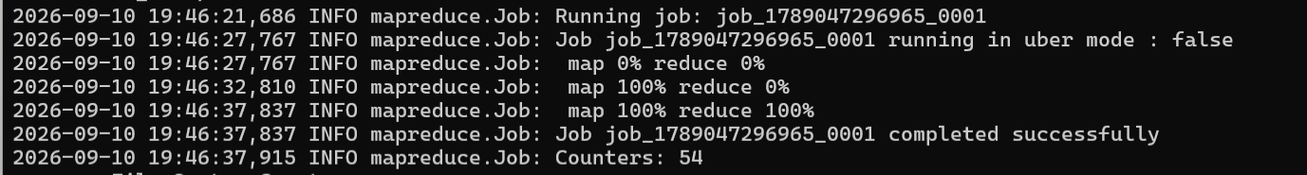
Output
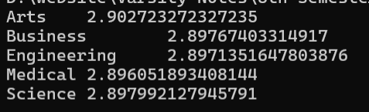
2. Average Stress Level by Gender:
Returns the average stress level of students for each gender. This analysis comprises of:
i. Driver Class : Sets the configuration for the Mapper and Reducer classes and defines the input and output paths.
ii. Mapper Class : Emits the gender of type Text as the key and stress level of type DoubleWritable as the value.
iii. Reducer Class : Calculates the average stress level for each gender and emits the gender of type Text and average stress level of type DoubleWritable.
Driver
public class AverageStressDriver {

public static void main(String[] args) throws Exception {

if (args.length != 2) {
System.err.println("Usage: AverageStressDriver <input> <output>");
System.exit(2);
}

Configuration conf = new Configuration();

Job job = Job.getInstance(conf, "Average Stress Level by Gender");

job.setJarByClass(AverageStressDriver.class);

job.setMapperClass(AverageStressMapper.class);
job.setReducerClass(AverageStressReducer.class);

job.setMapOutputKeyClass(Text.class);
job.setMapOutputValueClass(DoubleWritable.class);

job.setOutputKeyClass(Text.class);
job.setOutputValueClass(DoubleWritable.class);

FileInputFormat.addInputPath(job, new Path(args[0]));
FileOutputFormat.setOutputPath(job, new Path(args[1]));

System.exit(job.waitForCompletion(true) ? 0 : 1);
}
}

Mapper
public class AverageStressMapper
extends Mapper<Object, Text, Text, DoubleWritable> {

private final Text gender = new Text();
private final DoubleWritable stress = new DoubleWritable();

@Override
public void map(Object key, Text value, Context context)
throws IOException, InterruptedException {

String line = value.toString().trim();

if (line.isEmpty() || line.startsWith("Student_ID")) {
return;
}

String[] fields = line.split(",");

if (fields.length < 11) {
return;
}

try {
gender.set(fields[2].trim());
stress.set(Double.parseDouble(fields[9].trim()));

context.write(gender, stress);
} catch (NumberFormatException e) {
// Skip malformed records
}
}
}

Reducer
public class AverageStressReducer
extends Reducer<Text, DoubleWritable, Text, DoubleWritable> {

private final DoubleWritable result = new DoubleWritable();

@Override
public void reduce(Text key, Iterable<DoubleWritable> values, Context context)
throws IOException, InterruptedException {

double sum = 0.0;
long count = 0;

for (DoubleWritable value : values) {
sum += value.get();
count++;
}

if (count > 0) {
result.set(sum / count);
context.write(key, result);
}
}
}

Execution
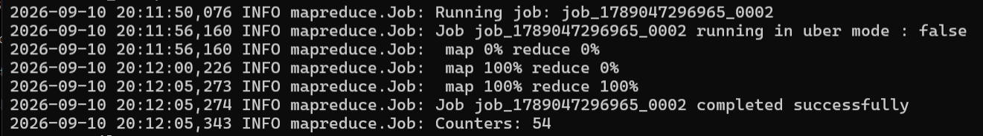
Output
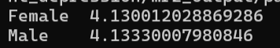
3. Number of Students by Depression Status:
Returns the number of students for each depression status (True or False). This analysis comprises of:
i. Driver Class : Sets the configuration for the Mapper and Reducer classes and defines the input and output paths.
ii. Mapper Class : Emits the depression status of type Text as the key and a count of 1 as the value.
iii. Reducer Class : Sums the counts for each depression status and emits the depression status of type Text and total number of students of type IntWritable.

Driver
public class DepressionCountDriver {

public static void main(String[] args) throws Exception {

if (args.length != 2) {
System.err.println("Usage: DepressionCountDriver <input> <output>");
System.exit(2);
}

Configuration conf = new Configuration();

Job job = Job.getInstance(conf, "Student Count by Depression Status");

job.setJarByClass(DepressionCountDriver.class);

job.setMapperClass(DepressionCountMapper.class);
job.setReducerClass(DepressionCountReducer.class);

job.setMapOutputKeyClass(Text.class);
job.setMapOutputValueClass(IntWritable.class);

job.setOutputKeyClass(Text.class);
job.setOutputValueClass(IntWritable.class);

FileInputFormat.addInputPath(job, new Path(args[0]));
FileOutputFormat.setOutputPath(job, new Path(args[1]));

System.exit(job.waitForCompletion(true) ? 0 : 1);
}
}
Mapper
import org.apache.hadoop.io.IntWritable;
import org.apache.hadoop.io.Text;
import org.apache.hadoop.mapreduce.Mapper;

import java.io.IOException;

public class DepressionCountMapper
extends Mapper<Object, Text, Text, IntWritable> {

private final Text depression = new Text();
private static final IntWritable ONE = new IntWritable(1);

@Override
public void map(Object key, Text value, Context context)
throws IOException, InterruptedException {

String line = value.toString().trim();

if (line.isEmpty() || line.startsWith("Student_ID")) {
return;
}

String[] fields = line.split(",");

if (fields.length < 11) {
return;
}

depression.set(fields[10].trim());

context.write(depression, ONE);
}
}

Reducer
public class DepressionCountReducer
extends Reducer<Text, IntWritable, Text, IntWritable> {

private final IntWritable result = new IntWritable();

@Override
public void reduce(Text key, Iterable<IntWritable> values, Context context)
throws IOException, InterruptedException {

int sum = 0;

for (IntWritable value : values) {
sum += value.get();
}

result.set(sum);

context.write(key, result);
}
}

Execution
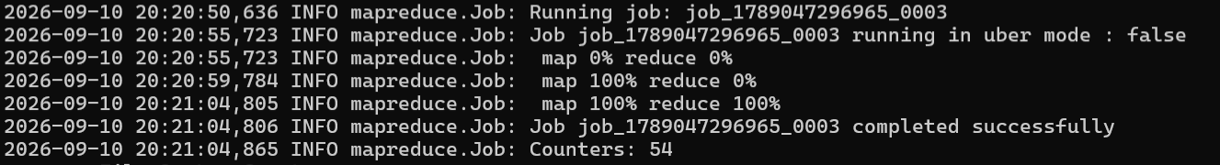
Output
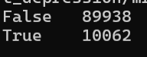

Pig Analysis
- Top 10 Students By CGPA: Returns the top 10 students with the highest CGPA.
Script
students = LOAD '/student_depression/student_lifestyle_100k.csv'
USING PigStorage(',')
AS (
Student_ID:chararray,
Age:chararray,
Gender:chararray,
Department:chararray,
CGPA:chararray,
Sleep_Duration:chararray,
Study_Hours:chararray,
Social_Media_Hours:chararray,
Physical_Activity:chararray,
Stress_Level:chararray,
Depression:chararray
);
data = FILTER students BY Student_ID != 'Student_ID';
typed = FOREACH data GENERATE
Student_ID,
Age,
Gender,
Department,
(double)CGPA AS CGPA,
Sleep_Duration,
Study_Hours,
Social_Media_Hours,
Physical_Activity,
Stress_Level,
Depression;
sorted = ORDER typed BY CGPA DESC;
top_10 = LIMIT sorted 10;
STORE top_10
INTO '/student_depression/pig1_output'
USING PigStorage('|');
Execution
Output
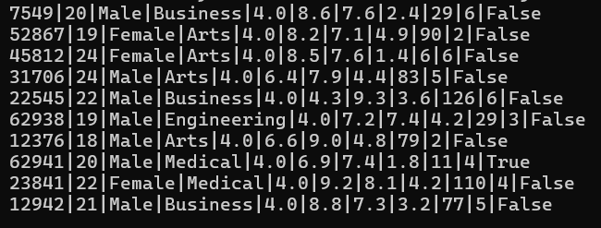

- Average Study Hours by Department: Returns the average study hours of students for each academic department.
Script
students = LOAD '/student_depression/student_lifestyle_100k.csv'
USING PigStorage(',')
AS (
Student_ID:chararray,
Age:chararray,
Gender:chararray,
Department:chararray,
CGPA:chararray,
Sleep_Duration:chararray,
Study_Hours:chararray,
Social_Media_Hours:chararray,
Physical_Activity:chararray,
Stress_Level:chararray,
Depression:chararray
);
data = FILTER students BY Student_ID != 'Student_ID';
typed = FOREACH data GENERATE
Department,
(double)Study_Hours AS Study_Hours;
grouped = GROUP typed BY Department;
result = FOREACH grouped GENERATE
group AS Department,
AVG(typed.Study_Hours) AS Average_Study_Hours;
STORE result
INTO '/student_depression/pig2_output'
USING PigStorage('|');
Execution

Output
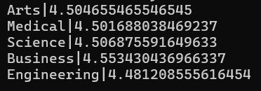

- Average Sleep Duration by Depression Status: Returns the average sleep duration of students for each depression status
Script
students = LOAD '/student_depression/student_lifestyle_100k.csv'
USING PigStorage(',')
AS (
Student_ID:chararray,
Age:chararray,
Gender:chararray,
Department:chararray,
CGPA:chararray,
Sleep_Duration:chararray,
Study_Hours:chararray,
Social_Media_Hours:chararray,
Physical_Activity:chararray,
Stress_Level:chararray,
Depression:chararray
);
data = FILTER students BY Student_ID != 'Student_ID';
typed = FOREACH data GENERATE
Depression,
(double)Sleep_Duration AS Sleep_Duration;
grouped = GROUP typed BY Depression;
result = FOREACH grouped GENERATE
group AS Depression,
AVG(typed.Sleep_Duration) AS Average_Sleep_Duration;
STORE result
INTO '/student_depression/pig3_output'
USING PigStorage('|');
Execution
Output
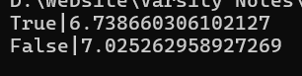
4. Average CGPA by Depression Status: Returns the average CGPA of students for each depression status.
Script
students = LOAD '/student_depression/student_lifestyle_100k.csv'
USING PigStorage(',')
AS (
Student_ID:chararray,
Age:chararray,
Gender:chararray,
Department:chararray,
CGPA:chararray,
Sleep_Duration:chararray,
Study_Hours:chararray,
Social_Media_Hours:chararray,
Physical_Activity:chararray,
Stress_Level:chararray,
Depression:chararray
);
data = FILTER students BY Student_ID != 'Student_ID';
typed = FOREACH data GENERATE
Depression,
(double)CGPA AS CGPA;
grouped = GROUP typed BY Depression;
result = FOREACH grouped GENERATE
group AS Depression,
AVG(typed.CGPA) AS Average_CGPA;
STORE result
INTO '/student_depression/pig4_output'
USING PigStorage('|');
Exectution
Output
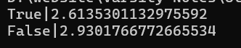
5. Top 10 Students By Study Hours: Returns the top 10 students with the highest study hours.
Script
students = LOAD '/student_depression/student_lifestyle_100k.csv'
USING PigStorage(',')
AS (
Student_ID:chararray,
Age:chararray,
Gender:chararray,
Department:chararray,
CGPA:chararray,
Sleep_Duration:chararray,
Study_Hours:chararray,
Social_Media_Hours:chararray,
Physical_Activity:chararray,
Stress_Level:chararray,
Depression:chararray
);
data = FILTER students BY Student_ID != 'Student_ID';
typed = FOREACH data GENERATE
Student_ID,
Age,
Gender,
Department,
CGPA,
Sleep_Duration,
(double)Study_Hours AS Study_Hours,
Social_Media_Hours,
Physical_Activity,
Stress_Level,
Depression;
sorted = ORDER typed BY Study_Hours DESC;
top_10 = LIMIT sorted 10;
STORE top_10
INTO '/student_depression/pig5_output'
USING PigStorage('|');
Execution
Output
