**PHASE 5 - PUBLIC TRANSPORT EFFICIENCY ANALYSIS**

**PROJECT DEFINITION:**

The project involves analysing public transportation data to assess service efficiency, on time performance, and passenger feedback. The objective is to provide insights that support transportation improvement initiatives and enhance the overall public transportation experience. This project includes defining analysis objectives, collecting transportation data, designing relevant visualizations in IBM Cognos, and using code for data analysis.

**DESIGN THINKING:**

1. Empathize: Understand the Stakeholders

- Identify and engage with key stakeholders, including passengers, transportation authorities, drivers, and local government officials.

- Conduct interviews, surveys, and observations to gain deep insights into the experiences, challenges, and needs of users.

2. Define: Problem Statement and User Needs

- Based on the information gathered, create a problem statement that clearly defines the challenges and opportunities within the public transportation system.

- Distil user needs and pain points to inform the analysis process.

3. Ideate: Generate Solutions and Innovations

- Organize collaborative brainstorming sessions with a cross-functional team, including designers, data analysts, and transportation experts.

- Encourage the generation of creative ideas to address the identified challenges and improve efficiency.

- Explore innovative concepts such as new routes, scheduling approaches, or passenger experience enhancements.

4. Prototype: Develop Concepts and Solutions

- Create prototypes or mock-ups of proposed solutions. This could involve redesigning route maps, experimenting with new scheduling algorithms, or designing user-friendly mobile apps for passengers.

- These prototypes serve as tangible representations of ideas and can be used for further testing and refinement.

5. Test: Gather Feedback and Iterate

- Implement pilot programs or small-scale trials of the proposed solutions to gather real-world data and feedback.

- Collect input from passengers and other stakeholders to assess the effectiveness and acceptance of the proposed changes.

- Iterate on the solutions based on feedback, making necessary adjustments.

6. Implement: Scale Solutions

- Once the proposed solutions have been refined and proven effective, implement them on a larger scale.

- Collaborate with transportation authorities and relevant agencies to integrate changes into the public transport system.

7. Evaluate and Monitor: Measure Impact

- Continuously monitor the performance of the system with the implemented changes.

- Evaluate whether the solutions are achieving the desired improvements in efficiency.

8. Iterate and Improve: Continuous Enhancement

- Use the insights gained from monitoring and evaluation to identify areas for further improvement.

- Apply design thinking principles iteratively to address evolving challenges and opportunities in public transport efficiency.

9. Communicate and Engage: Transparency and Collaboration

- Maintain open communication with stakeholders throughout the design thinking process.

- Engage with the public to ensure that their feedback and concerns are heard and addressed.

**Dataset Link: [https://www.kaggle.com/datasets/rednivrug/unisys?select=20140711.CSV](https://www.kaggle.com/datasets/rednivrug/unisys?select=20140711.CSV" \t "[object Object])**

**OBJECTIVE:**

To optimize routes, schedules, and resource allocation to maximize efficiency and urban mobility.

**PROCEDURE:**

Exploratory Data Analysis (EDA):

a. Analyse existing data to identify patterns, trends, and outliers relevant to operational efficiency, passenger satisfaction, environmental impact, and route optimization.

b. Visualize key performance metrics and variables to gain insights into the current state of the public transport system.

Performance Benchmarking:

a. Research industry benchmarks and standards related to public transport efficiency.

b. Compare the available data against benchmarks to identify areas for improvement.

Analysis and Optimization:

a. Analyse existing routes, schedules, and operational practices.

b. Propose optimizations based on the analysis to improve coverage, frequency, cost-effectiveness, and environmental sustainability of the public transport system.

Integration and Recommendations:

a. Integrate insights from the analyses to create a comprehensive view of the public transport system's efficiency.

b. Formulate actionable recommendations, considering input from all analyses, to optimize the public transport system for efficiency and sustainability.

Implementation and Continuous Monitoring:

a. Implement the recommended changes and improvements to the public transport system.

b. Establish a system for continuous monitoring, collecting post-implementation data, and making iterative adjustments to ensure sustained efficiency gains.

By following this procedure, the project aims to systematically analyse and enhance the public transport system's efficiency, aligning with the objective of improving urban mobility and sustainability.

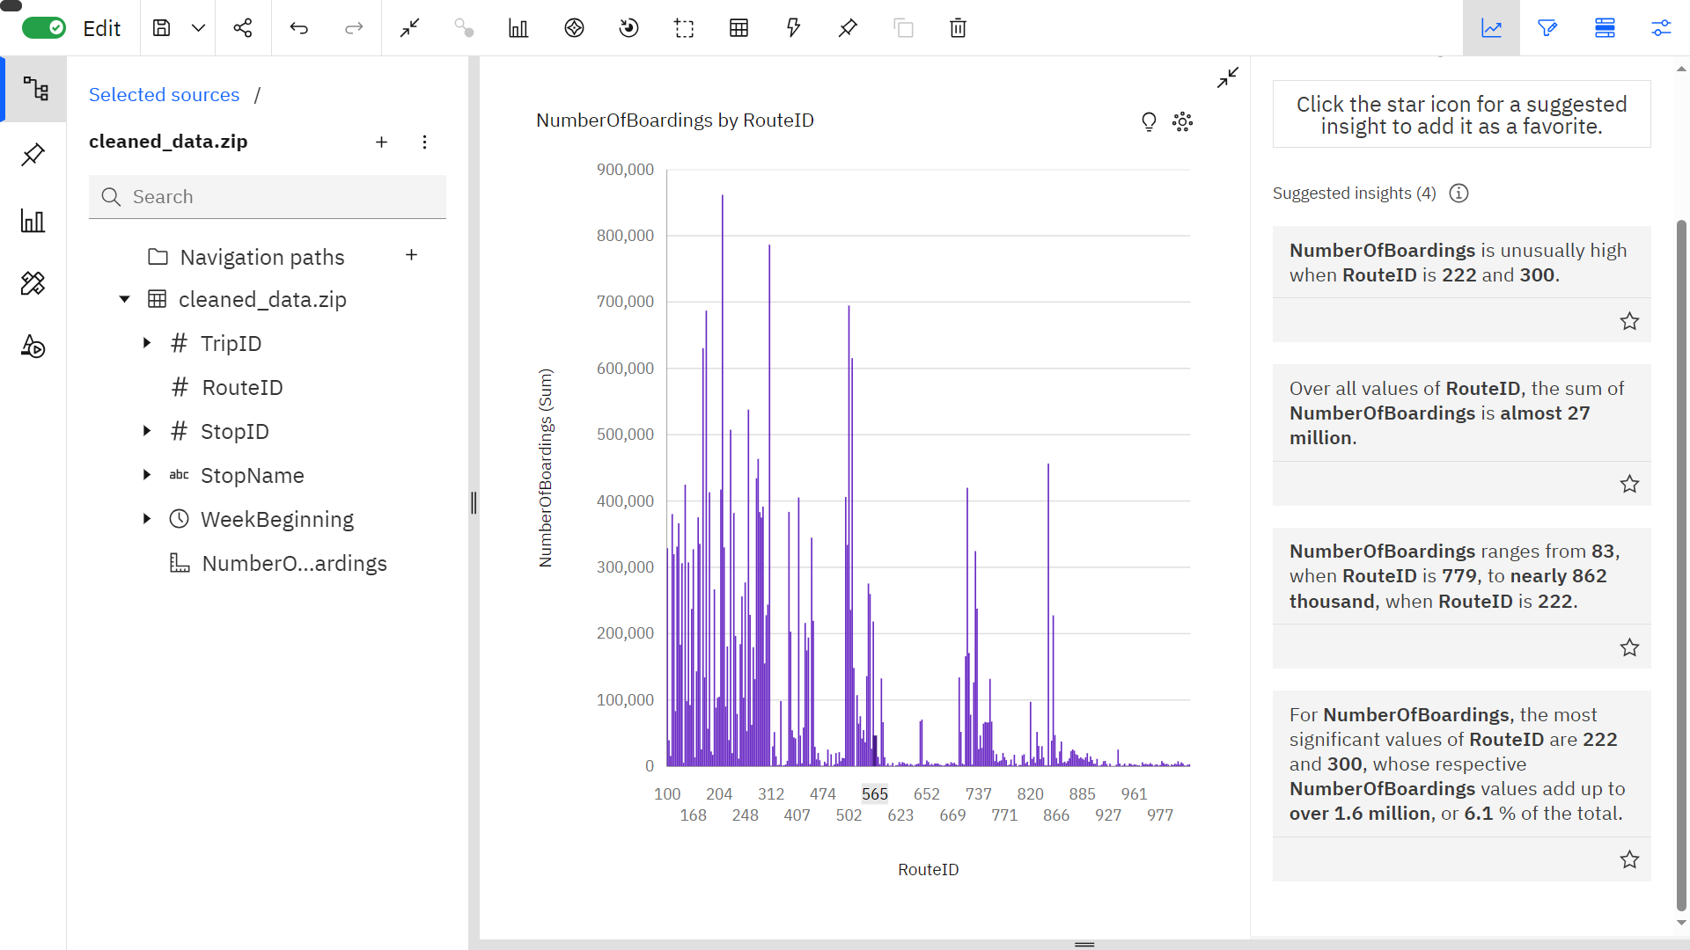

Insights:

* The Number of Boardings is unusually high when Route ID is 222 and 300.
* The sum of Number of Boardings is almost 27 million.
* The Route ID’s 222 and 300 are the most significant values, whose respective Number of Boarding values make up to 1.6 million, i.e., 6.1 % of the total.
* Number of Boardings range from 83, when Route ID is 779, to nearly 862K, when Route ID is 222.

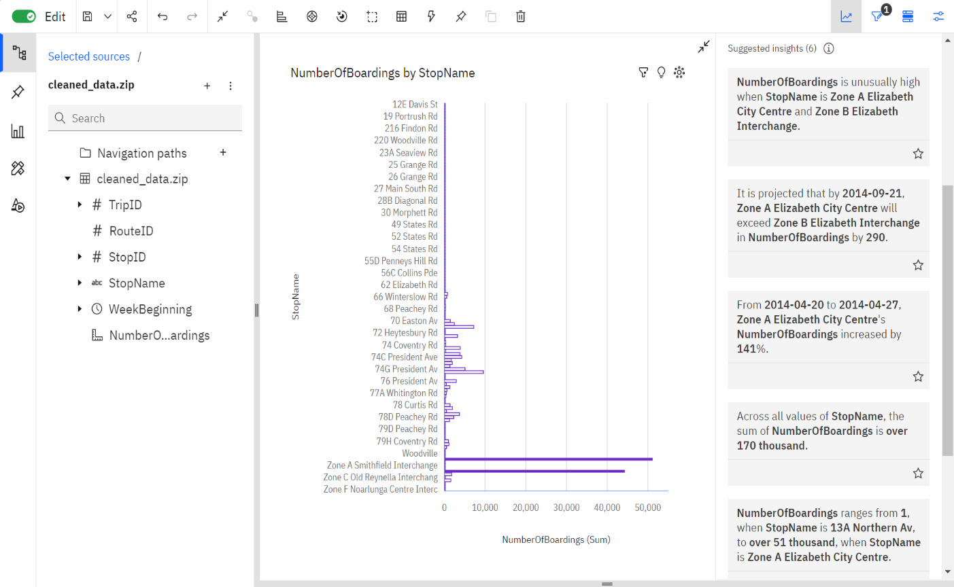

Insights:

* Number of Boardings are unusually high when StopName is “Zone A Elizabeth City Centre” and “Zone B Elizabeth Interchange”.
* It is projected that by 21st September 2014, “Zone A Elizabeth City Centre” will exceed “Zone B Elizabeth Interchange” in Number of Boardings by 290.
* From 20th April to 27th April 2014, the Number of Boardings of “Zone A Elizabeth City Centre” increased by 141%.
* Number of Boardings ranges from 1, when StopName is “13A Northern Av., to over 51K, when StopName is “Zone A Elizabeth City Centre”.
* The sum of Number of Boardings is over 170K.

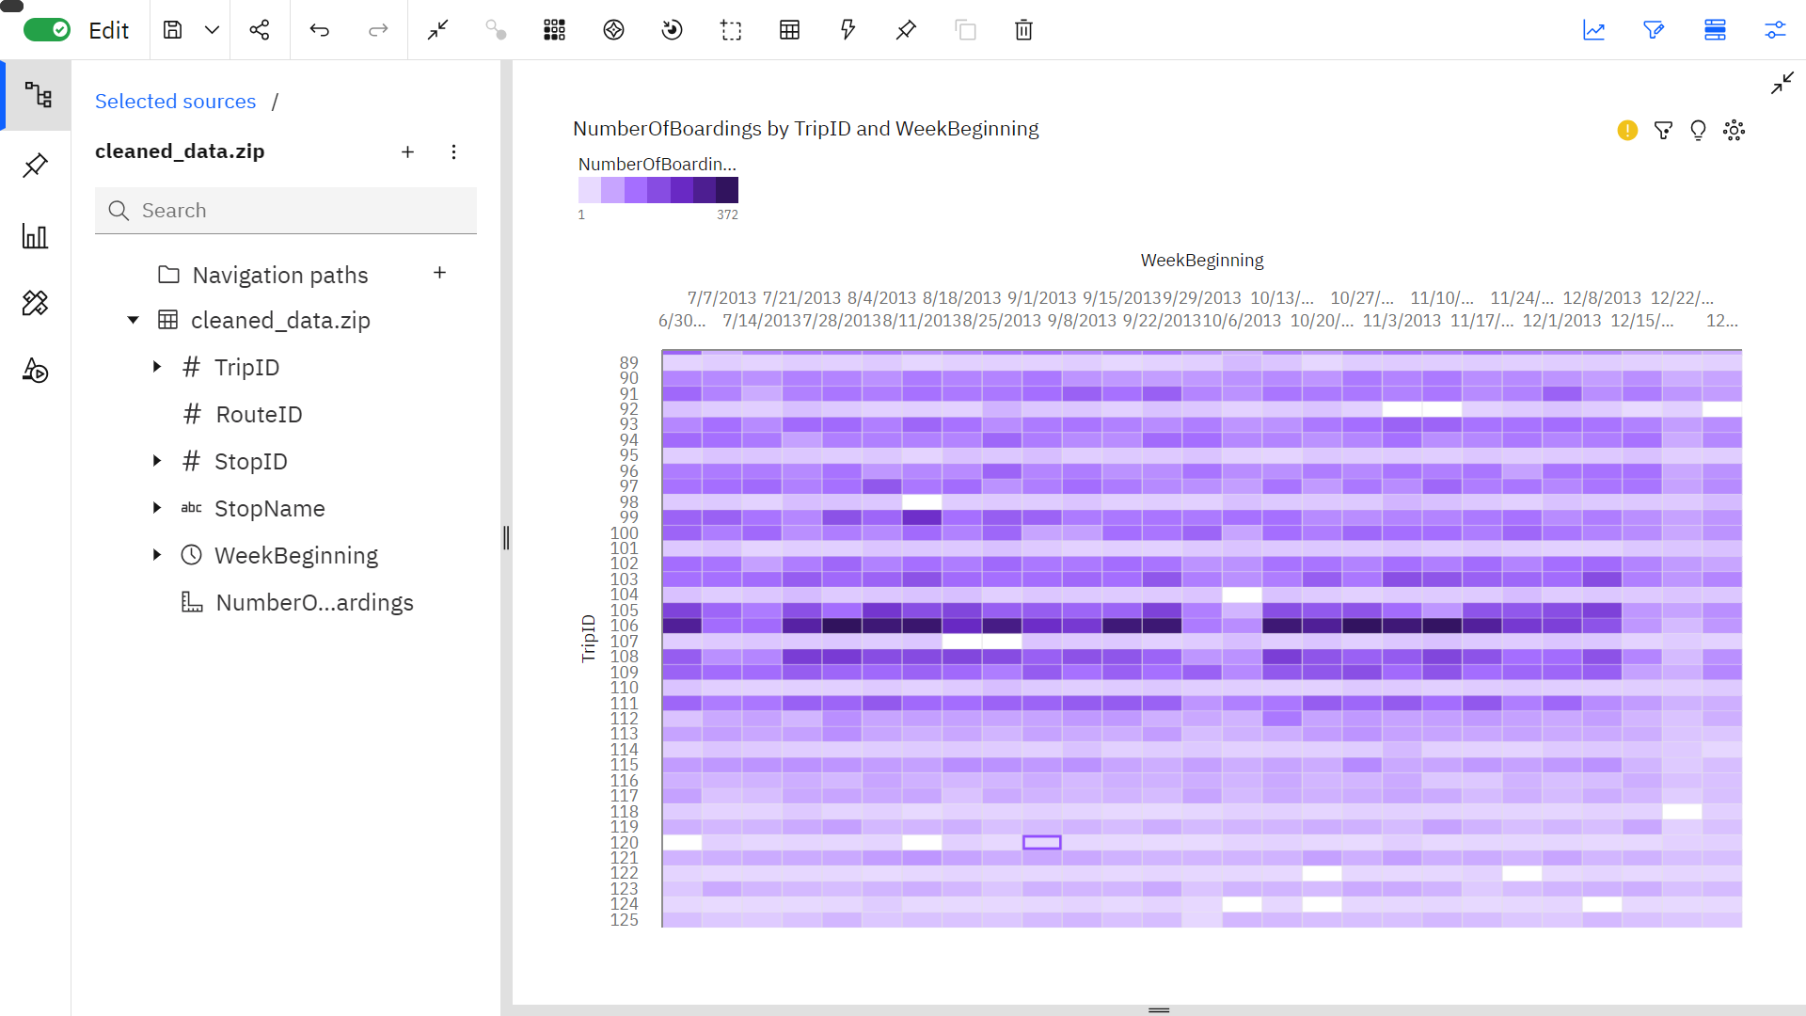

Insights:

* Trip ID 106 has the greatest Number of Boardings out of all ID’s, topping in various dates evenly.
* Trip ID 120 is the least popular Trip ID in terms of Number of Boardings.

**SOURCE CODE:**   
**<https://www.kaggle.com/code/vishal230404/notebook8f87557083>**

Vader Sentiment Analysis is the main analysis with the data the data was analysed using the vader Sentiment python module.

The data was then imported to IBM Cognos for visualisation and the following inferences were noted:

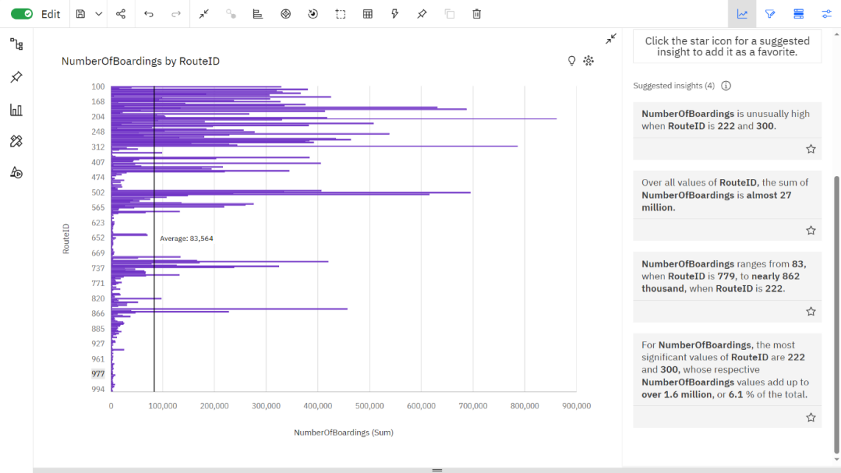

Insights:

• The number of boardings are unusually high when Route ID is 222 and 300.

• The Route ID’s 222 and 300 are the most significant values, whose respective Number of Boarding values make up to 1.6 million, i.e., 6.1 % of the total.

• Number of Boarding range from 83, when Route ID is 779, to nearly 862K, when Route ID is 222.

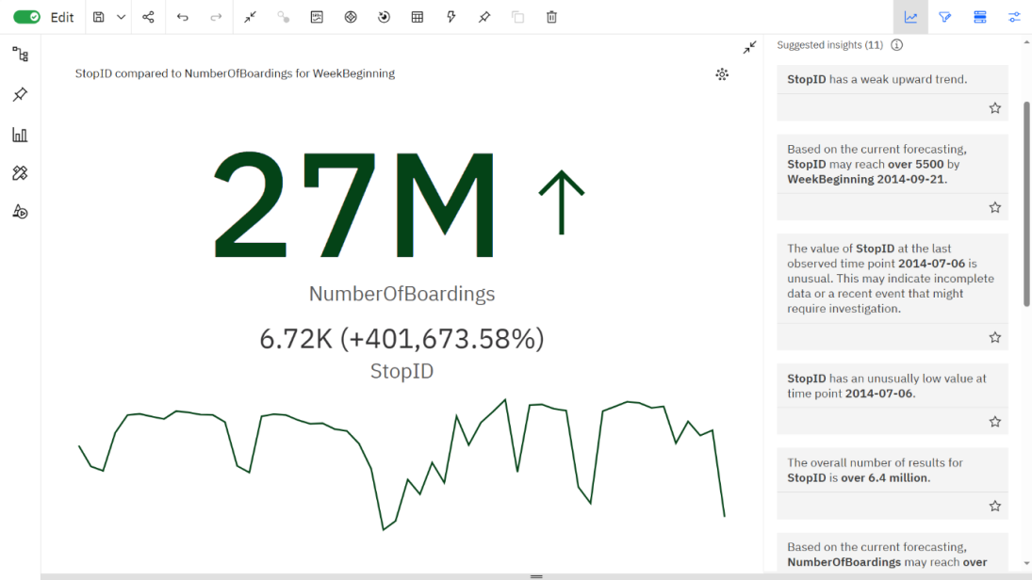

Insights:

* Stop ID may reach over 5500 by 21st September, 2014.
* The number of stops was very low on the 6th of July, 2014.
* From 20th April 2014 to 27th April 2014, the Number of Boardings are increased by 71%.
* The total number of boardings is almost 27 million.

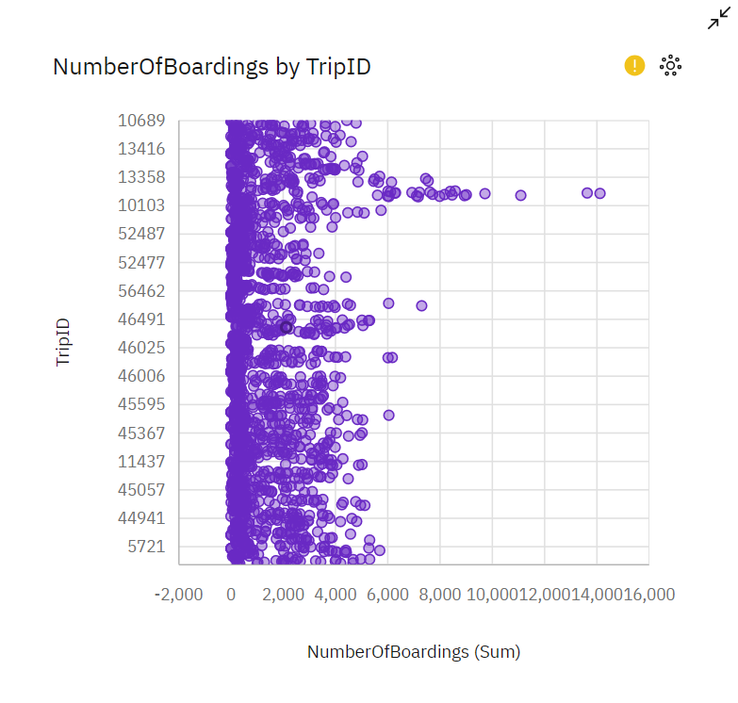

Insights:

* Trip ID 13203 had the highest number of boardings.
* The average number of boardings has ranged from 20 – 4000.
* Trip ID 52486 has the lowest number of boardings.

**DATABASE LINK**

[Public Bus Transport Dataset (kaggle.com)](https://www.kaggle.com/datasets/rednivrug/unisys?select=20140711.CSV)

**CONCLUSION**

Therefore, the given data set was analysed, trained through machine learning and visualised using IBM Cognos tool.

**TEAM MEMBERS**

Siddesh S - 2021504545

Vishal K - 2021504558

Mohamed Samasdeen S- 2021504301

Prasannah SKS - 2021504538