**PHASE 4 – PUBLIC TRANSPORT EFFICIENCY ANALYSIS**

**PROJECT DEFINITION:**

The project involves analysing public transportation data to assess service efficiency, on time performance, and passenger feedback. The objective is to provide insights that support transportation improvement initiatives and enhance the overall public transportation experience. This project includes defining analysis objectives, collecting transportation data, designing relevant visualizations in IBM Cognos, and using code for data analysis.

**OBJECTIVE:**

To further analyse and perform model training of data and visualising the new data using IBM Cognos tool.

**SOURCE CODE:**

**<https://www.kaggle.com/code/vishal230404/notebook8f87557083>**

Vader Sentiment Analysis is the main analysis with the data the data was analysed using the vaderSentiment python module.

The data was then imported to IBM Cognos for visualisation and the following inferences were noted:

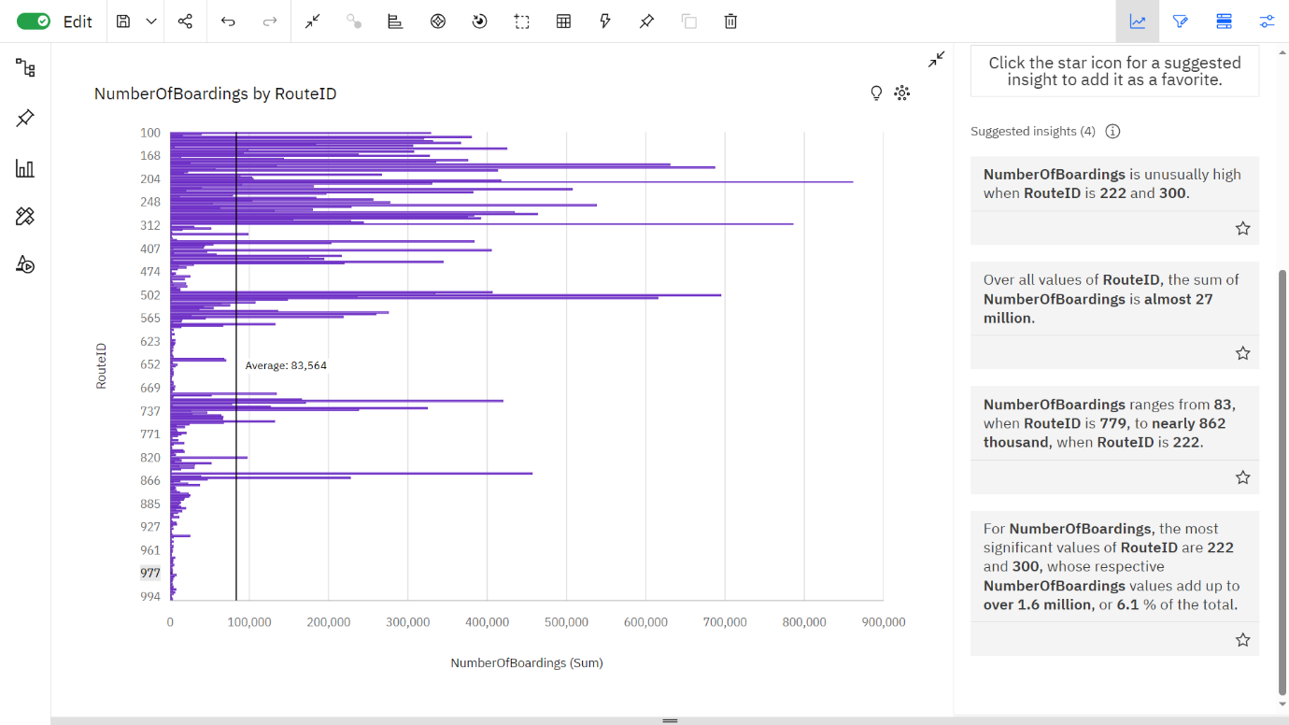

Insights:

* The number of boardings are unusually high when Route ID is 222 and 300.
* The Route ID’s 222 and 300 are the most significant values, whose respective Number of Boarding values make up to 1.6 million, i.e., 6.1 % of the total.
* Number of Boardings range from 83, when Route ID is 779, to nearly 862K, when Route ID is 222.

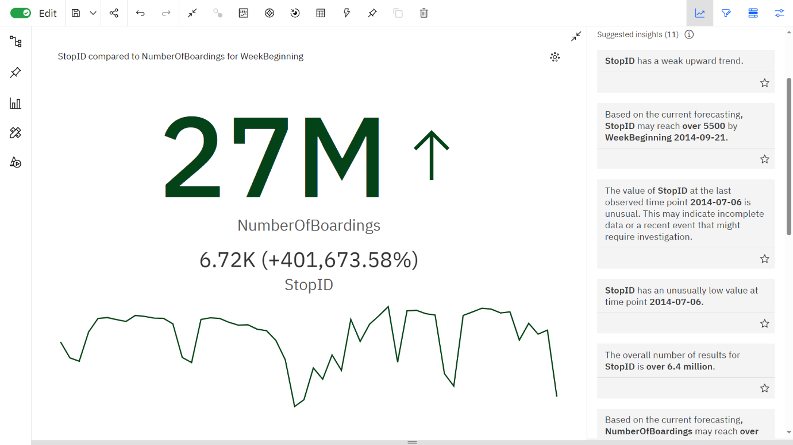

Insights:

* Stop ID may reach over 5500 by 21st September, 2014.
* The number of stops was very low on the 6th of July, 2014.
* From 20th April 2014 to 27th April 2014, the Numberof Boardings are increased by 71%.
* The total number of boardings is almost 27 million.

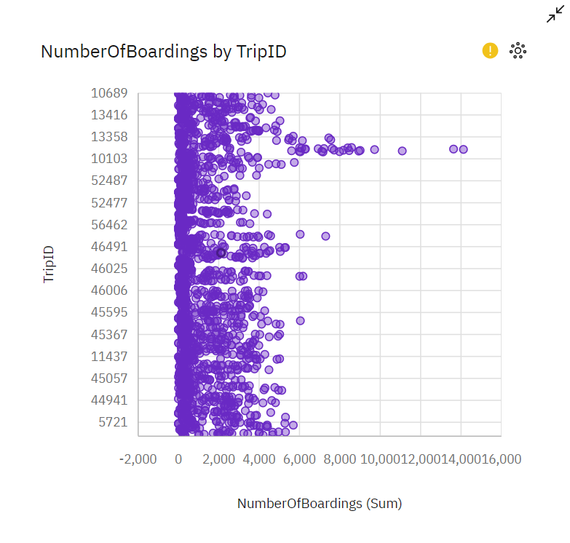

Insights:

* Trip ID 13203 had the highest number of boardings.
* The average number of boardings has ranged from 20 – 4000.
* Trip ID 52486 has the lowest number of boardings.

**DATABASE LINK**

[Public Bus Transport Dataset (kaggle.com)](https://www.kaggle.com/datasets/rednivrug/unisys?select=20140711.CSV)

**CONCLUSION**

Therefore, the given data set was analysed, trained through machine learning and visualised using IBM Cognos tool.

**TEAM MEMBERS**

Siddesh S - 2021504545

Vishal K - 2021504558

Mohamed Samasdeen S- 2021504301

Prasannah SKS - 2021504538