ASSIGNMENT-2

MACHINE LEARNING

NAME- MUTTA DATTA SAI VISHNU MOHAN

USN- 22BTRAD026

QUESTION

1. Load a dataset with outliers values (Boston Housing Dataset).

# MUTTA DATTA SAI VISHNU MOHAN (22BTRAD026)

import pandas as pd

# Load the Boston Housing dataset

boston_housing = pd.read_csv('HousingData.csv')

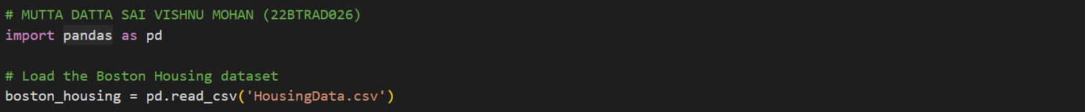

1. Use visualization or statistical methods to detect outliers.

# MUTTA DATTA SAI VISHNU MOHAN (22BTRAD026)

import matplotlib.pyplot as plt

# Create box plots for each feature

for col in boston_housing.columns:

boston_housing.boxplot(column=col)

plt.title(col)

plt.show()

import matplotlib.pyplot as plt

# Create box plots for each feature

for col in boston_housing.columns:

boston_housing.boxplot(column=col)

plt.title(col)

plt.show()

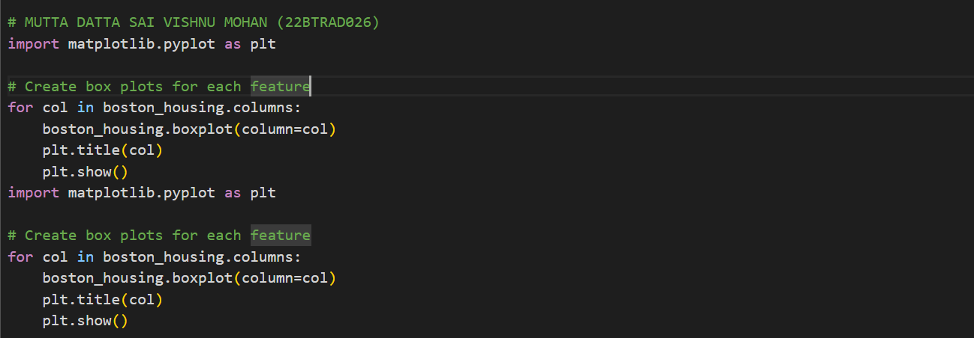

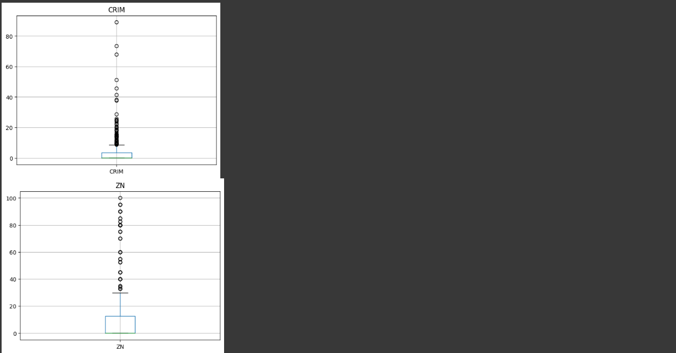 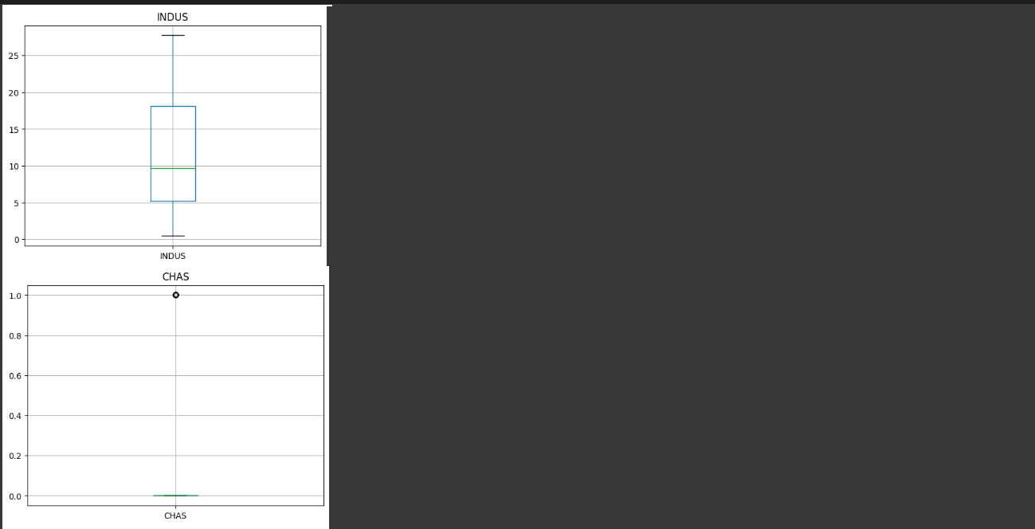 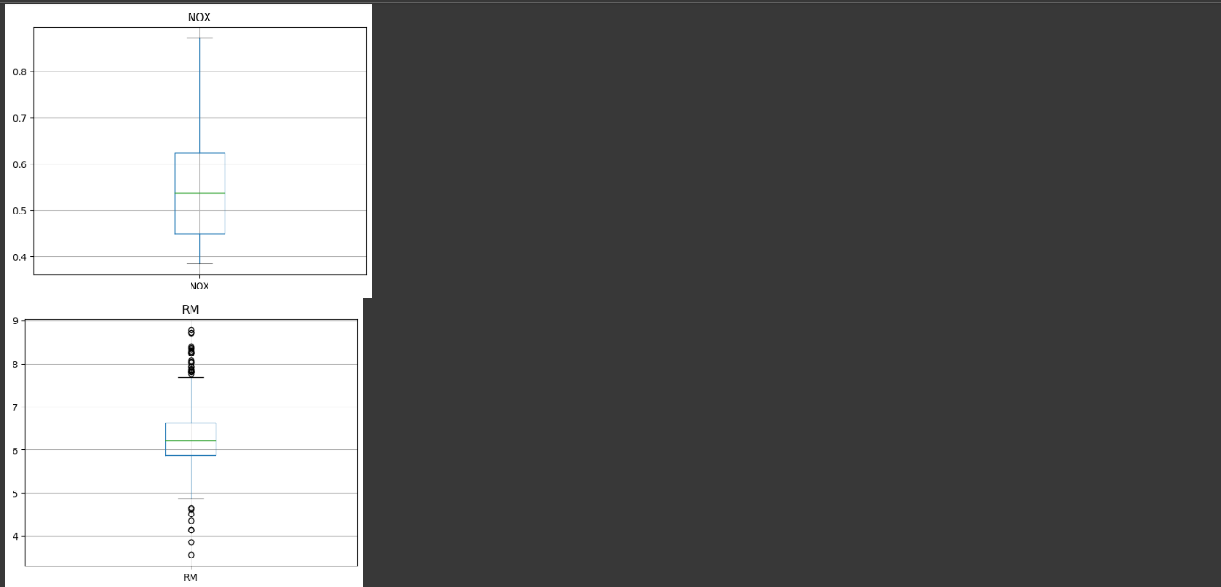 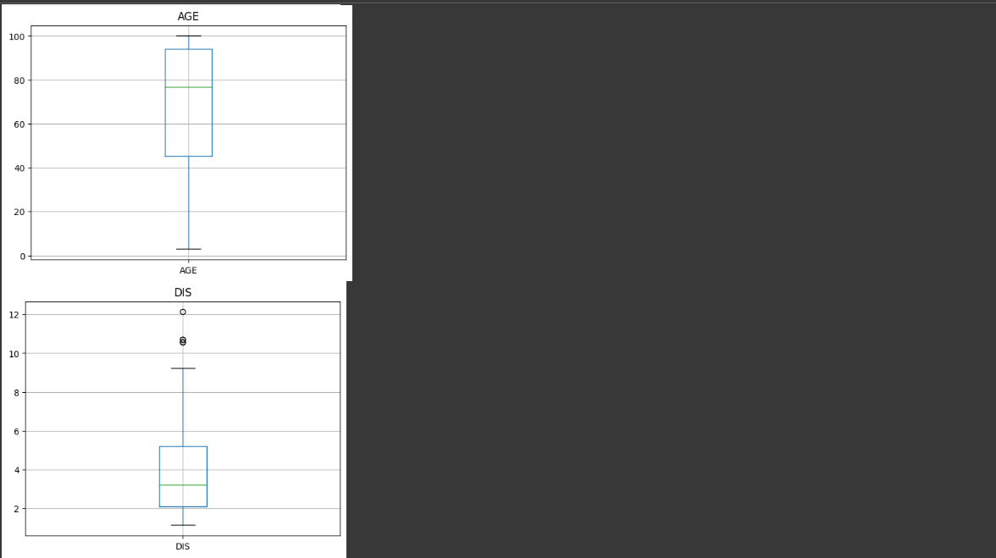 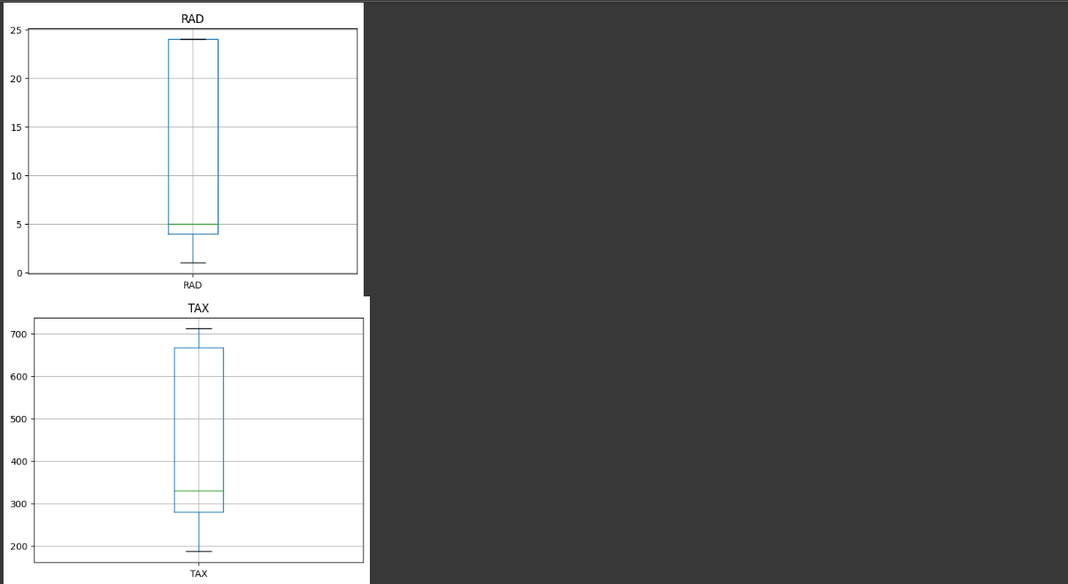 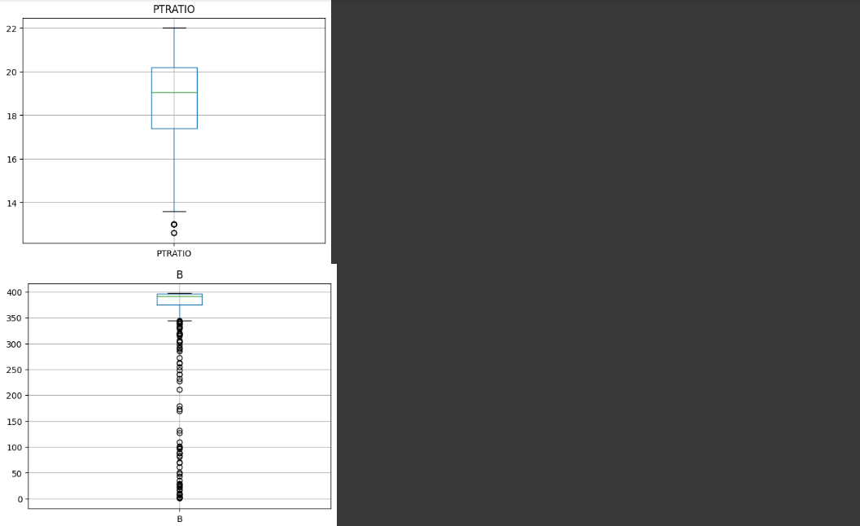 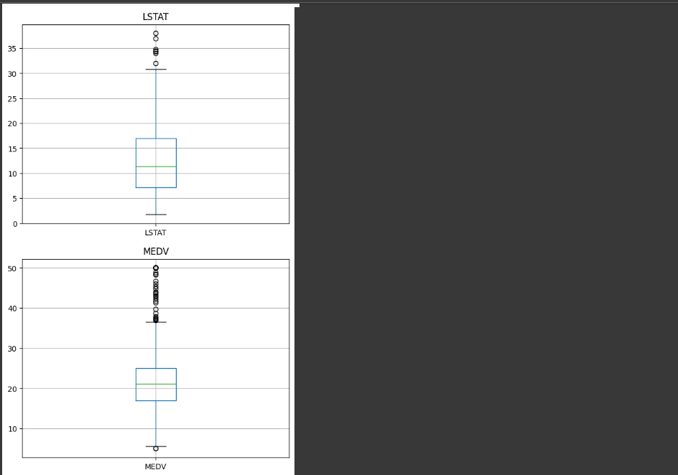 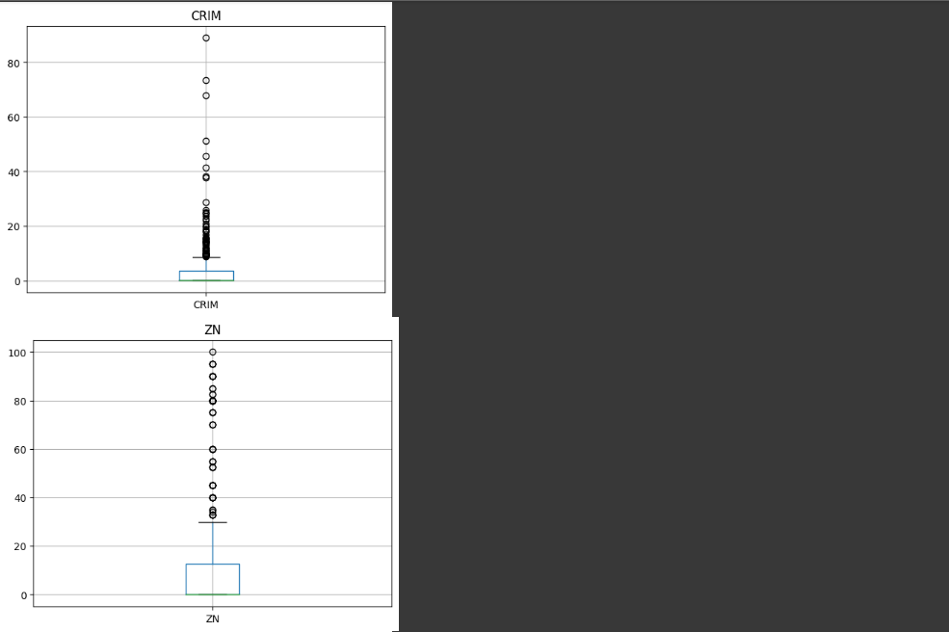 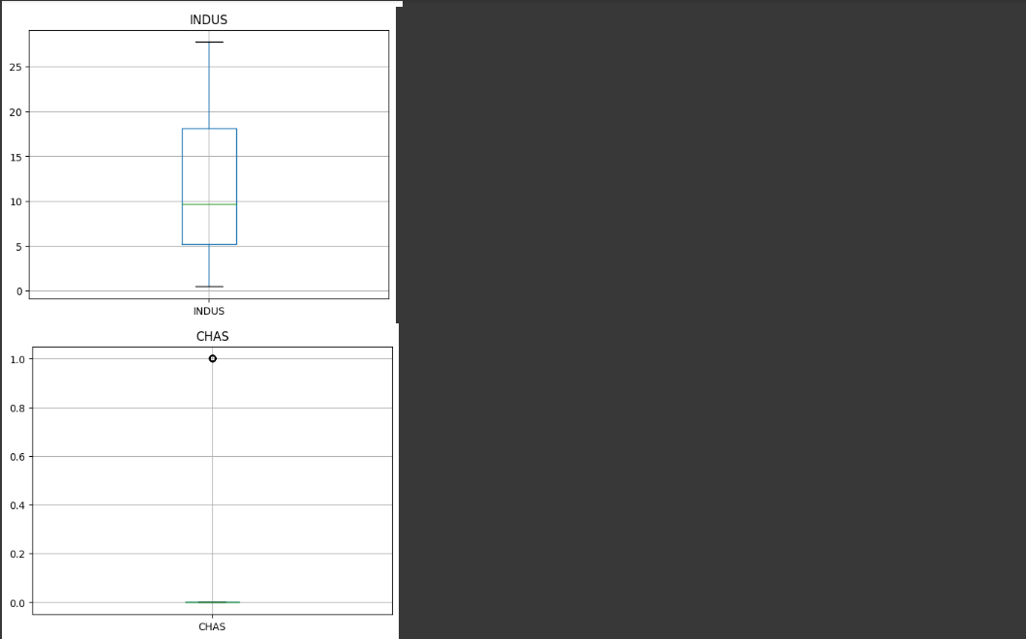 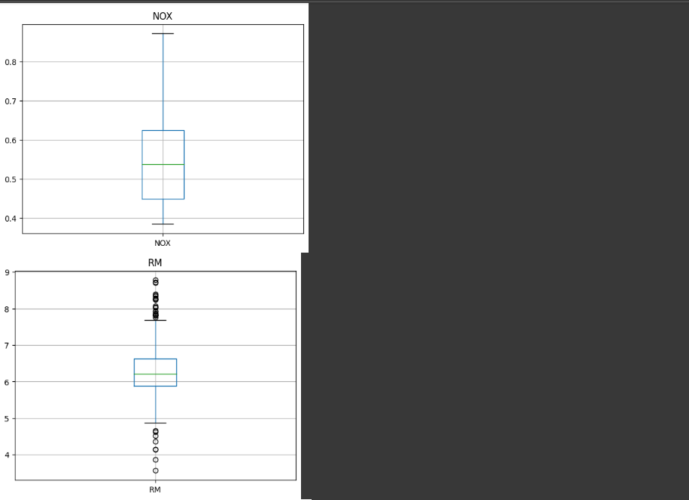 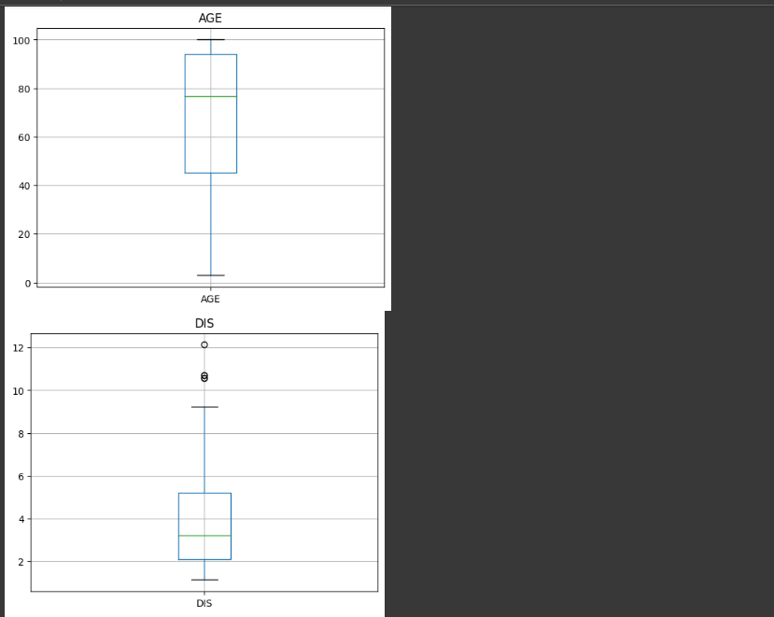 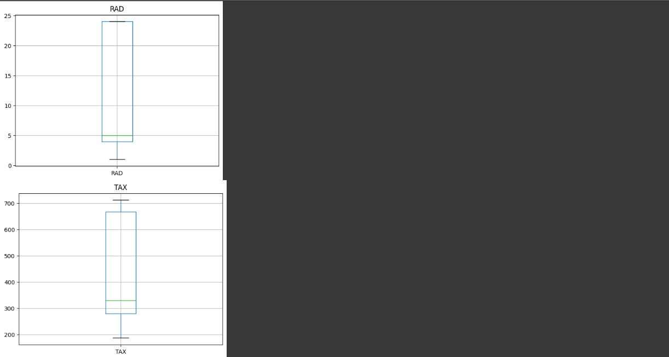 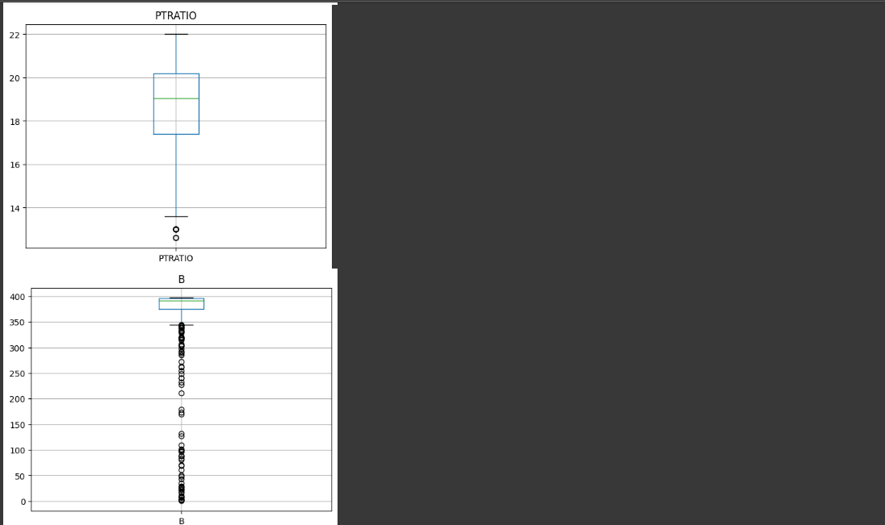 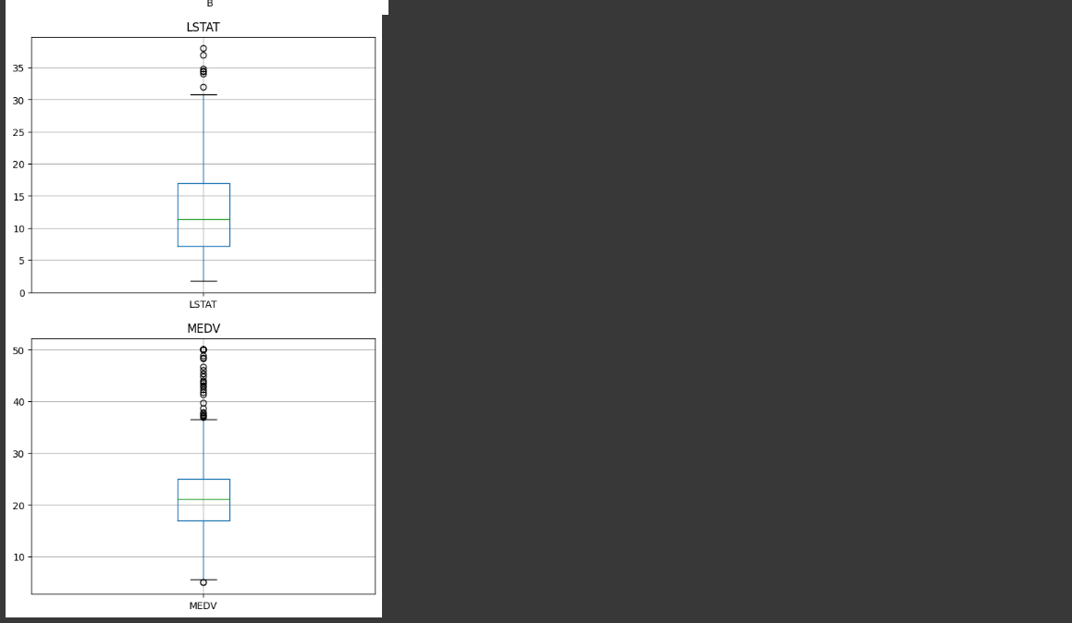

# MUTTA DATTA SAI VISHNU MOHAN (22BTRAD026)

# Calculate the z-score for each feature

for col in boston_housing.columns:

z = (boston_housing[col] - boston_housing[col].mean()) / boston_housing[col].std()

outliers = boston_housing[abs(z) > 3]

print(f"Number of outliers for {col}: {len(outliers)}")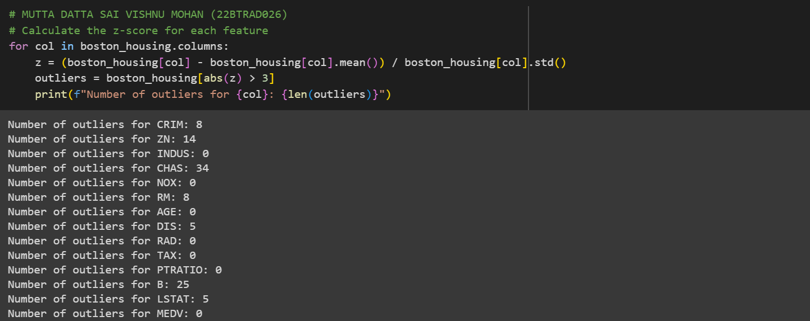

1. Implement a strategy to handle outliers (e.g., removal and transformation).

# MUTTA DATTA SAI VISHNU MOHAN (22BTRAD026)

import pandas as pd

# Load the Boston Housing dataset

boston_housing = pd.read_csv('HousingData.csv')

# Calculate the IQR for each feature

for col in boston_housing.columns:

q1 = boston_housing[col].quantile(0.25)

q3 = boston_housing[col].quantile(0.75)

iqr = q3 - q1

# Remove outliers

boston_housing = boston_housing[boston_housing[col] >= q1 - 1.5 * iqr]

boston_housing = boston_housing[boston_housing[col] <= q3 + 1.5 * iqr]

print(boston_housing)

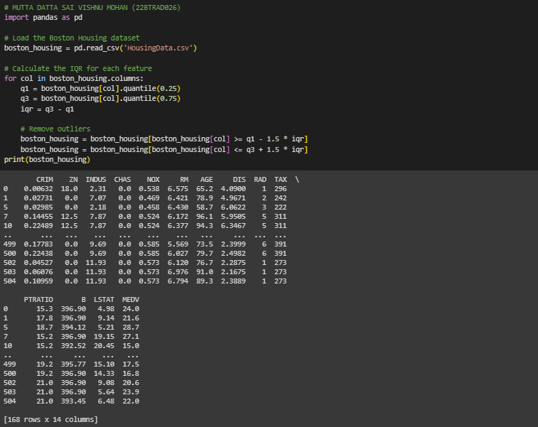

# MUTTA DATTA SAI VISHNU MOHAN (22BTRAD026)

import pandas as pd

import numpy as np

# Load the Boston Housing dataset

boston_housing = pd.read_csv('HousingData.csv')

# Transform outliers using log transformation

for col in boston_housing.columns:

if not pd.api.types.is_categorical_dtype(boston_housing[col]):

boston_housing[col] = np.log(boston_housing[col])

print(boston_housing)

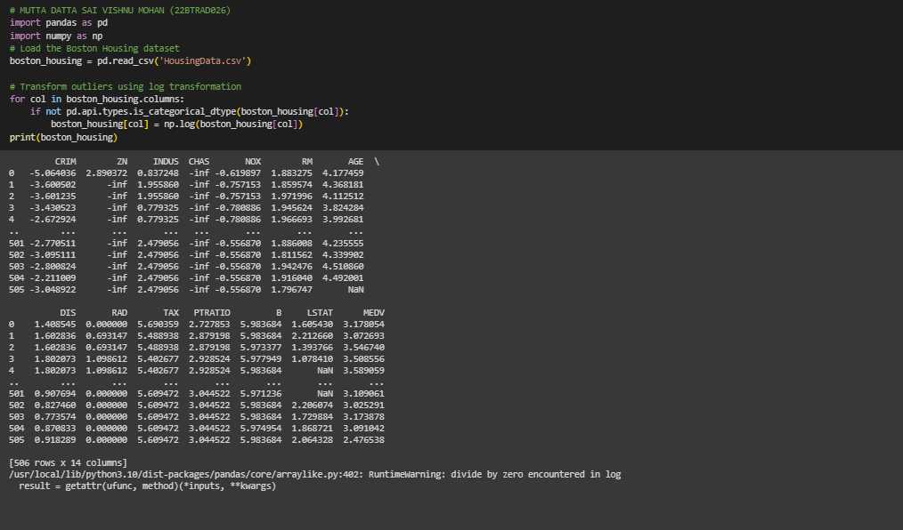

GITHUB:

https://github.com/MDSVISHNUMOHAN/MACHINE-LEARNING