SCALA PROGRAMMING

NAME- MUTTA DATTA SAI VISHNU MOHAN

USN- 22BTRAD026

Q. Write a Scala program that creates a class called Person with properties like name, age and country. Implement methods to get and set properties.

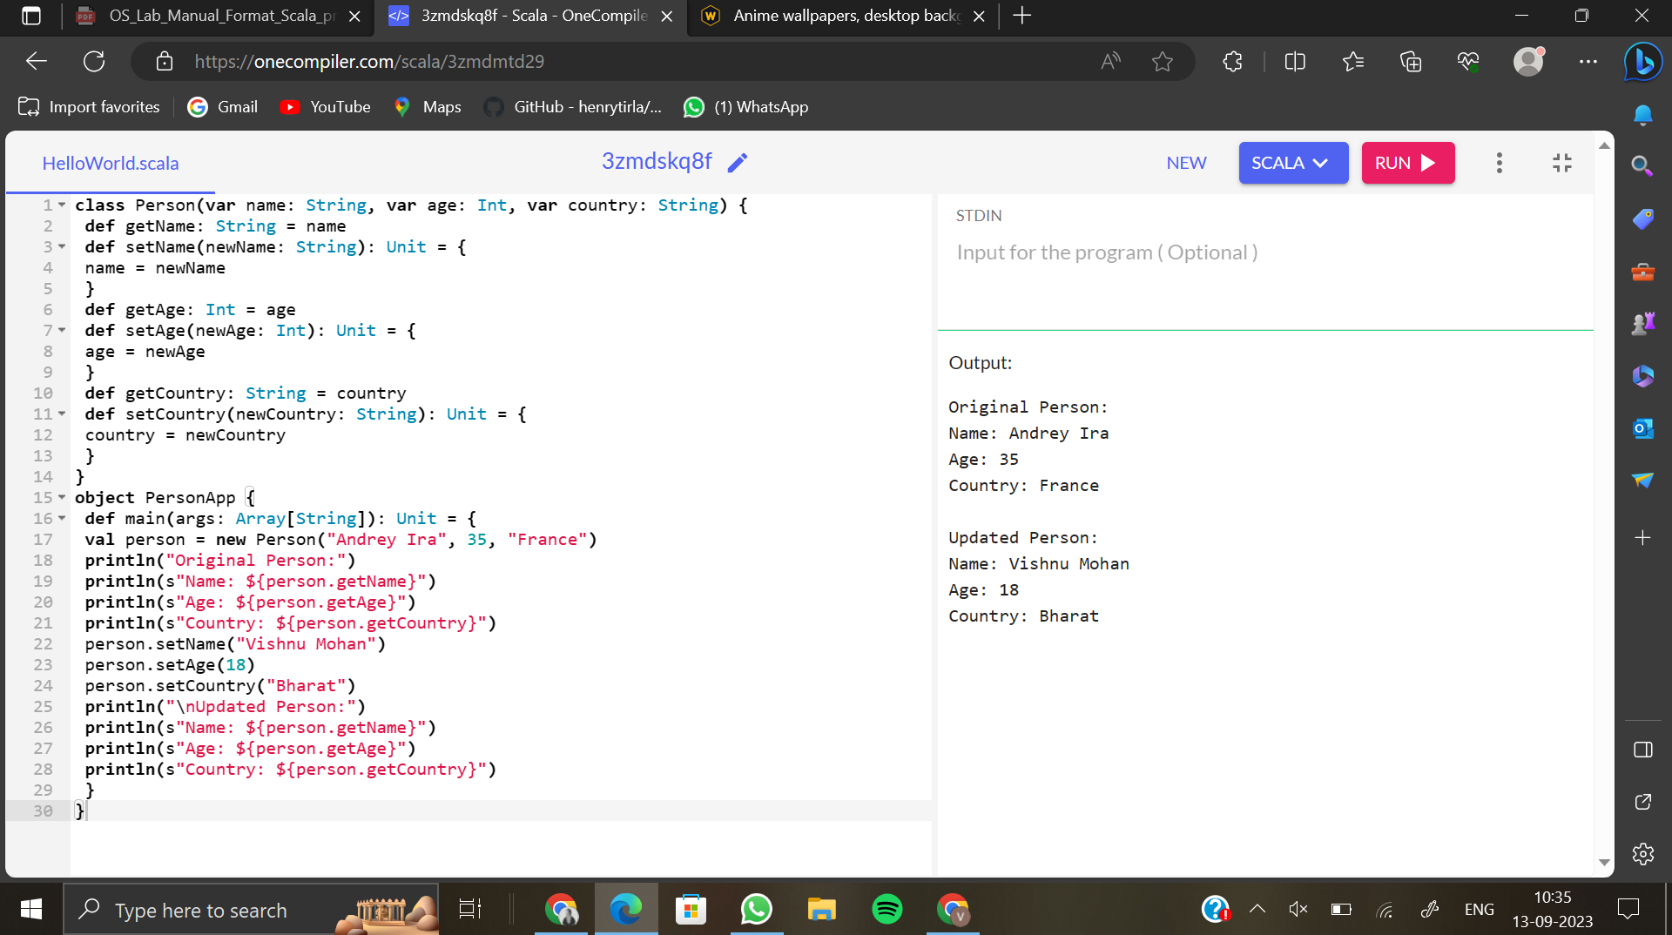

CODE:

class Person(var name: String, var age: Int, var country: String) {

def getName: String = name

def setName(newName: String): Unit = {

name = newName

}

def getAge: Int = age

def setAge(newAge: Int): Unit = {

age = newAge

}

def getCountry: String = country

def setCountry(newCountry: String): Unit = {

country = newCountry

}

}

object PersonApp {

def main(args: Array[String]): Unit = {

val person = new Person("Andrey Ira", 35, "France")

println("Original Person:")

println(s"Name: ${person.getName}")

println(s"Age: ${person.getAge}")

println(s"Country: ${person.getCountry}")

person.setName("DEERAJ REDDY")

person.setAge(18)

person.setCountry("BHARAT")

println("\nUpdated Person:")

println(s"Name: ${person.getName}")

println(s"Age: ${person.getAge}")

println(s"Country: ${person.getCountry}")

}

}

Q.