**SCALA PROGRAMMING**

NAME: MUTTA DATTA SAI VISHNU MOHAN

USN: 22BTRAD026

PROGRAM-1:

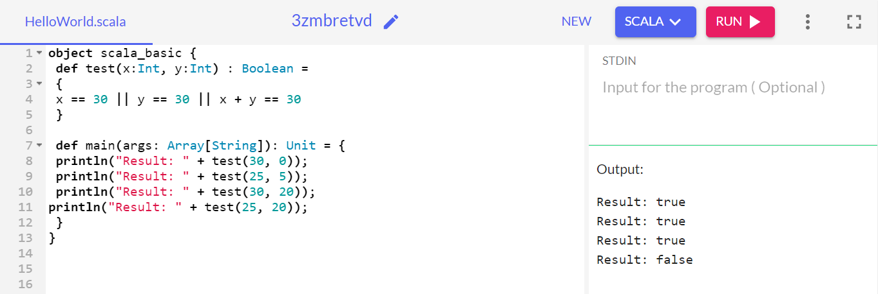

PROGRAM-2:

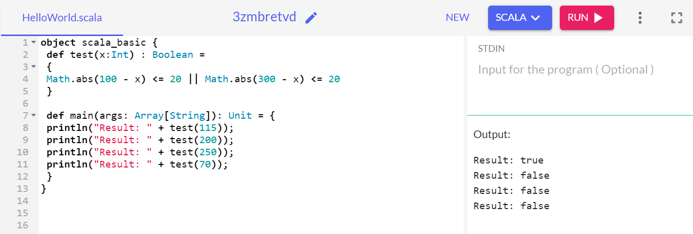

PROGRAM-3:

