**Abstract:**

Bendable Concrete also known as Engineered Cementitious Concrete(ECC) is a new class of FRC which has strain hardening property and multiple cracking behaviour in Tension and Flexure.It ia an Ultra ductile concrete which can be designed with strain capacity of about 3 to 5% compared to 0.01% of Normal concrete.To improve the Ductile property of normal concrete,Poly Vinyl Alcohol (PVA) fibers is used in place of coarse aggregates.

Since bendable concrete is 3 times more costlier than the conventional concrete it is still under experimental stage in india. This investigation investigates the possibility of utilizing granulated blast furnace slag(GBS) in bendable concrete as a substitute for partial fine aggregate to reduce the environmental problems relating to fine aggregate mining and waste disposal of slag. The use of GBS will also make the bendable concrete more economical to be used in India. The percentage of GBS replacement considered is 30%,40%,50% to fine aggregate for standard water cement ratio of 0.4. This investigation focuses on the comparison of compressive strength and flexural strength normal concrete with Bendable concrete with various replacements.

Keywords: Poly vinyl Alcohol ,fiber ,Engineered Cementitious Concrete(ECC).

1. INTRODUCTION

BENDABLE CONCRETE

Bendable concrete also known as Engineered Cementitious Composites abbreviated as ECC is class of ultra-ductile fibre reinforced cementitious composites, characterized by high ductility and tight crack width control. Conventional concretes are almost unbendable and have a strain capacity of only 0.1% making them highly brittle and rigid. This lack of bendability is a major cause of failure under strain and has been a pushing factor in the development of an elegant material namely, bendable concrete. This material is capable to exhibit considerably enhanced flexibility. A bendable concrete is reinforced with micromechanically designed polymer fibre. ECC is made from the same basic ingredients as conventional concrete but with the addition of superplastisizers is required to get good workability.

However, coarse aggregates are not used in ECCs, the powder content is relatively high. ECC incorporates silica sand and Polyvinyl Alcohol-fibres covered with a very thin (manometric thick), silk coating. This surface coating allows the fibre to begin slipping when they are over loaded so they are not fracturing. It prevents from rupturing which the fibre would lead to large cracking. Thus an ECC deforms much more than a normal concrete but without fracturing. The behavior of ECC under flexural loading and it can be seen that the beam can deform sufficiently without direct failure.

**2. OBJECTIVES**

1.To check the ductile behavior of the concrete.

2.To check the behavior of ECC – Bendable concrete under compression and flexure.

3.To investigate the effect of GBS, admixture and PVA fibres on the behavior of ECC-bendable concrete.

**3. INEDIENTS OF ECC CONCRETE**

Engineered cementitious composite is composed of cement, silica sand, GBS, PVA fibres, admixture and water. In the mix coarse aggregates not used because property of ECC concrete is formation of micro cracks with large deflection. Coarse aggregates increases crack width which is contradictory to the property of ECC.

**3.1.1 CEMENT**

Cement used is ordinary Portland cement. Numerous organic compounds used for adhering, or fastening materials, are called cements, but these are classified as adhesives, and term cement alone means a construction material. The color of the cement is due chiefly to iron oxide. In the absence of impurities, the color would be white, but neither the color nor the specific gravity is a test of quality. Ordinary Portland cement (OPC)-43 grade (Ultratech Cement) was used.

**3.1.2 SILICA SAND**

Silica sand is a quartz that overtime, through the work of water and wind, has been broken down into tiny granule. Also called silica sand or quartz sand, silica is silicon di –oxide (SiO2). Silicon compounds are the most significant component of the earth’s crust. Since sand is plentiful, easy to mine and relatively easy to process, it is the primary ore source of silicon.

Silicon (Si) is a semi metallic or metalloid, because it has several of the metallic characteristics. Silicon is never found in its natural state. Feldspar and quartz are the most significant silicate minerals. Silicon alloys include a variety of metals, including iron, aluminium, copper, nickel, manganese and ferrochromium. The fine aggregate was passing through 4.75mm sieve and had specific gravity of 2.81. The grading zone of silica sand was zone-I as per Indian standard specifications.

**3.1.3GRANULATEDBLAST FURNACE SLAG (GBS)**

Granulated blast furnace slag is a by- product of the steel industry. It is defined as “The non-metallic by-product consisting essentially of calcium silicates and other bases that is developed in a molten condition simultaneously with iron in a blast furnace”. The iron ore, which is made up of iron oxides, silica and alumina comes together fluxing agents, molten slag and iron are produced. The molten slag then goes through a particular process depending on what type of slag it will become. GBS is produced when molten slag is quenched rapidly using a water jets, which produces a granular glassy aggregate. This glassy aggregate with little fines used as sand replacement in the present investigation.

The size of the slag is that passing through 4.75mm and retained on 150 micron IS-sieve is also used as sand up to 50% replacement of sand. The specific gravity of GBS was found to be 2.5.

**3.1.4 POLYVINYL ALCOHOL (PVA) FIBRES**

While selecting the fibres for ECC, it was found that Polyvinyl Alcohol (PVA) Fibre was of low cost and high performance. The hydrophilic nature of PVA fibre imposed great challenge in the composite design, as fibres are susceptible to rupture instead of being pulled out because of tendency for the fibre to bond strongly to cementitious matrix.

Polyvinyl alcohol (PVA) fibres are a type of very strong synthetic fibres with a unique properties that offer advantages other fibres used in concrete countertops can’t provide. These advantages include very high tensile strength, low stretch, great mechanical and chemical bond with the concrete, and they nearly invisible when mixed and dosed properly. This product can be widely used in a Civil and industrial buildings, walls, roofing, flooring and roads, bridges, tunnels, reinforcement for embankment slopes.

**3.1.5ADMIXTURE**

Super plasticizer used is MYK superplast 200. This is used to high performance water reducing and super plasticizing admixture for concrete. Super plasticizers are additives to fresh concrete which help in dispersing the cement uniformly in the mix. When used to achieve reduction in mixing water they can reduce water up to 10% and hence decrease the W/C ratio by same amount. This results in increase in strength and other properties like density, water tightness The MYK superplast has many advantages such as, improved workability, increased strength, increased quality, higher cohesion, minimized bleeding and segregation.

**3.1.6 WATER**

Water fit for drinking is generally considered fit for making a concrete. Water should be free from acids, oils, alkalis, vegetables or other organic impurities. Soft waters also produce a weaker concrete. Water has two functions in a concrete mix. Firstly, it reacts chemically with the cement to form a cement paste in which the inert aggregates are held1 in suspension until the cement paste has hardened. Secondly, it serves as a vehicle or lubricant in the mixture of fine aggregates and cement.

**FOLLOWING METHODOLOGY WILL BE FOLLOWED FOR PROPOSED WORK**.

1. Studying the properties of cement by conducting tests as per BIS such as standard consistency test, initial and final setting time test.
2. To find the properties of the materials such as cement, sand, coarse aggregate, water and Granulate Blast Furnace Slag (GBS).
3. Mix design of Conventional concrete is done for preparation of concrete as per IS10262:2009.
4. To calculate the mix proportion of bendable concrete with partial replacement silica sand by GBS in percentages of 0%, 30%, 40%, and 50%.
5. 3 beams (500mmx100mmx30mm) and 3 cubes (150mmx150mmx150mm) of conventional concrete and bendable concrete with various replacements were casted.
6. The specimens were cured for 7 and 28 days.
7. Compression strength test and flexural strength test were carried out on cubes and beams.
8. Comparison and analysis was carried out between conventional concrete and bendable concrete.

**4.ECC MIX DESIGN:**

The mix design for ECC Concrete is basically based on Micromechanics design basis. Micromechanics are a branch of mechanics applied at the material constituent level that captures the mechanical interactions among the fiber,mortar,matrix,and fiber-matrix interface.Typically,fibers are of the order of millimeters in length and tens of microns in diameter,and they may have a surface coating on the nanometer scale.

Matrix heterogeneities in ECC,including defects,sand particles,cement grains,and mineral admixture particles,have size ranges from nano to millimeter scale.However the micromechanics based mix design requires pull test to be carried on the PVA fibers,which is not possible in the laboratory.Hence the ideal mix proportion given in the literature of ECC Concrete was the guidelines to determine the proportion of various constituents in the concrete.

**4.1 PROPORTIONING OF CONCRETE:**

The mix proportion was 1:0.8,PVA fiber 2% and super plasticizer dose was 250ml/bag and water to cementitious material ratio was 0.4.

For the mix,3 cubes and 3 beams were casted and cured using the accelerated curing tank and we tested to obtain desired strengthrequirement. After testing cubes and beams the mix proportion was finalized as 1:0.8.

**4.2 CASTING PROCEDURE OF ECC CONCRETE**

The performance of ECC concrete was influenced by mixing.This means that a proper and good practice of mixing can lead to better performance and quality of ECC concrete.The quality of the concrete is also influenced by the homogeneity of the mix material .A proper mix of concrete is encouraged to the strength of concrete and better bonding of cement with PVA fibers. Once the concrete mix design was finalized, the mixing was carried out. The mixing of ECC concrete was carried out by machine mixing.The procedure for machine mixing was as follows:-

Add cement,50% replacement of sand by GBS,50% water and super plasticizer. Once the homogeneous mixture is formed,add PVA fiber slowly.Mix all the constituents till the fibers are homogeneously mixed in the matrix.

**4.3 PLACING,COMPACTION AND CASTING OF CONCRETE SPECIMENS**

Before placing of concrete,the concrete mould must be oiled for the ease of concrete specimens stripping. The oil used is a mixture of diesel and kerosene.Special care was taken during the oiling of moulds,so that there are no concrete stains left on the moulds.Once the workability test of ECC concrete was done,the fresh concrete must be placed into the concrete moulds for hardened properties tests. During the placing of fresh concrete in to the moulds,tamping was done using tamping rod in order to reduce honeycombing.After placing the concrete into the moulds,vibrations were done using table vibrator.The vibration of concrete allows full compaction of the fresh concrete to release any entrained air voids contained in the concrete. If the concrete were not compacted to a proper manner,the maximum strength of concrete cannot be achieved after vibration operation,the leveling of concrete was done on the surface of concrete.Levelling is the initial operation carried out after the concrete has been palced and compacted after the leveling of fresh concrete was done,the concrete in the moulds was left overnight to allow the fresh concrete to set.

**4.4 CURING OF CONCRETE SPECIMEN**

After leaving the fresh concrete in the moulds to set overnight,the concrete specimens in the moulds were stripping. The identification of concrete specimens was done. After 24 hours,all the concrete specimens were placed into the curing tank with a controlled temperature 25 degree celcius in for further for 28 days for hardened properties test of concrete. Some of the cubes were cured in accelerated curing tank due to time limit.Curing is an important process to prevent the concrete specimens from losing of moisture while it is gaining its required strength. Lack of curing leads to improper gain in thestrength. After 28 days of curing, the concrete specimens were removed from curing tank to conduct hardened properties test of ECC concrete.

**5.TESTING OF CONCRETE**

This deals with tests and testing procedure for fresh concrete and hardened concrete specimen. Investigations are carried out by testing cubes, beams for 7 days and 28 days cubes are tested on Compression Testing Machine and beams were tested on Universal Testing Machine.

**5.1 WORKABILITY TEST OF FRESH CONCRETE**

Workability is a very important property of a concrete which will affect the rate of placement and degree of compaction of concrete. Cement Association of Canada (2003) stated that the workability is the ease of placing, combining and finishing freshly concrete mixed and the degree to which it resists segregation.

**5.2 SLUMP TEST**

Slump test is used to determine the workability of fresh concrete. The test is simple and cheap. It is suitable to use in the laboratory and also at site. Although the test is simple, but the testing has to be done carefully. Due to a huge slump may obtain if there is any disturbance in process. Logic sphere mentioned that the slump test will give a reasonable indication of how easily a mix can be places although it doesnot directly measure the work needed to compact the concrete. It also mentioned that a slump less than 25mm will indicate a very stiff concrete and a slump more than 125mm will indicate a very runny concrete.The apparatus andequipment used for the slump test and the procedure of the test according to IS-7320: 1974

**5.3 TESTING ON HARDENED CONCRETE SPECIMENS**

Concrete is a combination of Portland cement, Water and aggregate that consists of rocks and sand. Normally, concrete is strong in compression but weak in tension. There are many ways that we can used to indicate the strength of concrete. The testing for the strength if concrete is very important in the civil works.

**5.4 CRUSHING TEST [TEST ON CUBES]**

According to cement association of India (2003), Compressive strength of concrete is defined as measured maximum resistance of concrete to axial loading.Compression test is the most common test used to test the hardened concrete specimens because the testing is easy to make. The specimens used in the compression test were the cube of 150x150x150mm. Apparatus and test procedure of compression test the apparatus and equipment’s used in compression test were according to IS:509-1959. The test procedure was according to IS:509-1959.The procedure is as below: The testing for the specimens should be carried out soon as possible after taking out from the curing tank i.e. saturated surface dry condition(SSD).The specimen need to get measurement before testing.The length and height of specimen is measured and recorded.Clean the uncapped surface of the specimen and place specimen in the testing machine.The axis of specimen is aligned with the Centre of thrust of the seated plate. Plate is lowered until the uniform bearing is obtained.The force is applied and increased continuously at a rate equivalent to 20Mpa compressive stresses per minute until the specimen failed.Record the maximum force from the testing machine.

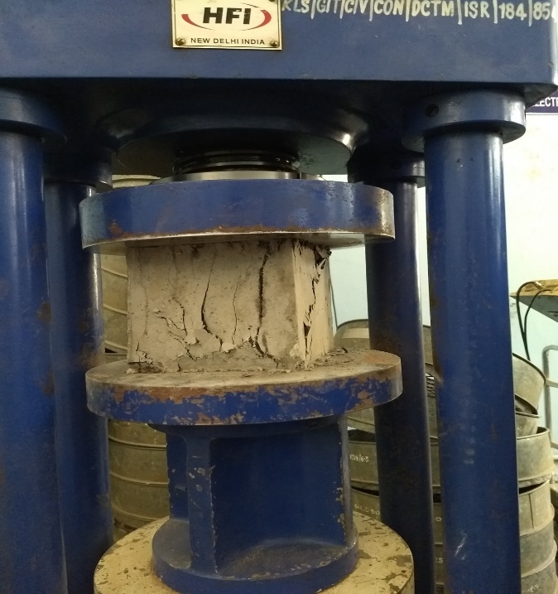

**FIG 1: COMPRESSION TESTING OF CUBES**

**5.5 FLEXURE TEST-[TEST ON BEAMS]**

Concrete is quite strong in compression and weak in tension.Hence in most of the design of concrete structures its tensile strength is ignored.However at certain situations like water retaining and pre stressed concrete structures the tensile strength of concrete is essentialrequirement. A direct application ofpure tensile stress is difficult. An indirect way is adopted by measuring the flexural strength of beam.

Three specimens shall be tested each at the end of three and seven days.The dimension of each specimen should be noted before the testing.The specimen shall then be placed in a machine in such a manner that the load shall be applied to the uppermost surface as cast in the mould.The specimen shall be supported on 38mm diameter roller with 600 mm span for 150mm size specimen and 400mm span for 100mm size specimen.The load shall be applied through two similar rollers mounted at the third points of the supporting span that is spaced 200mm or 133mm c/c.The spacing of the two load application points at the top of specimen is 200mm for a specimen size of 150mm*150mm*700mm and or 130mm for 100mm*100 mm* 500 mm.The loading arrangement employed for the test.The axis of the specimen shall be carefully aligned with the axis of loading device.The load is applied without stock data rate of 4 KN/min for 150 mm specimen and 1.8 KN/min for 100 mm specimen .The load shall be increased until the specimen fails and the maximum load applied to the specimen during test shall be recorded.If the line of rupture occurs in the middle third, the modulus of rupture is given by equation.

Fcr =PL/bd2

In case line of rupture lies outside the middle third at a distance ‘a’ from the support up then modulus of rupture is given by

Fcr=3Pxa/bd2

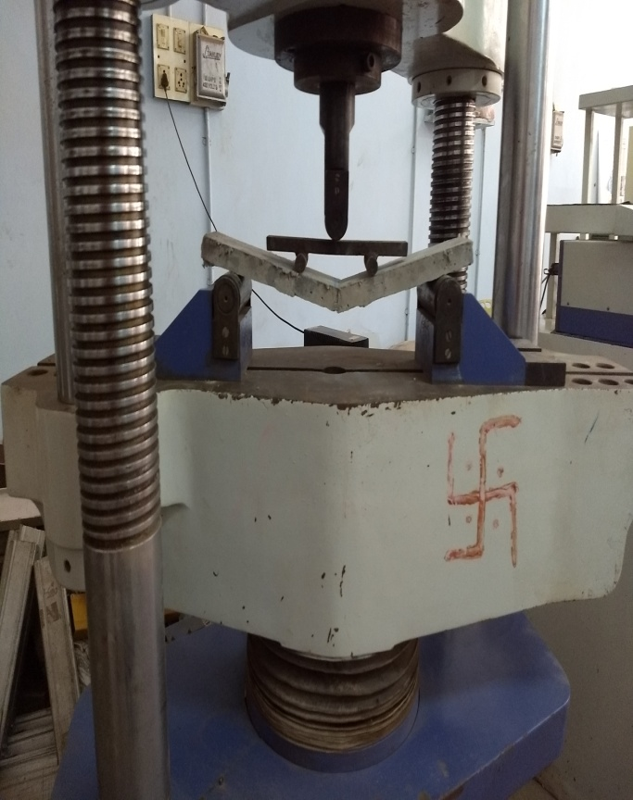

FIG 2(a): FLEXURAL TESTING OF BEAMS

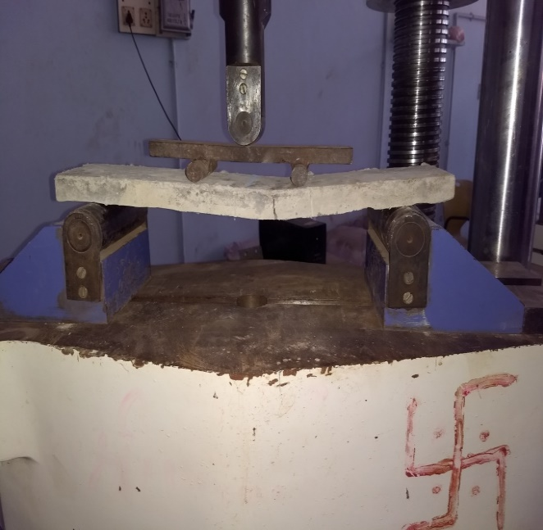

FIG 2(b): FLEXURAL TESTING OF BEAM

Compressive test results of Bendable concrete with 0% GBS

|  |  |  |  |  |
| --- | --- | --- | --- | --- |
| BC | Days | Failure load in KN | Average failure load in KN “P” | Compressive strength in Mpa (P/A) |
| 1 |  | 600 |  |  |
| 2 | 7 | 620 | 626.67 | 27.85 |
| 3 |  | 660 |  |  |
| 1 |  | 660 |  |  |
| 2 | 28 | 690 | 676.67 | 30.07 |
| 3 |  | 680 |  |  |

Table No. 1

Compressive test results of Bendable concrete with 30% GBS

|  |  |  |  |  |
| --- | --- | --- | --- | --- |
| BC | Days | Failure load in KN | Average failure load in KN “P” | Compressive strength in Mpa (P/A) |
| 1 |  | 590 |  |  |
| 2 | 7 | 490 | 530 | 23.56 |
| 3 |  | 510 |  |  |
| 1 |  |  |  |  |
| 2 | 28 |  |  |  |
| 3 |  |  |  |  |

Table No. 2

Compressive test results of Bendable concrete with 40% GBS

|  |  |  |  |  |
| --- | --- | --- | --- | --- |
| BC | Days | Failure load in KN | Average failure load in KN “P” | Compressive strength in Mpa (P/A) |
| 1 |  | 670 |  |  |
| 2 | 7 | 560 | 653.33 | 29.03 |
| 3 |  | 730 |  |  |
| 1 |  |  |  |  |
| 2 | 28 |  |  |  |
| 3 |  |  |  |  |

Table No.3

Compressive test results of Bendable concrete with 50% GBS

|  |  |  |  |  |
| --- | --- | --- | --- | --- |
| BC | Days | Failure load in KN | Average failure load in KN | Compressive strength in Mpa (P/A) |
| 1 |  | 510 |  |  |
| 2 | 7 | 560 | 526.67 | 23.4 |
| 3 |  | 510 |  |  |
| 1 |  |  |  |  |
| 2 | 28 |  |  |  |
| 3 |  |  |  |  |

Table No.4

Graph 1.Compressive strength results

Flexural strength test results of Bendable Concrete with 0% GBS

|  |  |  |  |  |
| --- | --- | --- | --- | --- |
| BC | Days | Peak load in KN | Average peak load in KN | Flexural strength in Mpa  (PL/bd2) |
| 1 |  | 1.4 |  |  |
| 2 | 7 | 0.8 | 0.93 | 4.15 |
| 3 |  | 0.6 |  |  |
| 1 |  |  |  |  |
| 2 | 28 |  |  |  |
| 3 |  |  |  |  |

Table No.5

Flexural strength test results of Bendable Concrete with 30% GBS

|  |  |  |  |  |
| --- | --- | --- | --- | --- |
| BC1 | Days | Peak load in KN | Average peak load in KN | Flexural strength in Mpa  (PL/bd2) |
| 1 |  | 1.8 |  |  |
| 2 | 7 | 0.6 | 1.33 | 5.92 |
| 3 |  | 1.6 |  |  |
| 1 |  |  |  |  |
| 2 | 28 |  |  |  |
| 3 |  |  |  |  |

Table No.6

Flexural strength test results of Bendable Concrete with 40% GBS

|  |  |  |  |  |
| --- | --- | --- | --- | --- |
| BC2 | Days | Peak load in KN | Average peak load in KN | Flexural strength in Mpa  (PL/bd2) |
| 1 |  | 1.6 |  |  |
| 2 | 7 | 1.0 | 1.4 | 6.22 |
| 3 |  | 1.6 |  |  |
| 1 |  |  |  |  |
| 2 | 28 |  |  |  |
| 3 |  |  |  |  |

Table No.7

Flexural strength test results of Bendable Concrete with 50% GBS

|  |  |  |  |  |
| --- | --- | --- | --- | --- |
| BC3 | Days | Peak load in KN | Average peak load in KN | Flexural strength in Mpa  (PL/bd2) |
| 1 |  | 1.6 |  |  |
| 2 | 7 | 0.6 | 1.13 | 5.04 |
| 3 |  | 1.2 |  |  |
| 1 |  |  |  |  |
| 2 | 28 |  |  |  |
| 3 |  |  |  |  |

Table No.8

Graph.2 Flexural test results

DISCUSSION OF RESULTS

In the above comparisons,

* The Compressive strength of bendable concrete is slightly less than the normal concrete.
* The Flexural strength of bendable concrete is higher than the normal concrete.
* In bendable concrete the mix having 40% replacement of fine aggregates by GBS shows the best results with higher compressive and flexural strength.
* It can be concluded that 40% is optimum % of replacement of fine aggregates by GBS.

REFERENCES

1)Ganesh S. Ghodke1,Nilesh S Daphal2, Yogesh S.Bandgar, “Experimental study of Bendable Concrete by using Admixture and Fiber”, International Journal For Technological Research In Engineering, Volume 4, Issue 9, May-2017.

2) Dr. A. W. Dhawale1, Mrs. V. P. Joshi2,” Engineered Cementitious Composites for Structural Applications”, International Journal of application or innovation in Engineering and Management(IJAIEM), Volume 2, Issue 4, April 2013

3)MandalVenugopal,VRajesh,”EXPERIMENTAL STUDY ON BENDABLE CONCETE”, International Journal of EngineeringResearch and Technological(IJERT), Volume 5, Issue 10,October 2016

4) B.D.Gohil, K.B.Parikh,”Study on Engineered cementitious composites with different fibers: A critical Review”, International Journal of application or innovation in Engineering and Management (IJAIEM), volume 6, Issue 3, February 2016

5) k.Selvakumar,R.Kishore Kumar,A.Deivasigamani,Ms.S.Amutha,” Experimental Study on Bendable Concrete”, International Journal of Civil Engineering(ICRTCETM),Special Issue ,April 2017