

# EXERCISE: USER DEFINED CLASS

**STIA1123 –PROGRAMMING II**

**Task 1**

// The Triangle class stores and manipulates data for a //triangle.  
   
public class Triangle  
{  
 private double height;  
 private double base;  
  
 // The setHeight method accepts an argument which is

//stored in the height field.  
  
 public void setHeight(double len)  
 {  
 height = len;  
 }  
  
 // The setBase method accepts an argument which is

//stored in the base field.

public void setBase(double b)  
 {  
 base = b;  
 }  
  
 //The set method accepts two arguments which are

//stored in the height and base fields.

public void set(double len, double b)  
 {  
 height = len;  
 base = b;  
 }  
  
 // The getHeight method returns the value stored in the

// height field.  
  
 public double getHeight()  
 {  
 return height;  
 }  
  
 // The getBase method returns the value stored in the

//base field  
  
 public double getBase()  
 {  
 return base;  
 }  
  
 // The getArea method returns the value of area

// with formula : 0.5 * height * base  
  
 public double getArea()  
 {  
 return 0.5 * height * base;  
 }  
}

Type the above definition of a Triangle class and save in a file.

1. What is the name to be given to this file?

**Triangle.java**

1. Compile this file. If you get any error, it means that you haven’t typed correctly the given codes.

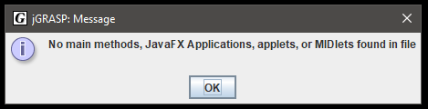

1. After a successful compilation, now try to run. Explain what happened and why.

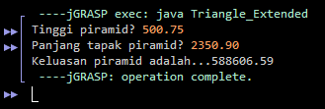

**The error occurs because there is no main method that can be operated in the source code.**

**Task 2**

import **java.util.Scanner;**

public class TriangleDemo  
{  
 public static void main(String[] args)  
 {

//create a Scanner object

**Scanner ya = new Scanner(System.in);**   
  
 // Create a Triangle object.  
 **Triangle segitiga = new Triangle();**  
  
 // Prompt user to input value for height and base

**System.out.print(**"**Enter the height:** "**);**

**double height = ya.nextDouble();**

**System.out.print(**"**Enter the base:** "**);**

**double base = ya.nextDouble();**

//Set the height and base (use mutator)   
 **segitiga.set(height);**

**segitiga.set(base);**

// Display the height, base and area (use accessor)  
 System.out.println("The pyramid's height is "  
 + **segitiga.getHeight()**);  
 System.out.println("The pyramid's base is "  
 + **segitiga.getBase()**);  
   
 System.out.println("The pyramid's area is "  
 + **segitiga.getArea()**);  
   
 }  
}

Complete the above Java program and save it **in the same folder** where the Triangle class file is located.

1. Compile this file. If you get any error, it means that you haven’t typed correctly the given codes.
2. After a successful compilation, now try to run. What’s the output?

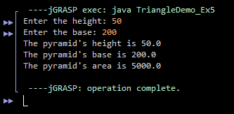

**The output is as the picture shown above.**

1. List **ALL** the following items based on the Triangle class:

a) object

**sc, segitiga**

b) user-defined methods with return value

**getHeight(), getBase(), getArea()**

c) user-defined methods with passing-parameters

**setHeight(double len), setBase(double b),**

**set(double len, double b),**

d) accessor methods

**getHeight(), getBase(), getArea()**

e) mutator methods

**setHeight(double len), setBase(double b),**

**set(double len, double b),**

**Task 3**

Develop an Employee class which consists of employee ID number, gross pay, state tax and federal tax. You also must create input () method to prompt a user to insert employee ID number, gross pay, state tax and federal tax.

Next, develop a Payroll class that consists of two user-defined methods, namely calculateNetPay() and printOutput() methods. The calculateNetPay() method is used to calculate the employee’s net pay, as follows:

|  |
| --- |
| **Net pay = gross pay – state tax - federal tax** |

In the same class, print the net pay value in the printOutput() method.

Then, develop a PayrollDemo class which consists of the main method. Inside the main method, create **TWO (2)** objects to invoke input(), calculateNetPay() and printOutput() methods.

Your program should produce the following output:

Enter your employee ID number: 2150  
Enter your Gross Pay :RM 4000  
Enter your State Tax :RM 300  
Enter your Federal Tax :RM 500  
  
Net pay is : RM 3200.00

*Note: The underlined values are entered by the user.*

