PART 1:

The following table is the result of regressing the log of real GDP per capita on the share of gross capital formation (logsk) and x, where x=ln(popg + 0.05).

|  |  |  |  |  |
| --- | --- | --- | --- | --- |
| **Table 1**  Dependent variable: log GDP per worker (2014) | | | | |
| **Sample Observations** | **Non-oil** | **Intermediate** | **OECD** | **Total Sample**  **(Our regression)** |
|  | 98 | 75 | 22 | 182 |
| **Variables** | **Coefficients and Standard Errors** | | | |
| CONSTANT | 5.48  (1.59) | 5.36  (1.55) | 7.97  (2.48) | 7.7958  (0.9420) |
| logsk | 1.42  (0.14) | 1.31  (0.17) | 0.50  (0.43) | 1.4595  (0.1471) |
| x | -1.97  (0.56) | -2.01  (0.53) | -0.76  (0.84) | -1.4296  (0.3283) |
| Adjusted R2 | 0.59 | 0.59 | 0.06 | 0.4037 |

The results obtained in the above table would further support the evidence found in the paper for a number of reasons. First, one can see that expected signs of the coefficients correspond with the theory and that the sum of logsk and x from our regression is approximately equal to zero which the theory supports since the coefficient of logsk from the theory is α/(1- α) and the coefficient of x is - α/(1- α). When comparing our coefficients to the ones obtained from the paper we see that they roughly resemble those found from the non-oil and intermediate country samples. Some possible reasons to why they deviate from the OECD sample could be that the OECD’s sample size is quite small and thus subject to further variation and upon inspecting the adjusted R2 for the OECD countries one can see that only 6% of the variation in log of GDP per worker is explained by the model. Secondly, the standard errors are low for all variables in the regression with p-values of 0 indicating that they are all significant regressors in the model. This evidence would indicate that the estimates are indeed statistically significant in the model. Finally, when inspecting the adjusted R2 of our regression and the regressions from the paper we can see that our R2 is slightly lower than that of the paper, but with an adjusted R2 value of 0.4037 it is still relatively high and indicates that our model can explain 40.37% of the variation in the log of GDP per worker.

Table 2 is the result of regressing the log of real GDP per capita on logsk and x for the 35 countries belonging to the OECD in our sample as well as the 147 countries that do not belong to the OECD.

The results obtained from running these two regressions yield different results than those obtained from the regression in the first question. First, the OECD countries regression is more similar to the results obtained from the OECD regression done in the paper. The p-value for x in the OECD countries was at 0.746 indicating that actual coefficient of x in this regression is equal to zero with 74.6% certainty. One reason that this may be the case is that we could suffer from a dimensionality problem where the sample size is quite small relative to the potentially large number of variables that could predict the log of GDP for OECD countries. In addition, there could be a correlation of x with one or many variables in the error term which would violate one of the assumptions made in OLS. Finally, one has to consider that there may be a case of omitted variable bias that could also skew the results of the coefficients obtained. Due to these factors, we arrive at a lower R2 with 10.56% of the variation in the log of GDP per worker being explained by the model. This is a similar result to that obtained in the paper where they achieved an R2 of 0.06. Now focusing on the non-OECD countries one observes that these values appear to be more in line with the theory and with our regression on the total sample of countries. First, the coefficients of logsk and x have the predicted signs and approximately sum to zero and are both significant in the model with p-values less than one percent. Likewise, the R2 of non-OECD countries is 0.3100 which is much closer to the R2 of the total sample.

|  |  |  |
| --- | --- | --- |
| **Table 2**  Dependent variable: log GDP per worker (2014) | | |
| **Sample Observations** | **OECD countries** | **Non-OECD countries** |
|  | 35 | 147 |
| **Variables** | **Coefficients and Standard Errors** | |
| CONSTANT | 11.8006  (1.2495) | 8.331  (1.0659) |
| logsk | 0.7423  (0.3143) | 1.2937  (0.1654) |
| x | 0.1411  (0.4317) | -1.0829  (0.3864) |
| Adjusted R2 | 0.1056 | 0.3100 |

Upon running the test command on the variables logsk and x after each regression, one can see that there are slightly different results for each of the tests. For the tests we used the test command with the hypothesis that logsk and x sum to zero. For the first regression on the total sample we accept the null hypothesis that logsk + x = 0 at all critical values greater than 7%. For the OECD countries however, the results show that we will reject the hypothesis that logsk + x = 0, due to the low probability of the coefficients summing to zero. This result could be attributed to the small sample size of OECD countries and looking at the coefficients it is very unlikely that they would support the theoretical hypothesis. Finally, we use the test command on the non-OECD countries which also leads us to a more ambiguous result than the previous two. The test shows that the equality of coefficients will hold approximately 61.23% of the time which although significant does not hold for many critical values. This leads us to conclude that the coefficients obtained in question one are statistically significant and coincide with the theoretical expectation of the coefficients summing to zero. However, the tests on the partitioned sample for OECD countries and non-OECD countries do no generate the same results as the total sample.

The results from running the regression of log GDP per worker on log share of gross capital formation (logsk), log share of government consumption (logsg) and x are statistically quite different from those obtained in questions one and two for several reasons. First, when observing the OECD countries we see that the adjusted R2 improved from a value of 0.1056 to a value of 0.1304. However, in doing so one can see that the p-value associated with the variable x is quite high at 0.728, meaning that it is not significant in modeling the variation in log GDP per worker when logsg is introduced. This could be the result of a possible correlation between the regressors which would violate one of the assumptions of OLS and potentially lead to a higher p-value for both x and logsg. Secondly, on observing the non-OECD countries one observes that there is not much change in the adjusted R2 value at 0.3100 from the first part and 0.3081 from this regression. There is not much change in the adjusted R2 value since the p-value for logsg is 0.437, there is a high likelihood that this variable is not significant in determining the variation in log GDP per worker. Lastly, on observing the total sample comparison we have similar R2 values with a value of 0.4037 from the first part and 0.4117 from this regression. However, unlike the non-OECD regression the p-value for the total sample is quite small for logsg at around 0.066 which indicates that the variable may be useful in determining the variation in log GDP per worker.

|  |  |  |  |
| --- | --- | --- | --- |
| **Table 3**  Dependent variable: log GDP per worker (2014) | | | |
| **Sample Observations** | **OECD countries** | **Non-OECD countries** | **Total Sample** |
|  | 35 | 147 | 182 |
| **Variables** |  |  |  |
| CONSTANT | 10.2601  (1.6605) | 7.8336  (1.2434) | 6.8185  (1.0741) |
| logsk | 0.6368  (0.3191) | 1.2924  (0.1656) | 1.4315  (0.1469) |
| x | -0.1691  (0.4811) | -1.1800  (0.4065) | -1.5904  (0.3374) |
| logsg | -0.2882  (0.2083) | -0.1454  (0.1864) | -0.3001  (0.1620) |
| Adjusted R2 | 0.1304 | 0.3081 | 0.4117 |

PART 2:

See below in Figure 1 where the y-axis represents the growth rate of per capita GDP over the period 1980-2014 and the x-axis represents log of per capita GDP in 1980 for the total sample. Figure 2 represents the sample of only OECD countries.

**Figure 1** **Figure 2**

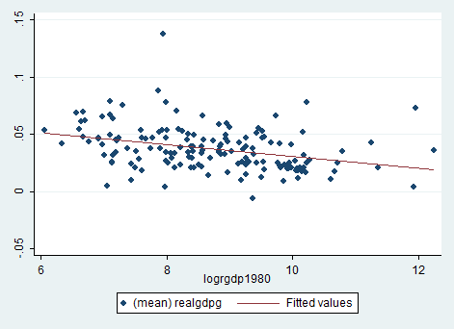 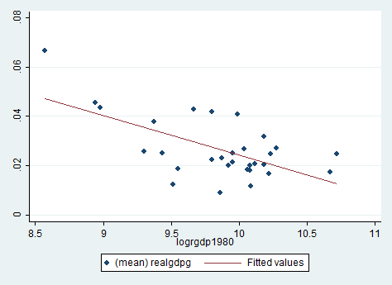

The results obtained from this twoway scatter plot are similar to figure one from the paper by Barro and sala-i-Martin. Both our figure and the one from the paper show a negative correlation between log of per capita GDP and the growth rate of per capita GDP over the period. The appearances of the graphs are slightly different due to the scale of the y-axis, however the sign of the relationship remains true regardless. Figure 2 also contains a similar result when looking at OECD countries only, the relationship between log of per capita GDP and the growth rate of per capita GDP over the period. It is worth noting again that the small sample size for OECD countries could lead to skewed results.

|  |  |
| --- | --- |
| **Table 4**  Dependent variable: Real GDP per capita growth (1980-2014) | |
| **Sample Observations** | **Total Sample** |
|  | 156 |
| **Variables** |  |
| CONSTANT | 0.0830  (0.0103) |
| logrgdp1980 | -0.0052  (0.0012) |
| Adjusted R2 | 0.1084 |

The first thing to note regarding the results of the above table is that the p-value for logrgdp1980 is zero which indicates that this regressor is statistically significant in determining the variation of real GDP per capita growth over the period observed. The sign is negative which is what should be expected since a negative relationship between logrgdp1980 and the real GDP per capita growth is what the evidence from the paper suggests. We can also see this as depicted in both of the Figures attached on the previous page. In conclusion, we see from the adjusted R2 that this model explains 10.84% of the variation of real GDP per capita growth over this time period.

|  |  |
| --- | --- |
| **Table 5**  Dependent variable: Real GDP per capita growth (1980-2014) | |
| **Sample Observations** | **Total Sample** |
|  | 156 |
| **Variables** |  |
| CONSTANT | 0.1212  (0.0165) |
| logrgdp1980 | -0.0077  (0.0014) |
| logsk | 0.0112  (0.0037) |
| logsg | -0.0006  (0.0034) |
| Adjusted R2 | 0.1482 |

The first observation to be noted in the regression is that the p-value for logsg is 0.874 indicating that this regressor is not significant in determining the variation in real GDP per capita growth. The sign of logrgdp1980 is negative which is what the evidence from the paper suggest and is statistically significant with a p-value of zero. Finally, the R2 indicates that this model can explain 14.82% of the variation of real GDP per capita growth over this time period.

In order to determine whether or not the world has become more unequal using our data, we can compare the variances in logrgdp2014 and logrgdp1980. Upon doing so one notices that the variance of logrgdp2014 is 1.3803 while the variance of logrgdp1980 was 1.5262. This would indicate that the world has not become more unequal because as the variance decreases, the distribution of log per capita GDP becomes less spread out meaning that inequality has decreased over this time period.