**CSS**

CSS stands for Cascading Style Sheet : -

**CSS Selectors**  
CSS selectors are used to “find” (or select) HTML elements based on their element name, id, class, attribute, and more.

* 1. **THE UNIVERSAL SELECTORS :**Rather than selecting elements of a specific type, the universal selector quite simply matches the name of any element type

filter_none

brightness_4

|  |
| --- |
| * {     color: #000000;  } |

This rule renders the content of every element in our document in black.  
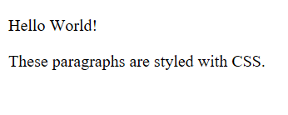

* 1. **THE ELEMENT SELECTOR :**The element selector selects elements based on the element name. You can select all p elements on a page like this (in this case, all p elements will be center-aligned, with a red text color) :

filter_none

brightness_4

|  |
| --- |
| p {      text-align: center;      color: red;  } |

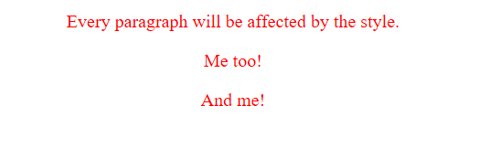

* 1. **THE DESCENDANT SELECTOR :**Suppose you want to apply a style rule to a particular element only when it lies inside a particular element. As given in the following example, style rule will apply to em element only when it lies inside ul tag.

filter_none

brightness_4

|  |
| --- |
| ul em {     color: #000000;  } |



* 1. **THE ID SELECTOR :**
     + The id selector uses the id attribute of an HTML element to select a specific element.
     + The id of an element should be unique within a page, so the id selector is used to select one unique element!
     + To select an element with a specific id, write a hash (#) character, followed by the id of the element.
     + The style rule below will be applied to the HTML element with id=”para1″:

filter_none

brightness_4

|  |
| --- |
| #para1 {      text-align: center;      color: red;  } |

  
The true power of id selectors is when they are used as the foundation for descendant selectors, For example:

filter_none

brightness_4

|  |
| --- |
| #black h2 {     color: #000000;  } |

In this example all level 2 headings will be displayed in black color when those headings will lie with in tags having id attribute set to black.  
**NOTE:** An id name cannot start with a number.

* 1. **THE CLASS SELECTORS :**
     + The class selector selects elements with a specific class attribute.
     + To select elements with a specific class, write a period (.) character, followed by the name of the class.
     + In the example below, all HTML elements with class=”center” will be red and center-aligned:

filter_none

brightness_4

|  |
| --- |
| .center {      text-align: center;      color: red;  } |



You can apply more than one class selectors to given element. Consider the following example:

filter_none

brightness_4

|  |
| --- |
| <p class="center large">This paragraph refers to two classes.</p> |



**GROUPING SELECTORS**

If you have elements with the same style definitions, like this:

filter_none

brightness_4

|  |
| --- |
| h1 {      text-align: center;      color: blue;  }    h2 {      text-align: center;      color: blue;  }    p {      text-align: center;      color: blue;  } |

It will be better to group the selectors, to minimize the code. To group selectors, separate each selector with a comma. In the example below we have grouped the selectors from the code above:

filter_none

brightness_4

|  |
| --- |
| h1, h2, p {      text-align: center;      color: red;  } |



**Before CSS**

filter_none

brightness_4

|  |
| --- |
| <!DOCTYPE html>  <html>  <head>  <title>Example</title>  </head>  <body>  <main>  <h1>HTML Page</h1>  <p>This is a basic web page.</p>  </main>  </body>  </html> |



**After CSS**

In this example we add some CSS.

filter_none

brightness_4

|  |
| --- |
| <!DOCTYPE html>  <html>  <head>  <title>Example</title>  <style>  main {    width: 200px;    height: 200px;    padding: 10px;    background: beige;    }  h1 {    font-family: fantasy, cursive, serif;    color: olivedrab;    border-bottom: 1px dotted darkgreen;    }  p {    font-family: sans-serif;    color: orange;    }  </style>  </head>  <body>  <main>  <h1>HTML Page</h1>  <p>This is a basic web page.</p>  </main>  </body>  </html> |

**All we did was add the following code to the example:**

filter_none

brightness_4

|  |
| --- |
| <style>  main {    width: 200px;    height: 200px;    padding: 10px;    background: beige;    }  h1 {    font-family: cursive;    color: olivedrab;    border-bottom: 1px dotted darkgreen;    }  p {    font-family: sans-serif;    color: orange;    }  </style> |



**CSS Versions**

* 1. CSS1
  2. CSS2
  3. CSS3
  4. CSS4  
     Version 4 comes with:-
     + CSS-Pro
     + CSS-Mobile

CSS | Combinators

CSS combinators are explaining the relationship between two selectors. CSS selectors are the patterns used to select the elements for style purpose. A CSS selector can be a simple selector or a complex selector consisting of more than one selector connected using combinators.  
There are four types of combinators available in CSS which are discussed below:

* General Sibling selector (~)
* Adjecant Sibling selector (+)
* Child selector (>)
* Descendant selector (space)

**General Sibling selector:** The general sibling selector is used to select the element that follows the first selector element and also share the same parent as the first selector element. This can be used to select a group of elements that share the same parent element.

filter_none

edit

play_arrow

brightness_4

|  |
| --- |
| <!DOCTYPE html>  <html>  <head>      <title>Combinator Property</title>      <style>          div ~ p{              color: #009900;              font-size:32px;              font-weight:bold;              margin:0px;              text-align:center;          }          div {              text-align:center;          }      </style>  </head>    <body>      <div>General sibling selector property</div>      <p>GeeksforGeeks</p>      <div>          <div>child div content</div>          <p>G4G</p>      </div>      <p>Geeks</p>      <p>Hello</p>  </body>  </html> |

**Output:**  
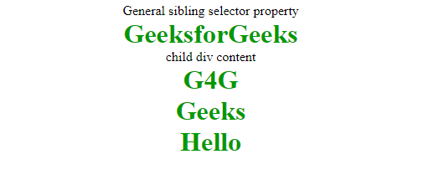

**Adjacent Sibling selector:** The Adjacent sibling selector is used to select the element that is adjacent or the element that is the next to the specified selector tag. This combinator selects only one tag that is just next to the specified tag.

filter_none

edit

play_arrow

brightness_4

|  |
| --- |
| <!DOCTYPE html>  <html>  <head>      <title>Combinator Property</title>      <style>          div + p{              color: #009900;              font-size:32px;              font-weight:bold;              margin:0px;              text-align:center;          }          div {              text-align:center;          }          p {              text-align:center;          }      </style>  </head>    <body>      <div>Adjacent sibling selector property</div>      <p>GeeksforGeeks</p>      <div>          <div>child div content</div>          <p>G4G</p>      </div>      <p>Geeks</p>      <p>Hello</p>  </body>  </html> |

**Output:**  
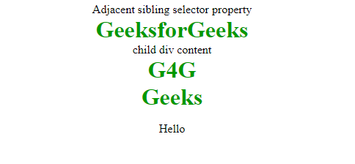

**Child Selector:** This selector is used to select the element that is the immediate child of the specified tag. This combinator is stricter than the descendant selector because it selects only the second selector if it has the first selector element as its parent.

filter_none

edit

play_arrow

brightness_4

|  |
| --- |
| <!DOCTYPE html>  <html>  <head>      <title>Combinator Property</title>      <style>          div > p{              color: #009900;              font-size:32px;              font-weight:bold;              margin:0px;              text-align:center;          }          div {              text-align:center;          }          p {              text-align:center;          }      </style>  </head>    <body>      <div>Child selector property</div>      <p>GeeksforGeeks</p>      <div>          <div>child div content</div>          <p>G4G</p>      </div>      <p>Geeks</p>      <p>Hello</p>  </body>  </html> |

**Output:**  


**Descendant selector:** This selector is used to select all the child elements of the specified tag. The tags can be the direct child of the specified tag or can be very deep in the specified tag. This combinator combines the two selectors such that selected elements have an ancestor same as the first selector element.

filter_none

edit

play_arrow

brightness_4

|  |
| --- |
| <!DOCTYPE html>  <html>  <head>      <title>Combinator Property</title>      <style>          div p{              color: #009900;              font-size:32px;              font-weight:bold;              margin:0px;              text-align:center;          }          div {              text-align:center;          }          p {              text-align:center;          }      </style>  </head>    <body>      <div>Descendant selector property</div>      <p>GeeksforGeeks</p>      <div>          <div>child div content</div>          <p>G4G</p>          <p>Descendant selector</p>      </div>      <p>Geeks</p>      <p>Hello</p>  </body>  </html> |

**Output:**  
