1.VALIDATE STACK PUSH AND POP SEQUENCES
Code:
import java.util.*;

public class Main {
public static void main(String[] args) {
Scanner s=new Scanner(System.in);
System.out.print("N:");
int n=s.nextInt();
System.out.print("Pushed array:");
int [] p1=new int[n];
for(int i=0;i<n;i++){
p1[i]=s.nextInt();
}
System.out.print("Popped array:");
int [] p2=new int[n];
for(int i=0;i<n;i++){
p2[i]=s.nextInt();
}
int index=0;
Stack<Integer> stack=new Stack<>();
for(int i=0;i<n;i++){
stack.push(p1[i]);
if(stack.peek()==p2[index]){
stack.pop();
index++;
}
}
for(int i=index;i<n;i++){
if(stack.peek()==p2[index]){
stack.pop();
index++;
}
}
if(stack.isEmpty()){
System.out.println("True");
}
else{
System.out.println("False");
}
}
}

Output:
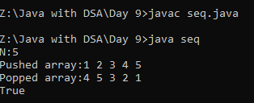
2.STRING PALINDROME IGNORE SPECIAL CHARACTER
Code:
import java.util.*;
class pali{
public static void main(String[] args){
Scanner sc=new Scanner(System.in);
System.out.print("Enter the string: ");
String str=sc.nextLine();
str=str.toLowerCase();
StringBuilder s=new StringBuilder();
for(int i=0;i<str.length();i++){
char ch=str.charAt(i);
if(Character.isLetter(ch)){
s.append(ch);
}
}
Stack<Character> stack=new Stack<>();
for(int i=0;i<s.length();i++){
char ch=s.charAt(i);
stack.push(ch);
}
System.out.println(stack);
for(int i=0;i<s.length();i++){
char ch=s.charAt(i);
if(stack.pop()!=ch){
System.out.print("False");
return;
}
}
if(stack.isEmpty()){
System.out.print("True");
}
}
}
Output:
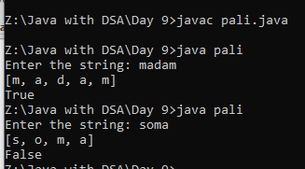
3.QUEUE OPERATIONS
Code:
import java.util.*;
class que{
public static void main(String [] args){
Queue <Integer> q=new LinkedList <>();
q.add(10);
q.add(4);
q.add(6);
q.add(32);
q.offer(2);
q.offer(8);
System.out.println("Size:"+q.size());
System.out.println("Elements:"+q);
q.remove();
System.out.println("Size:"+q.size());
System.out.println("Elements:"+q);
System.out.println("Front elmt:"+ q.element());
System.out.println("Front:"+ q.peek());
q.poll();
System.out.println("Size:"+q.size());
System.out.println("Elements:"+q);
System.out.println("contains 2:"+ q.contains(2));
System.out.println("contains 9:"+ q.contains(9));
System.out.println("IsEmpty:"+q.isEmpty());
}
}
Output:
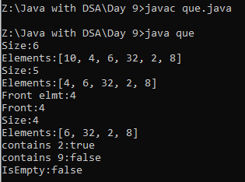

4.DEQUE OPERATIONS
Code:
import java.util.*;
public class DQ {
public static void main(String[] args) {
ArrayDeque<Integer> ad=new ArrayDeque<>();
ad.addFirst(8);
ad.addLast(4);
System.out.println("Elmts:"+ad);
ad.add(3);
System.out.println("Elmts:"+ad);
ad.addFirst(2);
ad.addLast(5);
ad.add(1);
System.out.println("Elmts:"+ad);
ad.add(0);
ad.add(7);
ad.addFirst(9);
System.out.println("Elmts:"+ad);
ad.offer(20);
ad.offerFirst(45);
ad.offerLast(90);
System.out.println("Get first:"+ad.getFirst());
ad.offer(78);
ad.offer(56);
System.out.println("Size:"+ad.size());
System.out.println("Elmts:"+ad);
ad.remove();
System.out.println("peek first:"+ad.peekFirst());
System.out.println("After remove Elmts:"+ad);
ad.removeLast();
ad.removeFirst();
System.out.println("after using remove 1st and last Elmts:"+ad);
ad.addLast(56);
ad.add(67);
System.out.println("Elmts:"+ad);
ad.poll();
ad.pollLast();
System.out.println(" after using poll and poll lastElmts:"+ad);
ad.pollFirst();
System.out.println("after using poll first Elmts:"+ad);
System.out.println("Peek:"+ad.peek());
System.out.println("Peeklast:"+ad.peekLast());
System.out.println("Size:"+ad.size());
System.out.println("Elmts:"+ad);
System.out.println("getLast:"+ad.getLast());
System.out.println("contains 56:"+ad.contains(56));
System.out.println("contains 56:"+ad.contains(23));
System.out.println("Isempty:"+ad.isEmpty());
}
}
Output:
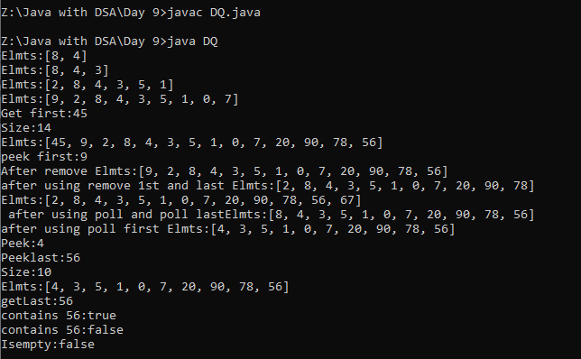
6.ADDING FIRST AND LAST IN ARRAY DEQUE USING K ELEMENTS
Code:
import java.util.*;
public class reverse {
public static void main(String[] args) {
Scanner s=new Scanner(System.in);
System.out.print("N:");
int n=s.nextInt();
int [] arr=new int[n];
System.out.println("Elements:");
for(int i=0;i<n;i++){
arr[i]=s.nextInt();
}
System.out.print("K:");
int k=s.nextInt();
ArrayDeque<Integer> ad=new ArrayDeque <>();
for(int i=0;i<k;i++){
ad.addFirst(arr[i]);
}
for(int i=k;i<arr.length;i++){
ad.addLast(arr[i]);
}
System.out.println(ad);
}
}
Output:
