1.Two Sum
CODE:
import java.util.*;
public class TwoSum {
public static void main(String[] args) {
Scanner s=new Scanner(System.in);
System.out.print("N:");
int n=s.nextInt();
System.out.print("Enter the sorted array:");
int [] arr=new int[n];
int l=0,r=n-1;
for(int i=0;i<n;i++){
arr[i]=s.nextInt();
}
System.out.print("Enter the target sum:");
int t=s.nextInt();
while(l<r){
int sum=arr[l]+arr[r];
if(sum==t){
System.out.print(l + "," + r );
return;
}
else if(sum>t){
r--;
}
else{
l++;
}
}
System.out.print("-1,-1");
}
}
OUTPUT:
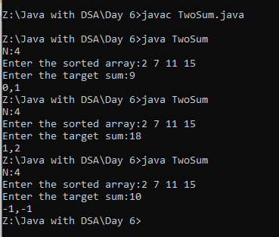
2.Remove duplicates from an array using two pointer
CODE:
import java.util.*;
public class Removedup {
public static void main(String[] args) {
Scanner s=new Scanner(System.in);
System.out.print("N:");
int n=s.nextInt();
System.out.print("Enter the sorted array:");
int [] arr=new int[n];
int l=0,r=1;
for(int i=0;i<n;i++){
arr[i]=s.nextInt();
}
while(r<arr.length){
if(arr[l]!=arr[r]){
l++;
arr[l]=arr[r];
}
r++;
}
for(int i=0;i<=l;i++){
System.out.print(arr[i] + " ");
}
}
}
OUTPUT:
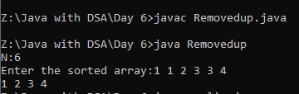
3.String palindrome using 2 pointer
CODE:
import java.util.*;
public class Palin {
public static void main(String[] args) {
Scanner s=new Scanner(System.in);
System.out.print("Enter str:");
String str=s.next();
int lft=0;
int ryt=str.length()-1;
boolean found=true;
while(lft<=ryt){
if(str.charAt(lft)==str.charAt(ryt)){
lft++;
ryt--;
}
else{
found=false;
break;
}
}
if(found){
System.out.println("Palindrome");
}
else{
System.out.println("Not a palindrome");
}
}
}
OUTPUT:
