5) RLC resonant circuits and AC circuit analysis

Lab Experiment 5 in the Bachelor Course Electronics, Signals and Measurement

**Content**

1. Learning Target 1

2. Board and Circuit Description 2

3. Theoretical Background 3

4. Simulation of the excited RLC parallel resonant circuit 6

5. Measurement of the excited RLC parallel resonant circuit 8

# Learning Target

Practical experience with the operation of a RLC (Resistor-Inductor-Capacitor) resonant circuit with forced excitation. Determination of the resonant circuit’s oscillation characteristics and comparison of the theoretical relationships of the circuit analysis with real world measurement results.

# Board and Circuit Description

The PCB shown in Figure 1 presents a configurable RLC resonant circuit with forced excitation by a periodically switched voltage source and series inductor . In the time the switch conducts, the DC voltage across the inductor leads to a triangular shaped current pulse stimulating the RLC parallel resonant tank network. In dependence on the switching frequency and jumper configuration an oscillation occurs at the resonance frequency of the components. This oscillation can be measured at the pins left and right of the damping resistors. The DC supply voltage is used for driving the circuit as well as supplying the gate driver circuit of the switch . The switching signal is provided by an extern function generator and connected to the board via a coaxial cable with a BNC connector. The switching signal can be varied in frequency for different excitation of the resonance circuit.

**Damping Resistor R**

Different jumper settings of J2-J5 allow for adjusting different damping resistors. From Figure 1 one can see, that placing all jumpers J2-J5 results in a damping resistor of 1Ohm. By taking one jumper away the damping resistor sees an increase of 1Ohm.

|  |  |  |  |  |  |
| --- | --- | --- | --- | --- | --- |
| Jumper | J2+J3+J4+J5 | J3+J4+J5 | J4+J5 | J5 | - |
| R [Ohm] | 1 | 2 | 3 | 4 | 5 |

**Resonant Capacitor C**

The jumper J10 and J9 allow for adjustment of the resonant capacitor. If none of these jumpers is set, the resonant capacitance is 254nF. Placing only J10 results in a capacitance of 254nF+254nF=508nF. If both Jumpers are set the resulting capacitance is 1016nF.

|  |  |  |  |
| --- | --- | --- | --- |
| Jumper | J9+J10 | J10 | - |
| C [nF] | 1016 | 508 | 254 |

**Resonant Inductor L**

The jumper J6 to J8 allow for adjustment of the resonant inductor, as follows:

|  |  |  |  |  |  |
| --- | --- | --- | --- | --- | --- |
| Jumper | J6+J7 | J7 | J6+J8 | J8 | - |
| L [µH] | 5 | 10 | 15 | 20 | Open Circuit |

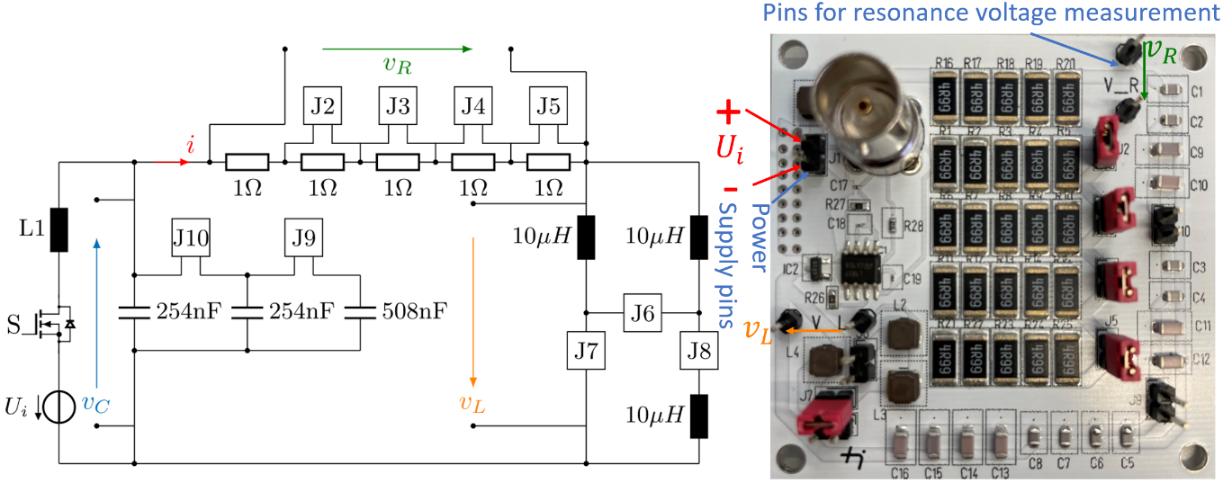

Figure 1 Circuit diagram and photo of the RLC resonant circuit

# Theoretical Background

**Excitation**

The excitation of the circuit is provided by the current flowing in the inductor L1 of the circuit shown in Figure 1. This current, henceforth called , can be approximated by the charging curve of L1 in dependence on the damping resistor R, the resonant inductance L, the supply voltage and the time the switch conducts , with being the duty cycle and being the period of the switching frequency. In regards of the excitation current, the circuit of Figure 1 can be simplified as shown below in Figure 2a.

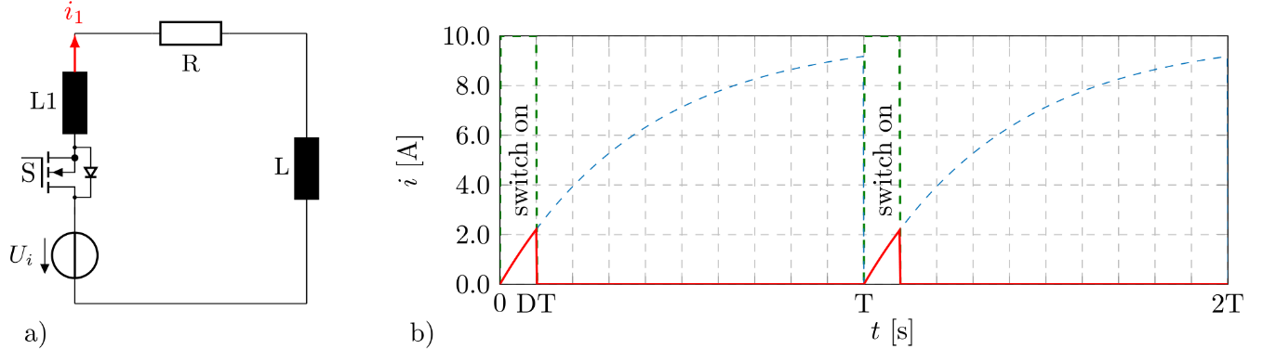

Figure 2 simplified circuit for excitation current determination

The charging curve of the current flowing in L1 is an exponential function in the time domain and is the result of the differential equation of the mesh, rearranged to the current:

|  |  |
| --- | --- |
|  | (1) |

In dependence on the switch position the current in L1 can thus be expressed in the interval of one switching period (0<t<T) as follows:

|  |  |
| --- | --- |
|  | (2) |

This current shall now be expressed in the fourier form as the sum of different cosine and sine waves with n being the order i.e. multiple of the switching frequency :

|  |  |
| --- | --- |
|  | (3) |

The fourier coefficients can be derived from the expression of the current in Equation (2):

|  |  |  |  |
| --- | --- | --- | --- |
|  | | | (4) |
|  | | | (5) |
|  | | | (6) |
|  | (7) |  | (8) |

The excitation current in the fourier form can now be investigated in the time domain. For this, Figure 3 shows the calculated current of Eq. (3) for different numbers of added

harmonics in the range . The red curve is the original current in the inductor L1, whereas the other curves show that the more harmonics are added, the better the result of the calculation is. Hence, for more accurate results should be chosen sufficiently high. However, this also comes with an increase of computational effort and time.

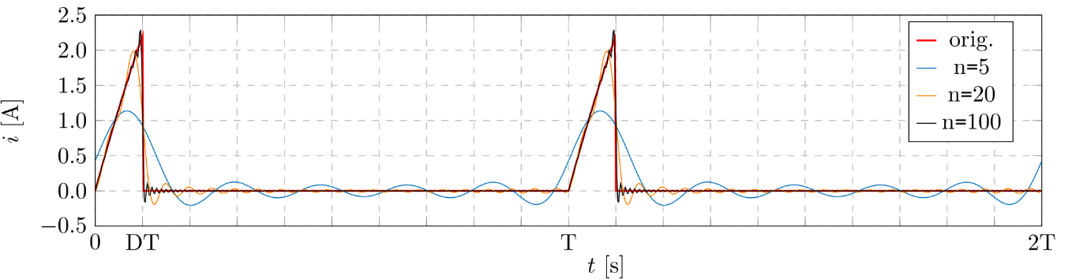

Figure 3 excitation current in the time domain for different number n of added harmonics

**Resonance**

The excitation of the parallel resonance is provided by the afore determined current flowing in the inductor L1, that can be expressed by cosine waves of different magnitudes and phases (Equation (3)). However, each of these current waves leads to a resonance between L and C, being damped by the resistance R. Superposition of all these excited waves gives the resulting resonance waveform, here being the current in the damping resistor R. Figure 4 shows simulated results for the current in L1 and resonant current in R. One can see, that for the chosen simulation configuration the excitation frequency with of the current (shown in red) is smaller than the frequency of the resonant current with (shown in green). In this case a free ringing can occur, that reduces in amplitude according to the damping resistance.

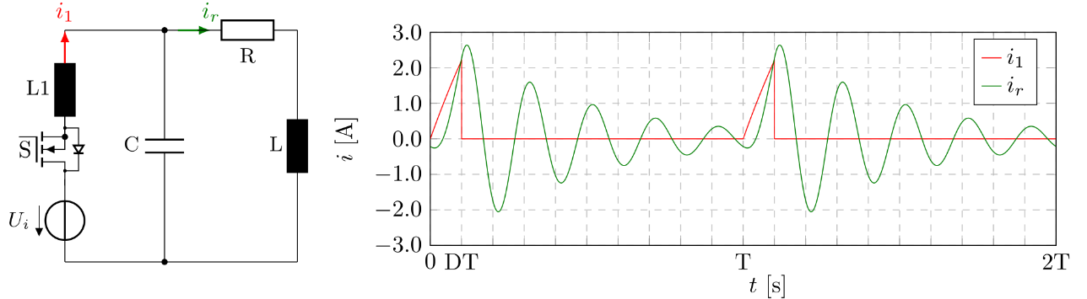

Figure 4 simulated excitation current and current in the damping resistor R

From the circuit in Figure 4 one can see, that the excitation current flows into the parallel connection of C and the series connection R and L. In complex nomenclature this impedance can be expressed as:

|  |  |
| --- | --- |
|  | (9) |

The resonance current can thus be derived from a current divider:

|  |  |
| --- | --- |
|  | (10) |

The absolute value of the new defined impedance scales the magnitude of each wave that consists of, whereas its phase leads to a shift. Applying these relationships to Equation 3 yields an expression for the resonance current:

|  |  |
| --- | --- |
|  | (11) |

In Figure 5 the analytic results for and hence with superposition of the first 100 harmonics of are compared with a LtSpice simulation (dashed). It can be seen, that the results fit well and the circuit can be described analytically with the assumptions made.

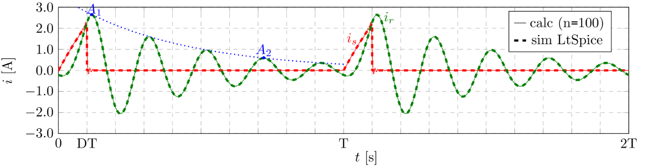

Figure 5 simulated and calculated (n=100) excitation current and current in the damping resistor R

**Damping**

Another way to describe the damped oscillation is by solving the differential equation of the circuit in Figure 4. According to the circuit, the mesh and capacitor equation are as follows:

|  |  |  |  |
| --- | --- | --- | --- |
|  | (12) |  | (13) |

Substitution of Equation (12) into Equation (13) yields the differential equation for the resonance current:

|  |  |  |  |  |  |
| --- | --- | --- | --- | --- | --- |
|  | (14) |  | (15) |  | (16) |

The solution of this homogenous differential equation gives two conjugated complex zeros, which is why it can be expressed as a cosine wave being damped by an exponential term in dependence on the so-called damping factor and time .

|  |  |
| --- | --- |
|  | (17) |

The amplitude of this wave reduces with the term over time as can be seen from Figure 5. The damping factor can thus not only be calculated with Equation (15), but also be obtained by measurement of subsequent peak values. The peaks of the damped wave occur when the cosine term of Equation (17) is 1 and hence the amplitudes and can be expressed as:

|  |  |  |  |
| --- | --- | --- | --- |
|  | (12) |  | (13) |

Solving both equations (12) and (13) for the damping factor , gives the so called **logarithmic decrement**  of the amplitude decrease:

|  |  |
| --- | --- |
|  | (18) |

With as the period of the resonance wave and being the number of periods resulting with in the overall time between the measurement points of and .

# Simulation of the excited RLC parallel resonant circuit

Built a simulation in LtSpice or use the simulation model of the LtSpice lecture and adjust it according to Figure 6.

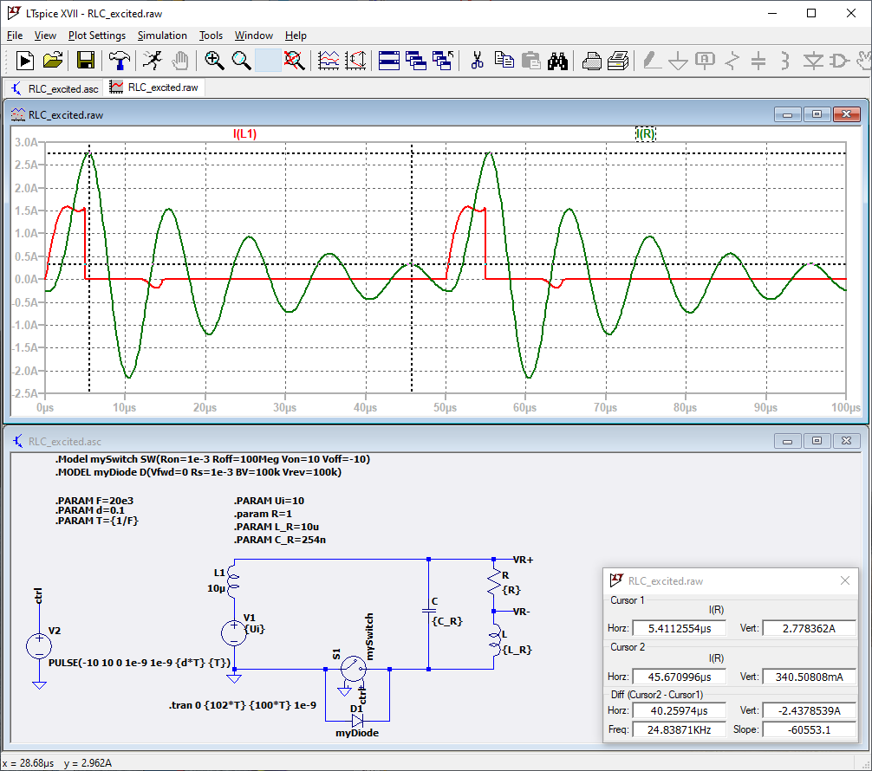

Figure 6 LtSpice model of the RLC parallel resonant circuit

1. **Simulate the circuit and display the excitation current in L1 as well as the current in R for the following setting:**

|  |  |  |  |  |  |  |
| --- | --- | --- | --- | --- | --- | --- |
| f [kHz] | d (duty cycle) | Ui [V] | L1 [µH] | R [Ohm] | L_R [µH] | C_R [nF] |
| 20 | 0.1 | 10 | 10 | 1 | 10 | 254 |

Explain why the excitation current in L1 does not fully equal the expected charging curve of an inductor. **Hint:** Cut C from the circuit and compare both simulation results.

The excitation current in L1 does not fully equal the expected charging curve of an inductor because the presence of capacitor C in the circuit introduces oscillatory behavior and also the Resistance when see the graph’s observing superposition. This causes the current to deviate from the smooth exponential rise seen in a simple inductor circuit. Cutting C from the circuit would result in a smooth charging curve for L1 as expected.

1. **Simulate the circuit and measure the damping factor according to Equation (18) for the following settings:**

|  |  |  |  |
| --- | --- | --- | --- |
| **f [kHz]** | **d (duty cycle)** | **Ui [V]** | **L1 [µH]** |
| 20 | 0.1 | 10 | 10 |
| **Nr.** | **R [Ohm]** | **L_R [µH]** | **C_R [nF]** | **R/(2*L_R)** | **[1/s]** |
| 1 | 1 | 5 | 254 | 100000 | 99708 |
| 2 | 1 | 20 | 254 | 25000 | 25265 |
| 3 | 1 | 10 | 254 | 50000 | 49917 |
| 4 | 2 | 10 | 254 | 100000 | 100677 |
| 5 | 3 | 10 | 254 | 150000 | 149606 |
| 6 | 3 | 10 | 508 | 150000 | 151580 |

How does the resistance of R, the resonant inductance L_R and the resonant capacitance C_R influence the damping of the oscillation? How does a change of capacitance influence the resonance?

According to the graph the resistance directly affects damping, while inductance and capacitance primarily determine the resonant frequency and. How does a change of capacitance influence the resonance? No change

1. **Simulate the circuit and measure the damping factor according to Eq. (18) for the following settings. Take the first amplitude for |A1| after the excitation current is 0!**

|  |  |  |  |  |  |
| --- | --- | --- | --- | --- | --- |
| **d** | **Ui [V]** | **L1 [µH]** | **R [Ohm]** | **L_R [µH]** | **C_R [nF]** |
| 0.1 | 10 | 10 | 1 | 10 | 254 |
| **f [kHz]** | **[A]** | **| [A]** | **[µs]** | **[1/s]** |
| 20 |  |  |  |  |
| 30 |  |  |  |  |
| 40 |  |  |  |  |
| 50 |  |  |  |  |
| 60 |  |  |  |  |
| 70 |  |  |  |  |
| 80 |  |  |  |  |

**Damping factor vs frequency:**

**Resonance magnitude vs frequency:**

How is the damping influenced by the excitation frequency? Why does the magnitude of the resonance current decrease the closer the excitation frequency is to the resonance frequency?

# Measurement of the excited RLC parallel resonant circuit

We now want to compare the theoretical analysis and simulation results to real world measurements with the PCB shown in Figure 1.

1. Place all Jumpers to achieve the following setting: R=1Ohm, L=10uH, C=254nF (according to the jumper tables of page 2).
2. Connect a differential voltage probe to the measurement pins of as shown in Figure 7. Set the voltage divider of the differential probe to 1/10.
3. Connect the differential probe to an oscilloscope and adjust a high input impedance (1MOhm) as well as a voltage divider ratio of 1:10. Adjust the time settings of the oscilloscope to 10us/Div and the voltage settings to 1V/Div.
4. Connect a function generator with a BNC coaxial cable to the board for controlling the switch. Adjust the function generator as shown in Figure 7.
5. Connect the power supply to the board, pay attention to polarity (see Figure 1). Adjust 10V input voltage in voltage supply mode (not limited by the current limiter)!

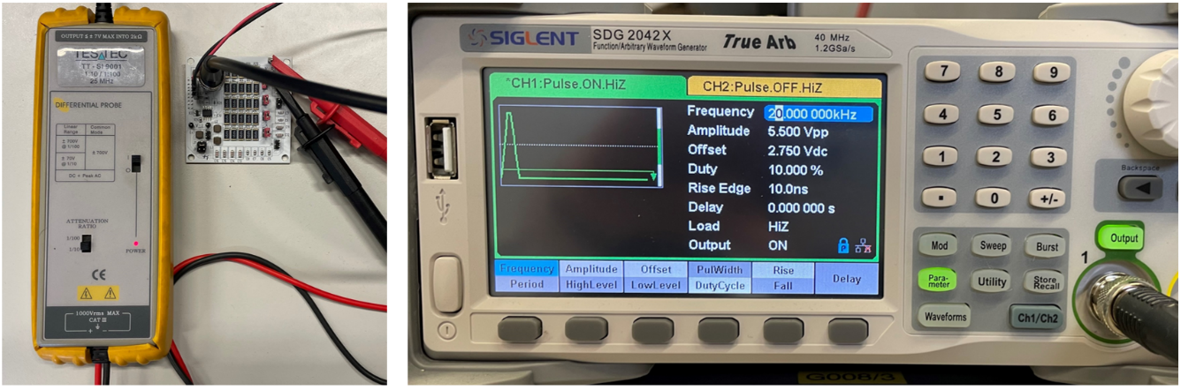

Figure 7 Measurement setup and function generator setting

1. **Measure the damping factor for the following settings with the first negative peak to the next following negative peak!**

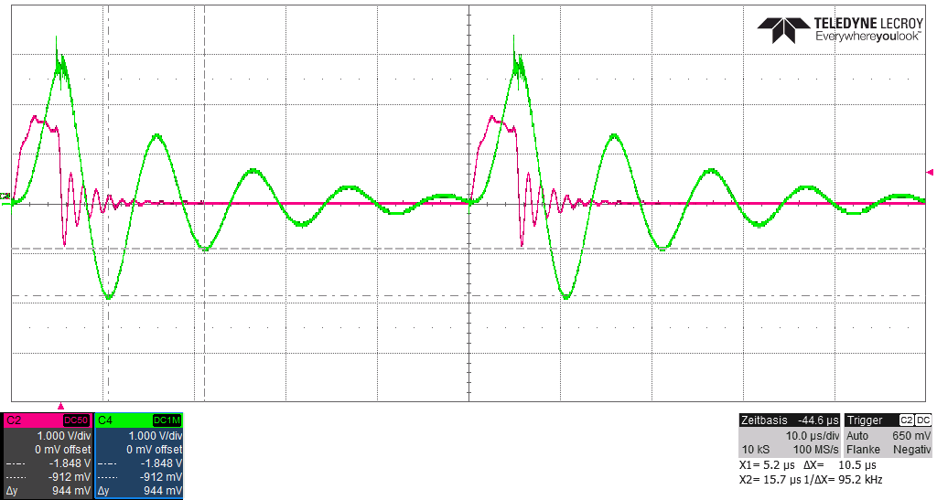

Figure 8 Oscilloscope picture of one measurement with the excitation current displayed

|  |  |  |
| --- | --- | --- |
| **f [kHz]** | **d** | **Ui [V]** |
| 20 | 0.1 | 10 |
| **R []** | **L_R [µH]** | **C_R [nF]** | **A_1/R [V]** | **A_2/R [V]** | **T [µs]** | **R/(2*L_R) [1/s]** | **[1/s]** | **1/T [kHz]** | **[kHz]** |
| 1 | 5 | 254 |  |  |  |  |  |  |  |
| 1 | 20 | 254 |  |  |  |  |  |  |  |
| 1 | 10 | 254 |  |  |  |  |  |  |  |
| 2 | 10 | 254 |  |  |  |  |  |  |  |
| 3 | 10 | 254 |  |  |  |  |  |  |  |
| 4 | 10 | 254 |  |  |  |  |  |  |  |
| 5 | 10 | 254 |  |  |  |  |  |  |  |

Why is the measured damping factor higher as expected? Explain why the resonance frequency 1/T changes in dependence on R and is not equal to **. Hint:** take a look in the theoretical background section!

1. **Measure the damping factor for the following settings with the first negative peak to the next following negative peak!**

|  |  |  |  |  |  |
| --- | --- | --- | --- | --- | --- |
| **d** | **Ui [V]** | **L1 [µH]** | **R [Ohm]** | **L_R [µH]** | **C_R [nF]** |
| 0.1 | 10 | 10 | 1 | 10 | 254 |
| **f [kHz]** | **[A]** | **| [A]** | **[µs]** | **[1/s]** |
| 20 |  |  |  |  |
| 30 |  |  |  |  |
| 40 |  |  |  |  |
| 50 |  |  |  |  |
| 60 |  |  |  |  |
| 70 |  |  |  |  |
| 80 |  |  |  |  |
| 90 |  |  |  |  |
| 100 |  |  |  |  |

What happens with the damping factor in the middle of the frequency range? Explain!

How do the simulation and measurement results differ from each other?