Portfolio: Web Analytics Case Study

Mitchell D. Shuey

January 17, 2019

# Introduction:

A librarian and researcher, Scott H. W. Young, working with Montana State University noticed that user services were not used frequently by users. Young used this opportunity to design an A/B test and publish both the results and the data collected.

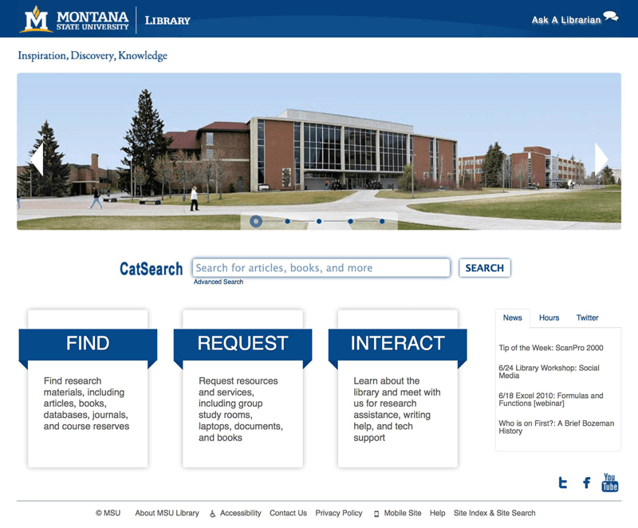

*The original index page design, with user services linked via the subtitle “Interact”*

# About the Data:

Several variations of the MSU library index page were made in the pursuit of A/B Testing their front page. Specifically, the altered piece of the website was the headline linking to user services the library provides. The original, “Interact”, and four alternatives were considered: “Connect”, “Learn”, “Help”, and “Services”.

Google Analytics and a click-tracking service (“CrazyEgg”) were used to generate the data. Users, when visiting the site, were randomly sent to one of the five variations. Our goal is to determine which led to more clicks (the “conversion rate” or click-through rate) overall.

The first dataset, titled Lib_msu, shows all the pages of the whole website that were clicked on between May 29th and June 18th, 2013 (the length of the trial), from Google Analytics. The variables of interest include the total page views, average time on the page in seconds, bounce rate, exit rate, and the click-through rate.

### Definitions

**Exit Rate**- Leaving the site entirely after reaching one of the home page variations. May have visited other pages prior to ending at this page. **Bounce Rate**- Leaving the site after reaching one of the home page variations. Entering and leaving, nothing more.

The next five sets, ctrl and v1-v4, are the index pages’ click counts over those three weeks for each variation. These datasets and their respective heat maps were generated by CrazyEgg. The only key field of interest on each is the click count for the user services section, and after this observation is collected the datasets will no longer be used.

## -- Attaching packages --------------------------------- tidyverse 1.2.1 --

## v ggplot2 3.0.0 v purrr 0.2.5  
## v tibble 1.4.2 v dplyr 0.7.6  
## v tidyr 0.8.1 v stringr 1.3.1  
## v readr 1.1.1 v forcats 0.3.0

## -- Conflicts ------------------------------------ tidyverse_conflicts() --  
## x dplyr::filter() masks stats::filter()  
## x dplyr::lag() masks stats::lag()

Now we’ll begin taking apart the data. The piece of interest is the clicks on each subtitle, compared to the total overall from the Lib_msu file.

clicks = rbind(ctrl[10,], v1[7,], v2[11,], v3[8,], v4[8,])  
index = Lib_msu[3:7,]  
#Re-ordering our columns  
index=index[c(4,5,2,3,1),]  
clicks=cbind(clicks[,-6], index)  
#Calculating click rate  
clicks$Clickthrough_Rate=clicks$`No..clicks`/clicks$Pageviews  
clicks$ctr_share=clicks$No..clicks/sum(clicks$No..clicks)

|  |  |  |  |  |  |  |  |  |  |  |
| --- | --- | --- | --- | --- | --- | --- | --- | --- | --- | --- |
|  | Name | Page | Pageviews | Unique Pageviews | Avg. Time on Page | Entrances | Bounce Rate | % Exit | Clickthrough_Rate | ctr_share |
| 10 | INTERACT | / | 2206 | 1750 | 57.83543 | 1694 | 0.4208973 | 0.3884859 | 0.0190390 | 0.2110553 |
| 7 | CONNECT | /index2.php | 2099 | 1618 | 69.40000 | 1583 | 0.4560960 | 0.4140067 | 0.0252501 | 0.2663317 |
| 11 | LEARN | /index3.php | 2213 | 1727 | 74.00000 | 1663 | 0.4678292 | 0.4306371 | 0.0094894 | 0.1055276 |
| 8 | HELP | /index4.php | 2210 | 1701 | 98.77056 | 1657 | 0.4990947 | 0.4497738 | 0.0171946 | 0.1909548 |
| 81 | SERVICES | /index5.php | 2284 | 1806 | 73.93903 | 1759 | 0.4860716 | 0.4470228 | 0.0197023 | 0.2261307 |

We see that with a rate of 2.5%, “Connect” has the highest click-through rate, but we need to determine the significance of this with a test. Visuals including error bars will also help judge the differences of results.

library(ggplot2)  
plotset=gather(clicks, RateType, percent, 11, 12, 14)  
#Calculating standard deviations for each rate versus the variation's , bernuolli  
plotset$sd=sqrt(plotset$percent*(1-plotset$percent)/plotset$Pageviews)  
#plotting  
rates=ggplot(plotset, aes(RateType, percent, fill=Name))  
bars=rates+geom_col(position="dodge")  
 bars+ geom_errorbar(aes(ymin=percent-sd, ymax=percent+sd), width=.4, position=position_dodge(.9))+ggtitle("Rates of Click-throughs and Departure, by Variation")

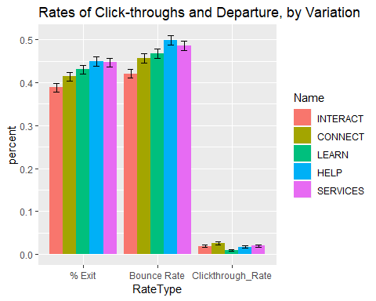

ggplot(plotset, aes(Name, `Avg. Time on Page`, fill=Name))+  
 geom_col(position="dodge")+ggtitle("Average Time Spent, by Variation (seconds)")

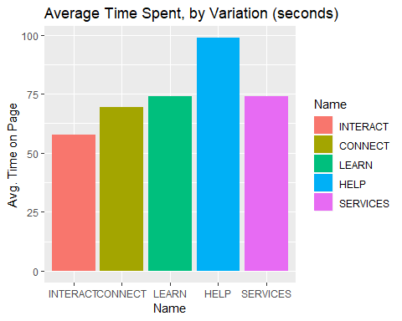

share=ggplot(clicks, aes(No..clicks, fill=Name))

While it’s hard to interperet whether a higher or lower exit rate means users found what they were looking for, we know that a lower bounce rate is better because the users found what they were looking for.

# Hypothesis Testing

We initially assume the null: All treatments (versions) have an equal conversion rate The alternative: they are unequal in some degree.

We can then dive into comparing all five click-through rates against each other, with the p-values in the matrix representing the chance that the difference between, say, the control (1) and “Help” (4) was due to the randomness of the data:

prop.test(clicks$No..clicks, clicks$Pageviews)

##   
## 5-sample test for equality of proportions without continuity  
## correction  
##   
## data: clicks$No..clicks out of clicks$Pageviews  
## X-squared = 15.836, df = 4, p-value = 0.003248  
## alternative hypothesis: two.sided  
## sample estimates:  
## prop 1 prop 2 prop 3 prop 4 prop 5   
## 0.019038985 0.025250119 0.009489381 0.017194570 0.019702277

#The p-value is significant enough to plan further testing  
  
pairwise.prop.test(clicks$No..clicks, clicks$Pageviews, p.adjust.method = "bonferroni")

##   
## Pairwise comparisons using Pairwise comparison of proportions   
##   
## data: clicks$No..clicks out of clicks$Pageviews   
##   
## 1 2 3 4   
## 2 1.0000 - - -   
## 3 0.1075 0.0011 - -   
## 4 1.0000 0.8322 0.3553 -   
## 5 1.0000 1.0000 0.0646 1.0000  
##   
## P value adjustment method: bonferroni

# Results

According to our proportion test, despite the Click-through rates being different, using the standard 5% p-value cutoff, few have a significant difference from other variations 1-on-1. The results of the original research state that “Learn” has the worst click-through performance. I conclude no significant difference was found within the data here; however this does not mean we are unable to make a recommendation.

Looking at the average time chart, we can see that the control, “Interact”, has the shortest average time on page. In an information services context such as a library, where finding what you want on the page quickly is important, this could mean that the experiment implementation led students to take more time on the home page to make sure they were going to select what they needed. They might be used to looking for “Interact”, versus interpereting the new variations. This is an important effect to consider when changing sections of a website. #Conclusion Given the chance to repeat the test, less variations, or limiting testing to one alternative at a time would be a good idea. It’s worth noting that comparing all of these proportions to each other at once calls for adjustments to the p-value. In this case, using the “Bonferroni” method, all p-values were multiplied by 15, the number of proportions being compared.

The timing of the experiment is also crucial. The number of users would likely be higher during a semester, rather than late May into early June. Another variation worth testing is the placement of the link within the website. It may be better served within the sidebar, or as a floating option in a corner.

It’s worth noting that on the MSU library’s current page, the choice was made to use “Services” and placed links in a hovering toolbar as well as alongside the other options later in the page, similar to the old design.

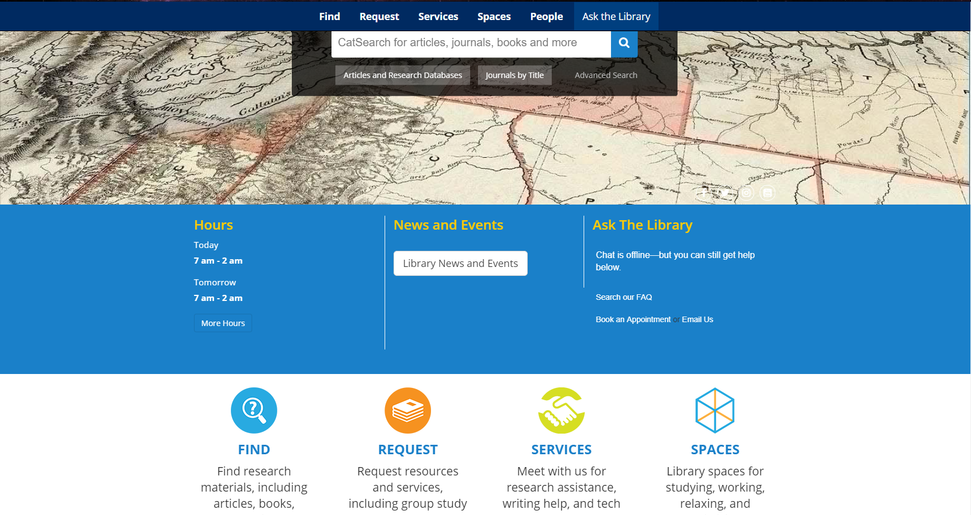

A section of the website’s new design. Notice the placement of links both at the top and side by side on the page.

The original paper made different choices in calculating the click rates and decided to forego testing for significance; I have emailed the author and asked about the calculation methodology. The original paper also conducted user surveys, which offer far more contextual insight into a user’s behavior and final click decisions. A good insight campaign uses all available sources of consumer experience information.

#### Works Cited:

Young, Scott W. H. “Improving Library User Experience with A/B Testing: Principles and Process.” Weave, Michigan Publishing, 2014, dx.doi.org/10.3998/weave.12535642.0001.101. Young SWH (2014) A/B Testing Web Analytics Data [dataset]. Montana State University ScholarWorks. <http://doi.org/10.15788/m2rp42>