Client Signup Guide
Step-by-Step Instructions for New Client Registration
Brightpath Ascend Group

Table of Contents
1. Overview
2. Step 1: Personal Information
3. Step 2: Credit Monitoring Access
4. Step 3: Select Your Plan
5. Step 4: Review & Submit
6. What's Next?
7. Need Help?

Overview
Welcome to Brightpath Ascend Group! This guide will walk you through our simple 4-step signup process. The entire registration takes approximately 5-10 minutes to complete. Please have the following information ready before you begin:
- Your personal identification details (name, address, date of birth)
- Your email address and phone number
- Last 4 digits of your Social Security Number
- Credit monitoring login credentials (if available)

Getting Started
Navigate to our signup page to begin your credit restoration journey.

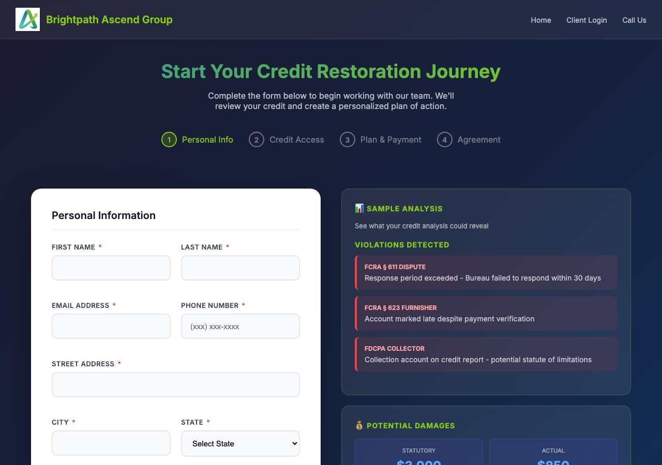
Figure 1: Signup Welcome Page

Step 1: Personal Information
Enter your personal details accurately. This information is required for credit bureau disputes and communication purposes. All fields marked with an asterisk (*) are required.

Required Information:
- First Name and Last Name - Enter your legal name as it appears on official documents
- Email Address - Provide a valid email for account access and updates
- Phone Number - Your primary contact number for case communications
- Street Address, City, State, ZIP - Your current mailing address
- Date of Birth - Required for credit bureau identification
- Last 4 of SSN - Used for credit report verification (encrypted and secure)
- Referral Code - Optional, enter if you were referred by another client

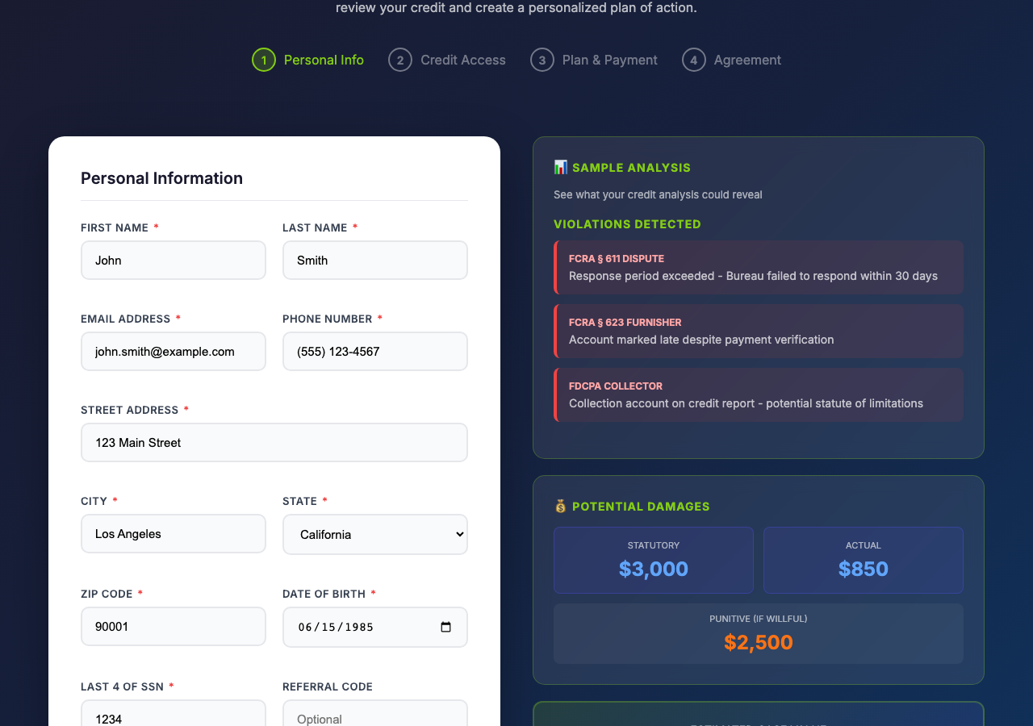
Figure 2: Personal Information Form (Completed)

Action: After completing all fields, click the "Continue to Credit Access" button to proceed.

Step 2: Credit Monitoring Access
To begin your credit analysis, we need access to your credit reports. Select your credit monitoring service and provide your login credentials. This allows us to securely pull your credit report and identify potential violations.

Supported Credit Monitoring Services:
- IdentityIQ
- MyScoreIQ
- SmartCredit
- PrivacyGuard
- MyFreeScoreNow
- Other (specify)

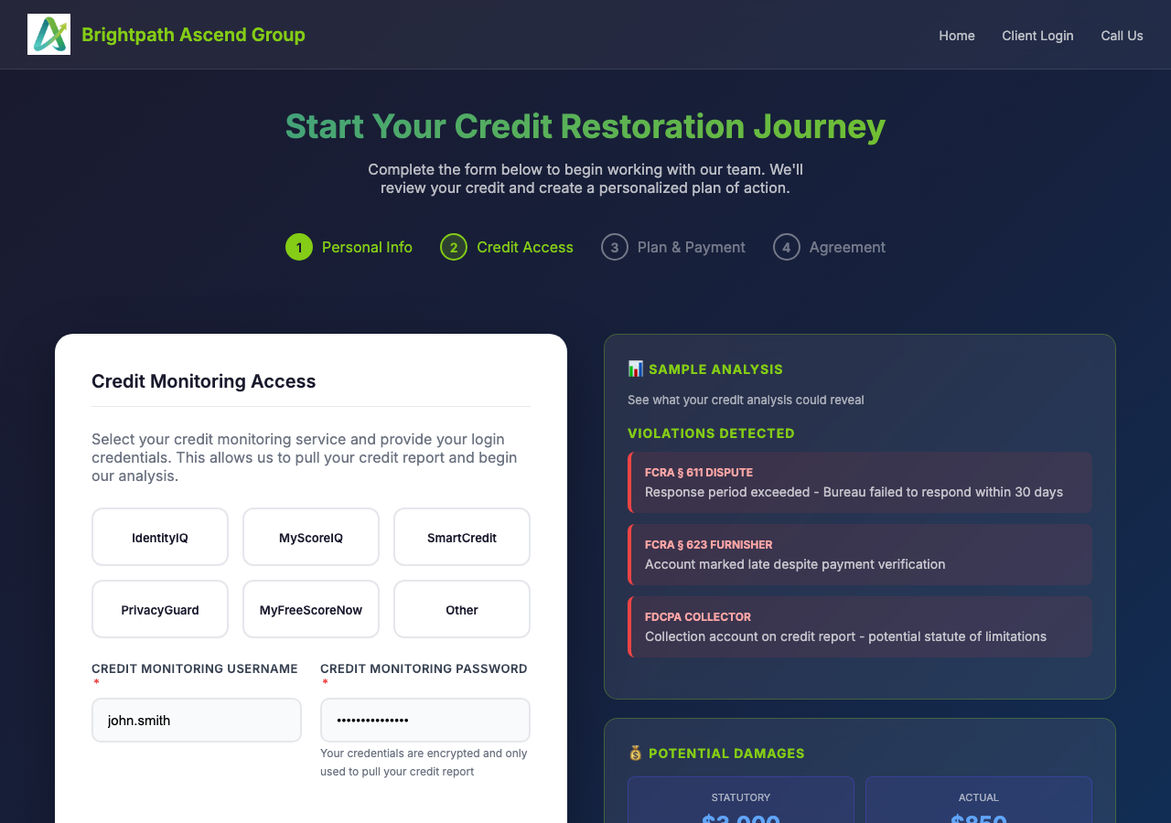
Figure 3: Credit Monitoring Access Form

Security Note: Your credentials are encrypted and stored securely. They are only used to access your credit report for analysis purposes.

Action: Select your service, enter your credentials, then click "Continue to Plan Selection".

Step 3: Select Your Plan
Choose the service plan that best fits your needs. Each plan offers different levels of analysis, dispute rounds, and support. Review the options carefully to select the plan that matches your credit restoration goals.

Available Plans:
Basic Analysis (FREE): Free credit analysis identifying negative items and potential issues.
Starter ($300): Full FCRA analysis plus Round 1 dispute letters to all bureaus.
Standard ($600): Complete analysis, Rounds 1-2 disputes, and violation documentation.
Premium ($900) - Most Popular: Litigation-ready package with Rounds 1-3, willfulness analysis, and damages calculation.
Professional ($1,200): Full litigation package with all 4 rounds plus settlement demand preparation.
Elite ($1,500): Maximum recovery option with attorney coordination and VIP support.

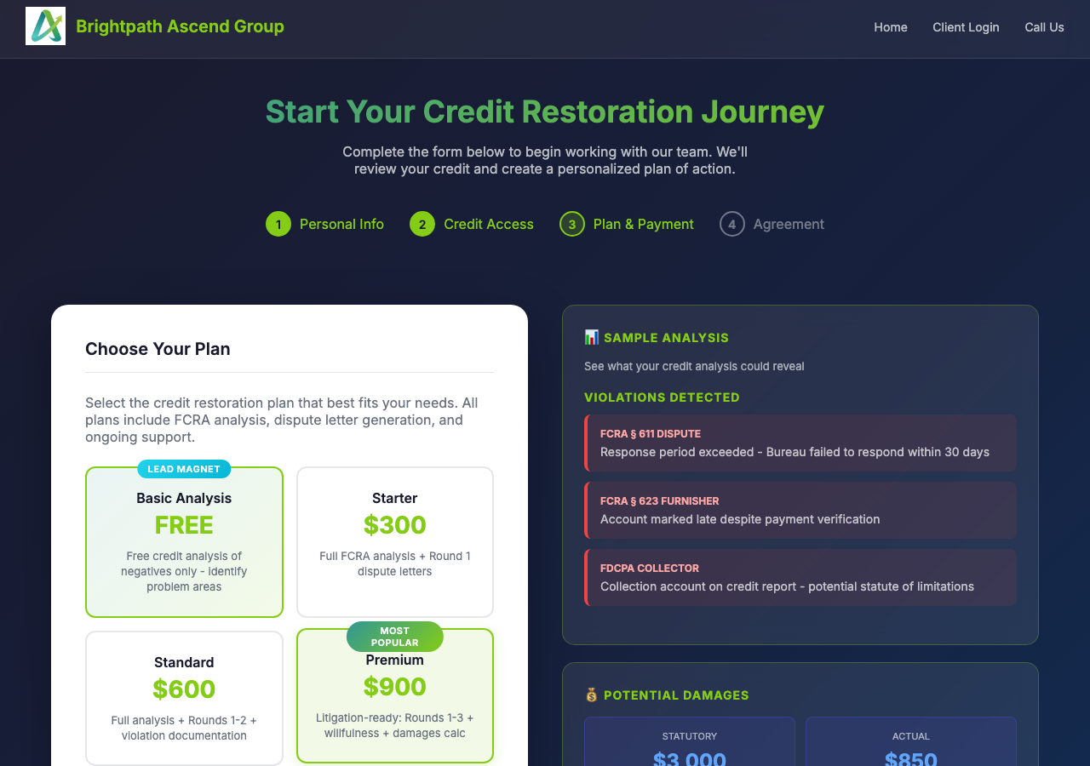
Figure 4: Plan Selection (Premium Plan Selected)

Action: Click on your preferred plan to select it, then click "Continue to Agreement".

Step 4: Review & Submit
This is the final step. Please review the service agreement carefully before proceeding. The agreement outlines your rights under the Fair Credit Reporting Act (FCRA), our services, and our privacy policy.

Agreement Highlights:
- Authorization for Brightpath Ascend Group to act on your behalf with credit bureaus
- Your rights under FCRA to dispute inaccurate information
- No guarantee of specific results (outcomes depend on information accuracy)
- Cancellation policy - you may cancel at any time
- Privacy policy - your information is kept confidential

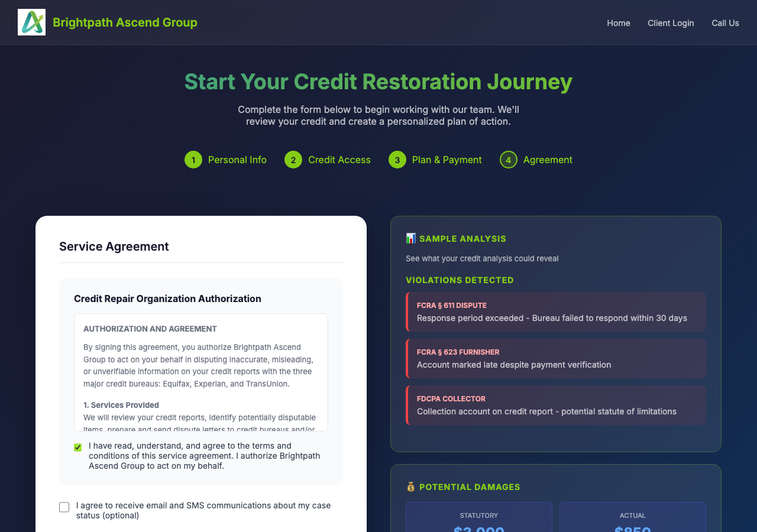
Figure 5: Service Agreement (Agreement Accepted)

Action: Read the full agreement, check the "I agree" checkbox, optionally check the communications preference, then click "Proceed to Payment" to complete your registration.

What's Next?
Congratulations on completing your registration! Here is what happens next:
- You will receive a confirmation email with your account details
- Our team will pull your credit report within 24-48 hours
- A comprehensive credit analysis will be performed
- You will receive your personalized credit analysis report
- Dispute letters will be prepared based on your selected plan
- Log in to the client portal to track your case progress

Client Portal Access: After registration, you can access your client portal to view your case status, uploaded documents, and communication history. Your login credentials will be sent to your registered email address.

Need Help?
If you encounter any issues during the signup process or have questions about our services, please do not hesitate to contact our support team.

Contact Information:
Phone: (917) 909-4051
Email: support@brightpathascend.com
Hours: Monday - Friday, 9:00 AM - 6:00 PM EST

Document Version: 1.0 | Last Updated: December 2025

