**🡺 APP (SMART_CAR)**

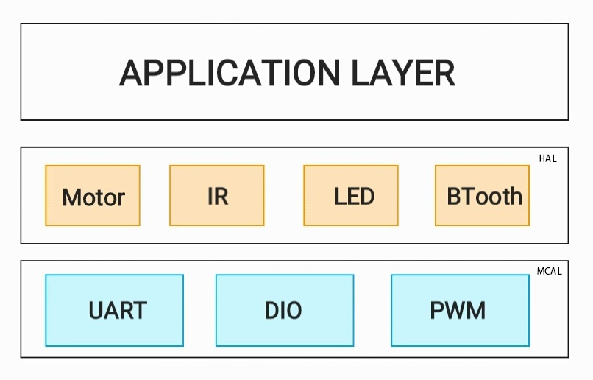

**🡺 API_CDD_APP_1**

**==> MOVE FORWARD (**covers **API_GDD_APP_1** from GDD**)**

Description: set two motor to move in same speed and the same direction (clockwise)

Inputs : u8 u8Speed : value to control the speed

Outputs: Error state

u8 **CAR_u8MoveForward**(u8 u8Speed);

No Error

Check Input Error

**CAR_u8MoveForward (u8)**

**MOTOR_u8ControlSpeedDirection_M1**(clockwise,Speed)

Error

No Error

Error

**MOTOR_u8ControlSpeedDirection_M2**(clockwise,Speed)

No Error

Error

**🡺 API_CDD_APP_2**

**==> MOVE BACK (**covers **API_GDD_APP_1** from GDD**)**

Description: set two motor to move in same speed and the same direction (Anticlockwise)

Inputs : u8 u8Speed : value to control the speed

Outputs: Error state

u8 **CAR_u8MoveBcak**(u8 u8Speed);

No Error

Check Input Error

**CAR_u8MoveBack (u8)**

**MOTOR_u8ControlSpeedDirection_M1**(Anticlockwise,Speed)

Error

No Error

Error

**MOTOR_u8ControlSpeedDirection_M2**(Anticlockwise,Speed)

No Error

Error

**🡺 API_CDD_APP_3**

**==> MOVE RIGHT (**covers **API_GDD_APP_2** from GDD**)**

Description: set each motor with different speed in same direction M1(Right) M2(left)

Inputs : u8 u8Speed : value to control the speed

Outputs: Error state

u8 **CAR_u8MoveRight**(u8 u8Speed);

No Error

Check Input Error

**CAR_u8MoveRight (u8)**

**MOTOR_u8ControlSpeedDirection_M1**(clockwise,halfSpeed)

Error

No Error

Error

**MOTOR_u8ControlSpeedDirection_M2**(clockwise,Speed)

No Error

Error

**🡺 API_CDD_APP_4**

**==> MOVE LEFT (**covers **API_GDD_APP_2** from GDD**)**

Description: set each motor with different speed in same direction M1(Right) M2(left)

Inputs : u8 u8Speed : value to control the speed

Outputs: Error state

u8 **CAR_u8MoveLeft**(u8 u8Speed);

No Error

Check Input Error

**CAR_u8MoveLeft (u8)**

**MOTOR_u8ControlSpeedDirection_M1**(clockwise,Speed)

Error

No Error

Error

**MOTOR_u8ControlSpeedDirection_M2**(clockwise,halfSpeed)

No Error

Error

**🡺 API_CDD_APP_5**

**==> STOP (**covers **API_GDD_APP_3** from GDD**)**

Description: set each motor with speed zero to stop the car

Inputs : u8 u8Speed : value to control the speed

Outputs: Error state

u8 **CAR_u8Stop**(u8 u8Speed);

No Error

Check Input Error

**CAR_u8Stop (u8)**

**MOTOR_u8ControlSpeedDirection_M1**(clockwise,zero)

Error

No Error

Error

**MOTOR_u8ControlSpeedDirection_M2**(clockwise,zero)

No Error

Error