**CDD**

|  |
| --- |
|  |
| |  |  | | --- | --- | | Version: | V0.0 | | Updated by: | Ahmed Tarek | | History: | 2/3/2019 | |
|  |
| |  |  | | --- | --- | | Version: | V0.1 | | Updated by: | Nada | | History: | 2/3/2019 | |
|  |
|  |
| |  |  | | --- | --- | | Version: | V0.2 | | Updated by: | Bassem | | History: | 2/3/2019 | |
|  |
| |  |  | | --- | --- | | Version: | V0.3 | | Updated by: | Mina | | History: | 2/3/2019 | |

**Description:**

This file contains all the information concerning the **Component Design Document for Bluetooth Component**

needed to specify the **Bluetooth** APIs and design in the MCAL Layer used in this project.

We also can find the coverage range of each API along with the GDD document.

**Component Layer:**

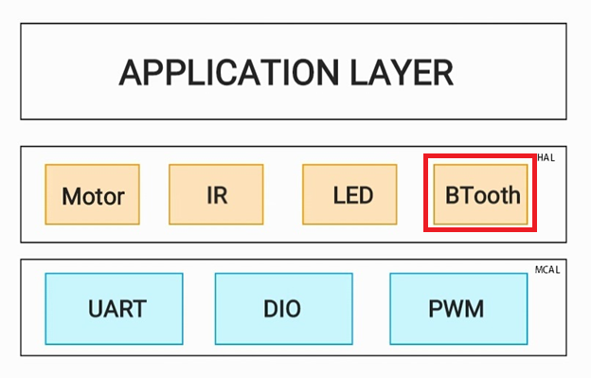

**APIs Used:**

**Covers API_CDD_BT_1**

**==> Initialize blueteooth ( Covers API_GDD_BT_1 )**

Description: Initialize Bluetooth to send and receive data serially

Inputs : void

Outputs: Error state

u8 **BLUETOOTH_Init**(void);

Return status

Check Error

No Error

Error

U8 BLUETOOTH_u8Init(void)

U8 DIO_u8UART_Init(Boadrate)

**API_CDD_BT_2**

**==> Bluetooth Send (Covers API_GDD_BT_2)**

Description: Bluetooth sends data serially through UART communication

Inputs : character to be send

Outputs: Error state

u8 **BLUETOOTH_u8Send**(void);

Return status

Check Error

No Error

Error

U8 BLUETOOTH_u8Send(u8 u8_copy_char)

U8 DIO_u8UART_Send(u8_copy_char)

**API_CDD_BT_3**

**==> Bluetooth Receive (Covers API_GDD_BT_3)**

Description: receiving data serially through UART communication via Bluetooth

Inputs: character to be send

Outputs: Data received

u8 **BLUETOOTH_u8Send**(void);

Return received data

Check Error

No Error

Error

U8 BLUETOOTH_u8receive(void)

U8 DIO_u8UART_receive(void)

UML Diagram:

