**CDD**

|  |
| --- |
|  |
| |  |  | | --- | --- | | Version: | V0.0 | | Updated by: | Ahmed Tarek | | History: | 2/3/2019 | |
|  |
| |  |  | | --- | --- | | Version: | V0.1 | | Updated by: | Nada | | History: | 2/3/2019 | |
|  |
|  |
| |  |  | | --- | --- | | Version: | V0.2 | | Updated by: | Bassem | | History: | 2/3/2019 | |
|  |
| |  |  | | --- | --- | | Version: | V0.3 | | Updated by: | Mina | | History: | 2/3/2019 | |

**Description:**

This file contains all the information concerning the **Component Design Document for DIO Component**

needed to specify the **DIO** APIs and design in the MCAL Layer used in this project.

We also can find the coverage range of each API along with the GDD document.

**UML:**

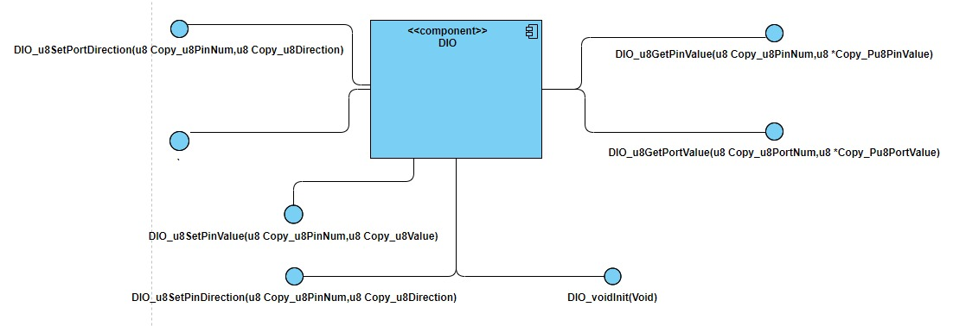

**Component Layer:**

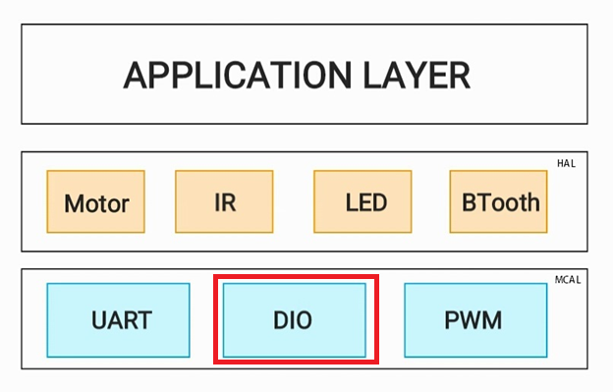

**APIs Used:**

**API_CDD_DIO_1**

**==> SET PIN DIRECTION ( Covers API_GDD_DIO_1 )**

Description: set pin Direction

Inputs : u8 u8PinNB : pin Number

: u8 u8Direction : if it DIO_INPUT_LOW mean that this pin is input , if it DIO_INPUT_HOGH mean that this pin is output

Outputs: Error state

u8 **DIO_u8SetPinDirection**(u8 u8PinNB,u8 u8Direction);

\

No Error

Error

Check Input Error

**DIO_u8SetPinDirection(u8,u8)**

ASSIGN_BIT(BIT_NUMBER,DIRECTION)

**API_CDD_DIO_2s**

**==> SET PIN VALUE ( Covers API_GDD_DIO_2 )**

Description: set pin value

Inputs : u8 u8PinNB : pin Number

: u8 u8Value : if it DIO_LOW mean that this pin is low , if it DIO _HOGH mean that this pin is high

Outputs: Error state

u8 **DIO_u8SetPinValue**(u8 u8PinNB,u8 u8Value);

No Error

Error

Check Input Error

**DIO_u8SetPinValue(u8,u8)**

ASSIGN_BIT(BIT_NUMBER,Value)

**API_CDD_DIO_3**

**==> GET PIN VALUE ( Covers API_GDD_DIO_3 )**

Description: GET pin value

Inputs : u8 u8PinNB : pin Number

: u8* u8Value : pointer to value which it may be high (1) or low (0)

Outputs: Error state

Outputs: Error state

u8 **DIO_u8GetPinValue**(u8 u8PinNB,u8* u8Value);

No Error

Error

Check Input Error

**DIO_u8GetPinValue(u8,u8*)**

GET_BIT(BIT_NUMBER,Value)