**CDD**

|  |
| --- |
|  |
| |  |  | | --- | --- | | Version: | V0.0 | | Updated by: | Ahmed Tarek | | History: | 2/3/2019 | |
|  |
| |  |  | | --- | --- | | Version: | V0.1 | | Updated by: | Nada | | History: | 2/3/2019 | |
|  |
| |  |  | | --- | --- | | Version: | V0.2 | | Updated by: | Bassem | | History: | 2/3/2019 | |

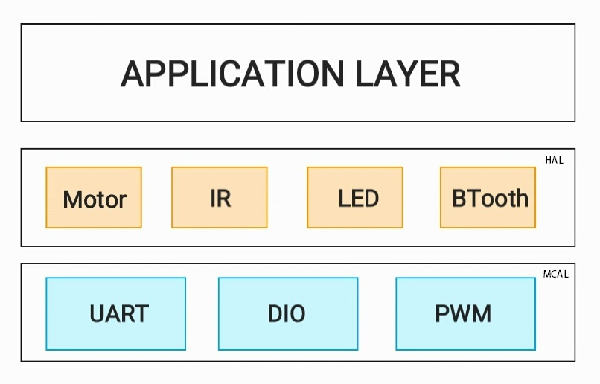

**UML :**

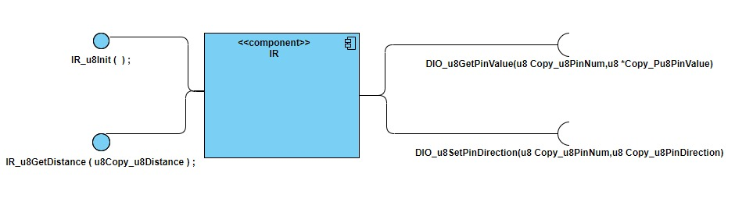

**==> Initialize Infrared**

Description: This API is used in initializing the IR LEDs in the configuration file to be used with the required frequency of operation of each the Tx and Rx IR LED.

Outputs: Error state

u8 **IR_u8Init**(void);

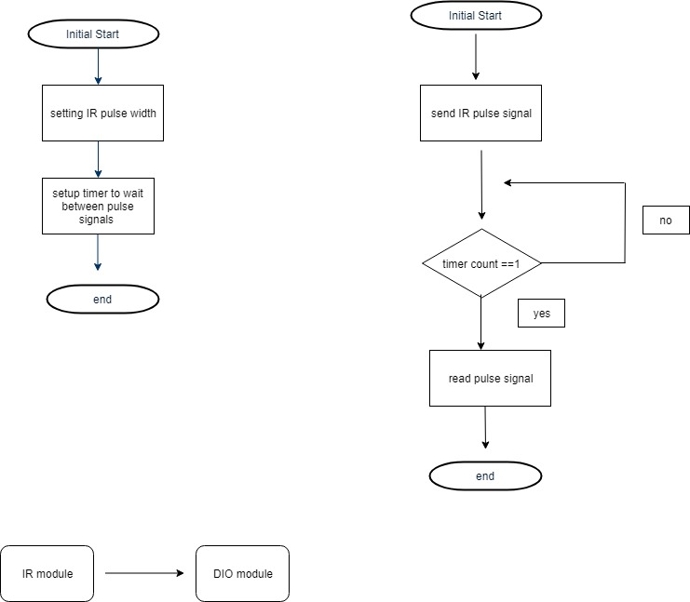

**==> Get Distance**

Description: This API is used to get the distance and save it in the variable “PCopy_u8Distance”.

Outputs: Error state

u8 **IR_u8GetDistance** ( u8 Copy_u8Distance ) ;

