🡺 **MOTOR COMPONENT**

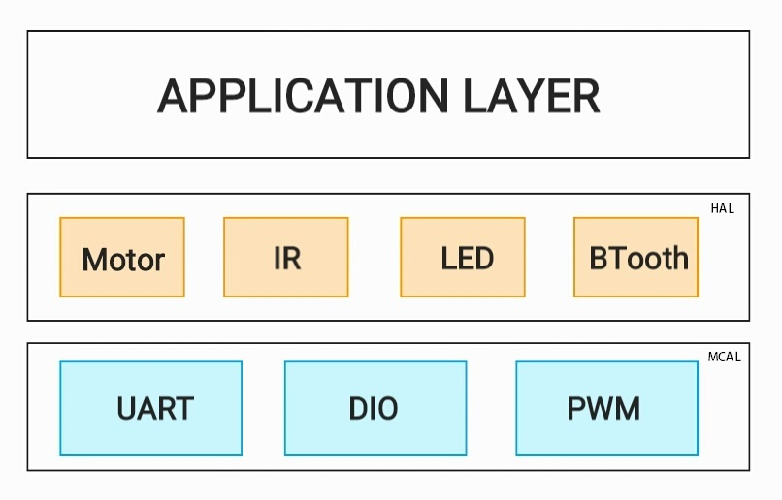

**UML:**

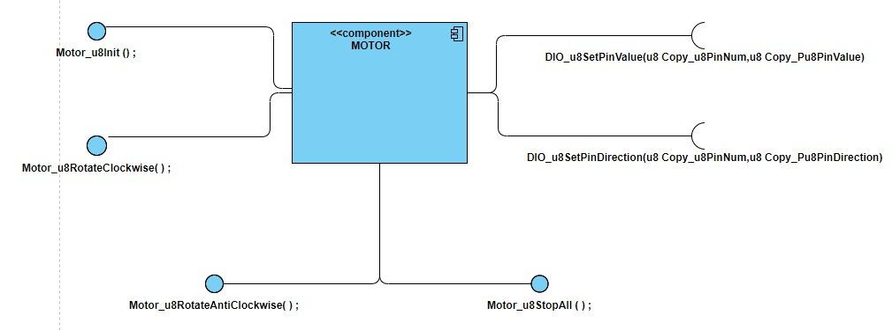

**🡺 API_CDD_MOT_1**

**==> SET MOTOR SPEED AND DIRECTION (**covers **API_GDD_MOT_1** from GDD**)**

Description: SET MOTOR SPEED AND DIRECTION

Inputs : u8 u8Speed : value to control the speed

: u8 u8Dirctio: to set the direction of the motor (anticlockwise) or (clockwise)

Outputs: Error state

u8 **MOTOR_u8ControlSpeedDirection**(u8 u8Dirctio,u8 u8Speed);

No Error

Check Input Error

**MOTOR_u8ControlSpeedDirection (u8,u8)**

**DIO_u8SetPinValue** (BIT_NUMBER,DIRECTION)

Error

No Error

Error

PWM_u8SetSpeed(Speed)