**CDD**

|  |
| --- |
|  |
| |  |  | | --- | --- | | Version: | V0.0 | | Updated by: | Ahmed Tarek | | History: | 2/3/2019 | |
|  |
| |  |  | | --- | --- | | Version: | V0.1 | | Updated by: | Nada | | History: | 2/3/2019 | |
|  |
| |  |  | | --- | --- | | Version: | V0.2 | | Updated by: | Bassem | | History: | 2/3/2019 | |

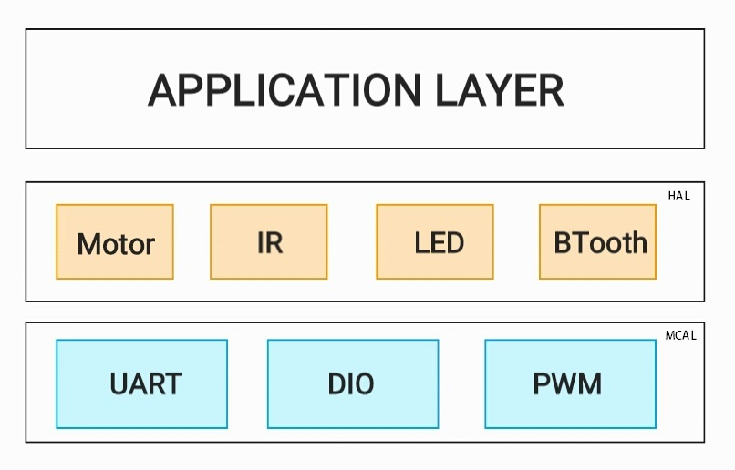

This is the Universal Asynchronous Receiver-Transmitter Peripheral Driver to be used in the MCAL layer. This Driver will be responsible of sending and receiving the data from and to the used micro controller.

**==> UART Initialize**

This API is used in initializing the UART pins to be used and the baud rate to send and receive on.

This API must be called before using the following APIs.

u8 **UART_u8Init**(void);

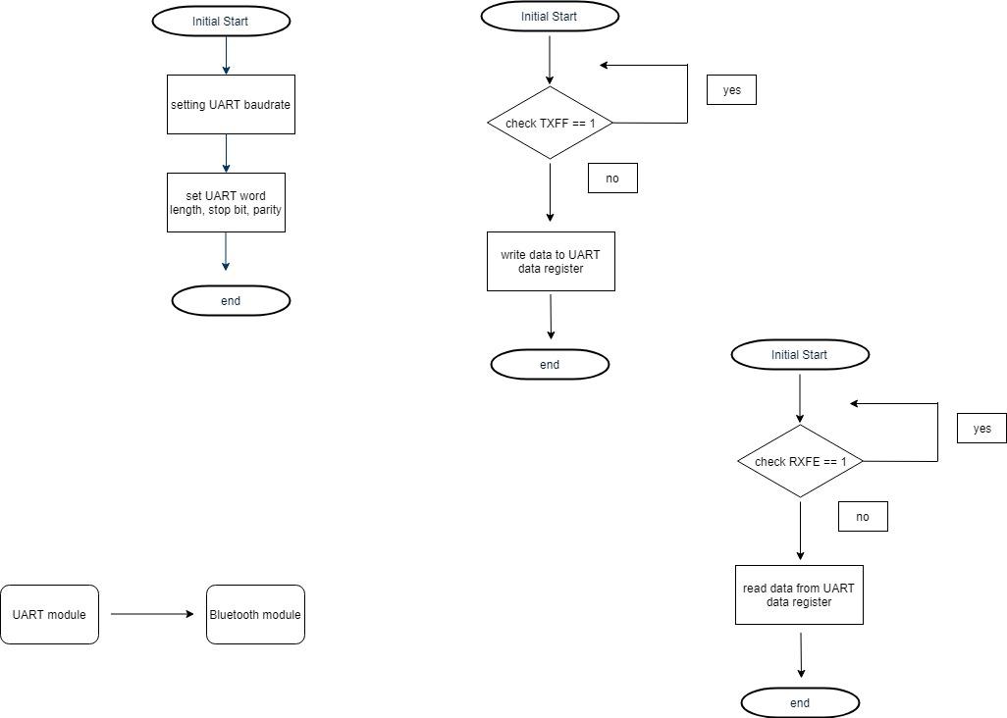

**==> UART Send Data**

This API is used to send the “Copy_u8Data” Data through the UART communication.

u8 **UART_u8Send** ( u8 Copy_u8Data) ;



**==> UART Receive Data**

This API is used to receive the data sent to the device on the pointer to u8 variable called “ PCopy_u8Data ”

u8 **UART_u8Receive** ( u8 * PCopy_u8Data ) ;

