SRS

|  |  |
| --- | --- |
| Name | SRS_smartCar |
| Author | Nada Hasan |
| Status | Not reviewed |
| Reference document | CRS_smartCar |

|  |  |  |  |
| --- | --- | --- | --- |
| Author | Version | Date | Discription |
| Nada | V0.1 | 16/1/2019 | Updating the movement of the robot and adding IDs for each requirement in the CRS |
| Emad | V0.2 | 22/1/2019 | Adding the hardware requirements in the SRS document |
| Ahmed Tarek | V0.3 | 31/1/2019 | Making sure that the SRS document covers all the requirements in the CRS |
| Nada | V0.4 | 13/2/2019 | Updating the quality of the document, like adding the history, the status, and author. |

Document context:  
This document explains how the car can be controlled through Bluetooth, the user uses mobile application to connect to the car to be able to send commands through serial communication,  
the user can move the car forward, backward, left and right. The car also has an object avoidance technology through Ultrasonic sensors and IR.

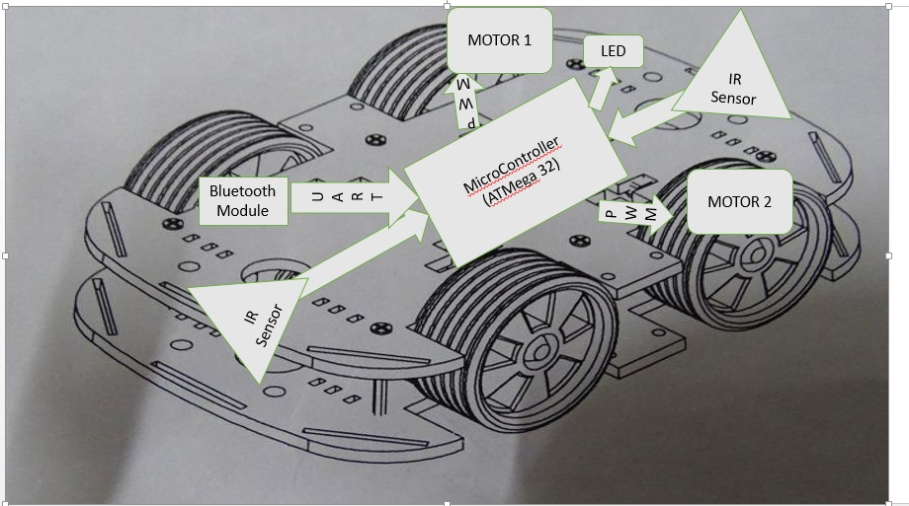

|  |  |
| --- | --- |
| Required ID | REQ_SRS_001 |
| Requirement | Sending f over USART -> means forward |
| Covers | REQ_CRS_003 |

|  |  |
| --- | --- |
| Required ID | REQ_SRS_002 |
| Requirement | Sending b over USART -> means backward |
| Covers | REQ_CRS_003 |

|  |  |
| --- | --- |
| Required ID | REQ_SRS_003 |
| Requirement | Sending r over USART -> means turn right |
| Covers | REQ_CRS_003 |

|  |  |
| --- | --- |
| Required ID | REQ_SRS_004 |
| Requirement | Sending l over USART -> means turn left |
| Covers | REQ_CRS_003 |

|  |  |
| --- | --- |
| Required ID | REQ_SRS_005 |
| Requirement | Sending s over USART -> means Stop |
| Covers | REQ_CRS_003 |

|  |  |
| --- | --- |
| Required ID | REQ_SRS_006 |
| Requirement | ultrasonic sensor at the front If distance is less than 20 cm, motors stop immediately (invoke stop function) |
| Covers | REQ_CRS_004 |

|  |  |
| --- | --- |
| Required ID | REQ_SRS_007 |
| Requirement | ultrasonic sensor at the end If distance is less than 20 cm, motors stop immediately (invoke stop function) |
| Covers | REQ_CRS_004 |

|  |  |
| --- | --- |
| Required ID | REQ_SRS_008 |
| Requirement | in each function we should invoke stop function to make sure the driver doesn't get two ones at the same time |
| Covers |  |

|  |  |
| --- | --- |
| Required ID | REQ_SRS_009 |
| Requirement | As long as the forward button is pushed the car keeps going forward |
| Covers |  |

|  |  |
| --- | --- |
| Required ID | REQ_SRS_010 |
| Requirement | when no button is pushed, the car stops |
| Covers |  |

|  |  |
| --- | --- |
| Required ID | REQ_SRS_011 |
| Requirement | Timers in PWM mode to control the speed of the motors |
| Covers | REQ_CRS_001 |

|  |  |
| --- | --- |
| Required ID | REQ_SRS_012 |
| Requirement | when turn right buttons are pushed, the right motor speed becomes 50/255 |
| Covers | REQ_CRS_001 |

|  |  |
| --- | --- |
| Required ID | REQ_SRS_013 |
| Requirement | when turn left buttons are pushed, the right motor speed becomes 50/255 |
| Covers | REQ_CRS_001 |

|  |  |
| --- | --- |
| Required ID | REQ_SRS_014 |
| Requirement | USART configuration:  - USART boadrate should be 9600  - USART stop bit (one stop bit) |
| Covers | REQ_CRS_002 |

|  |  |
| --- | --- |
| Required ID | REQ_SRS_015 |
| Requirement | If distance between car and an object is less than 20 cm , the leds turn on |
| Covers | REQ_CRS_002 |

|  |  |
| --- | --- |
| Required ID | REQ_SRS_016 |
| Requirement | Car speed 0.5 m/sec |
| Covers | REQ_CRS_005 |

|  |  |
| --- | --- |
| Required ID | REQ_SRS_017 |
| Requirement | Frequency of sending data over 1/100 msec |
| Covers | REQ_CRS_006 |