DIO_UTP_smartCar

|  |  |
| --- | --- |
| Name | DIO_UTP_smartCar |
| Author | Nada Hasan |
| Status | Not reviewed |
| Reference document | CCD_smartCar |

|  |  |  |  |
| --- | --- | --- | --- |
| Author | Version | Date | Discription |
| Mina | V0.1 | 18/2/2019 | Creating test for each component in the system |

Document context:  
This is a unit test for DIO component, to make sure that all the output and input pins are working fine, the table below descripses all the test cases for all the APIs mentioned in GDD.

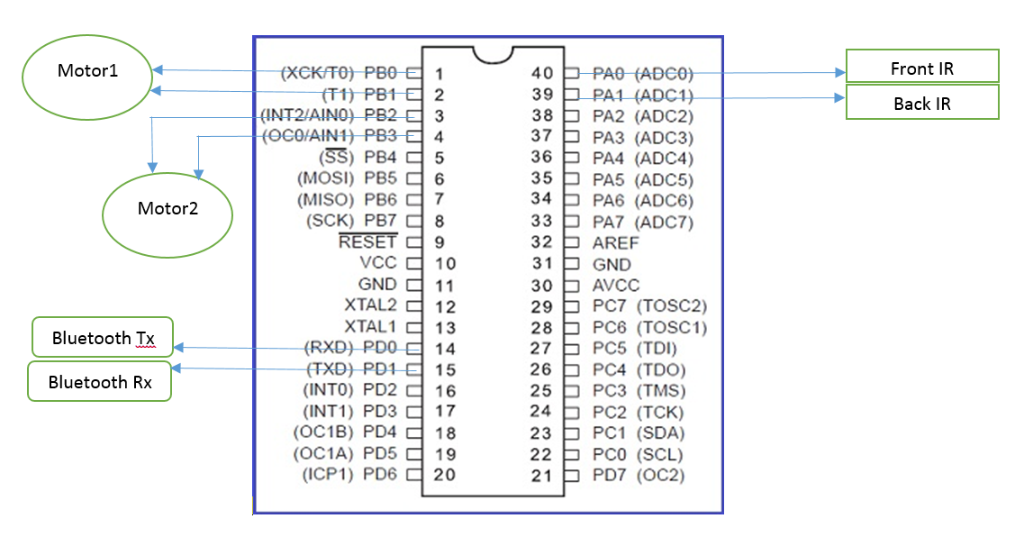

**Test Cases:**

|  |  |  |  |
| --- | --- | --- | --- |
| REQ_UTP_001 | | | |
| DIO_FUNCTION | TEST | EXPECTED | RESULT |
| U8 DIO_u8Init(void) | 1-call init function  2-connect led+ resistor to 5V to check the status of the pin | The led to light as the initial pin values is output with low voltage applied |  |
|  | | | |
| REQ_UTP_002 | | | |
| DIO_FUNCTION | TEST | EXPECTED | RESULT |
| U8 DIO_u8SetPinValue  (u8 PinNum) | 1-set Direction of pin to output  2-call SetPin function  3-use avometer to check voltage on the pin is high | Voltage difference between pin and ground is around 5V |  |
|  | | | |
| REQ_UTP_003 | | | |
| DIO_FUNCTION | TEST | EXPECTED | RESULT |
| U8 DIO_u8SetPinValue  (u8 PinNum,u8 value) | 1-set Direction of pin to output  2-call SetPin function by sending a wrong pin number  OR  By sending worng value | Returns Error level 1 |  |
|  | | | |
| REQ_UTP_004 | | | |
| DIO_FUNCTION | TEST | EXPECTED | RESULT |
| U8 DIO_u8SetPinDir  (u8 PinNum,u8 Direction) | 1-call SetPinDir function as output  2-put PORT value to high and use avometer to read the pin value | Voltage difference between pin and ground is around 5V |  |
|  | | | |
| REQ_UTP_005 | | | |
| DIO_FUNCTION | TEST | EXPECTED | RESULT |
| U8 DIO_u8SetPinDir  (u8 PinNum,u8 Direction) | 1-call SetPinValue function by sending a wrong pin number  OR  By sending worng Direction | Returns Error level 1 |  |
| REQ_UTP_006 | | | |
| DIO_FUNCTION | TEST | EXPECTED | RESULT |
| U8 DIO_u8GetPinValue  (u8 PinNum,u8 *Value) | 1-set pin direction as input  2-put 5v on the pin  1-call GetPinValue function | Pin should return 5v in value pointer |  |
| U8 DIO_u8GetPinValue  (u8 PinNum,u8 *Value) | 1-call SetPinDir function by sending a wrong pin number  OR  By sending a Null pointer | Returns Error level 1 |  |