UTP_UTP_smartCar

|  |  |
| --- | --- |
| Name | UTP_UTP_smartCar |
| Author | Nada Hasan |
| Status | Not reviewed |
| Reference document | CCD_smartCar |

|  |  |  |  |
| --- | --- | --- | --- |
| Author | Version | Date | Discription |
| Mina | V0.1 | 18/2/2019 | Creating test for each component in the system |

Document context:  
This is a unit test for Motor component, to make sure that all the output and input pins are working fine, the table below descripses all the test cases for all the APIs mentioned in GDD.

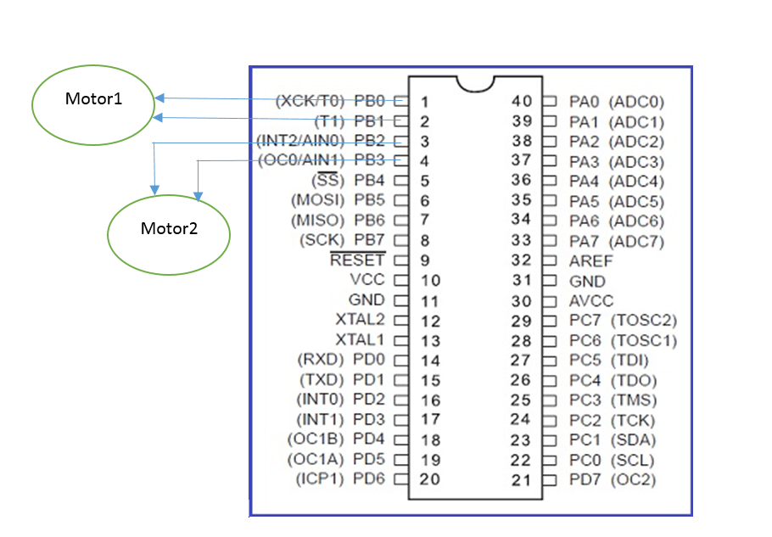

**Test Cases:**

|  |  |  |  |
| --- | --- | --- | --- |
| REQ_UTP_010 | | | |
| MOTOR_FUNCTION | TEST | EXPECTED | RESULT |
| U8 MOTOR_u8Init(void) | 1-call MOTORinit function  2- Connect motor to the pin | The motor doesn’t move |  |
|  | | | |
| REQ_UTP_011 | | | |
| MOTOR_FUNCTION | TEST | EXPECTED | RESULT |
| U8 MOTOR_LEFT | 1-call the function  2- Connect motor to the pin | Motor rotates left |  |
|  | | | |
| REQ_UTP_012 | | | |
| MOTOR_FUNCTION | TEST | EXPECTED | RESULT |
| U8 MOTOR_RIGHT | 1-call the function  2- Connect motor to the pin | Motor rotates Right |  |