UART_UTP_smartCar

|  |  |
| --- | --- |
| Name | UART_UTP_smartCar |
| Author | Nada Hasan |
| Status | Not reviewed |
| Reference document | CCD_smartCar |

|  |  |  |  |
| --- | --- | --- | --- |
| Author | Version | Date | Discription |
| Mina | V0.1 | 18/2/2019 | Creating test for each component in the system |

Document context:  
This is a unit test for UART component, to make sure that all the output and input pins are working fine, the table below descripses all the test cases for all the APIs mentioned in GDD.

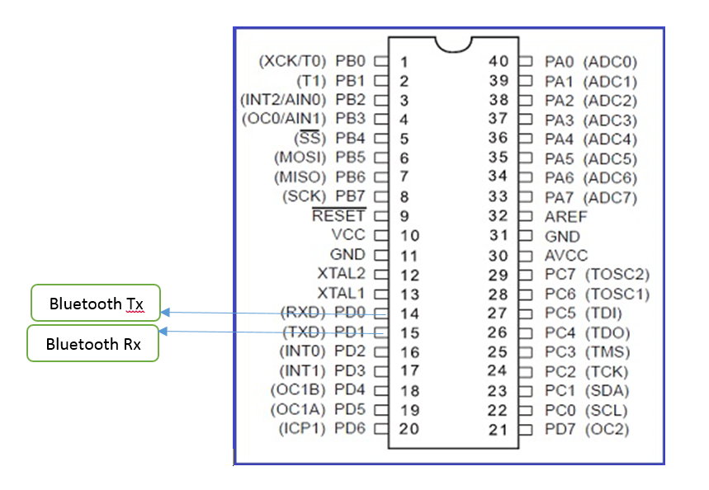

**Test Cases:**

|  |  |  |  |
| --- | --- | --- | --- |
| REQ_UTP_007 | | | |
| UART_FUNCTION | TEST | EXPECTED | RESULT |
| U8 UART_u8Init(void) | 1-call UARTinit function  2- Send and receive using Uart | The baud rate is set correctly |  |
|  | | | |
| REQ_UTP_008 | | | |
| UART_FUNCTION | TEST | EXPECTED | RESULT |
| U8 UART_Send | 1-call the function and send a character through  2-use a working UART reciever at the same baude rate | Receive sent character correctly |  |
|  | | | |
| REQ_UTP_009 | | | |
| UART_FUNCTION | TEST | EXPECTED | RESULT |
| U8 UART_Recieve | 1- use a working UART transmiter at the same baude rate  2- call the function and recieve a character through | Receive sent character  correctly |  |