**COMAPRE $display & UVM_INFO**

`include "uvm_macros.svh"

import uvm_pkg::*;

module tb;

    initial begin

        #10;

        `uvm_info("TB_TOP", "helloworld: uvm_info", UVM_MEDIUM);

        $display("[TB_TOP] hell0 world: $display @%0t", $time);

    end

endmodule

OUTPUT

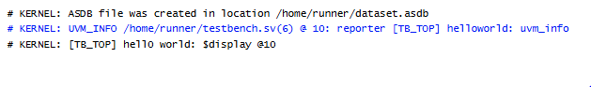

**REPORTING MACROS**

`include "uvm_macros.svh"

import uvm_pkg::*;

module tb;

    initial begin

        `uvm_info("[TB_TOP]","This is informative message",UVM_MEDIUM)

        #10;

        `uvm_warning("[TB_TOP]","This is warning")

        #10;

        `uvm_error("[TB_TOP]","This is error")

        #10;

        `uvm_fatal("[TB_TOP]","This is fatal error stopping simulation")

    end

endmodule

OUTPUT

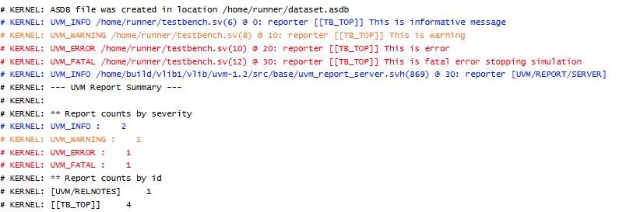

**VERBOSITY**

`include "uvm_macros.svh"

import uvm_pkg::*;

module tb;

    int verbosity=0;

    initial begin

        uvm_top.set_report_verbosity_level(UVM_HIGH);

        $display("default verbosity level")

        `uvm_info("tb_top","this is informative message",UVM_HIGH)

    end

endmodule

OUTPUT

