**به نام خدا**

**محمد ابراهیم نوازی 9931323**

**بخش تحویلی پایانترم هوش مصنوعی مقدماتی**

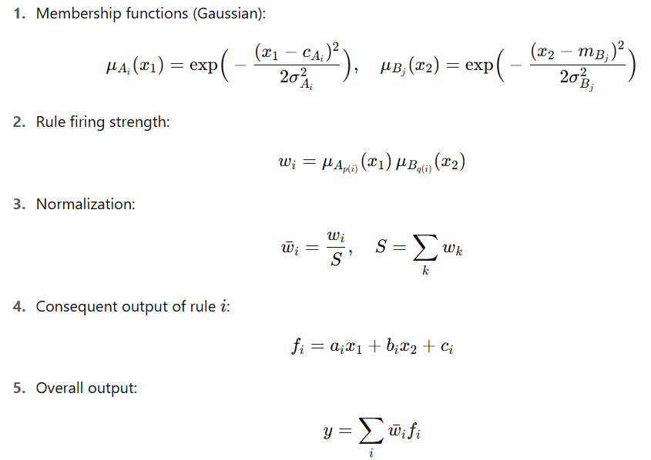سوال هماهنگ شده:

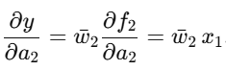گرادین نزولی برای a2 :

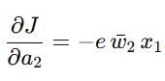

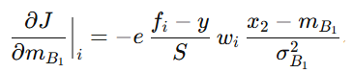گرادین نزولی برای mB1  :

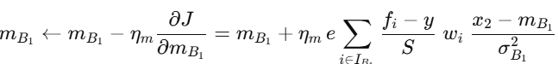

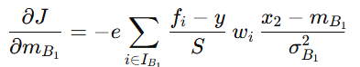

حل پایتون برای این سوال:

import numpy as np

# Gaussian membership function

def gaussian(x, c, sigma):

return np.exp(-((x - c) ** 2) / (2 * sigma ** 2))

# Forward pass through ANFIS

def anfis_forward(x1, x2, params):

# Memberships

mu_A = [gaussian(x1, params["c_A1"], params["sigma_A1"]),

gaussian(x1, params["c_A2"], params["sigma_A2"])]

mu_B = [gaussian(x2, params["m_B1"], params["sigma_B1"]),

gaussian(x2, params["m_B2"], params["sigma_B2"])]

# Rule firing strengths (2x2 = 4 rules)

w = [

mu_A[0] * mu_B[0], # Rule 1: A1 & B1

mu_A[0] * mu_B[1], # Rule 2: A1 & B2

mu_A[1] * mu_B[0], # Rule 3: A2 & B1

mu_A[1] * mu_B[1], # Rule 4: A2 & B2

]

S = sum(w)

w_bar = [wi / S for wi in w]

# Consequents

f = [

params["a1"] * x1 + params["b1"] * x2 + params["c1"],

params["a2"] * x1 + params["b2"] * x2 + params["c2"],

params["a3"] * x1 + params["b3"] * x2 + params["c3"],

params["a4"] * x1 + params["b4"] * x2 + params["c4"],

]

# Output

y = sum(w_bar[i] * f[i] for i in range(4))

return y, f, w, w_bar, S

# One gradient descent update for a2 and m_B1

def update_params(x1, x2, y_d, params, eta_a=0.01, eta_m=0.01):

y, f, w, w_bar, S = anfis_forward(x1, x2, params)

e = y_d - y

# ---- Gradient for a2 ----

grad_a2 = -e * w_bar[1] * x1

params["a2"] -= eta_a * grad_a2 # gradient descent update

# ---- Gradient for m_B1 ----

grad_mB1 = 0.0

for i in [0, 2]: # rules that use B1

grad_mB1 += (-e) * (f[i] - y) / S * w[i] * (x2 - params["m_B1"]) / (params["sigma_B1"] ** 2)

params["m_B1"] -= eta_m * grad_mB1

return params, y, e

# Example usage

params = {

"c_A1": 0.0, "sigma_A1": 1.0,

"c_A2": 1.0, "sigma_A2": 1.0,

"m_B1": 0.0, "sigma_B1": 1.0,

"m_B2": 1.0, "sigma_B2": 1.0,

"a1": 0.5, "b1": 0.2, "c1": 0.1,

"a2": -0.3, "b2": 0.4, "c2": 0.0,

"a3": 0.1, "b3": -0.2, "c3": 0.3,

"a4": 0.7, "b4": 0.5, "c4": -0.1,

}

# One training sample

x1, x2, y_d = 0.8, 0.5, 1.2

updated_params, y_pred, error = update_params(x1, x2, y_d, params)

print("Updated a2:", updated_params["a2"])

print("Updated m_B1:", updated_params["m_B1"])

print("Prediction:", y_pred, "Error:", error)

سوال امتحان پایانی در سایت :







