**MEALOR II:**

Exploring Damage Evolution in Metals

based on X-ray Tomography (XRT)

August 2023

Florent Hannard ([florent.hannard@gmail.com](mailto:florent.hannard@gmail.com))

Aude Simar ([aude.simar@uclouvain.be](mailto:aude.simar@uclouvain.be))

Sophie de Raedemacker ([sophie.deraedemacker@uclouvain.be](mailto:sophie.deraedemacker@uclouvain.be))

**Tomography and data analysis: A Recap**

**X-ray tomography** (**XRT**) is based on the acquisition of a high number of radioscopic images of the same sample under different viewing angles. The final reconstruction provides a 3D map of the local value of the attenuation coefficient of small elements of matter at a scale down to the resolution of the technique. Each of these elements, discretizing the material is called a **voxel** by extension of the term pixel used in 2D imaging. Each voxel is associated to a grey level in the reconstruction being proportional to the local attenuation level.

Once the stack of raw grey level has been produced, extracting quantitative parameters from 3D images requires appropriate image processing, segmentation and analysis :

*-* **Image processing** is generally applied to “improve” the image. It mainly involves grey level modification (equalization, normalization, brightness and contrast adjustment, etc.) and filtering (to remove noise or to subtract background) in the spatial or frequency domains.

*-* **Segmentation** is the procedure by which the grey level images are transformed into a much simpler information in which each point in the image is affected a color depending on the phase it belongs to. This can be made by simply **thresholding** the grey level images, but much more advanced procedures are sometimes necessary (adaptive thresholding, trainable segmentation based on machine learning algorithms, …).

- **Image analysis** is devoted to the determination of meaningful measures of the constituent phases and their geometries, for example to quantify their number, fraction, size and distribution.

There are two classes of measurements : **global or feature-specific**. Global measurements apply to the entire structure and do not attempt to distinguish the details of how the components are organized (ex: the volume fraction).

Feature-specific measurements attempt to describe the frequency distributions of particle size and shape. In order to compute parameters for each object individually, it is necessary to group all the pixels belonging to a same object (in this case, a void) and to give each of them the same label (i.e the same grey level, allowing to identify voxels belonging to the same void). This operation is called **labelling**. The resulting labelled images are then used to measure individual morphological parameters for each object (voids, particles, …).

**Objective:**

The objective of this exercise is to provide a first introduction to XRT applied to study the damage evolution within metal structures.

The following points will be covered:

* Learn to open and navigate 3D XRT scans (i.e. stack of images)
* Perform basic segmentation and morphological operations
* Generate 3D visualizations
* Compare 2D and 3D analysis regarding: (*i*) strain measurements (i.e. not directly related to damage), (*ii*) void volume fraction (global parameter), (*iii*) density and (*iv*) size of voids (feature-specific measurements).

This exercise only serves as a concise introduction and a collection of useful references can be found in chapter 8 of the *MEALOR II* book.

**Data set and software:**

The data sets used for this exercise session are related to the paper *"On the origin of the anisotropic damage of X100 line pipe steel, Part I: in-situ synchrotron tomography experiments"* published by Madi *et al.* in Integrating Materials and Manufacturing Innovation. We will only use a few scans, but the complete dataset is available here: <https://zenodo.org/record/3528199#.ZHb2OoTP02w>.

In this study, the damage evolution of a grade X100 line pipe steel were investigated using in-situ synchrotron-radiation computed tomography (SRCT) of notched round bars (see Fig. 1, right). Three scans (scan *01*, scan *06* and scan *13*, see Fig. 1 left) will be used (**folder SCAN INIT**), they have been obtained on a specimens loaded along the rolling (L) direction.

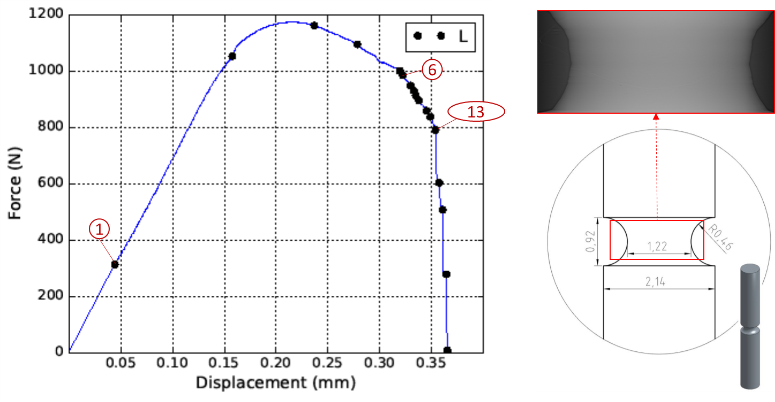

Figure 1. Left: Load-displacement curve of the in situ tensile test, with points corresponding to scan 01, 06 and 13. Right: Geometry of the notched axisymmetric sample, with the red box indicating the typical field of view and the corresponding X-ray projection (for scan 01).

The first scan (scan *01*) has been obtained in the early stage of elastic regime, and it will be used as the initial state (i.e. the minor *εel* is neglected). Scan *06* and scan *13* were obtained after significant void nucleation/growth and at the onset of the final coalescence stage that triggers catastrophic failure of the specimen, respectively.

1. **Open and explore 3D data:**

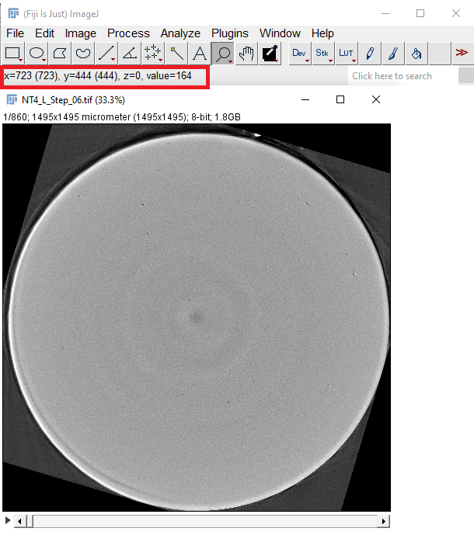A straightforward method to have a first quick look at your data is by using orthogonal views, accessed via *Image › Stacks › Orthogonal Views*. Windows containing the two planes will dock alongside the original stack, with the intersection of the yellow lines on the stack indicating the point in the stack that is being analyzed. The planes will update automatically by adjusting the lines on any of the three windows.

Note that the X, Y, Z and grey level of the voxel identified with your mouse is indicated in the ImageJ window.

What can you conclude regarding the plastic deformation of these samples ?

Useful tip: Note that when working with 3D data, i.e. stack of 2D images, several 3D operations can be found under via *Image › Stacks*.

Useful tip: *ImageJ > File > Import > TIFF Virtual Stack*

A virtual stack is a way to work with multiple images as if they were frames of a stack, without actually loading all the images into memory simultaneously. This is particularly useful when dealing with large datasets that might exceed available memory. Instead of loading all images into RAM, the virtual stack loads images on-demand as you navigate through them. However, note that some operations that require access to all images in the stack simultaneously might not be available or might behave differently when working with a virtual stack.

This material exhibits a pronounced anisotropy, as indicated by initial circular cross section (scan 01) deforming into an elliptical geometry.

Today, we will focus on damage evolution, but note that if you want to study the anisotropy of the deformation:

* It’s critical to keep track of the orientation of the sample (L, T, ST), as it’s not always possible to identify it within XRT scans (ex: grains structure is not visible)
* It is possible to quantify the anisotropy using the Lankford-like coefficient, defined as the ratio of the deformation along the major axis the ellipsoid cross-section.

1. **Segmentation and 3D Views of Damage Evolution (in ImageJ/Fiji):**

**Visualization**:

Open Scan 01 and do *Plugin>3D viewer*, select the volume of interest, select *display>Volume* and *Color>None* in the opened window.

In the ImageJ 3D Viewer, a noteworthy feature is that the “black” phase of the image is rendered as transparent. However, the background is not necessarily perfectly black (i.e. gray level of 0 in 8bit) and the 3D view is thus not very interesting.

Useful Tip: By adjusting the transparency settings (*Edit > Change Transparency* in 3D viewer), you can potentially achieve a clearer representation of your sample's internal structure. This can be particularly advantageous when exploring raw or unprocessed data, allowing you to manipulate transparency levels to visualize certain aspects of the image without performing segmentation.

**Segmentation**: The main thresholding command in ImageJ is *Image > Adjust > Threshold*.

It will open a threshold dialog that allows you to identify pixels above a threshold, below a threshold, or falling between two thresholds. These options are controlled using a combination of the threshold sliders and the Dark background checkbox. There is also a drop-down menu allowing you to select from a list of automated thresholding methods.

**A. Segmentation of external surfaces:**

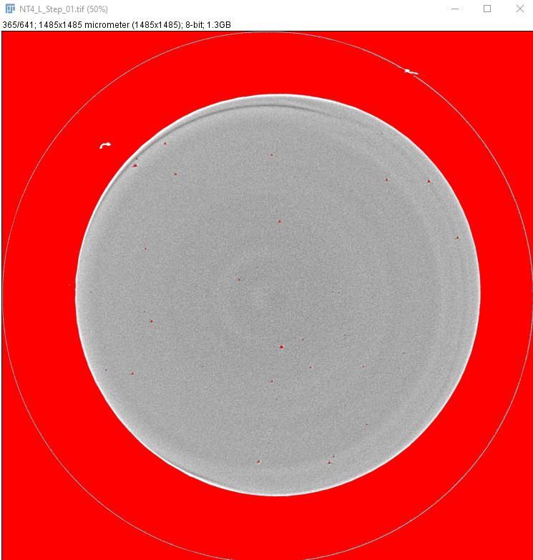Set the threshold value to encompass the entire specimen, with a particular emphasis on accurately defining the external edge of the sample. Prioritize achieving a well-defined outer boundary. It's not necessary to be concerned about internal porosities or background noise at this stage, as these aspects will undergo post-processing in the subsequent steps. The result generates a binary stack, i.e. black and white image (0 and 255 grey level in 8 bit).

A straightforward method to eliminate internal porosities involves employing the "Fill holes" operation: *Process > Binary > Fill Holes*. Note that several basic morphological operations are also available, e.g. erode/dilate, which are commonly used for 3D data analysis.

A practical way to keep only the edges is to use the Particle Analyzer in ImageJ and analyze each cross-section as a large particle. First, go to *Analyze > Set Measurements* and select Area and Stack Position. These results will be used later to compute the local strain for the corresponding cross-section.

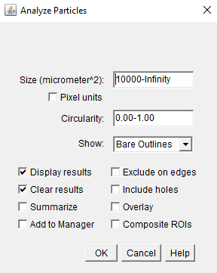Then, go to *Analyze > Analyze Particles*. A simple trick to ensure that only the large cross-section is analyzed (and not possible background noise which was selected during the Thresholding) is to set an appropriate minimum area of particles to analyze (see Figure).

In the *Show* dropdown menu, select *Bare Outlines*, which will generate a stack of image with only the boundary of each cross-section.

Save the generated stack containing these external boundaries (*File > Save as > Tiff…*), it will be used for 3D visualization of the external surface of the specimen.

Furthermore, save the results generated (i.e. Area/slice analysis). Note that the number of cross-sections should correspond to the number of slices (e.g. 641 for Scan 01). If you have extra/missing cross-sections, adjust the minimum cross-section in the previous step.

Useful Tip: Sometimes, you perform an operation in ImageJ, and realize that it was performed on the white/black pixels, while it should be the opposite. In such case, you can do *Edit>Undo* to undo the last operation and then *Edit>Invert* in order to invert white and black. This is also useful to make sure that the background is black before performing a 3D rendering.

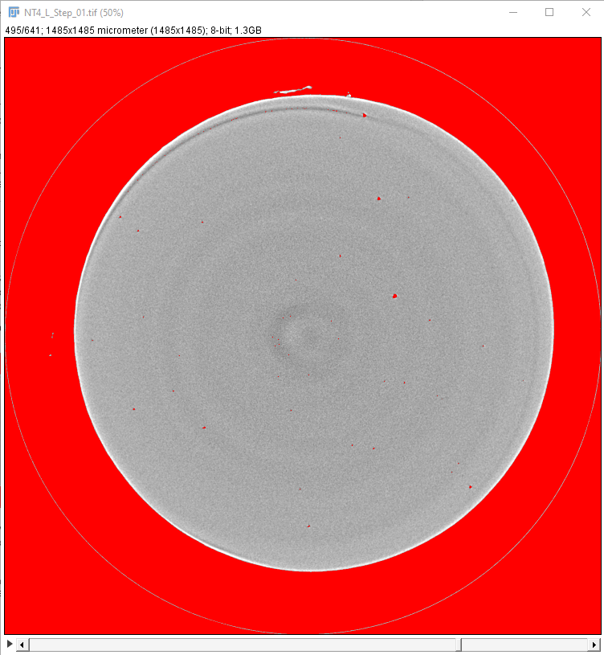**B. Segmentation of internal porosities:**

Open the original scan and this time set the threshold value to encompass the internal porosities. Again, it’s not necessary to be concernd about the background being selected at this stage.

A practical way to keep only the internal porosities is to use again the Particle Analyzer in ImageJ.

In this case, a simple trick to ensure that only internal porosities are analyzed (and not the background) could be to set an appropriate maximum area of particles. Another way is to select the *Exclude On Edges* option of the particle analyzer (which will exclude all objects touching the edge of the volume, i.e. the background in this case).

Furthermore, select *Masks* in the *Show* dropdown menu before running the analysis (which will open a new stack with the internal cavities). Again, save the generated stack and the results.

**C. Visualization**

Open the saved volume (ex: internal porosities) and open the 3d viewer: *Plugins > 3D Viewer*. Don’t forget that the background should be black for 3D rendering.

Select display as volume and select a color for the porosities. A 3D view of cavities will open. Then go to *File > Open* in the volume viewer window and select the second volume (i.e. the boundaries of the sample) and select a color.

Then, adjust the transparency of these external boundaries: *Edit > Select* and select the external volume. Then go to *Edit > Change Transparency* and adjust as needed.

Congratulation, you just made your first 3D rendering of an XRT data.

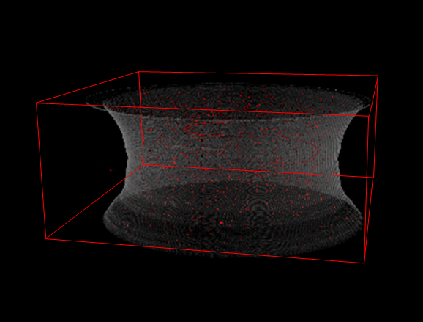

Note that some ring-shaped artifacts can be observed. They are inherent to the tomography technique and could be removed by post-processing (extensive literature available on the topic). During the analysis in the next sections, we will limit ourselves to exclude the slices containing these rings.

Importantly, you can add a scalebarusing*View > Edit Scalebar***.** Alternatively, you can annotate the image with a specific dimension directly on the 3D rendering, such as the diameter of the central cross-section. The second approach aids in providing a clear reference for the spatial scale, enhancing the interpretability of your rendered data.

**D. 3D analysis:**

**Finally, the last operation to be performed with Fiji/ImageJ is to analyze the internal porosities directly in 3D (as opposed to the previous steps, generating 2D results as a function of the Z position for each slice).** In order to compute the size and the position for each cavity, it is necessary to group all the pixels belonging to a void (i.e. labelling operation, see introduction). However, Fiji provide a useful tool “3D Objects Counter” which directly encompass the labelling step with the evaluation of parameters (much similar to what has been done in 2D with the Particles Analyzer).

Note however that 3D analysis becomes quickly very computationally expensive and it would probably not possible to analyze the full scans on your laptop. Sub-volumes of previous volumes containing the segmented internal porosities are provided in the folder Segmentation > Internal Porosity (again selected in such a way that they correspond to the same volume in 3D for each deformation step).

Perform the 3D analysis by doing: *Analyze > 3D-OC Set Measurements* and select volume and centroid. Then do *Analyze > 3D Objects Counter* and save the results for each scan.

**The results generated with Fiji/ImageJ on each scan within this section will be used for further analysis in the next sections. If you lost too much time for performing the analysis on all scans, these results are available in the SEGMENTATION folder, containing internal porosities and external surfaces (stacks and results).**

1. **Compare Average and Local Strain (in Matlab, Python or what you like)**

You might have noticed that the number of slice in each scan was different. This is due to the fact that a first "cropping" operation was performed in order to ensure that the same volume was observed in each scan. In other words, the first and last slice of each scan follow the same point physical point on the surface of the specimen. Since we are deforming the specimen, while the voxel size (also corresponding to the slice thickness) is constant, the number of slices is increasing. This cropping operation require might be done manually by following features in the volume when possible (note that markers are sometimes glued on the surface of the sample). Sometimes, it is also required to correct for rigid body motion of the sample between scans, and extensive literature is available for automatizing this correction called "rigid registration" (i.e. the process of aligning or matching different images to a common reference frame).

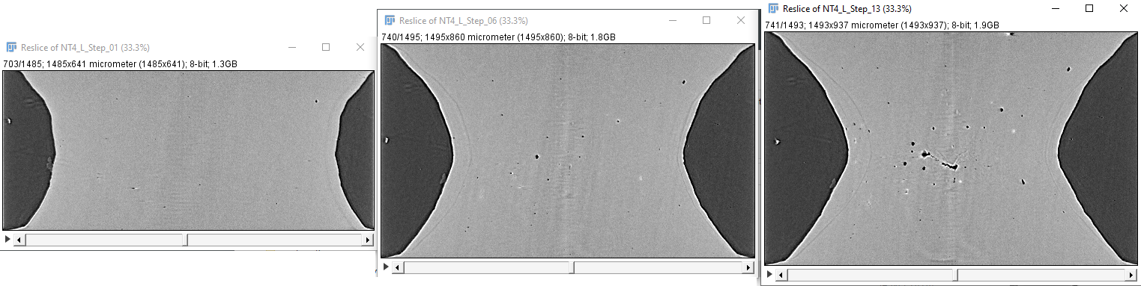

After cropping, the volume height can thus be associated with the displacement that would be measured by an extensometer (with the field of view dimension along the loading direction corresponding to the gauge length). On the other hand, the ratio between the initial area and the current area represents an average value of the true strain within a given cross-section: ***ε­loc = ln(A0/A)***.

Compare the average strain over the whole field of view with the evolution of the local strain. Compare and contrast the insights gained from average and local strain measurements.

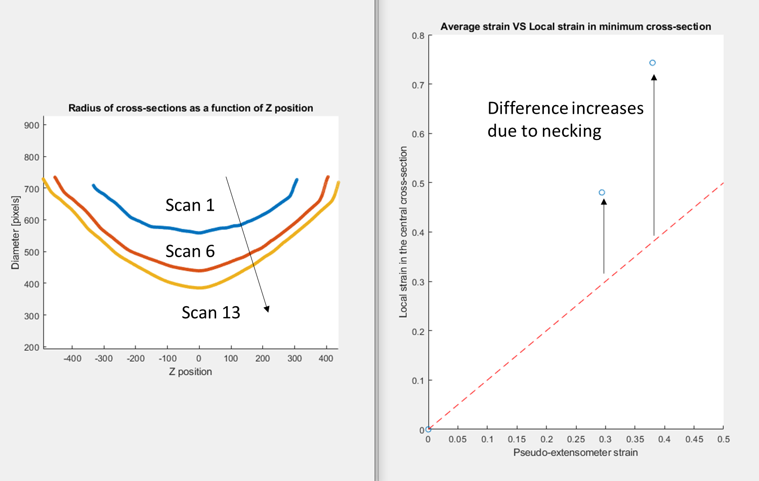**Results, just run *Analysis_Fv.m* function in Matlab:**

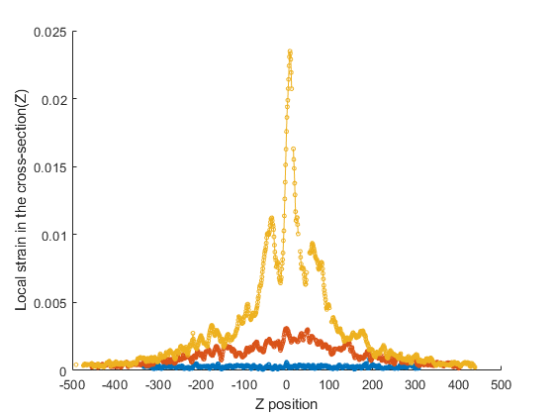Take-home message: you can quantify necking in 3D

Take-home message: The local strain is highly sensitive to the Z position after necking, which will significantly influence the damage evolution.

1. **Compute the evolution of the local void volume fraction**

One of the most frequently used global measurement is the volume fraction, usually noted as ***FV***. The subscript is used to indicate a dimensionless ratio of volume per unit volume.

In this section, we will evaluate how accurately the area fraction (***FA***), which can be obtained for each slice (Z position) allows to evaluate the volume fraction ***FV***. This is interesting because ***FA*** corresponds to what would have been obtained from conventional 2D methods (e.g. optical microscopy after polishing).

Furthermore, studying the evolution of ***FA*** from 2D slices of the tomographic volume is also interesting in the case of in situ tensile tests, especially after the onset of necking. Indeed, the evolution of porosity is significantly influenced by the local strain and ***fV*** is thus strongly linked to the position along the sample.

Using the results of previous sections, quantify the evolution of void area fraction *FA* as a function of the Z position (i.e. for each slice).

How can you compute the void volume fraction *Fv* from the evolution of *FA* ?

What can you conclude about the heterogeneity of damage within the sample ?

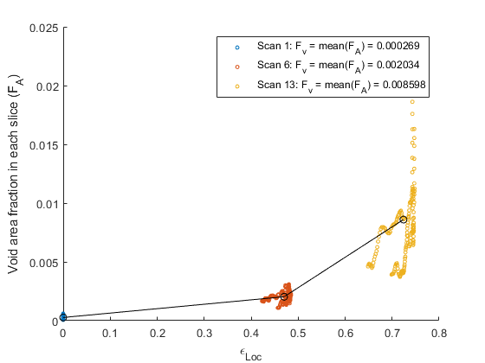 **Results, just run Analysis_Fv.m function in Matlab**:

Take-home message: You can obtain *Fv* which is simply the mean of *FA* in each cross-section. However, the value of *Fv* can only be compared if looking at the **same** ROI because it is highly dependent on the position. Exponential trend with strain, make the link with Rice and Tracey.

1. **Analyze the evolution of the density of voids:**

It is important to note that there are some fundamental parameters and three-dimensional structure that cannot be determined from two dimensional images.

For instance, it is not possible to look at a two dimensional image of a plane section and determine whether the phase of interest consists of discrete voids, or whether they are connected (i.e. forming a micro-crack after void coalescence).

Using the results of previous sections, quantify the evolution of the density of voids (i.e. *NA* number of voids per area unit in 2D or *NV* number of voids per volume unit in 3D).

What can you conclude about their evolutions ?

**Results, just run Analysis_Density.m function in Matlab**:

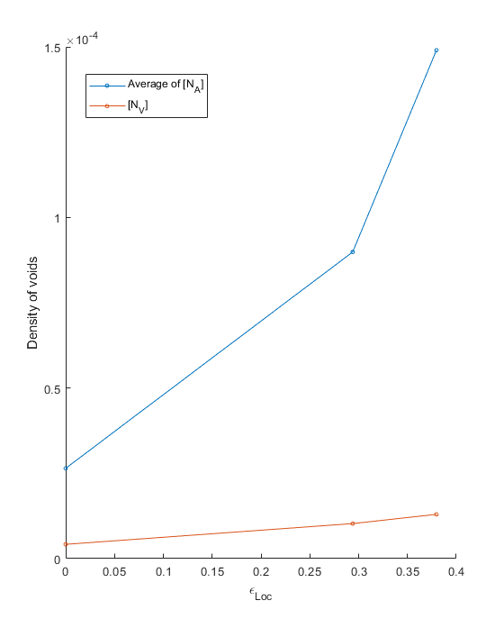

Take-home message: First, strongly increasing due to void nucleation.

Even if we could expect that the number of voids would decrease in scan 13 (onset of large scale coalescence), the density of voids keeps increasing because void nucleation is still active.

* It is thus important to look at the local evolution of FA (previous point) or the evolution of the largest porosities (next section).

Note: According to stereology, NA and NV should be related as follow:

NV = NA/(2*Rperp)

With Rperp being the average radius of the voids in the direction perpendicular to the plane section.

1. **Analyze the evolution of the void size distribution and basic tracking:**

Finally, compare the evolution of the average size obtained in 2D/3D/

Furthermore, it is sometimes useful to look at the evolution of parameters, following each void from one scan to the other (void tracking). A simplify approach to void tracking has traditionally been to assume that the largest Ntrack (usually 20) remains the same. Compute the size evolution of these Ntrack porosities, what can you conclude ?

**Results, just run Analysis_Size.m function in Matlab**:

***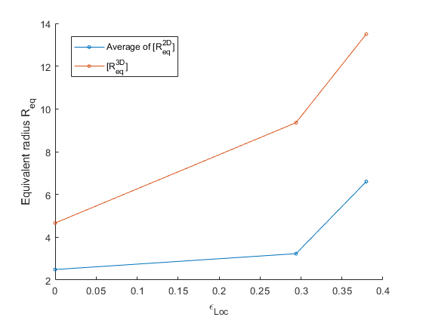*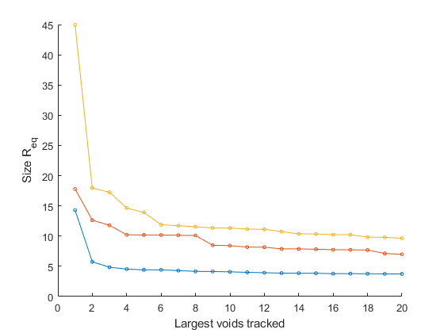**

Take-home message: Exponential evolution as a function of local strain, make the link with Rice and Tracey.

By tracking the largest voids, we can clearly see the explosion of the largest voids (keep in mind that volume is proportional to R^3), which clearly corresponds to the initiation of large scale coalescence of voids and failure of the specimen.