**StoryBoards**

Design Features

* I made sure the buttons were easy to use.
* I made sure the check button could not be pressed if the user did not select a radio button (and shows a toast message).
* I made toast messages for correct and incorrect answers.
* I made the question number be displayed at the top of the screen.
* I made a retry button.
* I used large text font, so it was easy to read.
* I made sure it was obvious which radio button was selected.

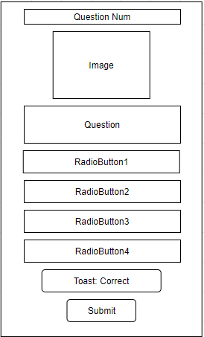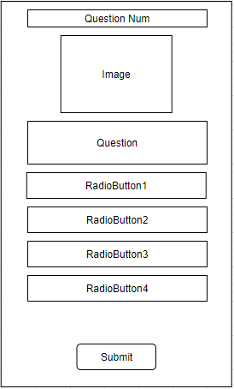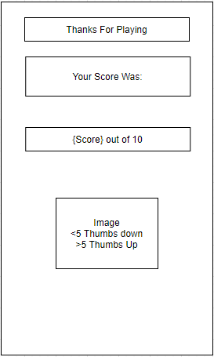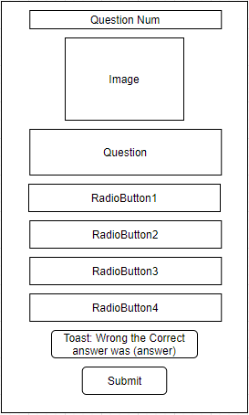

Results Page

Wrong answer

Retry Button

Correct answer

Main Page