Introduction

Maine’s 2020 presidential preference primary was held on March 3rd, 2020 during “Super Tuesday,” while the Democratic and Republican Primaries were held on July 14th, 2020. This timing—one election pre-COVID-19 and one after—gives us interesting leverage to examine how well Maine has conducted its elections during the pandemic, and may allow us to understand what needs to be done in advance of the 2020 general election in November.

This report addresses three key questions:

* How did Maine voters participate by Mail in March and in July 2020?
* How did Maine voter behavior correlate with demographic variables in March and July?
* Finally, how does VBM interact with instant-runoff voting (otherwise known as ranked-choice voting) in Maine elections?

Data Issues

Maine is one of several states that does not provide a voter file that is easily accessible. In order to gain any leverage on voting behavior, we were only able to utilize what was available. This was the absentee voter file, which the state releases the for every election. This file includes the town, unique voter identification number, partisanship, accepted/rejected status, date requested, and other similar attributes. As such, we are only able to provide town-level statistics at this time.

While this is relatively disappointing compared to our other reports, Maine partially makes up for this with the fact that nearly every municipality—with the exception of a handful of cities such as Lewiston, Bangor, and Portland—only have a single voting site, and thus these results may generally be seen as precinct-level results in precincts that do not change between elections.

The 2020 Presidential Preference Primary

During the 2020 Presidential preference primary and referendum in March 2020, there were a total of 58,734 absentee ballots requested. From this, 58,687 votes were issues and 53,496 were returned. From the returned ballots, 5,935 ballots were rejected. In total, 47,561 absentee ballots were counted, leading to an 81% completion rate from request to tabulation, and an 11% rejection rate based on ballots that were received by the state.

Table 1. Summary of Absentee Ballots in the March 2020 Presidential Preference Primary

|  |  |
| --- | --- |
| **Record Type** | **Number** |
| Total Requested | 58734 |
| Total Issued | 58687 |
| Total Returned | 53496 |
| Total Rejected | 5935 |

Comparison to the 2018 Primary

The first analysis that was conducted was in comparing the 2020 absentee ballot participation to the 2018 absentee ballot participation by municipality. As can be seen in both the graph and in the top ten towns by number of ballots cast, there were generally more ballots rejected in the March 2020 primary than there were in the 2018 primary. This can be seen in the graph below, where the data points are sized in proportion to the total number of votes cast in that municipality. Furthermore, as can be seen in the table below, the top ten towns experienced several times more rejected ballots than in 2018.

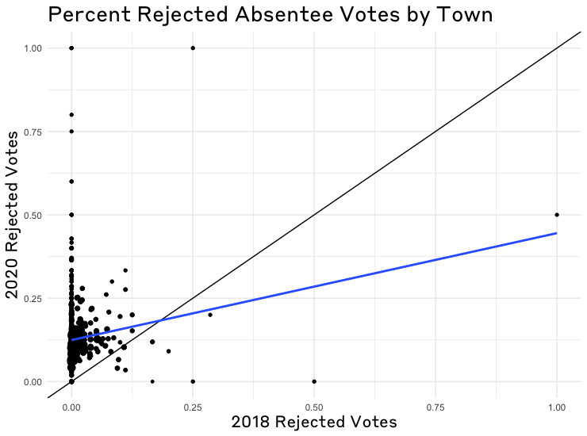

Table 2. Rejection rates in 2020 and 2018 in the largest municipalities by number of votes.

|  |  |  |  |  |  |  |
| --- | --- | --- | --- | --- | --- | --- |
| **Municipality** | **2020 Total** | **2018 Total** | **2020 Rejected** | **2018 Rejected** | **2018 Rejected Percent** | **2020 Rejected Percent** |
| PORTLAND | 3974 | 1663 | 552 | 12 | 0.72% | 13.89% |
| SCARBOROUGH | 1895 | 1615 | 126 | 5 | 0.31% | 6.65% |
| BRUNSWICK | 1576 | 1030 | 160 | 2 | 0.19% | 10.15% |
| YORK | 1464 | 620 | 94 | 1 | 0.16% | 6.42% |
| SOUTH PORTLAND | 1399 | 634 | 141 | 6 | 0.95% | 10.08% |
| BANGOR | 1285 | 1102 | 145 | 9 | 0.82% | 11.28% |
| FALMOUTH | 1200 | 731 | 103 | 6 | 0.82% | 8.58% |
| CAPE ELIZABETH | 1169 | 819 | 127 | 2 | 0.24% | 10.86% |
| CUMBERLAND | 1167 | 583 | 85 | 4 | 0.69% | 7.28% |
| LEWISTON | 1116 | 841 | 127 | 7 | 0.83% | 11.38% |

Reasons for Rejected Ballots

From the absentee voter file, we can find the reasons for each ballot rejections, which are shown in the table below. The vast majority of ballots rejected were a result of “ballot not returned by deadline” according to the data provided by the Secretary of State; this reason accounted for 5,064 of the 5,935 rejected ballots. Another 178 rejections were due to the ballots not being received until after the deadline. It should be noted that the state of Maine requires that ballots be [received before election day](https://www.maine.gov/sos/cec/elec/voter-info/absenteeguide.html); ballots postmarked before election day and received after are rejected by the state as “Received after Deadline Date.”

Table 3. Reasons for Ballot Rejection in Maine.

|  |  |
| --- | --- |
| Reason for Rejection | Number of Rejected |
| Aid Cert. Not Completed | 2 |
| Ballot not returned by deadline | 5064 |
| Ballot Undeliverable | 90 |
| Duplicate Ballot Received | 22 |
| Envelope not Signed | 234 |
| Not Enrolled when Necessary | 3 |
| Other | 207 |
| Received after Deadline Date | 178 |
| Spoiled by Voter | 87 |
| Signature does not Match | 7 |
| Voted in Person | 32 |
| Witness Certificate not Properly Completed | 9 |

Table 4. Reasons for Absentee Ballot Rejection in Municipalities with Most Rejections

|  |  |  |  |  |  |  |  |  |  |  |  |  |  |
| --- | --- | --- | --- | --- | --- | --- | --- | --- | --- | --- | --- | --- | --- |
| **Municipality** | **Total Rej** | **BND** | **ANC** | **BRU** | **DBR** | **ENS** | **NEN** | **OTH** | **RAD** | **SBV** | **SNM** | **VIP** | **WNC** |
| PORTLAND | 552 | 512 | 0 | 12 | 0 | 18 | 0 | 6 | 2 | 2 | 0 | 0 | 0 |
| BRUNSWICK | 160 | 134 | 0 | 3 | 1 | 2 | 0 | 9 | 10 | 1 | 0 | 0 | 0 |
| BANGOR | 145 | 133 | 0 | 3 | 0 | 1 | 0 | 7 | 1 | 0 | 0 | 0 | 0 |
| SOUTH PORTLAND | 141 | 127 | 0 | 0 | 1 | 3 | 0 | 3 | 1 | 4 | 0 | 2 | 0 |
| CAPE ELIZABETH | 127 | 113 | 0 | 4 | 0 | 1 | 0 | 6 | 0 | 0 | 0 | 3 | 0 |
| LEWISTON | 127 | 110 | 0 | 1 | 0 | 4 | 0 | 8 | 0 | 0 | 0 | 0 | 4 |
| SCARBOROUGH | 126 | 116 | 0 | 1 | 0 | 9 | 0 | 0 | 0 | 0 | 0 | 0 | 0 |
| YARMOUTH | 105 | 103 | 0 | 0 | 0 | 0 | 0 | 2 | 0 | 0 | 0 | 0 | 0 |
| FALMOUTH | 103 | 91 | 0 | 0 | 1 | 1 | 0 | 8 | 2 | 0 | 0 | 0 | 0 |
| GORHAM | 103 | 88 | 0 | 1 | 0 | 8 | 0 | 0 | 0 | 6 | 0 | 0 | 0 |