

1. **Theme:**

**A website that shows all information about the space project StarMist**

**http://projectpgkpi.eu3.biz**

1. **Participants:**

|  |  |
| --- | --- |
| Симеон Николаев Вангелов | Role: Front-end dev |
| Имейл :  SNVangelov22@codingburgas.bg | Grade:8V |
| Кристиян Димитров Димитров | Role: Front-end dev |
| Имейл : KDDimitrov22@codingburgas.bg | Grade:8B |
| Мартин Емануилов Димитров | Role: Scrum trainer |
| Имейл : MEDimtirov22@codingburgas.bg | Grade:8G |
| Николай Евгеневич Калашник | Role: Designer |
| Имейл : NEKalashnik22@codingburgas.bg | Grade:8A |
| Габриел Григоров Димитров | Role:Mentor |
| Имейл : GGDimitrov21@codingburgas.bg | Grade:9V |

1. **Summary**

**3.1. Goals of the project**

The goal of the project is to present our knowledge and skills in web design by creating a website that aims to introduce all people interested in this topic to the use of robots in outer space

**3.2. Main Stages in the realization:**

1. Brainstorming for ideas
2. Проучване на подобните истински проекти
3. Defining a goal
4. Drawing prototypes for pages
5. Creating a main site template
6. Coding the site and the pages within the prototypes
7. Drawing the pictures and inserting them in the main site
8. Adding animations and Java Script
9. Arranging the code
10. Hosting the site on a free server

The work is divided between the four of us.

**3.3. Level of difficulty on the project:**

The level of difficulty on this project was high, due to the fact that most of us are beginners in the technologies like html and css. We weren’t familiar with any web design libraries, much less how to use them. This makes the project difficult, but also very rewarding because we have the chance to learn in the process.

Used programming languages:

- html

- css

- bootstrap

- javascript

In the process of work, we had difficulties with the adaptability of the site to devices of different sizes and resolutions. After researching how we could solve it, we saw that there are different possibilities like flex, media query, bootstrap. We decided to use mostly the bootstrap library, which is ready-made classes described through css and java script.

**3.4. Логическо описание на сайта. Тестове**

The site has been hosted on [http://projectpgkpi.eu3.biz/](http://projectpgkpi.eu3.biz/index.html) It can be visualised in all current versions of the main browsers. Its design is adaptable to devices of different sizes and resolutions. The block of our site has been created in the online app <https://octopus.do>

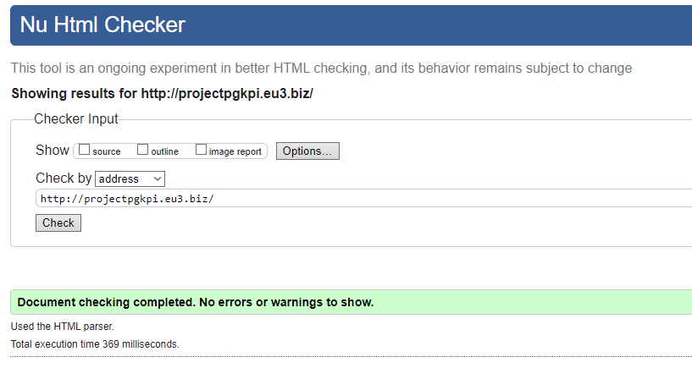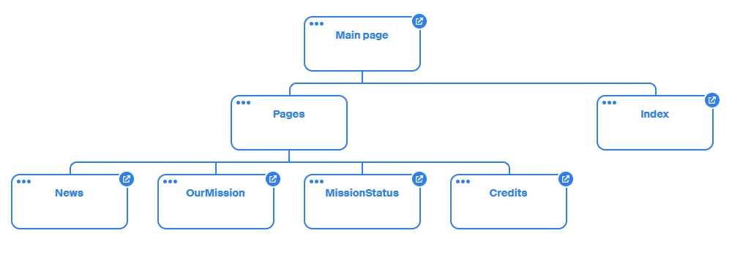

**3.5. In conclusion:**

Working on this project was very useful for us. We have a desire to supplement our website with other pages as well as to work on other interesting school projects in the future.