**PROTOTYPING A S.M.A.R.T. VEHICLE NETWORKING PROTOCOL**

**FINAL REVIEW REPORT**

Submitted in partial fulfilment for the award of the degree of

**B. Tech.**

in

**B.Tech Mechanical Engineering**

*By*

NIKHIL PANDITA

**[ 14BME0133 ]**

**School of Mechanical Engineering**



**April, 2018**

(Project Title here)

|  |  |
| --- | --- |
| **Project ID** | Winter2018/SMEC/B.Tech/Mechanical/ **17DES0055** |
| **Date of Review** | **11.04.2018** |
| **VIT Guide** | Prof. **Kalaiarassan G.** |
| **External Guide** | Name:  Designation:  Mobile:  Email:  Business Unit: |
| **Project Team Members** | Student 1   1. Name: **Nikhil Pandita** 2. Reg. No: **14BME0133** 3. Email: 4. Mobile:   Student 2   1. Name: 2. Reg. No: 3. Email: 4. Mobile:   Student 3   1. Name: 2. Reg. No: 3. Email: 4. Mobile: |
| **Guide’s Remarks** |  |
| **Name and Signature of the guide** |  |
| **Comments of Reviewer(s)** |  |
| **Name and Signature of the Reviewer** |  |

**DECLARATION BY THE CANDIDATE**

I hereby declare that the project entitled “Prototyping a S.M.A.R.T. Vehicle Networking Protocol” that was submitted by me to the Vellore Institute of Technology, Vellore, was in the partial fulfilment of the requirement for the award of the degree of B. Tech. in Mechanical Engineering, is a record of bonafide project work carried out by me under the supervision of Dr. Kalaiarassan G.. I hereby declare that this report represents my concepts written in my own articulation, with wherever appropriate, others’ ideas or words have been included. I have adequately cited and referenced the original sources and the codebases. I further declare that I have adhered to all principles of academic honesty and integrity and have not misrepresented or fabricated or falsified any idea, data, fact or source code in my submission. I understand that any violation of the above will be the cause for disciplinary action by the Institute and can also invoke penal action from the references that have not been cited explicitly or properly, or from whom proper permission has not been prior to publication. Furthermore, I affirm that the contents of this report have not been submitted either in part or in full, for the award of any other degree or diploma and the same is certified.

Venue: VIT, Vellore

Date: 29-06-2018

NIKHIL PANDITA {14BME0133 }

(Signature of the candidate)



**BONAFIDE CERTIFICATE**

This is to certify that the project report entitled “**Prototyping a S.M.A.R.T. Vehicle Networking Protocol”** submitted by **Nikhil Pandita,** bearing the registration number **14BME0133**, to the Vellore Institute of Technology, VIT University, Vellore, in the partial fulfilment of the requirement for the award of the degree of B. Tech. in Mechanical Engineering, is a record of bonafide work carried out by him under my guidance. The project fulfils the requirements as per the regulations of the Institution, and in my opinion meets the necessary standards for submission. I confirm that the contents of this report have not been submitted either in part or in full, for the award of any other degree or diploma and the same is certified.

Venue: VIT, Vellore

Date: 14-04-2018

**(Project Coordinator) (Project Supervisor)**

**(Head of the Department) (External Examiner)**

**ACKNOWLEDGEMENT** :

I would like to thank the lab faculty, the lab attendants and the support staff at the School of Mechanical Engineering, VIT University for endowing their extremelybeneficial encouragement and support during the period of project completion. I am also greatly indebted to the University for providing the requisite resources and extending the lab permit beyond class hours. It was indeed the major force that helped shaped the project outcome. I would also like to acknowledge the moral support and the coaching of the project guide and reviewers, VIT Management and Parents, Internal and External Guides, Staff members and various other specific people that helped me in accomplishing the project work. I further my heartfelt gratitude to my internal mguide, Dr. Kalaiarassan (Robotics, SMEC) and my reviewer, Dr. Sundaramali, for their incessant inspirational mentorship.

Venue: VIT, Vellore

Date: 14-04-2018

**(Signature of the student)**

**TABLE OF CONTENTS**

|  |  |  |  |  |  |  |  |  |  |  |
| --- | --- | --- | --- | --- | --- | --- | --- | --- | --- | --- |
| **CHAPTER NO.** | | | **DESCRIPTION** | | | | | **PG. NO** | | |
|  | | | **PREFACE** | | | | | 1 | | |
|  | | | Declaration | | | | |  | | |
|  | | | Bonafide Certificate | | | | |  | | |
|  | | | Acknowledgements  List of Figures  List of Abbreviations  Abstract 9 | | | | |  | | |
|  | | |  | |  |  | |  | | |
| Chapter – I | | | **INTRODUCTION AND LITERATURE REVIEW** | | | | | 10 | | |
|  | | |  | | 1.1 | Introduction | | 11 | | |
|  | | |  | | 12 | Literature Review | | 12 | | |
|  | | |  | | 1.3 | Knowledge Gained from Literature | | 13 | | |
|  | | |  | | 1.4 | Gaps in the Literature | | 14 | | |
|  | | |  | | 1.5 | Objectives | | 15 | | |
| Chapter - II | | | **METHODOLOGY & EXPERIMENTAL PROCEDURE** | | | | |  | | |
|  | | |  | | 2.1 | Methodology | | 16 | | |
|  | | |  | | 2.2 | Design Elements Included | | 17 | | |
|  | | |  | | 2.3 | Realistic Constraints to be addressed | | 18 | | |
| Chapter - III | | | **RESULTS AND DISCUSSION** | | | | |  | | |
|  | | |  | | 3.1 | Conclusion | | 19 | | |
|  | | |  | | 3.2 | Work Done so far | | 21 | | |
|  | | |  | | 3.3 | Objectives Accomplished | | 24 | | |
|  | | |  | | 3.3 | Gantt Chart | | 27 | | |
|  | | |  | | 3.4 | Day-to-Day Activity | | 27 | | |
|  | | |  | | | | |  | | |
|  | | | References | | | | | 30 | | |
|  | | | Sources and Code Snippets | | | | | 31 | | |

|  |  |  |
| --- | --- | --- |
|  | **LIST OF FIGURES** |  |

|  |  |  |
| --- | --- | --- |
| **Figure No.** | **Title** | **Page No.** |
|  |  |  |
| Fig. 1 | Vehicle to Infrastructure Communication, (schematic) | 12 |
| Fig. 2 | Schematic Protocol Componential to execute HVAC | 18 |
| Fig. 3 | An Example in cloud run: Vehicle Occupancy Flag | 19 |
| Fig. 4 | Hybrid or Modern Day Infrastructure | 21 |
| Fig. 5 | Schematic peer-to-peer approach | 23 |
| Fig. 6 | Ad-hoc networked nodes | 24 |
| Fig. 7 | Client-to-Server type connection | 25 |
| Fig. 8 | Client-to-Client type connection | 26 |
| Fig. 9 | Signal Messaging Distributed Architecture | 28 |
| Fig. 10 | Real-Time Implementation and Scaling approach | 29 |

|  |  |  |
| --- | --- | --- |
|  | **LIST OF ABBREVIATIONS** |  |

|  |  |  |
| --- | --- | --- |
| **S. No.** | **Abbreviated Form** | **Long Description.** |
|  | CAN | Controller Area Network |
|  | AGL | Automotive Grade Linux |
|  | V | Vehicle |
|  | *N* | Node |
|  | *V2V* | Vehicle to Vehicle |
|  | ECU | Electronic-Engine Control Unit |
|  | O.S.S. | Open Source Software |
|  | R.O.L.L. | Routing over LowPAN & Lossy Networks |
|  | VHF | Very High Frequency |
|  | VM | Virtual Machine |
|  | HVAC | High Voltage A/C |
|  | GIS/GPS | Global/Geospatial Information/Positioning System |

**Abstract**:

A novel approach to tackle various inefficiencies of the modern day Vehicle-to-Vehicle communication technology, specifically the modern-day implementation using the Automotive-Grade Linux.

The paper begins with sampling the actual hardware and software deployed by the leading manufacturers and industry, highlighting use-cases like the Toyota Prius, Tesla Model S, Reva, etc, employing an ECU approach, and concludes with delivering optimizational remedies.

**Keywords**:

Automotive Communication Networks; Decentralized Communications; In-Vehicle Networking; Hybrid Platooning; S.M.A.R.T. Automobile Clustering;

**CHAPTER –I**

**INTRODUCTION & LITERATURE REVIEW**

## **Introduction:**

Nowadays , the culture of hybrid, all-electronic S.M.A.R.T. and connected autonomous vehicles is on an ever-peaking demand-curve. This also means an extension of the vehicle-security exploitations increment we hear about through daily media, about theft, hijacking or simply vandalism. Such an overwhelming need for an automobiles’ security and longevity can only be met by the far-reaching, impactful and tailored technology, suited for the respective scenario. Realizing such endeavors could be only possible owing to the Open Source (F.L.O.S.S.) collective, and thence garnered resources and source codes.

On account of solving this research conquest, such an approach has been applied, such that in order to be able to cater the needs of almost everyone with a direct contact with a vehicle, or any automobile, public, personal or even private can be realized at the minimal costs of upgradation.

We, through the medium of this project, would aspire to address such vehicle optimization adversing security related tradeoffs, and conclusively suggest remedies.

**Literature Review**

## A wide variety of scholarly articles have been referenced to survey the current as well as the previously outdated inter and intra vehicular and network communication and signaling technology. In order to maintain standard universality, all implementations are based using Linux kernel 4.1.

## [https://mee499.github.io/MEE499R01V007/req002.html - literature-review](https://mee499.github.io/MEE499R01V007/req002.html#literature-review)

### 

|  |  |  |
| --- | --- | --- |
| Sample | Description | Remarks |
| List of Sampled Technology Protocols | 1: Contoller Area Network (C.A.N.)  2: MAC layer Addressing  3: IEEE 802.11 (b.g.n/a/c) | [https://mee499.github.io/MEE499R01V007/req002.html - list-of-sampled-technology-protocols](https://mee499.github.io/MEE499R01V007/req002.html#list-of-sampled-technology-protocols) |
| List of Sampled Technology Hardware | 1: Adafruit’s Arduino UNO  2: Raspberry Pi’s ‘Model B+’  3: Reannaisance’s PorterBoard 2  4: Orange Pi’s IoT+ Embedded  5: Stock Daragonboard410c (QEMU Emulated-VM) | [https://mee499.github.io/MEE499R01V007/req003.html - list-of-sampled-technology-hardware](https://mee499.github.io/MEE499R01V007/req002.html#list-of-sampled-technology-hardware) |
| List of Sampled Software Releases | 1: Automotive Grade Linux (A.G.L., Linux Kernel 3.9)  2: Tyzen Operating System (UNIX Kernel 4.11)  3: Qt ( For the Graphical Release, Applications)  4: Ubuntu IoT Core (+2.3.26) | [https://mee499.github.io/MEE499R01V007/req004.html - list-of-sampled-software-releases](https://mee499.github.io/MEE499R01V007/req002.html#list-of-sampled-software-releases) |
| List of Sampled Libraries and Modules: | 1: AGL  1.1: agl-demo  1.2: agl-appfw-smack  1.3: agl-devel  1.4: agl-netboot  2: UNIX  2.1: gawk  2.2: wget  2.3: git-core  2.4: diffstat  2.5: texinfo  2.6: chrpath  2.7: cpip  2.8: socat  3: libdll  3.1: libsdl.2-dev  3.2: gcc-multilib  3.3: libhvac  3.4 libssh-dev | [https://mee499.github.io/MEE499R01V007/req004.html - list-of-sampled-libraries-and-modules](https://mee499.github.io/MEE499R01V007/req002.html#list-of-sampled-libraries-and-modules) |
| List of Sampled Prototyping (cMake) Softwares: | 1: Reading/Writing a PCB (.gerber format)  2: C, PyPi (Writing Functional Code Snippets)  3: make, build (C-lang)  4: bash (UNIX Scripting) | [https://mee499.github.io/MEE499R01V007/req006.html - list-of-sampled-authoring-softwares](https://mee499.github.io/MEE499R01V007/req002.html#list-of-sampled-authoring-softwares) |

**Knowledge gained from the Literature:**

## Most of the projects in IV, V2V and V2I use the standard IEEE 802.11 protocol for communication. But also GSM, UMTS, GPRS protocols are used in some of these projects. Generally WSNs (Wireless Sensor Networks) are deployed ineffectively and thus “platoonong” is inefficient, since the convoluted network is not ‘big’ enough in terms of the ‘no. of nodes’ present in the V2V (Vehicle-to-Vehicle) or V2I(Vehicle-to-Infrastructure) network.

Traditionally, IEE standards like the Basic layers have been employed tor the information transmission. Routing inside a low power area network (LoWPAN) might be considered a challenge, as the RPL has to work over lossy radio links, with battery-powered nodes, multi h-op mesh topologies and frecuent topology changes.

To give a solution several working groups are giving support to the RFC’s for this protocol.

One of them is the routing over lowpan and lossy networks (ROLL) who is in charge of routing tasks. Meanwhile the “6LoWPAN” is trying to bring the new IPv6 addressing system to these resource-constrained devices.

In our design, we have tried to predict the points of failure in such technology from a penetration and security testing point of view and conclude with instantly applicable remedies via pull requests to the FOSS code repositories.

**Gaps in the Literature:**

Radio waves and infrared have been studied to give medium support to IVCs. The radio waves include micro, millimeter and VHF waves. The communication with millimeter waves and infrared are usually directional, while VHF is used for broadcast.

The typical radio bandwidth used in IVC is 5.9 GHz in US, 5.8 GHz in Japan and 5.8 GHz in Europe. The FleetNet project chose ULTRA TDD due to the availability of the unlicensed frequency band 2010-2020 MHz in Europe. Most projects, however, have adopted the use of infrared (CarTALK, COOPER, JSK, PA, etc.).

There are two approaches in developing MAC for IVCs. One is using IEEE 802.11 as a radio interface, while the other consists on extended 3G technology, such as CDMA for distributed access.

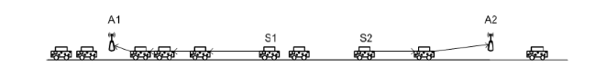

(*Fig. 3*) : Vehicle to Infrastructure Communication (schematic)

Both of them have to be modified and adapted to provide an efficient solution for IVCs. The only advantage of using IEEE 802.11 is the inherited support for distributed coordination in ad-hoc mode. On the other hand, 3G extensions present high granularity for data transmission

## **Program** **Objectives**:

* To come up with a neat-networking protocol schema to address inefficient hop-on /ad-hoc communication propogation delays, possibly trying to implement in a decentralized contract.
* To be able to successfully reproduce the hardware based real-time implementation of the AGL release on an ARM based development board.
* To provide an future roadmap for Non-hybrid cum Hybrid on-road network integration in a cheap (feasible), environment-friendly (sustainanble) and energy-efficient (if not, utilitarian) by means of a snap-on dashboard powered by a simple smartphones’ sensors, transmitters and transducers.
* To demonstrate a successful implementation of AGL (improvised fork) during the final review.

**Others:**

## **Design Elements included :**

Engineering Standards Prototype and Fabrication

Design Analysis Experimentation

Modeling and Simulation Software Development

## **Realistic Constraints to be addressed :**

Economic Ethical

Environmental Health and Safety

Social Manufacturability

Political Sustainability

**CHAPTER –II**

**METHODOLOGY AND EXPERIMENTAL PROCEDURE**

**2.1 Methodology**

The AGL is first ported to a VM with a usual DebianOS base kernel.

Next, the images are downloaded and flashed onto a SDHCeMMC Memory Card.

Third, the auxiliary input and output peripherals are serially connected to the used Raspberry Pi, or UNO module.

**2.2 Experimental Procedure**

Hardware Requirements

* Dragonboard410c
* 96Boards Compliant Power Supply
* Linksprite 96Boards Touch Screen
* Sensors Mezzanine
* Audio Mezzanine(Required if using External Arduino)
* Arduino Uno(Optional)
* DC motor with Propellers
* L298 Motor Driver
* 5mm LED's
* 330 ohm resistors
* Connecting (patch) wires

Arduino

* Controlling Fan Speed and LED intensity are handled by the Arduino. Sensors Mezzanine has an ATMega328 microcontroller compatible with Arduino Uno. We use that or any external Arduino Uno for PWM control.
* In case of using Sensors Mezzanine, the sketch can be uploaded by using Dragonboard410c itself..
* If using Sensors Mezzanine, please follow the below steps on Dragonboard410c running Debian otherwise use Arduino IDE on the host system for programming.

$ cd ~/Documents

$ git clone https://github.com/96boards-projects/agl-demo.git

$ cd agl-demo/arduino/hvac

* Now open the hvac.ino using Arduino IDE and flash it onto the Sensors Mezzanine or Arduino Uno.

Dragonboard410c

* Execution environment: Host PC
* Software Dependencies:

$ sudo apt-get install gawk wget git-core diffstat unzip texinfo gcc-multilib \

build-essential chrpath socat libsdl1.2-dev xterm cpio curl

**Loading AGL Source Code**

* AGL uses repo tool for maintaining repositories. We need to download the source on the host machine and cross compile it for Dragonboard410c.

$ export AGL_TOP=$HOME/workspace_agl

$ mkdir -p $AGL_TOP

$ mkdir -p ~/bin

$ export PATH=~/bin:$PATH

$ curl https://storage.googleapis.com/git-repo-downloads/repo > ~/bin/repo

$ chmod a+x ~/bin/repo

* Next, checkout the stable branch of AGL.

$ cd $AGL_TOP

$ repo init -b dab -m dab_4.0.2.xml -u https://gerrit.automotivelinux.org/gerrit/AGL/AGL-repo

$ repo sync

**Building AGL**

* Now, to build the agl-demo-platform for Dragonboard410c.

$ source meta-agl/scripts/aglsetup.sh -m dragonboard-410c agl-demo agl-appfw-smack agl-devel agl-netboot

* Now to move to the directory:

$ cd agl-demo

* Copying the custom HVAC recipie to AGL source:

$ cp hvac_git.bb $(AGL_TOP)/meta-agl-demo/recipes-demo-hmi/hvac/hvac_git.bb

* Executing bitbake command by moving to the build directory of AGL source.

$ cd $(AGL_TOP)/build

$ bitbake agl-demo-platform

**Flashing AGL onto Dragonboard410c**

* Once the build has been completed, we have to flash the boot and rootfs images onto Dragonboard410c. Now, boot Dragonboard into fastboot mode by following the instructions here. Then follow the below instructions to flash AGL onto Dragonboard410c.

$ cd $AGL_TOP/build/tmp/deploy/images/dragonboard-410c

$ sudo fastboot flash boot boot-dragonboard-410c.img

$ sudo fastboot flash rootfs agl-demo-platform-dragonboard-410c.ext4

Hardware Setup 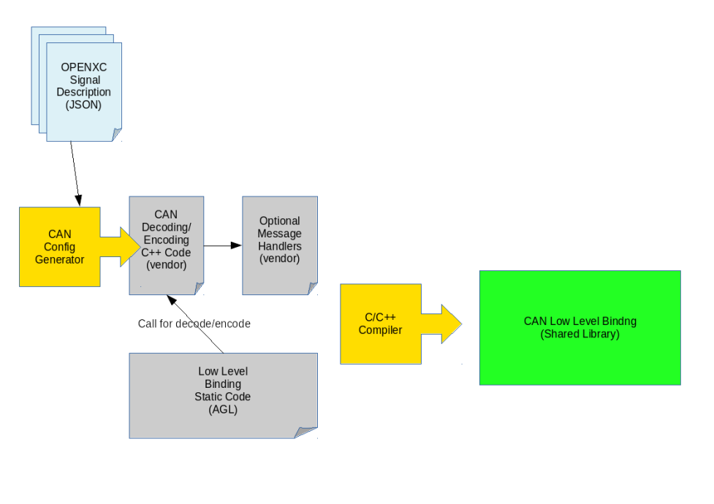

(Schematic Protocol Componential to execute HVAC).

* Made sure the Dragonboard410c is powered off
* Connected DC motor and LEDs to Arduino as per above schematic
* Connected LCD to Dragonboard410c via HDMI cable for display and Micro USB cable for touch input
* Powered on 96Boards CE with compatible power supply
* Dragonboard410c should now boot into AGL and homescreen should be visible.

**HVAC Utilities**

Execution environment: Dragonboard410c

Navigated to the HVAC application from the Homescreen.

1. To control the Fan speed, change the position of slider at top.
2. To control the LED intensities, change the values of L/R temperatures by dragging up the LO box. Turned off power by using the following:

$ sudo cd ..

$ poweroff --no-latch

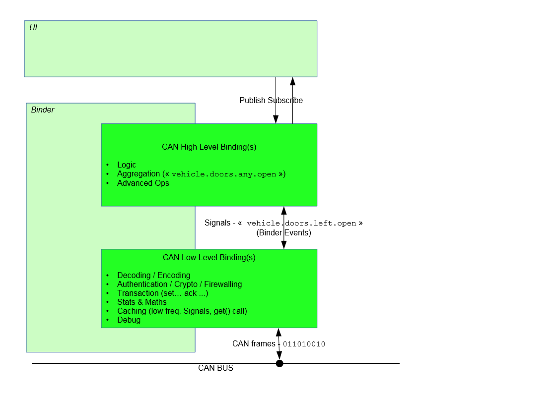

*Fig. 3* (An Example in cloud run: Vehicle Occupancy Flag)

**Protocol Parameter Development**

Note: About Network Layer based communication:

Almost all routing protocols used by the different IVC projects are position-based.

In addition, existing MAC ad hoc protocols could be directly applied. But if an optimal performance is desired taking into account the linear nature of the networks seen in section III, modification of the existing routing protocols must be performed.

In addition, the features most of vehicles offer nowadays makes possible to get position information via GPS or GIS, very useful for routing.

The protocol uses a forwarding scheme which avoids beacons for impactful transmission and effective sensing.

**Applied Ad-hoc Approach to Network**

## 

## We employ a Virtual Network layer based on-board computation cum signaling:

## 

## (Fig 4:) Hybrid or Modern Day Infrastructure

We aspire to prototype a modular approach to convert existing infrastructure of sensors and wireless telecommunication devices, and perhaps even provide pointers on an improved protocol fabrication, which could be deployed at scale, feasibly.

## 

## **CHAPTER –III**

## **RESULTS AND DISCUSSION**

## **PHASE I**

**3.1 Implementational Details:**

* Successfully studied the architecture of a PCB (printed) board.
* Gained a deep understanding of remote-sensing and GIS in application-layer deployment.
* Ported AGL unto raspberryPi and successfully emulated on a HDMI-connected monitor.
* Pull Request was successfully merged with the source at git.automotivelinux.com.
* Cost and Capacity based market economic analysis.

**3.2 Work objectives accomplished:**

* Came up with a neat-networking protocol schema to address inefficient hop-on /ad-hoc communication propagation delays, possibly trying to implement in a decentralized contract.
* Were able to successfully reproduce the hardware based real-time implementation of the AGL release on an ARM based development board.
* To provide an future roadmap for Non-hybrid cum Hybrid on-road network integration in a cheap (feasible), environment-friendly (sustainable) and energy-efficient (if not, utilitarian) by means of a snap-on dashboard powered by a simple smartphones’ sensors, transmitters and transducers.
* To demonstrate a successful implementation of AGL (improvised fork) during the final review.

## **PHASE II**

## **LAYOUT OF NODES**

**3.1 Networking Approach:**

The independent vehicles are coupled within a WLAN region, with each and every client being a separate node.

t=-n t=-1 t=0  t=1  … t=n+1.

Fig 5 (Schematic peer-to-peer approach)

The intrinsic chararteristics of the protocol specifically aim to reducy latency within the network at a controller level adminstrative scope.

|  |  |
| --- | --- |
| (*Fig. 6*) | * Figure showing networked nodes at a schematic note. Each node is identified with a unique tag, or roll no. * Each Autonomous Node Is Indexexed.viz.0x00-0x05. * Current Figure Shows A Total Of 6 Openly Connected Communication Channels. |

It is serialized in such a fashion that no two nodes could have the same unique identifier. Hence, a specific roll is given to each member node connected to the peer-to-peer network.

## **PHASE III**

## **Conclusion**

The networking was successfully deployed in real-time on a two-wheeler, and the Raspberry-Pi microcontroller was used to process the network traffic throughput over a locally established WLAN using an ad-hoc approach.

|  |  |
| --- | --- |
| * Figure showing traditional approach. * Client-to-Server type connection * Time Complexity = O(N) |  |

The benefit of using such an approach diminishes the requirement to have communication channels opened all over the so-called grid network having all clients simultaneously connected at a given point in time.

Using a protocol with ad-hoc approach enables us to avoid the slack (latency) caused due to congestion prevalence. Thus, a time complexity of O(N) is simly transformed into a time complexity of O( ln(N)), due to connection channels being only opened with the other clients in the domain of the end-client’s fidelity domain, i.e. the currently (time-dependent) region of local reactance to a received wireless signal.

**Formulation**

For high-speed internetworking, i.e. in our case 36Km/h (10m/s), we found a connection latency of 0.0014 bauds/m-sec, with boundary at roughly 20m-25m.

|  |  |
| --- | --- |
|  | * Figure showing traditional approach. * Client-to-Client type connection * Time Complexity = O(ln(N)) |

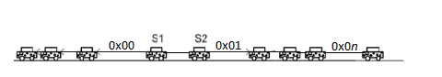

(*Fig. 8*) Client-to-client, one to one approach

Rather than establishing a direct client-to-server connection, our approach uses a peer-to-peer, ad-hoc approach to route the throughput in a region temporally local to the client device.

Furthermore quality development is still required to network autonomous vehicles going at a greater speed, whereas, for applications on vehicles like electric-bikes, or even simple bicycles is currently technically feasible.

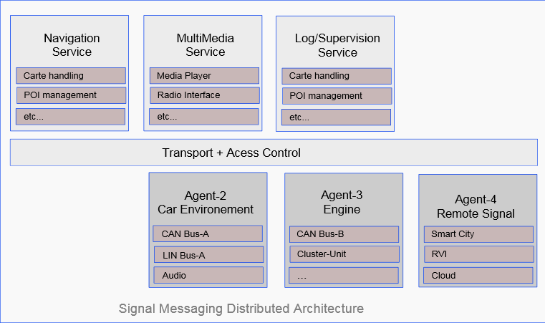

(*Fig 9*) : Signal Passing as bypassed within the subnet (local).

These strengths increased significantly with reduction in vehicle speed, and as a consequence, reduced latency, providing a faster-to-establish communication link, rather than a traditional fast (e.g. Lifi) link, with a small delay, nonetheless a trade off in quality assurance of the success in link establishment.

## **Inference**

|  |  |
| --- | --- |
| * Fig.1 Ad-hoc approach. * Fig.2 Real-time Routing | * O(ln(N)) time complexity * Client-to-Client type connection |

## The Automotive Grade Linux system when implemented hands-on with an ad-hoc approach drew better results in terms of connection stability, ease-of-user-setup and higher reactance in slow mobility environments, which could be seen as far more reliable over any GSM or Client/Server networking approach.

*(Fig. 10) Real*-Time Implementation and Scaling approach

## This protocol benefits the end-node applications on the client device such as distance-to-drop forecasting, local neighbor detection, faster network resource sharing, improved auto-pilot torque prediction model, among other functions inbuilt to the AGL core.

## **Gantt (Progression / Commits) chart**

|  |  |  |  |  |  |  |  |  |  |  |  |  |  |  |  |  |  |  |  |  |  |  |  |  |  |  |  |  |  |
| --- | --- | --- | --- | --- | --- | --- | --- | --- | --- | --- | --- | --- | --- | --- | --- | --- | --- | --- | --- | --- | --- | --- | --- | --- | --- | --- | --- | --- | --- |
| Week | 1 | 2 | 3 | 4 |  | 5 | 6 | 7 | 8 |  | 9 | 10 | 11 | 12 |  | 13 | 14 | 15 | 16 |  | 17 | 18 | 19 | 20 |  | 21 | 22 | 23 | 24 |
| Pre-Activity | # | # | # |  |  |  |  |  |  |  |  |  |  |  |  |  |  |  |  |  |  |  |  |  |  |  |  |  |  |
| Literature |  | # | # | # |  |  |  |  |  |  |  |  |  |  |  |  |  |  |  |  |  |  |  |  |  |  |  |  |  |
| 0th Review |  |  |  |  | # |  |  |  |  |  |  |  |  |  |  |  |  |  |  |  |  |  |  |  |  |  |  |  |  |
| Lit. Survey |  |  | # | # | # | # | # | # |  |  |  |  |  |  |  |  |  |  |  |  |  |  |  |  |  |  |  |  |  |
| Sampling |  |  |  |  | # | # | # | # | # |  |  |  |  |  |  |  |  |  |  |  |  |  |  |  |  |  |  |  |  |
| 1st Review |  |  |  |  |  |  |  |  |  | # |  |  |  |  |  |  |  |  |  |  |  |  |  |  |  |  |  |  |  |
| Re-Editting |  |  |  |  |  |  |  |  |  |  | ! | ! |  |  |  |  |  |  |  |  |  |  |  | ! |  |  |  |  |  |
| Experiments |  |  |  |  |  |  |  |  |  |  |  | ! | ! | ! |  | ! | ! | ! | ! |  | ! |  |  |  |  |  |  |  |  |
| Anlysis |  |  |  |  |  |  |  |  |  |  |  |  |  | ! |  | ! | ! | ! |  |  |  |  |  |  |  |  |  |  |  |
| Thesis |  |  |  |  |  |  |  |  |  |  |  |  |  |  |  |  |  | ! | ! |  | ! | ! | ! | ! |  |  |  |  |  |
| 2 nd Review |  |  |  |  |  |  |  |  |  |  |  |  |  |  |  |  |  |  |  |  |  |  |  |  | ! |  |  |  |  |
| Submission |  |  |  |  |  |  |  |  |  |  |  |  |  |  |  |  |  |  |  |  |  |  |  |  | ! |  |  |  |  |
| Acceptence |  |  |  |  |  |  |  |  |  |  |  |  |  |  |  |  |  |  |  |  |  |  |  |  |  | ! | ! | ! |  |
| Result |  |  |  |  |  |  |  |  |  |  |  |  |  |  |  |  |  |  |  |  |  |  |  |  |  |  |  |  | # |

! := done (submission)

# := done (review)

Note:

* Commit history as taken from https://github.com/MEE499/
* Code frequency history as taken from https://github.com//14BME0133/
* Pull Request was successfully merged with the Automotive Grade Linux repository hosted (public::master@master).

**References :**

Books, Whitepapers and Journal Publications referenced through the literature are cited below:

# ﻿[1] Jawhar, I., Mohamed, N., Zhang, L.: Inter-Vehicular Communication Systems, Protocols and Middleware. pp. 1–3 (2010)

# [2] Yang, X., Liu, J., Zhao, F., Vaidya N. H.: A Vehicle-to-Vehicle Communication Protocol for Cooperative Collision Warning. pp 1–14. (2003)

# [3] Thangavelu, A., Saravanan, K. Rameshbabu, K.: A Middleware Architectural Framework for Vehicular Safety over VANET (In-VANET).pp 277–282 (2009)

# [4] Luo, J., Hubaux, J.: A survey of Inter-Vehicle Communication. pp 1–12. (2004)

# [5] Böhm, A.: State-of-the-art in networks aspect for Inter-Vehicle communication. pp 1–25. (2007)

# [6] Keskin, U.: In-Vehicle Communication Networks: A literature Survey. pp 14 (2009).

# [7] Nekovee., M.: Quantifying Performance Requirements of Vehicle-to-Vehicle Communication Protocols for Rear-end Collision Avoidance. pp. (2008)

# [8] Inter-Vehicular Communication Systems, Daniel López García, Danckelmannstrasse 46/47 Berlin.

# **Sources and Code Snips:**

* https://MEE499.github.io/
* https://14BME0133.github.io/MEE499/
* <https://git.automotivelinux.com>
* <https://MEE499.github.io/agl-7782-0002-0009/>
* https://github.com/14BME0133/MEE499/Wiki/docs